#3 Fundamentals

**Creating a table**

CREATE TABLE test(

a INTEGER,

b TEXT

);

* **Anything between the brackets () is called the schema of the table**

INSERT INTO test (a,b) VALUES (1,'hello');

SELECT * FROM test;

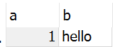

**Drop a table**

**DROP TABLE** test;

This query will Drop(remove) the table test. Everything!, schema too.

**What if a table doesn’t exists?**

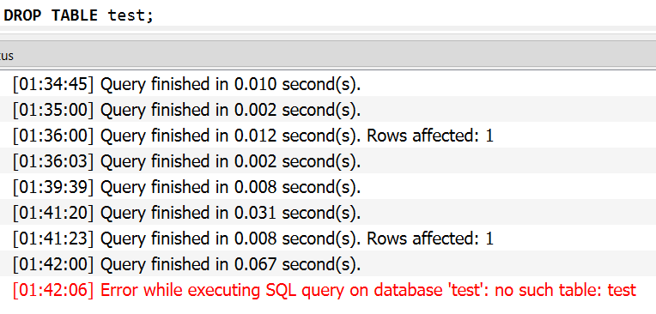

Use **DROP TABLE IF EXISTS** table

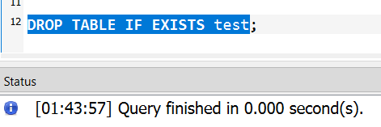

No ERROR!!

**INSERT INTO query**

Used to add records(rows) into the table.

🡪 INSERT INTO table DEFAULT VALUES

This will add the Default values in all the columns(if defined), else **every value will be set as NULL.**

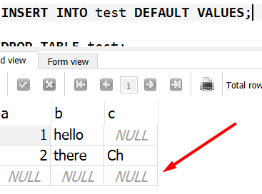

You can also add contents from another table using INSERT INTO SELECT statement

**🡪INSERT INTO test (a,b,c) SELECT id,name,description FROM item;**



**🡪DELETE FROM**

Used to delete records from a table.

DELETE FROM test WHERE b='Beauty';

This will delete the complete record where b is set as ‘Beauty’



**🡪NULL** is not 0 or an empty string – we know this, obvio, still for the sake of taking notes. Remember this!

🡪**Creating Schema where the column cannot be NULL. NOT NULL constraint**

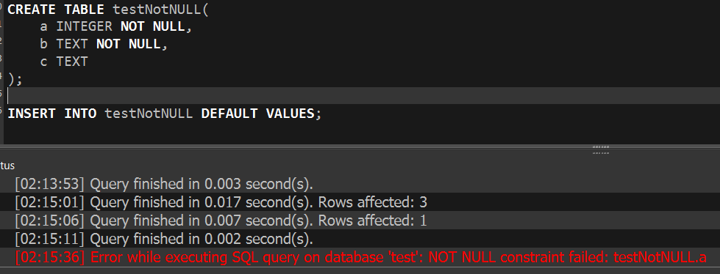

Constraints are rules used to define the schema of a table.

🡪**DEFAULT** constraint

Used to specify a DEFAULT value for a column(field).

🡪**Some Constraints – Unique, Default & Not Null**

DROP TABLE IF EXISTS constraints;

CREATE TABLE constraints (

SNO INTEGER UNIQUE,

A TEXT NOT NULL DEFAULT 'Default',

B TEXT NOT NULL

);

--Successfull query

INSERT INTO constraints VALUES (1,'SAHIL','SINGH');

INSERT INTO constraints (SNO,B) VALUES (2,'SINGH');

INSERT INTO constraints VALUES(3,'','SINGH');

--Below will fail

INSERT INTO constraints DEFAULT VALUES;

INSERT INTO constraints VALUES(4,NULL,'BETH');

SELECT * FROM constraints;



🡪**Primary Key**

A UNIQUE and NOT NULL column of a table. There can be only one PRIMARY KEY in a table.

CREATE TABLE alterTab (

id INTEGER PRIMARY KEY,

A TEXT NOT NULL,

B TEXT DEFAULT 'dragon'

);

**This schema will automatically add INTEGER values (Unique) in the id field.**

🡪 **Changing a SCHEMA**

ALTER TABLE alterTab ADD C STRING;

🡪SELECT * FROM Customer WHERE Name LIKE ‘_n%’;

**The _ wild char is used to tell SQL to take any string or number in place of that.**

**The % is used to define match anything.**

**🡪 Conditional Expressions**

SELECT

CASE WHEN a THEN 'true' ELSE 'false' END as boolA,

CASE WHEN b THEN 'true' ELSE 'false' END as boolB

FROM booltest;