Rotation Invariance in Spiking and Analog
p4-Equivariant CNNs
Consolidated Findings Report
Full-Capacity (24,744-Param) and Reduced-Capacity (2,420-Param) Studies,
the Priority Experimental Programme (Experiments 2-4), and Two Post-Hoc Corrections

Sahil Singh
CMI Summer Research Internship
Supervisor: Prof. K.V. Subrahmanyam
Consolidated: August 2026

Table of Contents
Right-click and choose 'Update Field' to build the table of contents.

Part 0 -- How to Read This Report
This document consolidates four previously separate reports and two post-hoc corrections into a single, internally consistent record. It reproduces no new experiments and trains no new models -- every table and figure below reads from results already on disk in ~/snn/ at the time of writing.
The four source reports being merged:
- Report 1. Report 1 (“full-capacity companion report”): 7-layer, 10-channel, 24,744-parameter SpikingP4CNNSmall, T=50 simulation timesteps, 20 training epochs, 4 spike-placement configurations, 3 seeds. File: findings_report.tex / findings_report.pdf.
- Report 2. Report 2 (“reduced-capacity companion report”): 5-layer, 4-channel, 2,420-parameter SpikingP4CNNSmall, run under two independent regimes (T=50/10ep and T=30/5ep), 5 spike-placement configurations, 3 seeds. Files: findings_report_small.tex (both regimes) and findings_report_t30.tex (T=30 regime, revised after seed 1 arrived, more cautious framing of the group-angle-error finding).
- Report 3. Report 3 (“Priority Experimental Programme, Experiments 2-4”): Experiments 2 (spike placement vs. accuracy/E90), 3 (layer/time representation distance D_{ℓ,t}), and 4 (Fourier decomposition of the rotation response), run on the same reduced-capacity checkpoints as Report 2, both regimes, no retraining. File: findings_report_experiments234.tex.
- The corrections. A code-vs-methodology audit of three specific anomalies raised across Reports 2 and 3, followed by two concrete fixes applied to the analysis code: Fix 1 (a layer-relative epsilon and floor-masking for the D_{ℓ,t} metric) and Fix 2 (multi-draw Monte-Carlo averaging for the E90 direct-equivariance-error statistic). No model, training, or architecture code was touched by either fix -- both are corrections to analysis/metric code only.
Superseding notice: the E90 numbers in Part 5 and the D_{ℓ,t} numbers in Part 6 supersede the equivalent single-draw / fixed-epsilon numbers reported in Reports 2 and 3. Every place this applies is flagged inline with the phrase “supersedes” rather than left implicit. The mechanism behind both corrections is explained once, in Part 1's closing paragraph, and referenced from Parts 5/6 as “the correction described in Part 1” rather than re-explained.
Reading order: Parts 1-2 establish shared setup and the accuracy backdrop against which every other finding should be read. Parts 3-8 present the substantive findings, one experiment family per part, each explicitly stating which report(s) and which regime(s) it draws from. Part 9 is a permanent settled-questions record of the code-vs-methodology audit, so this project's anomalies are not re-investigated by a future reader. Part 10 synthesizes at the confidence level each finding actually supports. Part 11 consolidates limitations and next steps against the current deadlines.

Part 1 -- Setup

1.1 Architecture
Both variants share the same qualitative design: a stack of p4-equivariant convolutions (P4ConvZ2 lifting the input into the p4 group, then P4ConvP4 layers operating within it), P4BatchNorm2d (sharing statistics and affine parameters across the 4 orientation channels -- see the callout below), a final group-pooling step (max over the 4 orientation channels) producing an orientation-invariant feature map, and a linear classifier. Full implementation: gconv_small.py (P4ConvZ2 / P4ConvP4 / P4BatchNorm2d / P4GroupPool) and p4cnn_small.py / spiking_p4cnn_small.py (the analog and spiking network definitions).
 | Full-capacity variant | Reduced-capacity variant
Layers | 7 | 5
Channels per layer | 10 | 4
Parameters | 24,744 | 2,420 (10.2x fewer)
Kernels | six 3x3 + one 4x4 (valid conv) | 3x3 throughout, two 2x2 maxpools
Used in | Report 1 only | Reports 2 and 3
P4BatchNorm2d exists because standard BatchNorm assigns each of the 4 orientation channels independent running statistics, which breaks the architecture's equivariance guarantee once trained upright-only (verified: untrained equivariance error ~1e-6; after training with standard BatchNorm, ~0.1-0.2). Sharing statistics and affine parameters across the 4 orientation channels restores equivariance to ~1e-6 even after training. This fix is used throughout every result in this document -- it is a settled, resolved issue, listed here for completeness and cross-referenced from Part 9.

1.2 Task
4-class rotated-MNIST: digits {3, 4, 8, 9}, chosen because none is rotationally self-symmetric under 90 degrees/180 degrees. Models are trained on upright (0 degree) images only and evaluated on a 24-angle sweep, theta in {0, 15, 30, ..., 345} degrees, on the held-out test split (Reports 1-2) or a fixed probe set (Report 3 -- see Part 5/6/7 setup notes).

1.3 Spike-Placement Configurations and Which Report Trained Which
Configuration | Spiking layers | Full-capacity (Report 1) | Reduced-capacity (Reports 2-3)
Analog / None | none | yes (“Analog”) | yes (“None”)
Alternating | interleaved through depth (2,4,6 full-cap; 2,4 reduced) | yes | yes
Full Spiking | all layers | yes | yes
Hybrid Late | final layer only | yes | yes
Hybrid Early | first 1-2 layers | not trained -- see note | yes
Hybrid Mid | middle layers | not trained -- see note | does not exist at depth 5
Note: Report 1 explicitly states Hybrid Early and Hybrid Mid were implemented in the codebase but not yet trained under its corrected setup, so Report 1 says nothing about them. Both were trained for the reduced-capacity model (Reports 2-3); Hybrid Mid has no reduced-capacity analogue since a 5-layer network has no distinct “middle” block the way a 7-layer network does.

1.4 Training Regimes and Seed Counts
Regime | Model | T (timesteps) | Epochs | Params | Seeds | Used by
Full-capacity | SpikingP4CNNSmall (7L/10ch) | 50 | 20 | 24,744 | 3 (0,1,2), full repr. analysis | Report 1
Regime A | SpikingP4CNNSmall (5L/4ch) | 50 | 10 | 2,420 | 3 (0,1,2) | Reports 2, 3
Regime B | SpikingP4CNNSmall (5L/4ch) | 30 | 5 | 2,420 | 3 trained; repr. analysis on seeds 0-1 only (seed 2 intentionally incomplete, by explicit instruction) | Reports 2, 3
All regimes: Poisson/Bernoulli rate coding of the input, Adam, learning rate 1e-3, batch size 64, best checkpoint by 0-degree test accuracy, gpuserver.cmi.ac.in.

1.5 The Two Corrections (Referenced Throughout as “the correction described in Part 1”)
Both corrections were produced by a code-vs-methodology audit that investigated three specific anomalies raised in Reports 2-3 (full detail and verdicts in Part 9). Two of the three anomalies turned out to be genuine methodological artifacts worth correcting in the analysis code -- not bugs in the model, training, or the p4-equivariant conv/BatchNorm implementation, which were independently verified to have no mode-dependent branching.
- Fix 1 (D_{ℓ,t} epsilon). A single fixed epsilon (1e-8) is added to a reference-norm denominator when computing the layer/time representation distance D_{ℓ,t}(θ) (Report 3, Experiment 3). At the network's narrowest layer (layer 5, 16 units), the true reference norm is legitimately exactly zero for a nontrivial fraction of (timestep, image) cells -- dividing by the 1e-8 floor rather than a real signal produced the reported ~1e7 blowups. Fix: a per-layer epsilon (max(1e-8, 1% of the median nonzero reference norm at that layer), computed once from the reference batch) plus explicit exclusion of any cell whose raw reference norm falls below 1e-4 from the reported mean. Applied in representations_small.py's layer_time_distance() and rerun via the new plot_experiment3_layertime_fixed.py.
- Fix 2 (E90 multi-draw averaging). The direct equivariance-error computation (E90, used for Experiment 2's “does spike placement matter” ordering claim) resets the encoding RNG to the same seed value for both the upright image x and its rotation R_theta(x) before drawing the Poisson/Bernoulli spike encoding. Because rotation moves image content between tensor positions, sharing a seed value reproduces the same raw random stream but does not reproduce a matched spike encoding under rotation -- it only gives run-to-run reproducibility, not the variance cancellation the convention seems to have intended. A single draw's E90 is therefore dominated by Monte-Carlo spike-sampling variance, not a stable property of the trained model (confirmed empirically: re-drawing the encoding seed alone, with no rotation or config change, reproduces the reported group-angle magnitudes and ordering). Fix: draw the encoding 8 independent times per (model seed, config), each with a genuinely different encoding seed (seed*1000 + draw_index, never reused), and report the mean and std across draws instead of a single value. Added as equivariance_error_multidraw() in representations_small.py and run via the new plot_experiment2_summary_multidraw.py.
Both fixes touch analysis/metric code only (representations_small.py plus two new driver scripts); gconv_small.py, p4cnn_small.py, spiking_p4cnn_small.py, and every training script are untouched, and no model was retrained.

Part 2 -- Baseline Accuracy (All Configs, All Regimes)
Across every regime in this project, the qualitative story is the same: once training is done properly (P4BatchNorm2d, adequate epochs), rotation-accuracy curves for every spike-placement configuration sit within a few percentage points of each other, with substantial seed-to-seed error-bar overlap at the hardest angles. Accuracy alone does not distinguish spike placement in any regime tested. The numeric tables below make this precise per regime.

2.1 Full-Capacity (Report 1): T=50, 20 Epochs, 24,744 Params
Report 1 does not publish a per-configuration numeric accuracy table -- only the comparison figure below plus qualitative text are available in that report. Its text states the four configurations' curves sit within a few points of each other at every angle, with substantial error-bar overlap at the hardest angles (45, 135, 225, 315 degrees), confirming that two dramatic accuracy-level findings from an earlier, compute-constrained (T=30, 5 epoch, single-seed, CPU-only) draft of the same project did not replicate under this corrected setup (Full Spiking's earlier flat 51-57% and Hybrid Late's earlier collapse to chance at non-group angles). Under the corrected setup, Full Spiking reaches ~99% upright and ~94% mean accuracy across all angles; Hybrid Late's worst case across all seeds and angles is 80.9%.
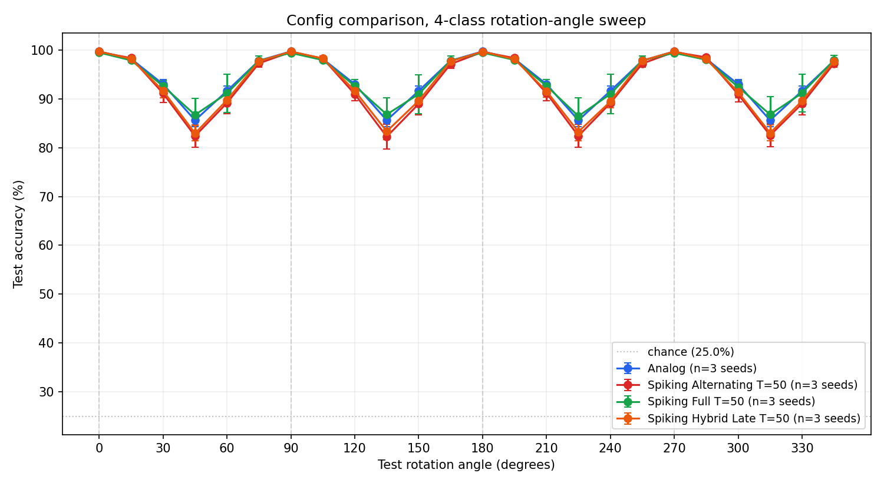
Full-capacity: 4-class rotation-angle sweep, mean +/- std over 3 seeds, Analog / Alternating / Full Spiking / Hybrid Late (Hybrid Early/Mid: not trained, see Part 1.3). [plots/n4_comparison_final.png]

2.2 Reduced-Capacity, Regime A: T=50, 10 Epochs, 2,420 Params
Configuration | Best 0-deg acc. (%), mean+-std, 3 seeds | Mean acc. over 24 angles (%)
None | 97.67 +/- 0.48 | 84.77
Alternating | 97.39 +/- 0.73 | 85.62
Full Spiking | 96.39 +/- 0.36 | 86.30
Hybrid Early | 95.14 +/- 3.53 | 81.32
Hybrid Late | 97.60 +/- 0.24 | 85.84
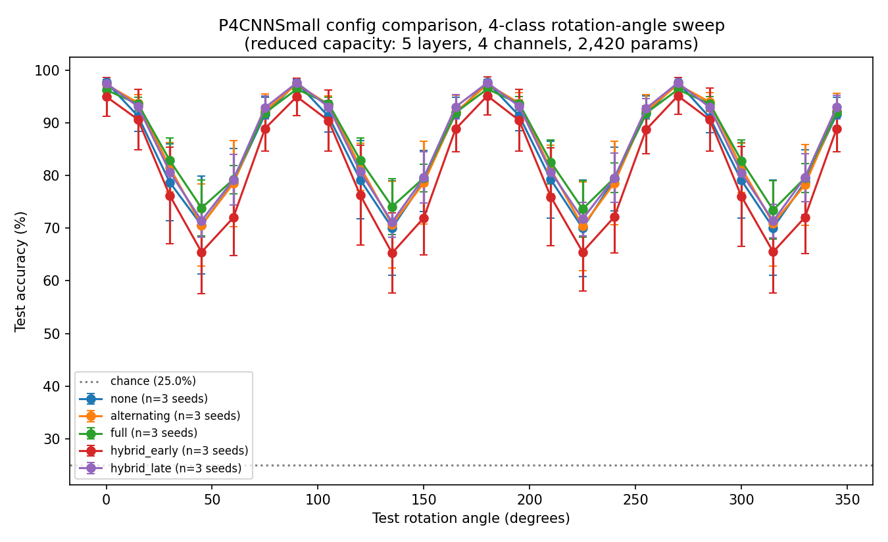
Regime A (T=50, 10 epochs), all 5 configurations, mean +/- std over 3 seeds. [plots_small/small_n5_comparison.png]

2.3 Reduced-Capacity, Regime B: T=30, 5 Epochs, 2,420 Params
Configuration | Best 0-deg acc. (%), mean+-std, 3 seeds | Mean acc. over 24 angles (%)
None | 97.25 +/- 0.34 | 84.52
Alternating | 96.71 +/- 0.12 | 86.87
Full Spiking | 95.14 +/- 0.53 | 84.31
Hybrid Early | 91.39 +/- 5.71 | 77.86
Hybrid Late | 97.09 +/- 0.08 | 82.03
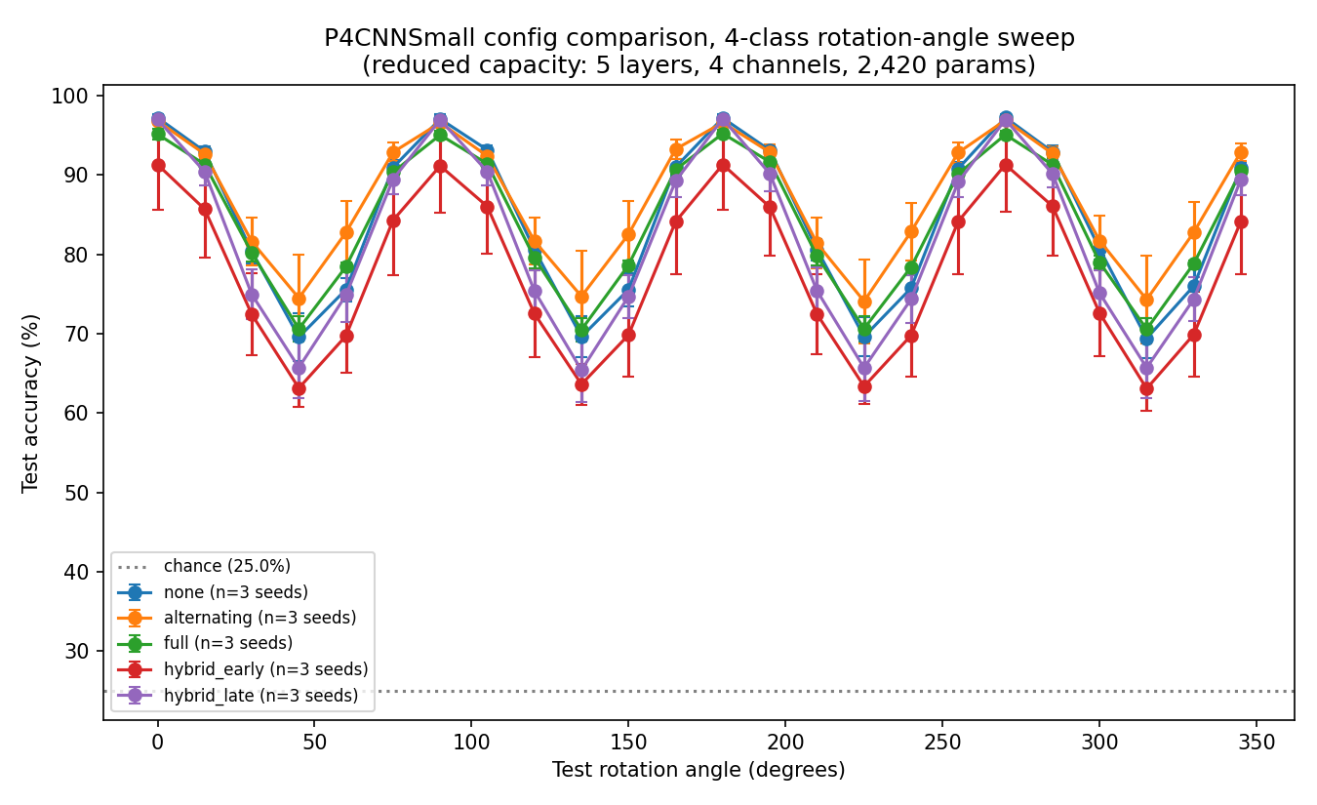
Regime B (T=30, 5 epochs), all 5 configurations, mean +/- std over 3 seeds. [plots_small_t30/small_n5_comparison.png]
One configuration breaks the “accuracy is uninformative” pattern in both reduced-capacity regimes: Hybrid Early shows a conspicuously large seed-to-seed standard deviation (+/-3.53 at Regime A, +/-5.71 at Regime B), driven by a single unstable seed (seed 2: 90.20% and 83.33% best-upright-accuracy respectively, versus >=95% for seeds 0 and 1 in both regimes). This instability has no full-capacity analogue since Report 1 never trained Hybrid Early; it is plausibly a capacity effect (at only 4 channels, Hybrid Early's spiking layers 1-2 sit immediately after the lifting convolution, where the network has the least redundancy to absorb a bad initialization's interaction with the surrogate-gradient spiking nonlinearity) and was not investigated further (Part 11).

Part 3 -- Layer-wise Representation Similarity (Experiment 5.1)
This finding was consistent everywhere it was tested -- full capacity, both reduced-capacity regimes, every spike-placement configuration including the zero-spiking control -- and is stated here plainly, without hedging, because the evidence does not call for any.
Representational similarity to the upright image (measured by cosine similarity, CKA, and SVCCA between h_ell(x) and h_ell(R_theta x)) stays high through the early and middle layers and collapses only at the final layer(s), in every configuration tested at every capacity, including Analog / None, which has zero spiking neurons anywhere in the network. Whatever causes deep-layer representations to become rotation-sensitive is a property of the p4-equivariant architecture itself (most plausibly the group-pooling and final linear-classifier stages, the only components not built from strictly equivariant convolutions) -- not something introduced by spiking dynamics.

3.1 Full Capacity (Report 1)
CKA similarity to the upright representation stays at or above roughly 0.97-0.99 through layers 1-5 in every configuration, then drops sharply in layers 6-7 to roughly 0.70-0.85 at the hardest angles (typically 15, 30, 45, 60 degrees etc., the non-group angles nearest a group angle). Spike placement modulates the shape somewhat -- Alternating and Full Spiking show a slightly earlier onset of divergence (visible already around layer 5) relative to Analog and Hybrid Late -- but not the existence or final location of the collapse: all four configurations land in the same 0.70-0.85 CKA range by layer 7 at the hardest angles. Cosine similarity is much lower and noisier throughout (typically 0.3-0.6 even at shallow layers) since it demands exact neuron-by-neuron agreement with no tolerance for internal reshuffling of which channel encodes which feature; CKA and SVCCA both stay near 1.0 through layer 5 and diverge only at layers 6-7.
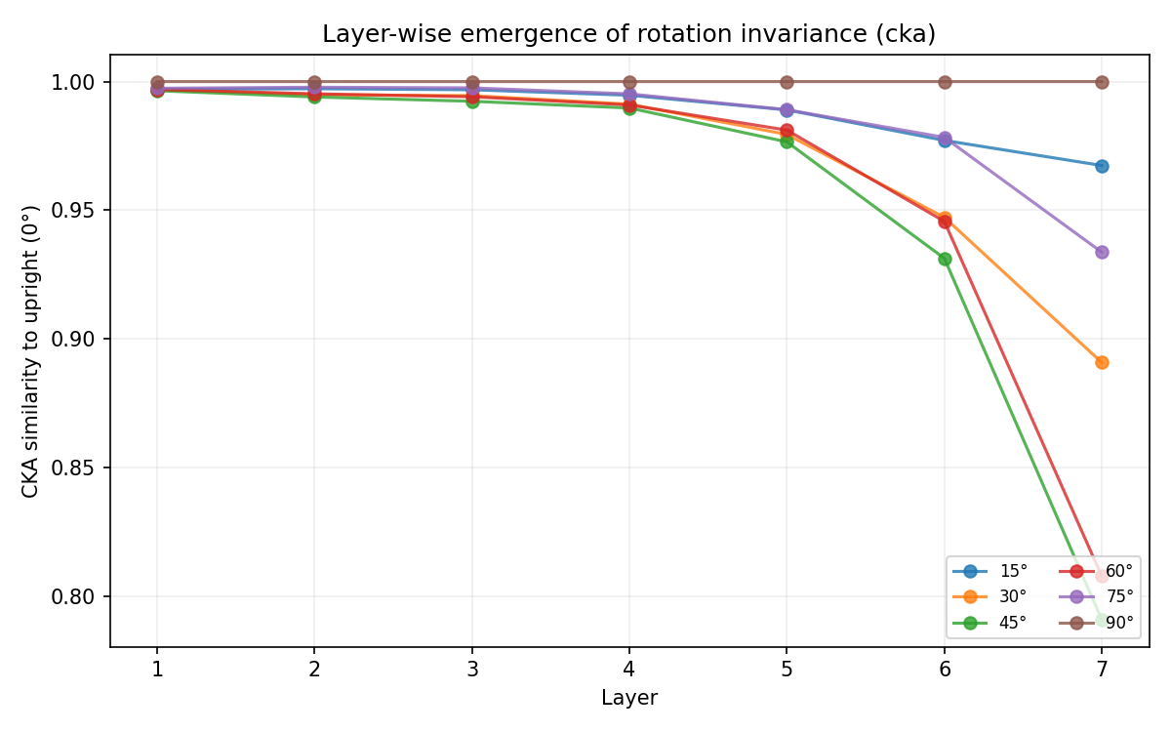
Full capacity, Analog -- CKA similarity to upright vs. layer, one line per test angle. [plots/analog_layerwise_cka.png]
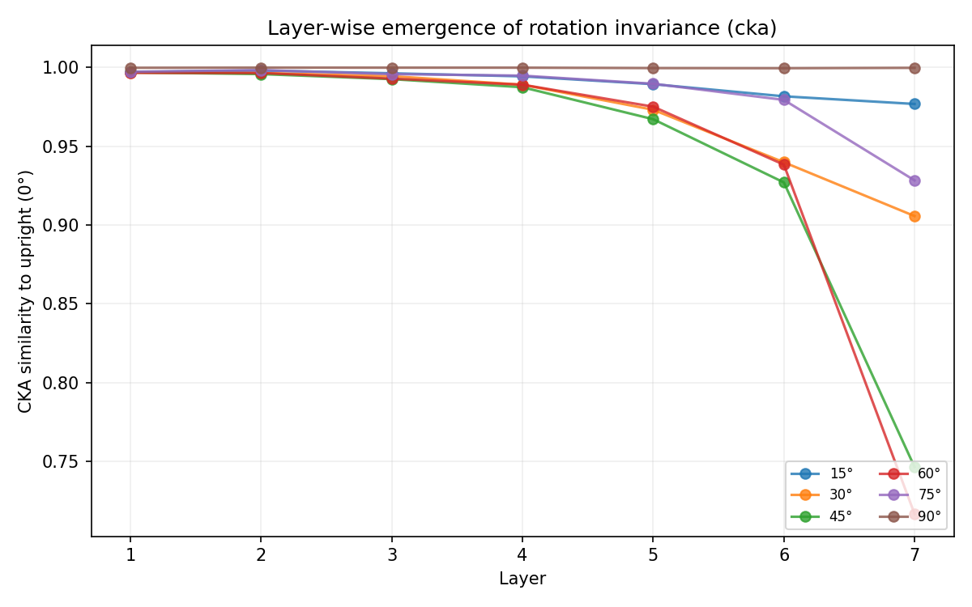
Full capacity, Alternating -- same quantity. [plots/alternating_layerwise_cka.png]
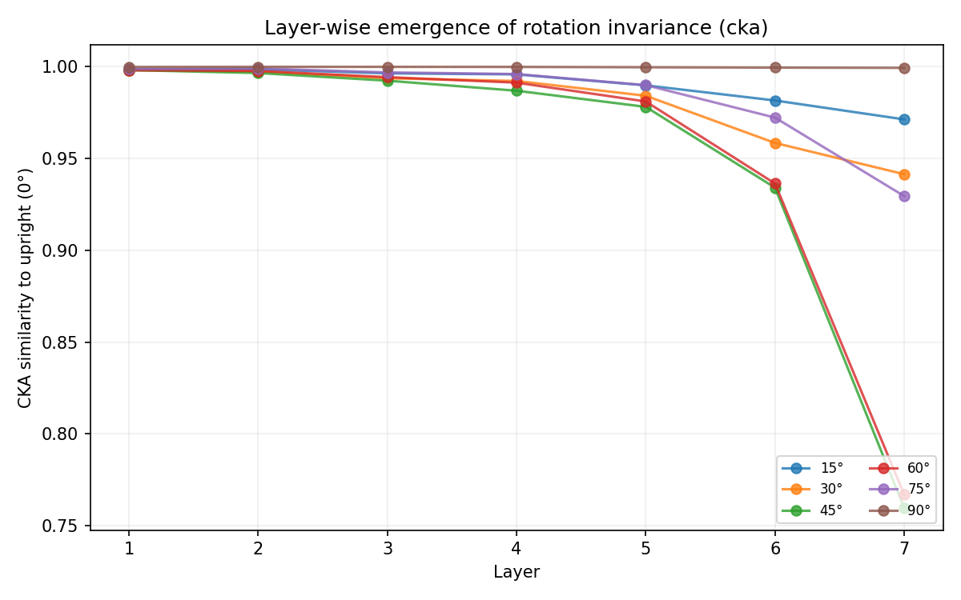
Full capacity, Full Spiking -- same quantity. [plots/full_layerwise_cka.png]
Hybrid Late's standalone aggregate CKA plot (hybrid_late_layerwise_cka.png) was not generated in Report 1's pass -- explicitly noted there, not silently omitted here. Its per-seed 5.1 figures were used instead in that report and show the same collapse pattern.

3.2 Reduced Capacity, Both Regimes (Reports 2-3)
With only 5 layers instead of 7 there is less “room” for a late-layer-only collapse to look visually distinct from a whole-network effect, yet the qualitative pattern reproduces cleanly: similarity to the upright representation stays high through the early-to-middle layers and drops at the final layer(s), in every configuration and both training regimes, including None. This is the single most important replication in Report 2: the architectural (not spiking) origin of the collapse holds at 10.2x less capacity, 40% less simulation time (Regime B), and a quarter of the training epochs (Regime B).
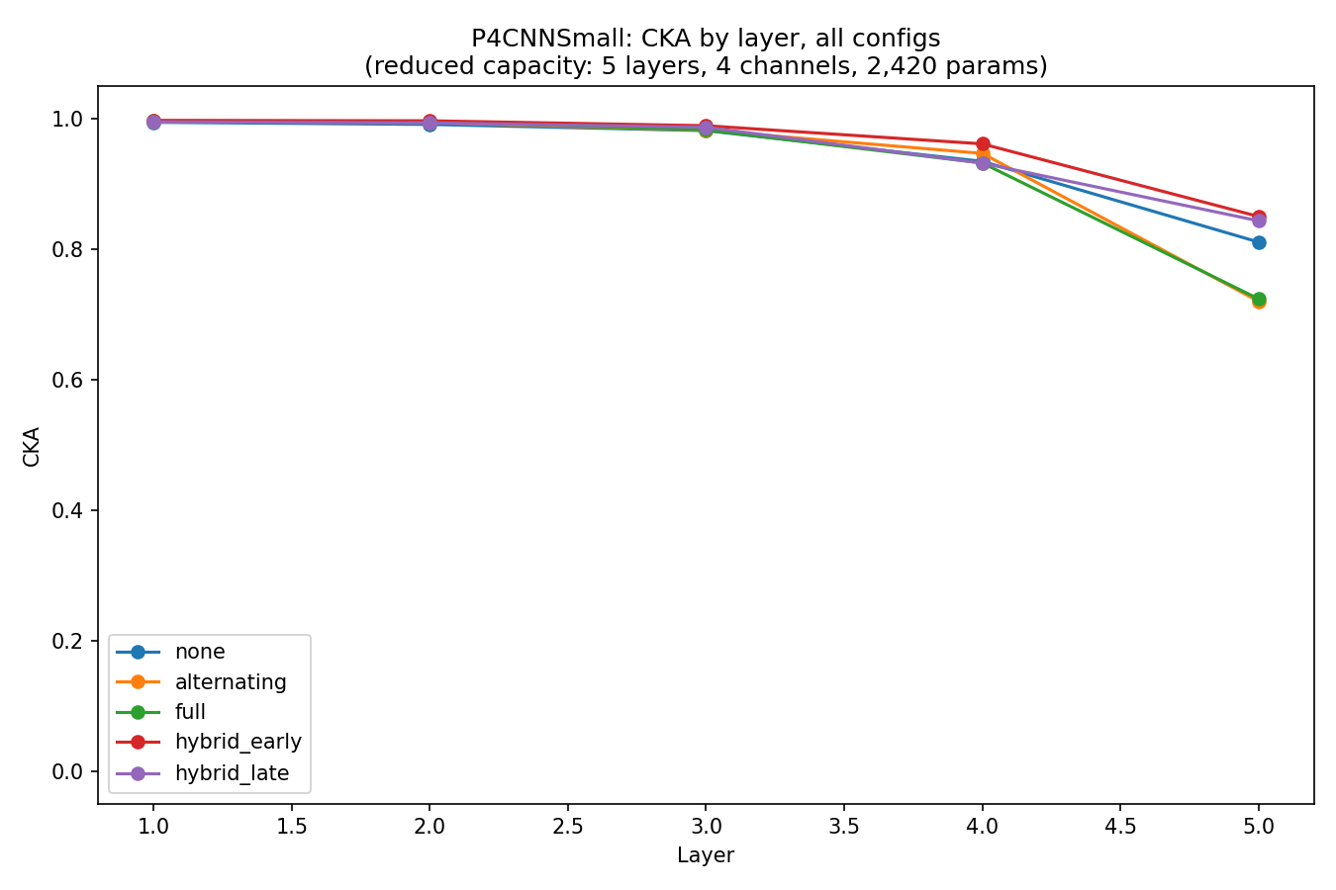
Regime A, seed 0 -- CKA similarity to upright vs. layer, all 5 configurations overlaid. [plots_small/repr_seed0/similarity_comparison_cka.png]
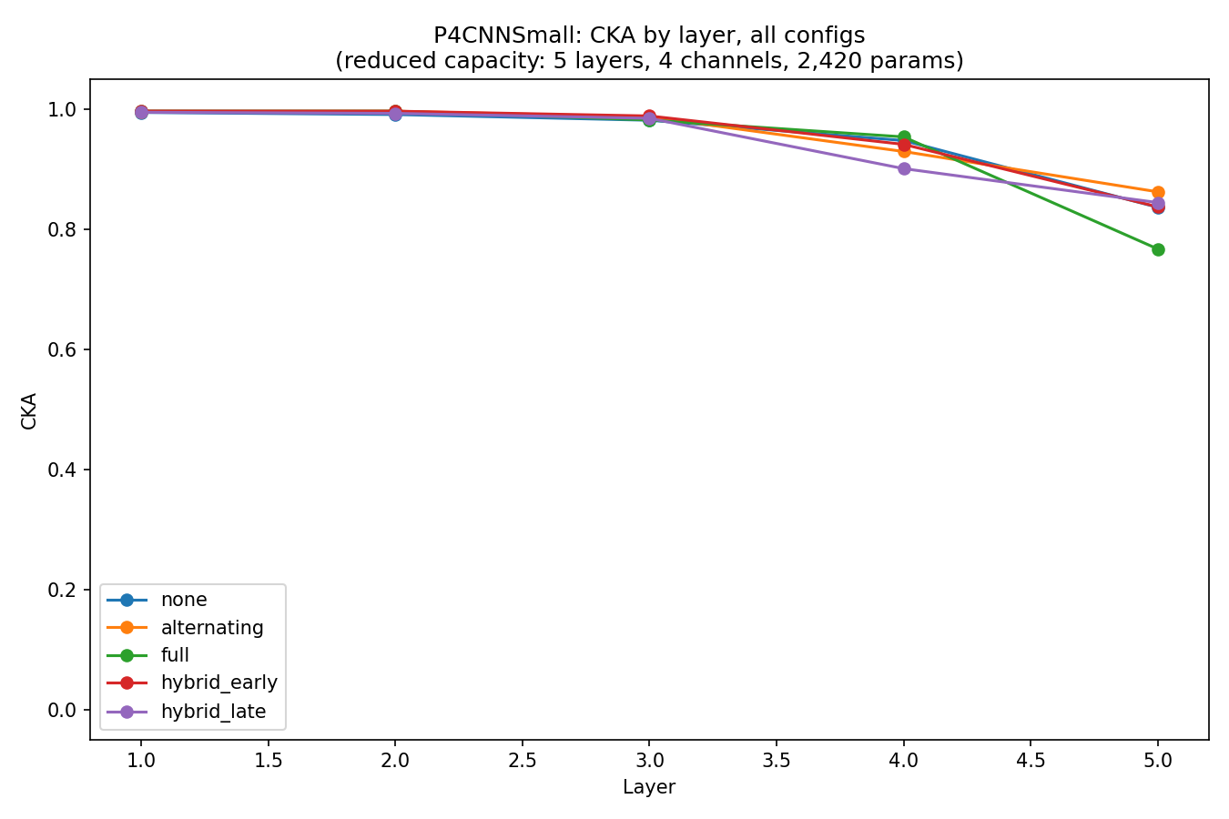
Regime B, seed 0 -- same comparison. [plots_small_t30/repr_seed0/similarity_comparison_cka.png]
Spike placement's secondary modulation of exactly where the divergence first becomes visible (Alternating/Full Spiking diverging one layer earlier than None/Hybrid Late, per the full-capacity finding) is harder to isolate cleanly with only 5 layers to distribute the effect across -- this is a genuine capacity-driven limitation on how finely the secondary claim can be tested at this depth, not a contradiction of it.

Part 4 -- Rotation Sensitivity, by Layer and by Time (Experiments 5.3, 5.4)

4.1 5.3: Distribution of R_i Across Layers
R_i = Var_theta(a_i(R_theta x)), the rotation sensitivity of neuron i over the 24 test angles. In every configuration and every capacity, the final layer sits at or near the top of the R_i ranking, consistent with Part 3's identification of the last layer(s) as where invariance breaks down. The shape of the climb to the final layer differs meaningfully by spike placement, at full capacity:
Configuration | Shape of R_i climb to final layer (full capacity)
Alternating | sharp, order-of-magnitude jump only at the final layer: median R_i ~10-100 for the earlier layers, jumping to ~400-800 at layer 7
Full Spiking | gradual, full-depth climb: median R_i rises roughly monotonically from ~10 (layer 1) to ~90-100 (layer 7), no single sharp jump
Hybrid Late | nearly flat across all layers: median R_i in a comparatively narrow band (~10-80) at every depth, including the final layer
Analog | gradual full-depth climb similar in shape to Full Spiking, but ~1000x smaller in absolute scale (~0.01-0.05 throughout)
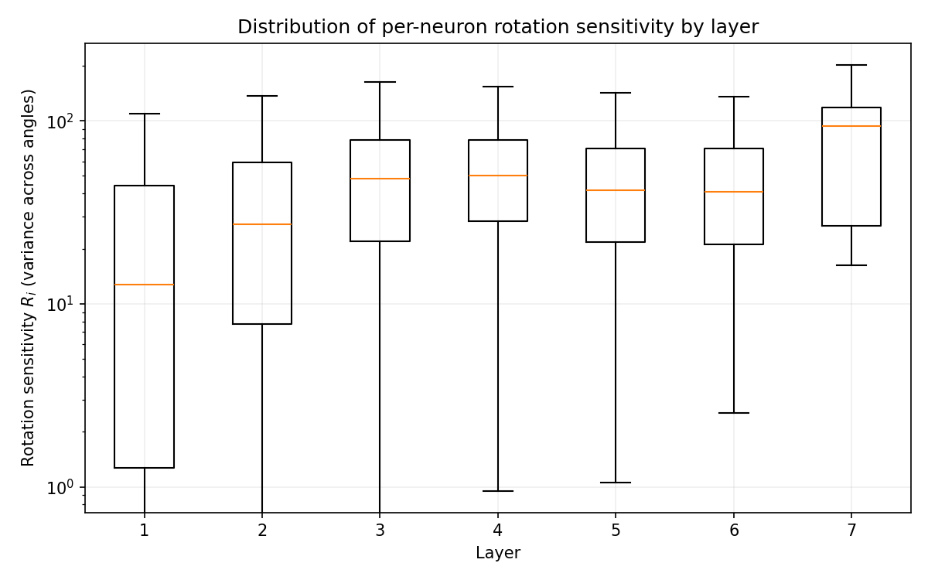
Full capacity, Full Spiking -- R_i distribution by layer (log scale). [plots/full_rotation_sensitivity.png]
Hybrid Late's standalone aggregate boxplot (hybrid_late_rotation_sensitivity.png) was likewise not generated in Report 1's pass; its per-seed 5.3 figures were used instead there.
Reduced capacity: the same qualitative fingerprint (sharp late jump for Alternating, gradual climb for Full Spiking/None, flatter profile for Hybrid Late) reproduces, but is harder to resolve cleanly with only 5 layers to distribute the pattern across. This is consistent with, not contradicted by, the full-capacity finding -- the reduced-capacity report is underpowered to cleanly distinguish the shapes at this depth, not evidence the shapes actually converge.
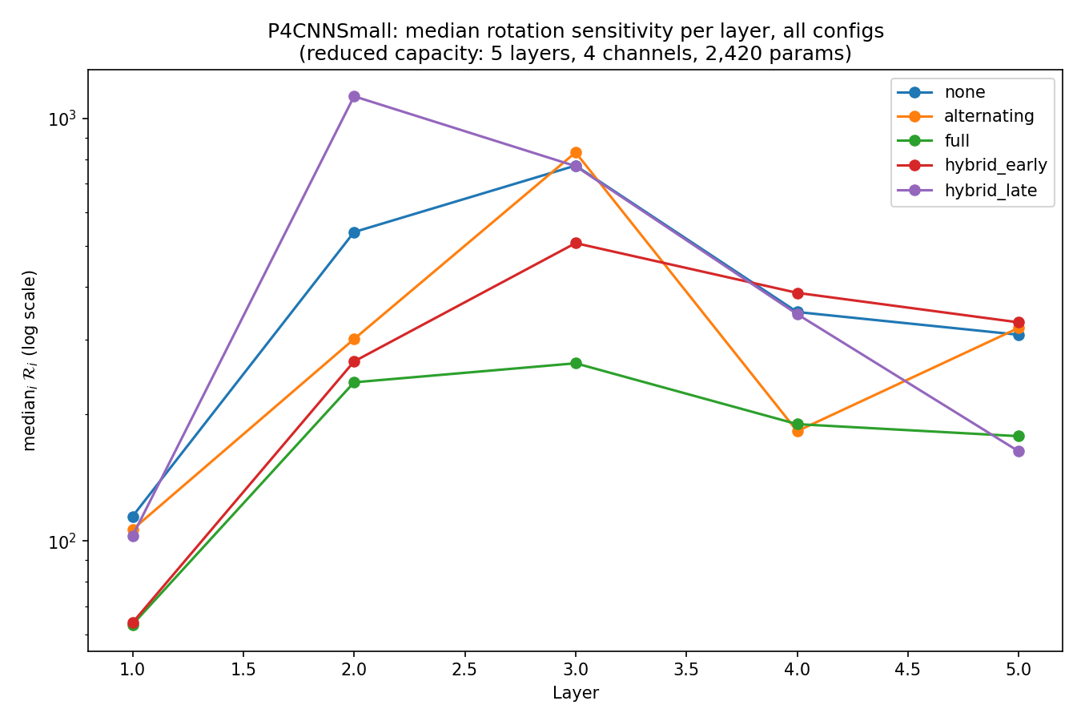
Regime A, seed 0 -- median R_i per layer, all 5 configurations overlaid (log scale). [plots_small/repr_seed0/rotsens_median_comparison.png]
R_i's absolute scale depends on whether the underlying activation is a continuous ReLU output or a spike count, so the fair cross-configuration comparison is the shape of the R_i-vs-layer curve, not the raw magnitude. Within a single configuration, comparisons across layers or seeds are on safe footing.

4.2 5.4: Rotation Sensitivity Through Time
R_i(t): the same quantity computed from the instantaneous per-timestep spike output alone, plotted against timestep t. In every configuration, every seed, and every capacity/regime tested, R_i(t) rises quickly over the first few timesteps and then plateaus for the remainder of the simulation, with no visible downward trend. This directly contradicts the temporal-contraction hypothesis that motivated this experiment (that temporal averaging should progressively reduce sensitivity, R_i(t) decaying toward 0 as spikes accumulate) -- sensitivity is set almost immediately and then stays fixed.
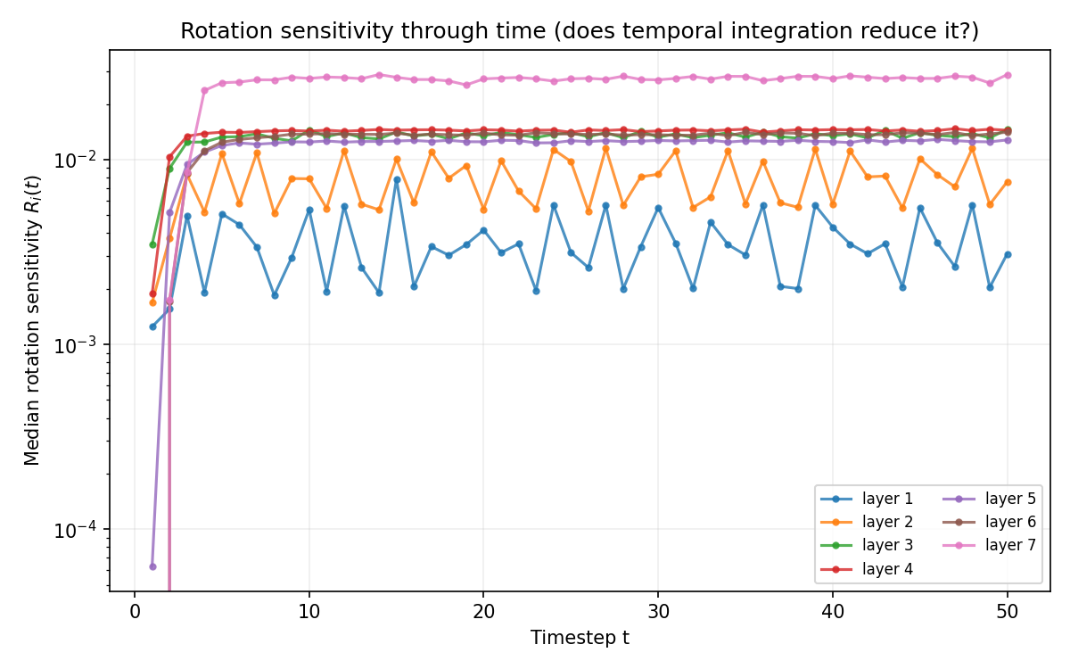
Full capacity, Full Spiking, seed 0 -- R_i(t) vs. timestep, all 7 layers. [plots/full_seed0/full_seed0_5.4_rotation_sensitivity_through_time.png]
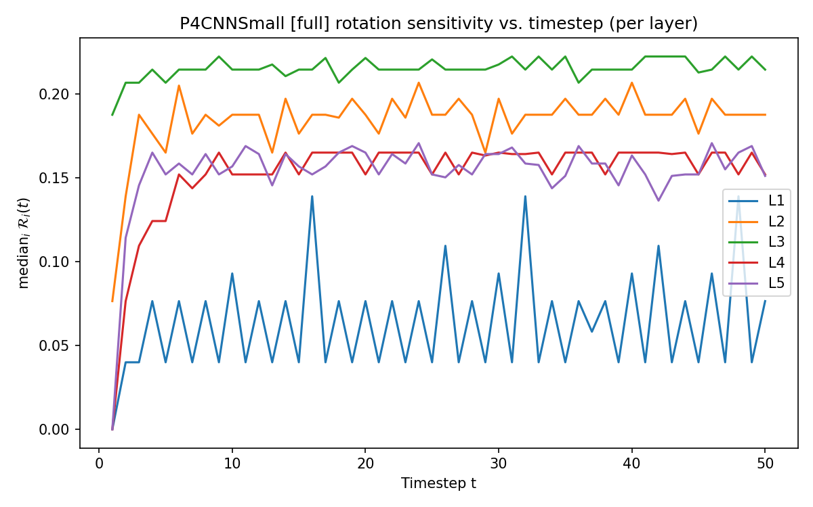
Regime A, Full Spiking, seed 0 -- median R_i(t) vs. timestep, all 5 layers. [plots_small/repr_seed0/rotsens_temporal_full.png]
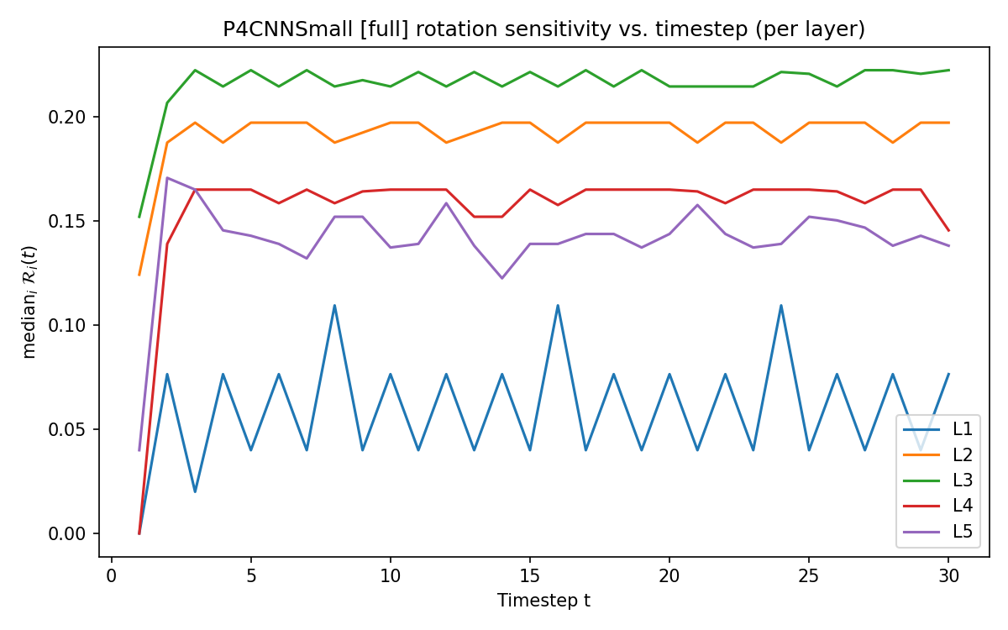
Regime B, Full Spiking, seed 0 -- same quantity, T=30. [plots_small_t30/repr_seed0/rotsens_temporal_full.png]
Layer 7 (full capacity) plateaus visibly higher than other layers in Alternating and Full Spiking, consistent with Part 3; in Hybrid Late the plateau levels across layers are closer together, consistent with that configuration's flatter layer-wise sensitivity profile. Analog has no meaningful 5.4 plot at full capacity (T=1, no timestep axis). The plateau-not-decay result reproduces exactly at reduced capacity, in both regimes, with no exceptions found in any configuration or seed examined.

Part 5 -- Direct Equivariance Error (Experiment 5.8 / Experiment 2's E90)
This is the part of the project where the most care is required, because two genuinely different quantities were measured under the same name (“equivariance error”) across reports, and one of them (the reduced-capacity E90 value) needed a genuine correction. This section is deliberately structured in four steps so none of that gets blurred together.

5.1 (a) Two Different Quantities, Not Directly Comparable
Both quantities are legitimate, correctly-implemented computations of the relative error ||f(R_theta x) - f(x)|| / ||f(x)||, which the p4 architecture guarantees is exactly 0 at the four group angles {0, 90, 180, 270} by construction. They differ in two ways that turn out to matter a great deal:
 | Report 1 (full capacity) | Reports 2-3 (reduced capacity, E90)
Space | raw accumulated-spike-count logits (no softmax) | softmax class-probability vector
Angle reduction | peak (max) over all 24 test angles | value at exactly theta=90 degrees
The audit confirmed directly (not just by formula inspection) that this difference, not model capacity, drives the apparently contradictory orderings below: recomputing BOTH formulas on the SAME reduced-capacity checkpoints reproduces Report 1's ordering under the raw-logit/peak-over-angles formula (None highest at 0.417, Full Spiking lowest at 0.270) and reproduces the opposite ordering under the softmax/value-at-90 formula (Full Spiking highest at 0.498) -- on identical models. Softmax compresses outputs onto a bounded probability simplex, which changes both which angle maximizes the disagreement and how the denominator scales with each configuration's confidence/calibration, which differs systematically by configuration. Sections (b) and (c) below report each quantity as its own report found it; they are not reconciled into one ordering (see (d)).

5.2 (b) Full-Capacity Finding: Peak Equivariance Error (Report 1, As-Is)
Quantity: raw-logit relative error, peak over all 24 angles. Every configuration's error touches (or comes extremely close to) 0 at exactly the four group angles and rises to a local maximum roughly halfway between them, in every configuration and every seed -- the expected sawtooth, and a strong sanity check that P4BatchNorm2d's equivariance fix functions correctly in fully trained models.
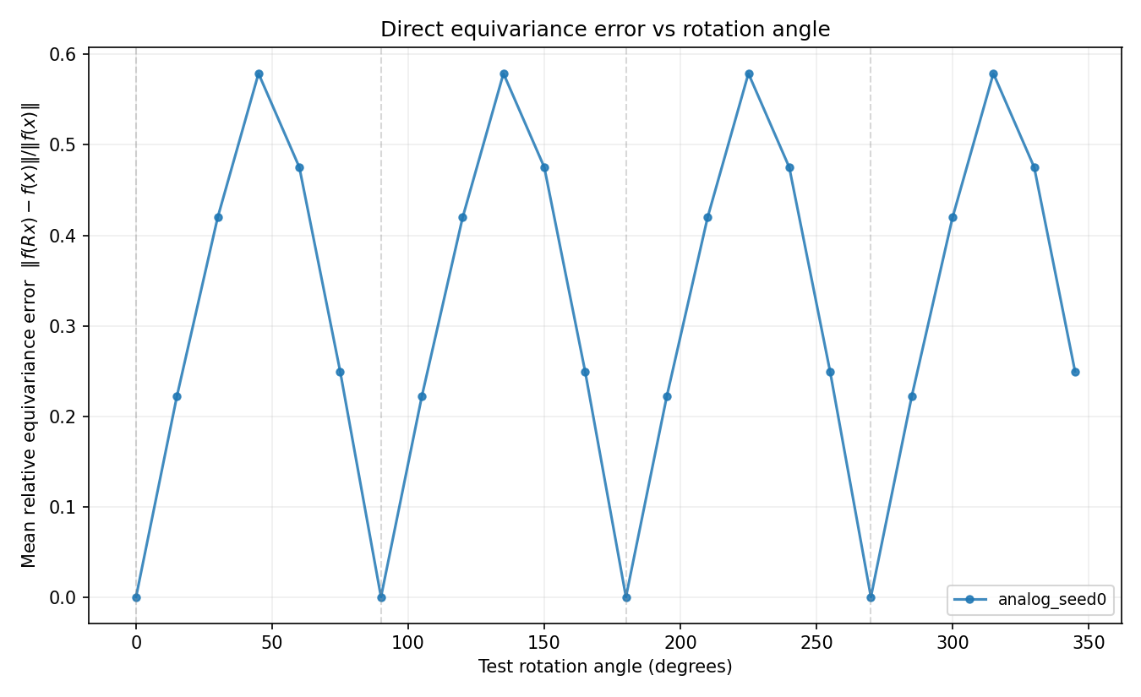
Full capacity, Analog, seed 0 -- equivariance error vs. angle. [plots/analog_seed0/analog_seed0_5.8_equivariance_error.png]
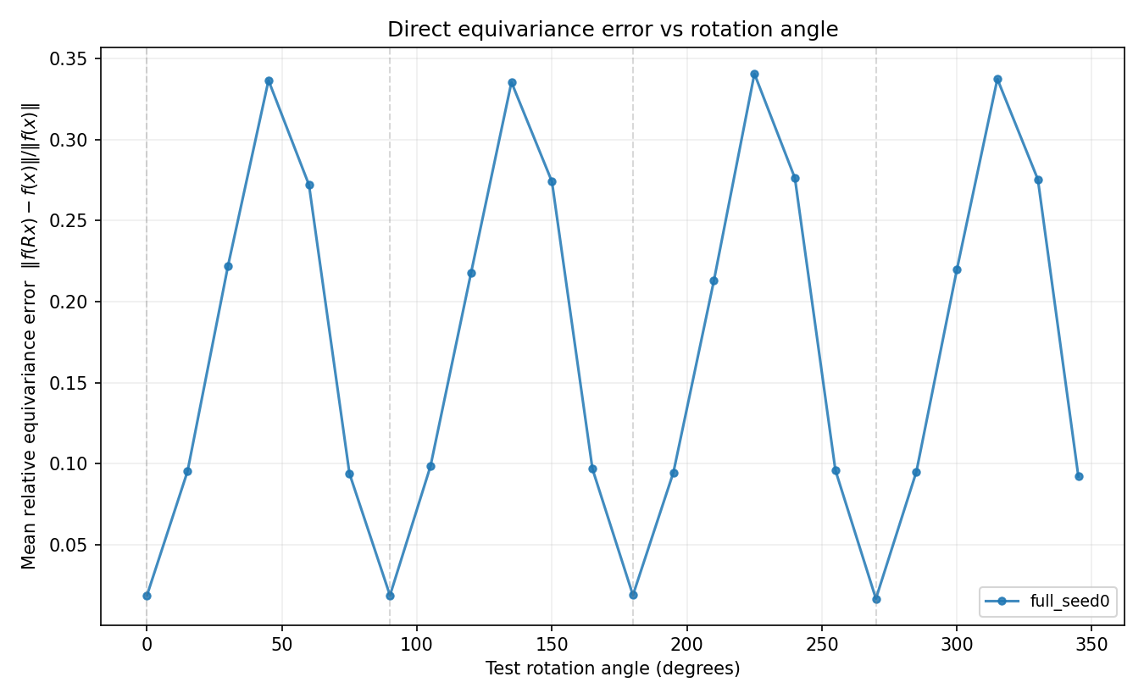
Full capacity, Full Spiking, seed 0 -- same quantity. [plots/full_seed0/full_seed0_5.8_equivariance_error.png]
Configuration | Spiking layers | Approx. peak equivariance error (mean over seeds)
Analog | 0/7 | ~0.58-0.59 (highest)
Alternating | 3/7 | ~0.50-0.60
Hybrid Late | 1/7 | ~0.35-0.40
Full Spiking | 7/7 | ~0.33-0.42 (lowest)
If spiking dynamics simply degraded invariance in proportion to how many layers spike, peak error should increase monotonically from Analog through Hybrid Late through Alternating through Full Spiking. The data does not show this: Analog has the highest peak error and Full Spiking the lowest -- the opposite of the naive “spiking hurts invariance” expectation. Report 1 reports this as an open, reproducible observation, not an explained result; no experiment run in that report isolates why this ordering holds.

5.3 (c) Reduced-Capacity E90 Finding, CORRECTED (Supersedes Reports 2 and 3)
Quantity: softmax-probability relative error, value at exactly theta=90 degrees (“E90”).
This supersedes two earlier readings of the same quantity. Report 2's single-seed-0 reading first suggested Full Spiking was uniquely, severely anomalous at the group angles; Report 2's seed-1 revision (findings_report_t30.tex) walked that back to “noisy across every configuration, no configuration reproducibly anomalous, n=2 is not enough to tell.” Report 3, using a probe set held fixed across seeds (a genuine methodological improvement over Reports 2's per-seed-varying probe set), found a clean monotonic ordering (None < Alternating < Full Spiking) in both regimes and described it as materially cleaner than Report 2's reading. The correction described in Part 1 (Fix 2: 8 independent encoding draws per model seed, each with a genuinely different encoding seed) was applied on top of Report 3's fixed-probe-set protocol, because the audit traced the underlying noise source to Monte-Carlo spike-sampling variance in the encoding, not to the probe set.
Regime | None | Alternating | Full Spiking
A (T=50) | 0.0038 +/- 0.0044 | 0.0102 +/- 0.0038 | 0.0249 +/- 0.0151
B (T=30) | 0.0146 +/- 0.0087 | 0.0248 +/- 0.0147 | 0.0455 +/- 0.0168
(Mean +/- std of E90 over 3 model seeds; each seed's own value is itself the mean of 8 independent encoding draws, so this combines model-seed variance and encoding-draw variance.)
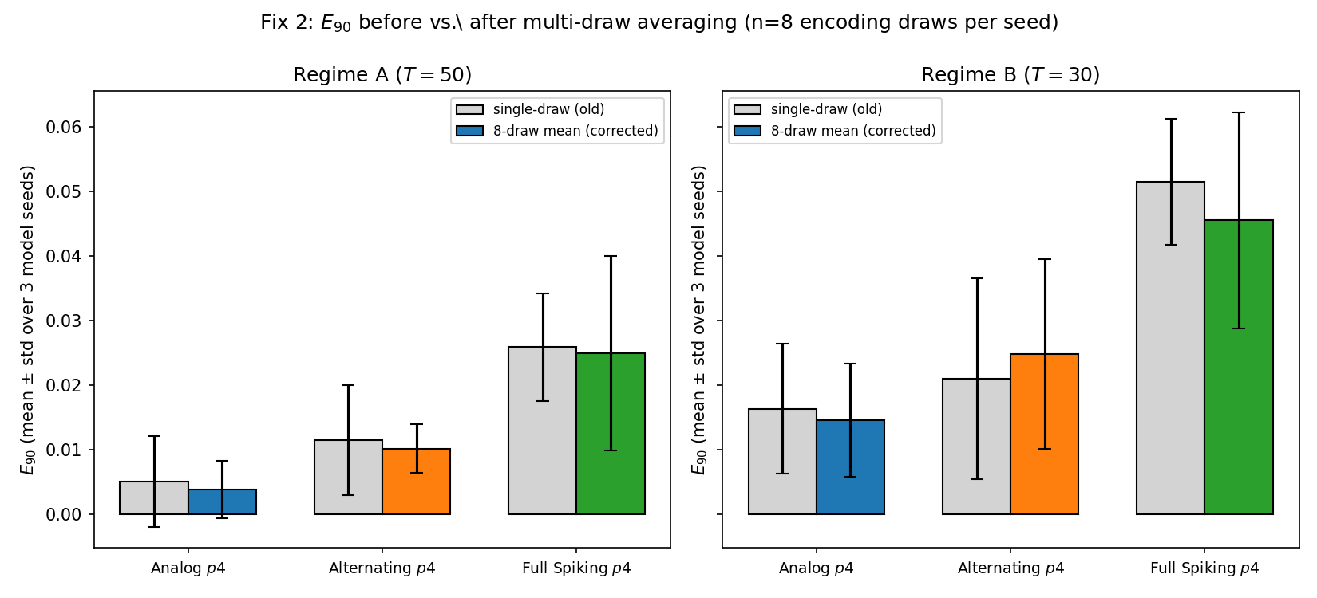
E90 before (single-draw) vs. after (8-draw mean) the Fix 2 correction, both regimes, mean +/- std over 3 model seeds. [plots_small/experiment2/exp2_e90_multidraw_comparison.png]
What survives: the mean ordering None < Alternating < Full Spiking holds in both regimes, independently -- and it is now corroborated two ways rather than one, since it reproduces at T=50 and T=30 on entirely different checkpoints and is stable to which encoding draw is used, not just to which model seed happened to be picked. That is a real strengthening of the claim relative to any single-draw reading.
What does not survive: the word “clean.” The mean +/- std bands overlap substantially between adjacent configurations at n=3 model seeds in both regimes (e.g. Regime A: None's upper band 0.0083 already overlaps Alternating's lower band 0.0064; Alternating/Full Spiking overlap even more heavily). This is not new noise introduced by the correction -- the old single-draw per-seed numbers already had the same overlap (e.g. Regime A seed 1: Alternating=0.0213 > Full Spiking=0.0177) -- multi-draw averaging simply makes the overlap explicit and quantified rather than hidden behind a single point estimate per seed. Directional and cross-regime-consistent is a defensible claim at n=3 seeds; clean statistical separation between adjacent configurations is not, and would require more model seeds, not more encoding draws.

5.4 (d) These Two Findings Are Not Reconciled
Part 5.2 (full-capacity, peak-over-angles, raw logits) and Part 5.3 (reduced-capacity, value-at-90, softmax, multi-draw-corrected) are different measurements on different models. No attempt is made here to merge them into one ordering or one causal story, because Part 5.1 already demonstrated that switching the formula alone flips the ordering on identical checkpoints -- any apparent agreement or disagreement between (b) and (c) as currently computed would not be informative. This is flagged as an explicit open question for future work: computing BOTH quantities (raw-logit peak-over-angles, and softmax multi-draw value-at-90) on the SAME set of checkpoints, ideally the full-capacity model, would be needed before any claim relating them could be made.

Part 6 -- Layer/Time Representation Distance D_{ℓ,t} (Experiment 3)
D_{ℓ,t}(theta) = E_x[ ||h_{ℓ,t}(R_theta x) - h_{ℓ,t}(x)|| / (||h_{ℓ,t}(x)|| + eps) ], the representation distance at a single layer and single timestep, evaluated at theta=45 (no exact group guarantee) and theta=90 (exact C4 guarantee). This section reports the CORRECTED numbers (the correction described in Part 1, Fix 1) and states plainly that the original raw values (~1e5 to ~3.4e7) were floor-division artifacts carrying no signal about representation distance, not a real result to be interpreted.

6.1 Layer 5, Mean D_{ℓ,t}(45 deg): Before vs. After
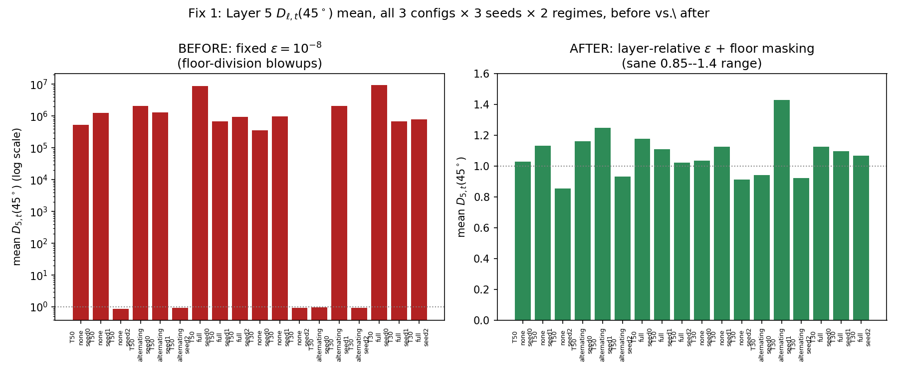
Layer 5 mean D_{45deg}, all 3 configs x 3 seeds x 2 regimes, before (fixed eps=1e-8, log scale) vs. after (layer-relative eps + floor masking) the Fix 1 correction. [plots_small/experiment3_fixed/exp3_layer5_before_after_all_combos.png]
Regime | Config | Seed | Mean BEFORE | Mean AFTER | Cells excluded
T50 | None | 0 | 5.2e5 | 1.03 | 1.0%
T50 | None | 1 | 1.3e6 | 1.13 | 6.6%
T50 | Alternating | 0 | 2.1e6 | 1.16 | 7.6%
T50 | Full Spiking | 0 | 8.9e6 | 1.18 | 9.5%
T30 | Full Spiking | 0 | 9.6e6 | 1.12 | 12.8%
Full 18-combination table is in exp3_eps_diagnostics.csv under each regime's experiment3_fixed/ folder. Every blown-up value collapses to the 0.85-1.4 range once the floor artifact is removed; seeds that were already sane (e.g. None seed 2: 0.87 before and after) barely move -- confirming the fix targets exactly the broken cells and does not disturb the ones that were already correct.

6.2 Visual Before/After: Heatmaps
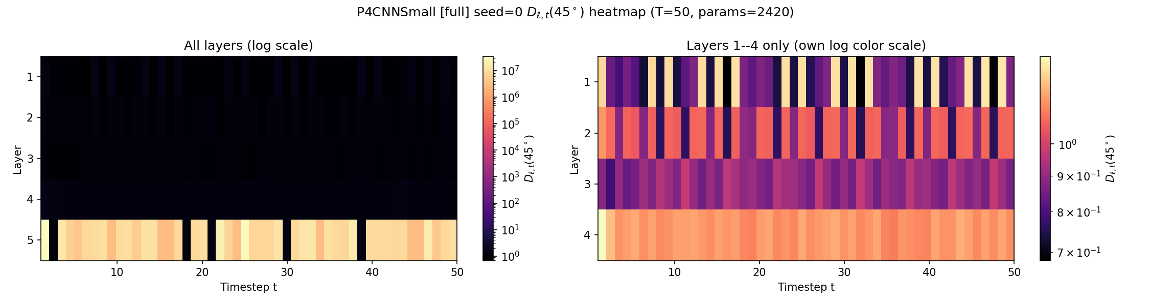
BEFORE (original, plots_small/experiment3/): Full Spiking, Regime A, seed 0 -- D_{ℓ,t}(45deg) heatmap. The deepest layer's color range is dominated by floor-division spikes. [plots_small/experiment3/exp3_heatmap_full_seed0.png]
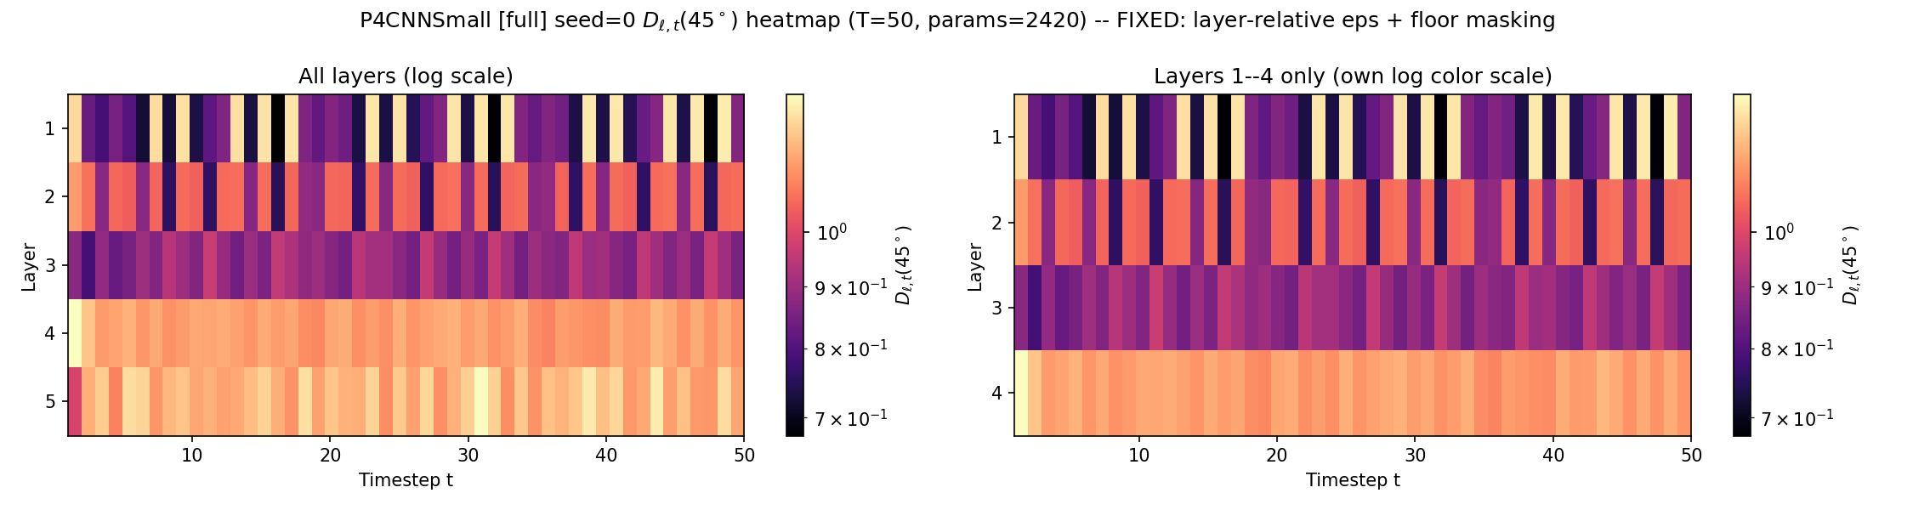
AFTER (corrected, plots_small/experiment3_fixed/): same model/seed/quantity, with the Fix 1 layer-relative epsilon and floor masking applied. [plots_small/experiment3_fixed/exp3_heatmap_full_seed0.png]

6.3 Collapse-Frequency-by-Configuration Finding, Corrected Caveat
Report 3 originally described the layer-5 floor-collapse frequency as “rare in None, frequent in Alternating, near-constant in Full Spiking,” read from single-seed data. With the corrected metric computed across all 3 seeds and both regimes, the directional claim survives on average but the “near-constant” language does not -- it overstates what a single seed showed.
Regime | None | Alternating | Full Spiking
T50, mean % cells excluded (theta=45) | 2.5% +/- 3.6 | 3.1% +/- 4.0 | 3.8% +/- 5.0
T30, mean % cells excluded (theta=45) | 2.1% +/- 3.1 | 0.7% +/- 1.1 | 4.7% +/- 7.0
On average, across seeds, Full Spiking does have the highest floor-collapse rate in both regimes, consistent with more spiking layers upstream propagating more sparsity into the narrow final layer. But this is not a clean per-seed pattern: Full Spiking seed 0 hits 9.5-12.8% exclusion while Full Spiking seed 1 hits only 0.5-0.6%, comparable to None. The correct framing is “higher on average, consistent with the number of spiking layers, but with seed-to-seed variance as large as the effect itself” -- not “near-constant.” This is the same seed-variance caution that recurs elsewhere in this project (Part 9, Part 10).
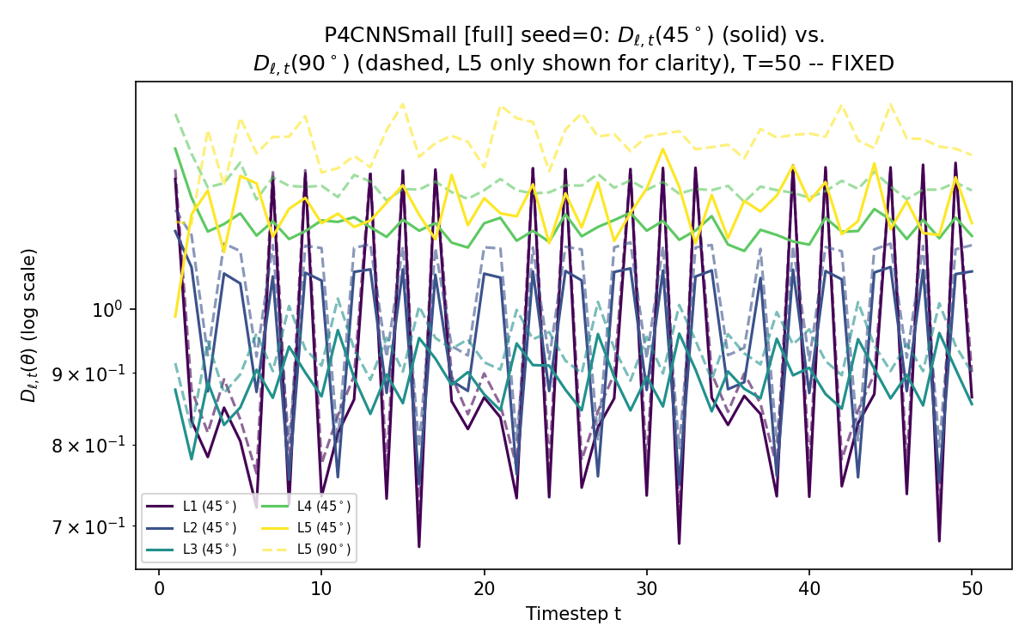
Regime A, Full Spiking, seed 0 (corrected) -- D_{ℓ,t}(45deg) solid vs. D_{ℓ,t}(90deg) dashed (layer 5 only), log scale. [plots_small/experiment3_fixed/exp3_lines_full_seed0.png]
The upstream-sparsity-propagation hypothesis first proposed in Report 3 -- that sparsity introduced by an upstream spiking layer propagates forward and makes a downstream analog layer's pre-activation more likely to be exactly zero at a given timestep, rather than the layer's own activation type being what matters -- remains a plausible, mechanistically motivated reading of the corrected data, but is still not directly verified (Part 11).

Part 7 -- Fourier Analysis of the Rotational Response (Experiment 4)
This experiment needs no correction and is the strongest, most seed-stable result in the project. It is presented here as reported in Report 3, unchanged, as the headline confirmatory result of the whole programme.
Setup: for None, Alternating, Full Spiking, all 3 seeds, both regimes, the classification margin M(theta) = z_y(R_theta x) - max_{c != y} z_c(R_theta x) and accuracy A(theta) are evaluated at 1-degree resolution (360 angles) on a fixed 32-image probe set, using raw accumulated-spike-count logits (not softmax). M(theta) is Fourier-decomposed up to k_max=20, giving E_noninv (non-constant energy fraction) and E_forbidden (energy at k not divisible by 4 -- architecturally, this should be ~0 for an exact p4 network).
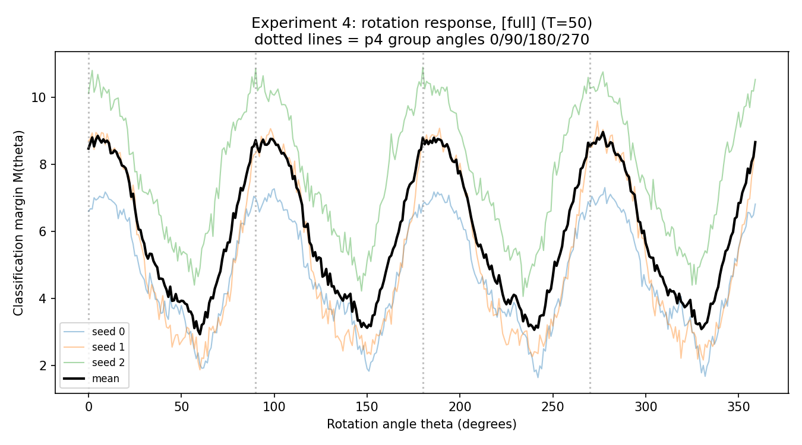
Regime A, Full Spiking -- classification margin M(theta), all 3 seeds + mean, 1-degree resolution. [plots_small/experiment4/exp4_rotation_response_full.png]
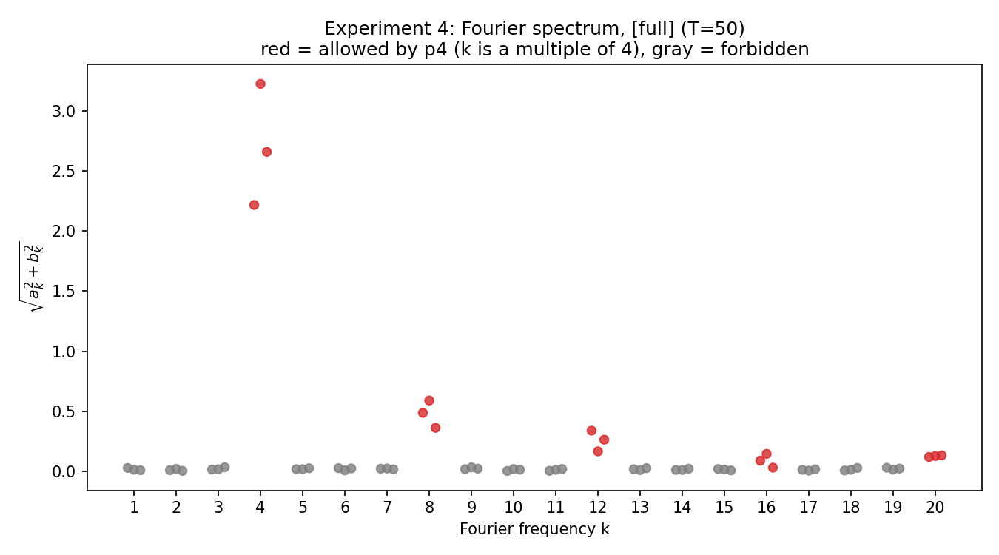
Regime A, Full Spiking -- Fourier spectrum magnitude vs. k; red = allowed (k a multiple of 4), gray = forbidden. [plots_small/experiment4/exp4_fourier_spectrum_full.png]
The spectrum is unambiguous: every forbidden frequency sits at a uniform noise floor (sqrt(a_k^2+b_k^2) <~ 0.03) indistinguishable from zero, while the allowed frequencies show a clear, decaying spectrum dominated by k=4 (~2-3), with smaller but clearly nonzero contributions at k=8,12,16,20. This is the clearest confirmation in the entire project of the p4 architecture's exact discrete-symmetry guarantee, directly in Fourier space rather than through an accuracy or representation-similarity proxy.
Regime | Config | a0 | E_noninv | E_forbidden | |coef k=4| | |coef k=8|
A | None | 7.11+/-2.62 | 0.278+/-0.094 | 9.2e-5+/-3.9e-5 | 4.07+/-0.74 | 0.63+/-0.28
A | Alternating | 7.80+/-1.88 | 0.228+/-0.058 | 1.11e-4+/-5.5e-5 | 4.08+/-0.34 | 0.36+/-0.34
A | Full Spiking | 5.94+/-1.61 | 0.192+/-0.086 | 1.18e-4+/-3.8e-5 | 2.70+/-0.51 | 0.48+/-0.11
B | None | 5.73+/-0.96 | 0.252+/-0.095 | 1.56e-4+/-2.6e-5 | 3.31+/-1.16 | 0.37+/-0.15
B | Alternating | 6.27+/-0.99 | 0.174+/-0.064 | 1.33e-4+/-4.9e-5 | 2.77+/-0.23 | 0.22+/-0.14
B | Full Spiking | 4.07+/-0.66 | 0.201+/-0.050 | 2.84e-4+/-6.7e-5 | 2.01+/-0.44 | 0.22+/-0.18
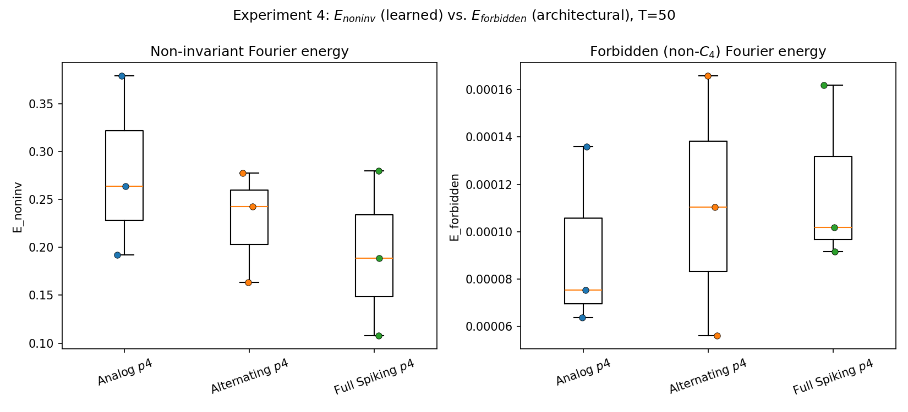
Regime A -- E_noninv (left) vs. E_forbidden (right), boxplot + individual seeds, all 3 configurations. [plots_small/experiment4/exp4_enoninv_eforbidden.png]
E_forbidden is architectural, not learned: all three configurations cluster tightly in the same narrow band (~6e-5 to ~2.8e-4) across both regimes, with heavily overlapping seed distributions -- exactly the “essentially independent of the random seed” prediction this experiment was designed to test. E_noninv is NOT architectural: it varies more across configurations and seeds (0.17-0.28), with a mild trend toward lower non-invariant energy as more layers spike, visible for the k=4 coefficient specifically (None > Alternating > Full Spiking in both regimes) though not fully consistent for E_noninv itself. This is exactly the architecture-determines-symmetry / training-determines-learned-invariance-strength distinction the experimental programme set out to isolate.

Part 8 -- Compute-Budget Findings: Truncated-T' Accuracy (Experiment 5.7)
A single model, trained once at its regime's full T, has its recorded spike train truncated to the first T' timesteps at evaluation time and a classification decision decoded from only those, without retraining. This tests whether rotation-robust accuracy structure emerges progressively as spikes accumulate, and how quickly.

8.1 Full Capacity (Report 1)
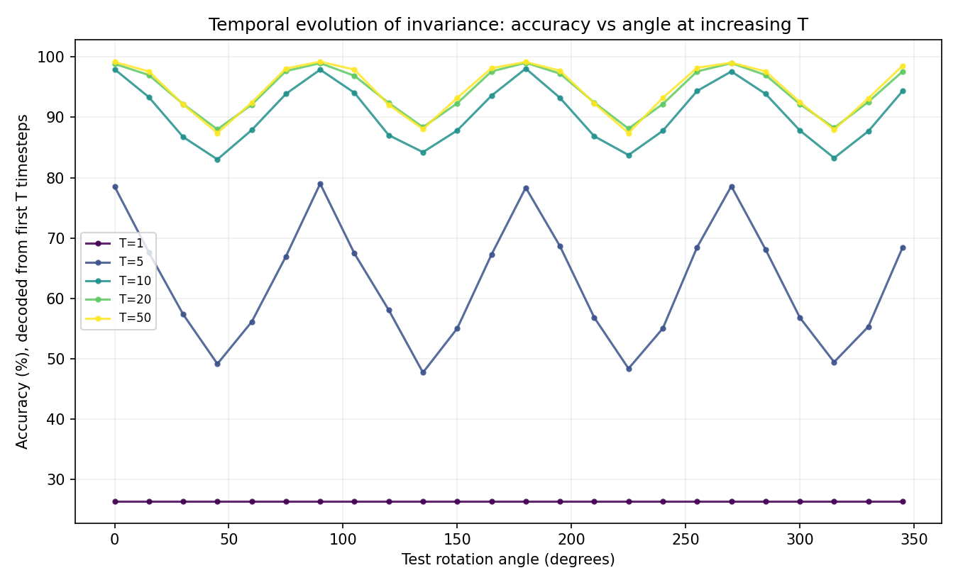
Full capacity, Full Spiking, seed 0 -- accuracy vs. angle at T'=1,5,10,20,50. [plots/full_seed0/full_seed0_5.7_temporal_evolution.png]
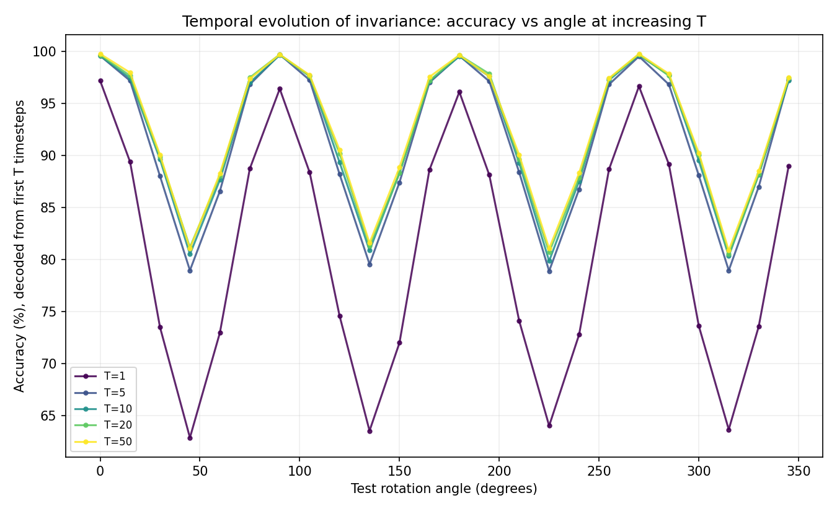
Full capacity, Hybrid Late, seed 0 -- same T' grid. [plots/hybrid_late_seed0/hybrid_late_seed0_5.7_temporal_evolution.png]
Full Spiking's T'=1 curve is flat at ~25-27% (chance) across every angle -- with all 7 layers spiking, every layer needs several timesteps to integrate enough input spikes to pass a meaningful signal onward, and this startup delay compounds across all 7 layers. Real W-shaped structure appears only by T'=10 and is nearly indistinguishable from T'=50 by T'=20. Alternating's T'=1 curve already shows a weak but genuine W-shape (25-70%, seed/angle-dependent). Hybrid Late's T'=1 curve already closely tracks the full T'=50 curve's shape (63-99%) -- with only the final layer spiking, six of seven layers process instantaneously regardless of T'. This gives a consistent, monotonic ordering across all 9 seed-runs examined (3 configs x 3 seeds): the more layers that spike, the more timesteps needed before rotation-robust accuracy structure appears.

8.2 Reduced Capacity, Both Regimes (Reports 2)
Regime | Config | T'=1 | T'=5 | T'=10 | T'=20 | T'=50
A (T=50, seed 0) | Alternating | 51.2% | 84.4% | 86.6% | 87.0% | 89.4%
A (T=50, seed 0) | Full Spiking | 31.2% | 71.0% | 82.6% | 84.7% | 85.9%
A (T=50, seed 0) | Hybrid Late | 58.7% | 87.0% | 88.7% | 89.1% | 89.6%
A (T=50, seed 0) | None | 77.1% | 85.9% | 88.4% | 88.7% | 90.5%
B (T=30, mean+-std, seeds 0-1) | Alternating | 45.5+/-6.6% | 79.6+/-12.6% | 83.9+/-9.7% | 85.1+/-9.0% | 84.9+/-9.0%
B (T=30, mean+-std, seeds 0-1) | Full Spiking | 34.3+/-6.9% | 66.1+/-17.4% | 78.6+/-8.9% | 82.0+/-4.8% | 83.3+/-4.3%
B (T=30, mean+-std, seeds 0-1) | Hybrid Late | 60.3+/-9.1% | 76.0+/-7.3% | 79.1+/-6.0% | 80.3+/-6.7% | 81.5+/-6.3%
B (T=30, mean+-std, seeds 0-1) | None | 73.1+/-6.1% | 80.9+/-4.0% | 83.2+/-3.7% | 84.5+/-3.1% | 84.8+/-3.0%
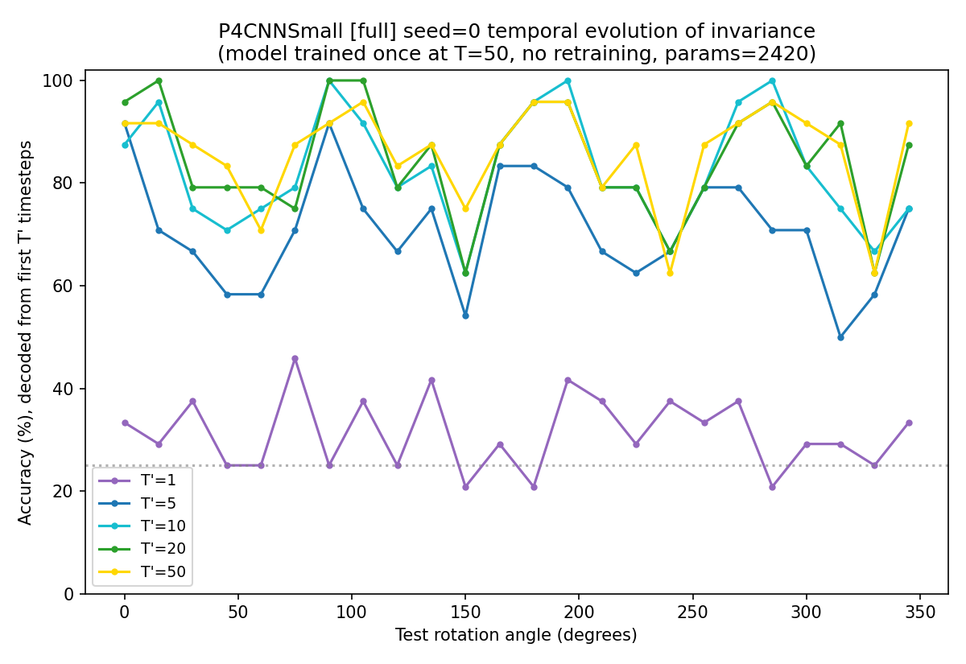
Regime A, Full Spiking, seed 0 -- accuracy vs. angle at T'=1,5,10,20,50. [plots_small/repr_seed0/truncated_T_by_angle_full.png]
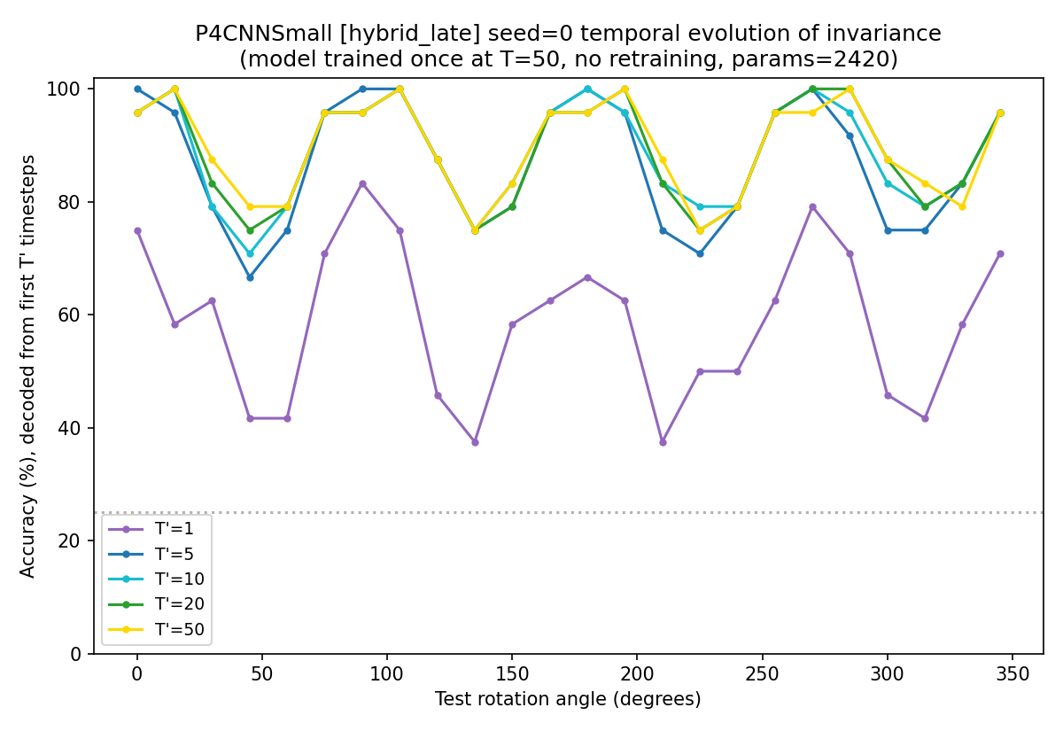
Regime A, Hybrid Late, seed 0 -- same T' grid. [plots_small/repr_seed0/truncated_T_by_angle_hybrid_late.png]
The same “more spiking layers => longer warm-up” ordering reproduces at reduced capacity, in both regimes.
Practical implication, consistent across every capacity and regime tested: T'=10 already recovers most of the T'=50 accuracy everywhere (full capacity: visually indistinguishable by T'=20; reduced capacity Regime A: >=94% of T'=50 accuracy for every configuration; reduced capacity Regime B: 93-99% of the T=30-clamped T'=50 accuracy for every configuration). Models trained and evaluated at the full T throughout this project may be using substantially more simulation time than necessary at decode time.

Part 9 -- What Was Ruled Out: Code vs. Methodology Audit
This is a permanent settled-questions record of every anomaly investigated during this project's code-vs-methodology audit, so a future reader does not need to re-investigate them. For each: what was suspected, what was ruled out, the verdict (code bug vs. methodological/metric artifact), and the one-line resolution.

9.1 P4BatchNorm2d Breaking Equivariance After Training (resolved before this audit)
Suspected: standard BatchNorm's independent per-orientation-channel statistics might interact badly with upright-only training.
Verdict: CONFIRMED CODE ISSUE, already fixed. Untrained equivariance error ~1e-6; after training with standard BatchNorm, ~0.1-0.2. Resolution: P4BatchNorm2d, sharing statistics/affine parameters across the 4 orientation channels, restores ~1e-6 post-training. Used throughout every result in this document. This is the one genuine architecture-level bug found and fixed in this project.

9.2 Group-Angle Equivariance-Error Noise (Reports 2-3)
Suspected: at exact group angles (90/180/270 degrees), equivariance error should be ~0 by construction, but was observed 10-100x higher than expected for some configs, inconsistently across seeds.
- Ruled out (1): Rotation-implementation noise (grid_sample vs. torch.rot90). Ruled out: max abs pixel difference ~2e-6 (float32 noise floor), 4-5 orders of magnitude below the observed 0.01-0.06 errors; feeding the model the bit-exact rotation instead left the error unchanged to 6 decimal places.
- Ruled out (2): Mode-dependent code branching in gconv_small.py. Ruled out: P4ConvZ2, P4ConvP4, P4BatchNorm2d, P4GroupPool contain no reference to mode or spiking_layers anywhere -- one code path for every configuration, confirmed by direct code reading, not inference.
Verdict: METHODOLOGICAL ARTIFACT, not a code bug. The evaluation code resets the encoding RNG to the same seed value for x and R_theta(x). Because rotation moves image content between tensor positions, this reproduces the same raw random stream but not a matched spike encoding under rotation -- it gives run-to-run reproducibility, not the noise-cancellation the convention seems to have intended. Confirmed empirically: re-drawing the encoding seed alone (same model, same probe images, no rotation or config change) reproduces the exact reported magnitudes and None < Alternating < Full Spiking ordering. Also discovered along the way: layer 1's input is stochastically spike-encoded in EVERY configuration, including None -- “Analog” is not literally analog at the input, only in its internal layers -- which is why None also showed nonzero, seed-inconsistent noise at group angles rather than being immune to the effect. Resolution: Fix 2 (Part 1), multi-draw averaging.

9.3 D_{ℓ,t} Reference-Norm Collapse (Report 3, Experiment 3)
Suspected: the deepest layer's D_{ℓ,t}(45deg) values explode to ~1e7 because the denominator ||h_{ℓ,t}(x)|| + eps is near-zero when that timestep's activation is mostly/all zero.
Verdict: METHODOLOGICAL/METRIC-DESIGN ARTIFACT, not a model or training bug. eps=1e-8 was a fixed global constant; measured layer-5 reference norms directly on real checkpoints and confirmed 9.5% of (timestep, image) cells there have a raw norm of EXACTLY zero (the whole 16-unit layer silent that timestep), so denom = eps exactly and any nonzero numerator explodes the ratio. Layers 1-4 never hit an exact zero in the same probe set -- the problem is specific to the narrowest, sparsest layer. Resolution: Fix 1 (Part 1), layer-relative epsilon plus floor masking.

9.4 Report 1 vs. Report 3 Equivariance-Error Direction Reversal
Suspected: Report 1 found peak equivariance error highest for Analog, lowest for Full Spiking; Reports 2-3 found error at 90 degrees specifically lowest for Analog/None, highest for Full Spiking -- apparently contradictory.
Verdict: NOT A BUG IN EITHER -- genuinely different quantities being compared (see Part 5.1 for the full formula comparison). Confirmed directly: recomputing both formulas (raw-logit peak-over-angles; softmax value-at-90) on the IDENTICAL reduced-capacity checkpoints reproduces each report's ordering under its own formula -- the formula choice alone flips the ranking, not model capacity. Both implementations correctly compute what they claim to; the issue is that the two numbers were juxtaposed across reports as if directly comparable “equivariance error” when they are not. Left unreconciled by design (Part 5.4).

9.5 Evolution of the “Full Spiking Anomaly” Narrative Across Reports
For completeness: the understanding of 9.2 evolved visibly across this project's own reports, and this evolution is itself worth recording so it is not mistaken for inconsistency. findings_report_small.tex (seed-0-only reading) proposed “cascaded LIF-threshold amplification of spike-sampling stochasticity, scaling with spiking-layer count” as the explanation, based on Full Spiking looking uniquely and reproducibly elevated across its two available regimes. findings_report_t30.tex (after seed 1 arrived) walked this back: four of five configurations showed at least one elevated group-angle value depending on seed, so no single configuration could responsibly be called uniquely anomalous at n=2. The final audit (Part 9.2, this document) confirms the original mechanism's core intuition was directionally right (more spiking layers does correlate with more noise, confirmed cleanly via the multi-draw experiment in Part 5.3) but locates the root cause more precisely (RNG/pixel-position mismatch at the stochastically-encoded input, present in every configuration including None, not a LIF-threshold-specific cascade) and treats the effect as quantifiable Monte-Carlo variance rather than a per-configuration “bug.” Later readings are more reliable than earlier ones here; this document uses the final audit's framing throughout.

Part 10 -- Synthesis
Written at the confidence level each finding actually supports -- Part 5's now-corrected E90 finding is not upgraded back to “clean ordering” language here just because this is the summary.
- Accuracy alone is uninformative about spike placement, at every capacity and regime tested. Once training is done properly, all configurations reach rotation-accuracy curves within a few points of each other, with one reproducible exception (Hybrid Early's large seed-to-seed variance at reduced capacity, absent at full capacity only because Report 1 never trained it).
- The layer-wise representational collapse at the deepest layer(s) is a genuine, unhedged, universal finding: it appears in every configuration at every capacity tested, including the zero-spiking control, and is a property of the p4-equivariant architecture's final stages, not of spiking dynamics.
- Rotation sensitivity through spiking time rises quickly and then plateaus -- it does not decay -- in every configuration, every seed, and every regime tested, directly contradicting the project's original temporal-contraction hypothesis. Per-configuration differences in the shape of the R_i-vs-layer climb (sharp late jump, gradual climb, or flat) are real at full capacity and reproduce qualitatively but less cleanly at reduced capacity, where 5 layers give less room to resolve the shapes distinctly.
- Truncated-T' accuracy shows a clean, reproducible, mechanistically sensible ordering across every capacity and regime: more spiking layers means a longer warm-up before rotation-robust accuracy structure appears, and T'=10 recovers most of the full-T accuracy everywhere -- a genuine, actionable compute-budget finding.
- Direct equivariance error tells two different, non-reconciled stories depending on exactly what is measured. At full capacity, peak error over all angles is non-monotonic in spiking extent (Analog worst, Full Spiking best) and remains unexplained. At reduced capacity, the corrected (multi-draw) E90 at exactly 90 degrees shows a directionally consistent, cross-regime-reproducible ordering (None < Alternating < Full Spiking in the mean) that does NOT achieve clean separation between adjacent configurations at n=3 model seeds -- this is a real but modest finding, not the “clean ordering” one of its source reports originally claimed.
- Experiment 4's Fourier analysis is the project's strongest and most seed-stable confirmatory result: forbidden-mode energy is architecturally pinned near zero regardless of configuration or seed, while allowed-mode amplitude (the learned component) varies substantially -- a clean empirical separation of what the architecture guarantees from what training actually learns.
- Two of the three anomalies investigated in this project's code-vs-methodology audit were genuine methodological artifacts (Monte-Carlo spike-encoding noise; a fixed epsilon inappropriate for a narrow layer), now corrected in the analysis code; none was a bug in the p4-equivariant conv/BatchNorm implementation itself, which was independently verified to have no mode-dependent branching. The one genuine historical code bug in this project (standard BatchNorm breaking equivariance) was found and fixed before this audit began.
- A recurring methodological lesson across this entire project, worth stating on its own: single-seed or single-draw readings repeatedly looked cleaner than they turned out to be once a second seed, a second draw, or a corrected metric arrived (the Full-Spiking-anomaly narrative, the D_{ℓ,t} collapse-frequency ordering, and the E90 ordering all followed this pattern). Every finding in this document that still holds at n=3 seeds has been cross-checked against this pattern before being stated plainly.

Part 11 -- Limitations and Recommended Next Steps

11.1 Limitations, Consolidated Across All Reports
- Seed counts below programme recommendations. Every seed-averaged number in this document uses n=3 model seeds (n=2 for several reduced-capacity Regime B representation-level quantities, since seed 2's representation analysis was intentionally left incomplete by explicit instruction). The Priority Programme recommends n=10 (Experiment 2) and n=5 (Experiment 3); this project has not reached either.
- SVCCA absolute-scale caveat. SVCCA is not on an absolute 0-1 similarity scale -- independent, genuinely dissimilar data produces a nonzero baseline of roughly 0.2-0.4 at the batch sizes used here. Read SVCCA values relatively (larger = more similar), never as an absolute invariance measure.
- R_i cross-activation-type scale caveat. R_i's absolute magnitude depends on whether the underlying activation is a continuous ReLU output or a spike count (the spiking configurations' R_i sits roughly 1000x larger than Analog/None's at comparable layers). Only within-configuration comparisons (across layers or seeds) are on safe footing; cross-configuration comparisons must use shape, not magnitude.
- Untrained Hybrid Early/Mid at full capacity. Report 1 (full capacity) never trained Hybrid Early or Hybrid Mid, so Part 3/4/5/8's full-capacity sections say nothing about them; only the reduced-capacity reports (which trained Hybrid Early, and have no Hybrid Mid analogue at depth 5) cover it.
- Experiment 1 not run. Experiment 1 (a parameter/depth-matched non-equivariant SNN baseline) was never run at any capacity -- it requires building and training a new architecture, out of scope for every pass in this project so far, all of which were either representation-analysis-only or explicitly no-retraining.
- Probe-set quantization. Report 3's 32-image fixed probe set quantizes accuracy-derived quantities (D_s in particular) in steps of 1/32 ~= 3.1%; this is why Experiment 2's D_s should be read as indicative, not precise, at this probe-set size.
- D_{ℓ,t} 45-vs-90 comparison still limited at layer 5. The Fix 1 correction addresses the reference-norm-collapse artifact, but Experiment 3's original design goal (cleanly comparing D_{ℓ,t} at theta=45 vs. theta=90 to show the exact-group-angle guarantee reducing sensitivity specifically at 90 degrees) is still not achievable at the deepest layer even post-fix, since both angles are compared against the same reference representation and are equally exposed to any residual near-zero-norm cells.
- Upstream-sparsity-propagation mechanism unconfirmed. The claim that sparsity from an upstream spiking layer propagates into a downstream analog layer's collapse frequency (Part 6.3) is a plausible, mechanistically motivated reading of the corrected data, not a directly verified mechanism (e.g. via direct inspection of layer 4's pre-layer-5 output sparsity per configuration).
- Hybrid Early seed-2 instability uninvestigated. Hybrid Early's large seed-2 accuracy instability (Part 2.2-2.3) was noted in both reduced-capacity regimes but never investigated further -- unclear if it is a property of that configuration at this capacity or an isolated bad initialization.

11.2 Recommended Next Steps, Prioritized Against the Sept 19 Abstract / Sept 24 Full-Paper Deadlines
Today's date: August 31, 2026 -- roughly 19 days to the abstract deadline, 24 to the full paper.
- Immediate (before Sept 19), zero additional compute: Both corrections (Fix 1, Fix 2) are already applied and this document already reflects them -- no further action needed before the abstract; simply draw the abstract's claims from Parts 5.3, 6, and 7 of this document rather than the superseded single-draw/fixed-epsilon numbers in the original Report 2/3 files.
- Cheap, before Sept 24: Directly test the upstream-sparsity-propagation mechanism (Part 6.3/11.1) by inspecting layer 4's pre-layer-5 output sparsity per configuration on existing checkpoints -- cheap, no retraining, would upgrade a plausible reading to a confirmed one before the full paper.
- Moderate effort, before Sept 24 if time allows: If GPU time allows before the full-paper deadline, add 2 more model seeds (to n=5) for Experiment 2's E90 specifically, since Part 5.3 identified overlapping mean+/-std bands between adjacent configurations as the main remaining weakness in an otherwise cross-regime-consistent finding -- this is the single highest-leverage additional-compute item in the project given it directly strengthens the report's most novel corrected finding.
- Moderate effort: Complete reduced-capacity Regime B seed 2's representation-level analysis (a few-minutes-per-stage job) to bring Part 4/6/8's Regime B tables from n=2 to n=3, matching Regime A.
- Larger effort, only if time remains after the above: Train Hybrid Early and Hybrid Mid at full capacity, extending Parts 3-5/8's full-capacity sections to the same 5-configuration coverage the reduced-capacity reports already have; run a controlled ablation isolating which of P4BatchNorm2d/longer training/higher T explains the original compute-constrained draft's non-replicating findings (Part 2.1).
- Largest effort, full-paper timeframe only: Experiment 1 (parameter/depth-matched non-equivariant SNN baseline) -- the largest remaining lift in the project, requiring a new architecture and full retraining; realistically a full-paper-cycle item rather than an abstract-cycle one.

