**Analysis on VAST-2015 Mayhem at Dinofun World**

**Introduction**

Visual Analytics Science and Technology (VAST) has aimed for the development of the tools and technologies for the approach towards Visual analytics through the various types of challenges and competitions. These competitions are conducted every year concerning specified problems effectively. The competitions consist of various challenges containing two mini-challenges and one grand challenge. The mini-challenges involve the part of the human behavior towards imaginary Amusement Park. The case scenario for the 2015 challenge holds the imaginary park named Dinofun World that is 215 hectares big with thousands of visitors every day and it is famous for the exciting rides and events. The town organized a weekend event in the name of the famous soccer star from their town named Scott Jones. It was a three-day event held on Friday, Saturday, and Sunday. The event was marred with crime and mayhem from his past life before the fame came in. Although crimes were solved, the park officials and law enforcement decided to prepare themselves for these kinds of future events. They decided to analyze the visitor's movement and location across the park, to create the patterns for the movements of the people.

The figure displayed below is the layout of the Amusement park. The most favorite rides and exciting places are numbered, and the red line describes the pathway of the visitors around the park. Visitors carry mobile devices, that help the officials to track their location around the map of the park [6]. They can also track the ride check-ins and the logs of text messages.

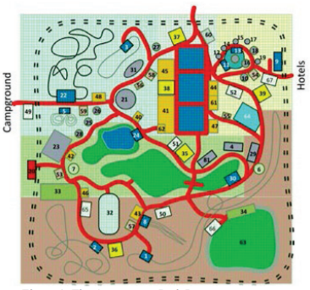

*Figure 1: The Amusement Park Layout[6]*

They had taken up the ideas and the elements from the other parks around the world with the help of software agents. The agent came up with a plan from the movement of the people by classifying them into the age group of similarity. The age group was primarily classified into adults, teen, child, and infant. The developers did the analysis of the movements, track locations, text for the days.

**Challenges**

The VAST – 2015 which consists of the two mini-challenges and one grand challenge. VAST was looking for visual analysis with something different and innovative. They encouraged contestants to deal with the data given to them differently.

* **Mini-Challenge 1: Visitor Movement –** This challenge consists of tracking the movement of each and everyone in the park. The contestants have access to the data of the visitor's movement. The primary focus of the challenge was to answer the questions such as getting the total attendance of the visitors over the weekend, characterize the group in twelve parts, is there any suggestion for the better experience of the group needs? It also generates the patterns of the visitor's movements among all the three days. Were there any unwanted behavior patterns from the groups of people? The group here describes a family with 1-2 adults and 1-5 children.
* **Mini-Challenge 2: Visitor Communication –** The park provided an app for visitors to send and receive text messages to their group members, as well as send messages outside the park to anyone to describe their experience. They also had a “Cindysaurus Trivia Game” which allowed the guest to play the game and win prizes while in the park. These methods were to collect the data. The participants were given data that included timestamps of the messages, originator’s ID, and recipient ID. Also seen in the figure above, the park was divided into five areas, although the location was not that precise, they had the geo-coordinate location to determine the parks. The fundamental of the challenge was to generate the communication pattern to detect the crime. It was based on answering questions like identification of the ID’s and develop the hypothesize and pattern of the communication messages.
* **Grand Challenge: Uncovering a Nefarious Plot –** The grand challenge dwells the knowledge of the two mini-challenges, and answer the question concerning the law enforcement officer. The question should answer, for example, Scott is a celebrity guest he doesn’t have an ID, track his location, where does he spend most of the time at? When did he leave? The other principal questions to be answered were where the crime happened, how did it happen, and who are likely to be the suspects.

**Analysis**

The paper describes the analysis of the solution by teams addressing the challenges. The table shows the best approach of the contestants, which in my opinion is the best ones, who participated in the competition.

|  |
| --- |
| Mini-Challenge 1 |
| Middlebury College - Award for Integrated Analysis Environment |
| Mini-Challenge 2 and Grand Challenge |
| Purdue University – Honorable Mention for Compelling Narrative Debrief |

*Table 1: Best Provided Solutions*

Firstly, talking about the solution provided by the students of Middlebury College. For instance, how they approached the Mini-Challenge 1 by developing the analysis tool named Middguard that can analyze group view, individual timeline, query tool, location heatmap, and individual movement traces. One of the best visual analyses of the Middguard was Connectedness visualization which gave the analysis of the individual for how long he stayed at the same location as in the type of heatmap. This was beneficial as the analysts can combine the location and person where the mayhem occurred and who all was in the nearby location [2].

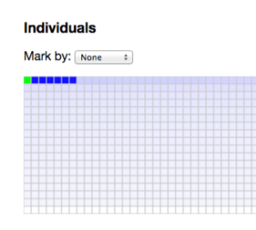

*Figure 2: The amount of time, an individual was the same location (Green) [2]*

Secondly, taking the best approach for the team from Purdue University concerning Mini-Challenge 2 that is Visitor Communication and the Grand Challenge. They advanced the analysis by developing the Park Analyzer. They came up with different analyses like heatmap, check-in frequency, control panel, and communication frequency graph. In the grand challenge, they integrated the MC2(Mini-Challenge 2) for the results. The main attraction in their paper was again the heatmap w.r.t. timely based analysis over the park map layout. They developed a heatmap based on the check-in data [8]. With the movement data, they refined the analysis by building trajectories of the visitor and their movement over the park with timestamps. Further with the help of the communication data, they provided a communication frequency graph to show the number of messages exchanged over the weekend.[5]

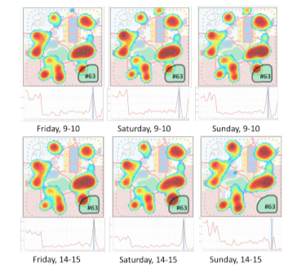

*Figure 3: Heatmap and Line Graph based on check-in data [8].*

Lastly, the results of the grand challenge are based on the insights of Scott’s activities from tracking his location with the help of his entourage. Primarily they focused on the crowd movement first and after the show was performed by Scott, also they generated the report for his location and timestamp where he goes and spends the time most [8]. One of the weaknesses, according to me is the integration of the crowd analysis with the IDs given to the group of people with Scott. What if there is a condition where one of the team members would be responsible for the mayhem. Because they are the only ones near to Scott.

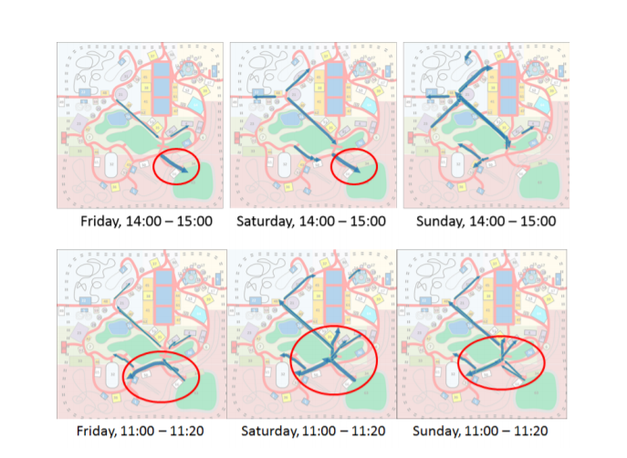

*Figure 4: Scott’s Movements over the weekend after the stage show[8]*

The location heatmap is one of the best visual analysis tools for example from plotting the earthquakes around the globe to track the customers with the cellphone number all over the world. In 2018 the conference in Austria, Albayrak, and Zeydan developed the intelligent heatmap that was utilized by Mobile Network Operator. They demonstrated the density of the subscribers over the map on weekdays and weekends. This resulted to analyze how the subscribers rapidly increase and decrease the use of the phones [2].

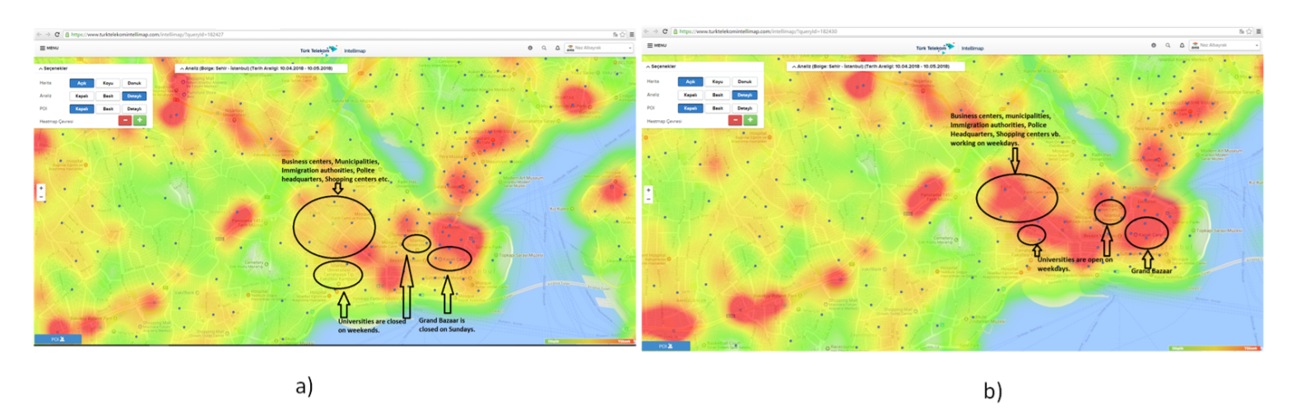

*Figure 5: a) Density over weekday and b) Over Weekend [2]*

One of the other Visual Analyses that I found was interesting that helps to develop the heatmap over the map is Location Tracking gradually with the classification of the phone users by brands. For example, to keep the GPS location of the individual over time by defining certain colors to the point assigned to it [7]. The tracking location results in dots, that help generate the density which further helps to create the heatmap w.r.t. to the movement of the devices every minute.

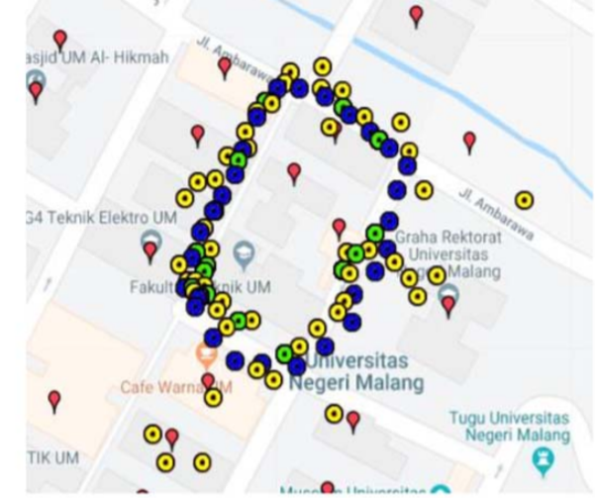

*Figure 6: Location Tracking[7]*

As shown in the figure the legend of the dots is as follows, the demonstration is based near the university, the Blue dot describes the users with Samsung Phone, Green is a VIP tracker device and yellow is the Huawei users.

Another example of location tracking in the real-world application is tracking the location IoT device that is a mobile phone. This analysis is related to the grand challenge as in analyzing Scott’s movement over the park after the stage show. This paper is collecting the location message and using the longitude and latitude of the device makes the track the movement of the device [1].

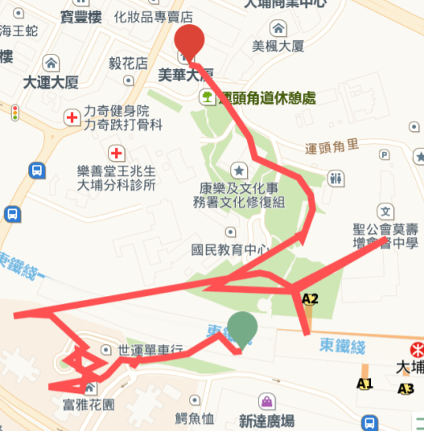

*Figure 7: Location Movement Tracking [1]*

**Conclusion**

The results of comparing the different solutions of VAST-2015 to the Visual Analysis based on the real-world application problems. The visual analysis is the part of the subject to understand the data that is too big. The huge data is always a hassle to deal with. In this paper, the priority was to define the strength and weaknesses of the solutions provided by the participants, but also relate the visual analytics techniques that were approached by the contestants.

**References**

[1] H. Tang, J. Shi, and K. Lei, “A smart low-consumption IoT framework for location tracking and its real application,” in *2016 6th International Conference on Electronics Information and Emergency Communication (ICEIEC)*, Jun. 2016, pp. 306–309, doi: 10.1109/ICEIEC.2016.7589744.

[2] N. Albayrak and E. Zeydan, “An Intelligent Data Visualization Service Platform for Mobile Network Operators,” in *2018 Network Traffic Measurement and Analysis Conference (TMA)*, Jun. 2018, pp. 1–2, doi: 10.23919/TMA.2018.8506552.

[3] C. Andrews and J. Billings, “Middguard at dinofun world,” in *2015 IEEE Conference on Visual Analytics Science and Technology (VAST)*, Oct. 2015, pp. 129–130, doi: 10.1109/VAST.2015.7347644.

[4] A. N. Handayani, D. Lestari, H. Ar-Rasyid, R. A. Asmara, and K. Arai, “Monitoring of Visual Impaired Person Movement using Wemos D1 Mini GPS,” in *2019 International Conference on Electrical, Electronics and Information Engineering (ICEEIE)*, Oct. 2019, vol. 6, pp. 342–345, doi: 10.1109/ICEEIE47180.2019.8981452.

[5] M. Steptoe *et al.*, “VAST challenge 2015: Grand challenge - Team VADER/VIS Award for Outstanding Comprehensive Submission,” in *2015 IEEE Conference on Visual Analytics Science and Technology (VAST)*, Oct. 2015, pp. 119–120, doi: 10.1109/VAST.2015.7347639.

[6] M. Whiting *et al.*, “VAST Challenge 2015: Mayhem at dinofun world,” in *2015 IEEE Conference on Visual Analytics Science and Technology (VAST)*, Oct. 2015, pp. 113–118, doi: 10.1109/VAST.2015.7347638.

[7] W. Hatton *et al.*, “Visual analytics for detecting communication patterns,” in *2015 IEEE Conference on Visual Analytics Science and Technology (VAST)*, Oct. 2015, pp. 137–138, doi: 10.1109/VAST.2015.7347648.

[8] J. Chae *et al.*, “Visual analytics of heterogeneous data for criminal event analysis VAST challenge 2015: Grand challenge,” in *2015 IEEE Conference on Visual Analytics Science and Technology (VAST)*, Oct. 2015, pp. 149–150, doi: 10.1109/VAST.2015.7347654.