ISTE – 782 Final Paper Proposal

Analysis of VAST-2015 Mayhem at Dinofun World

The VAST-2015 consists of the fictitious amusement park with the event organized for the visit of internationally renowned football player Scott Jones, and planned for a weekend event and analyze the movement and communication patterns. The challenge includes two mini-challenges. Challenge 1 is the Identification of the groups from the Visitors in the park. The identification of the group is for the period of the three-day event. The analysis of the challenge consist of the visitor's movements around the park, and the formation of the groups based on the time and location of each visitor. This analysis will help the park officers where the crowd for the park focuses on and also help the analysis for the rides, which are people favorite and like to ride. I aim to analyze the grouping patterns of the people and clustering the age-based groups near the rides in the park. Derive the analysis on the amusement park map.

Challenge 2 consists of the communication pattern of visitors in the period of the three days event. The primary aim of the mini-challenge is to analyze the text message patterns near the park rides with the various pattern related to the sending and the receiving messages. The point of the analysis will be based on the NLP based on different sentiments. The sentiments are based on crime-related activities near the rides.

Lastly, the main challenge is based on the results of the two challenges. The analysis of the main challenge is to detect the crime event analysis for crowd gathering and time analysis into a heat-map with the highest possible threat. It will be helpful from the results of the two challenges, considering the time constraint, the location of the visitors and the communication pattern happening near the rides. The proposal aims to go through each possible solution presented in the year 2015 for VAST, and the strengths and weaknesses of the results.

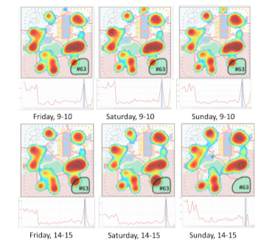

*Source: HeatMap (J. Chae 2015)*

**References :**

[1] P. Benjamin, K. Madanagopal, K. Akella, and K. Vadakkeveedu, “Group identification from visitor movement data: VAST 2015 mini-challenge 1,” in *2015 IEEE Conference on Visual Analytics Science and Technology (VAST)*, Oct. 2015.

[2] P. Banerjee, “Rapid exploration and analysis of VAST 2015 ‘Mini-Challenge 2’ dataset,” in *2015 IEEE Conference on Visual Analytics Science and Technology (VAST)*, Oct. 2015.

[3] J. Chae *et al.*, “Visual analytics of heterogeneous data for criminal event analysis VAST challenge 2015: Grand challenge,” in *2015 IEEE Conference on Visual Analytics Science and Technology (VAST)*, Oct. 2015.