**101413469 – Mohmadsahil Shaikh**

**Github link:** [**https://github.com/sahils777/101413469_comp3123_assignment2_reactjs.git**](https://github.com/sahils777/101413469_comp3123_assignment2_reactjs.git)

**MongoDB data(1 user & 1 Employee):**

**REST API tests with Postman:**

* **User signup**

* **Create employee**

* **Read employee(s)**

* **Read employee by Id**

* **Update employee**

* **Delete employee**

**Frontend CRUD operations:**

* **Login page**

* **Signup page**

* **Employee list page**

* **Add employee form**

* **Edit employee form**

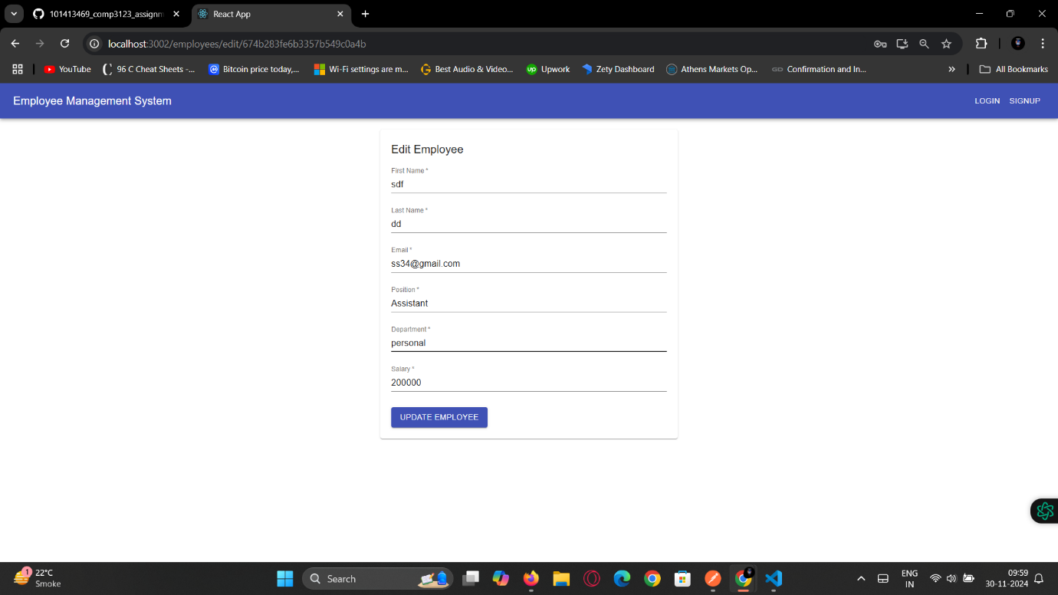

* **Delete employee confirmation**

* **Employee details view**

**Search Screen:**

* **Empty search form**

* **Search results for a specific query**

**(searched by position)**

**(searched by Department)**

* **No results found**

**Docker containers:**

