Equipment/Components

* Raspberry Pi Zero
* Pulse Sensor
* Analog to Digital converter (ADS1015)
* Seven Breadboard Jumper cables, female to female
* Charliplex LED sensor

This project can be completed in 3 days.(Required all parts and neccessary tools are already in hand).Sometimes it may take only 2 days where as sometimes it takes more than a month to ship the product. Generally, it should take around 7-8 hours to finish (taking into account that the PCB has been printed effectively, generally the PCB should take about a half-day to be printed). The major steps in the process are:

* [Raspberry Pi and Noobs installation](https://github.com/kuljeet-Singh/charli0x74#Raspberry-Pi-initialisation-and-Image-creation) (2.5 hours)
* [Other Installations, Connections and Verifications](https://github.com/kuljeet-Singh/charli0x74#Other-Installations-Connections-and-PowerUp) (2 Hours)
* [Soldering](https://github.com/kuljeet-Singh/charli0x74#Soldering) (1.5 Hours)

### Raspberry Pi initialization and Image creation

* Format the [micro-SD card](https://www.raspberrypi.org/learning/software-guide/)
* Download the latest version of [**NOOBS** OS](https://www.raspberrypi.org/downloads/noobs/)
* Downloading the software takes a while. Click on the link for step by step [video](https://www.raspberrypi.org/help/videos/#noobs-setup) to flash the image of OS to your micro-SD card.
* When downloading is done connect your Raspberry Pi to a screen and plug amouse and keyboard to it.
* Once setup is done, just enable I2C, VNC and SSH interfaces. This can be done by selecting Preference from Start Menu and then clicking Raspberry Pi configuration and then select Interfaces and now set I2C, SSH and VNC to enable mode.

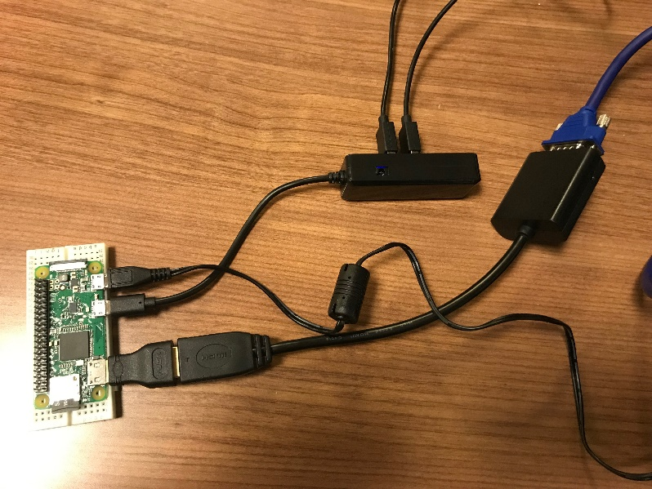

## Mechanical Assembly

Connections

1. Here's the Raspberry Pi wired to with I2C:

* 3V3 to ADS1015, Pulse Sensor and LED’s VIN
* GND to ADS1015, Pulse Sensor and LED’s GND

The ADS1015 and Charliplex LED uses I2C communication protocol so,

* SCL to ADS1015, LED’s SCL
* SDA to ADS1015, LED’s SDA
* Then connect the pulse sensor to the ADC on channel A0 (make sure to check the channel in the code below).

Once I2C is detected we are ready for next step.  
Now intall and update python libraries on Raspberry Pi.

### Other Installations Connections and PowerUp

sudo pip3 install adafruit-circuitpython-is31fl3731

Now create a new file using nano editor by name it as a ".py" file as you you did earlier and write following code into it:

import board

import busio

import adafruit_is31fl3731

display = adafruit_is31fl3731.Matrix(i2c)

When the display initializes it will go through and clear each frame (there are 8 frames total) of the display. You might see the display momentarily flash and then turn off to a clear no pixel lit image.  
You can control all of the board's pixels using the fill function. Send to this function a value from 0 to 255 where 0 is every LED pixel turned off and 255 is every LED pixel turned on to maximum brightness. For example to set all the pixels to half their brightness run:

display.fill(127)

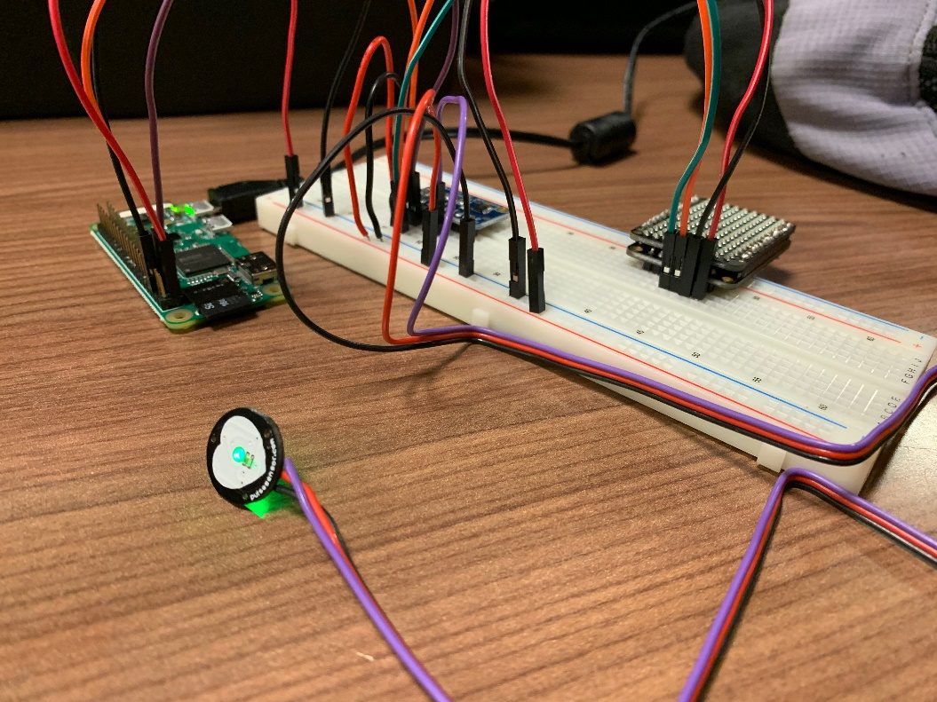

Soldering

Soldering the LED's matrix and driver together. This is required before any further step. Also solder headers to ADC and PCB.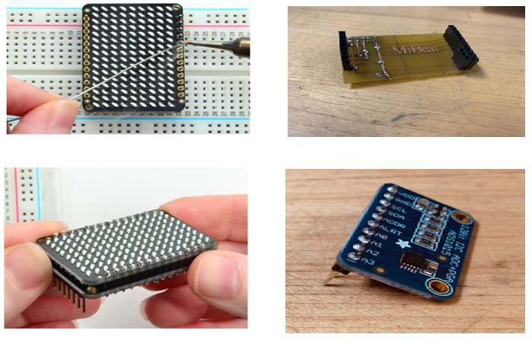

1. Final look of soldered PCB attached to Raspberry Pi all sensors connected to it looks like this :

