MiBEAT : The Innovative Wearable Technology

**Project By:**

Kuljeet Singh

Sahil Saini

Anshul Sanan

A technical report submitted in partial fulfillment of the requirements for

Computer Engineering Course

School of Applied Technology

Humber College of Applied Arts and Technology

24 January, 2018

# Declaration of Joint Authorship

I, Kuljeet Singh affirm that this work submitted for appraisal on the portability and software requirements of the hardware components, connection of the drivers & sensors to that of the Android application and output to be displayed is my own and is communicated in my own words. Any utilizations made inside it of crafted by some other creator, in any structure (thoughts, conditions, figures, writings, tables, programs), are legitimately recognized at the point of utilization. A list of the references used is also incorporated.

I, Anshul Sanan affirm that this work submitted for appraisal on the Android application to make it usable on Android device, display the readings retrieved from the database and used in application to produce a meaningful output is my own and is communicated in my own words. Any utilizations made inside it of crafted by some other creator, in any structure (thoughts, conditions, figures, writings, tables, programs), are legitimately recognized at the point of utilization. A list of the references used is also incorporated.

I, Sahil Saini affirm that this work submitted for appraisal such as attaching all the hardware components sensors to the Raspberry Pi Zero and configuring the hardware to store the variables and values on a remote server, Firebase and also configuring the I2C and SPI drivers of the sensors with the Raspberry Pi Zero is my own and is communicated in my own words. Any utilizations made inside it of crafted by some other creator, in any structure (thoughts, conditions, figures, writings, tables, programs), are legitimately recognized at the point of utilization. A list of the references used is also incorporated.

# Proposal

2019-01-17

***Proposal for the development of MiBEAT***

Prepared by Sahil Saini, Kuljeet Singh, Anshul Sanan  
*Computer Engineering Technology Students*

**Executive Summary**

As the students in the Computer Engineering Technology program, we will be integrating the knowledge and skills learned from our program into this MiBEAT themed capstone project. This proposal requests the approval to build the hardware portion that will connect to a database as well as to a mobile device application. The internet connected hardware will include a custom PCB with the IS31FL3731 144-LED CharliePlex driver (0x74), Pulse Sensor Amped, ADS1015 12-Bit ADC - 4 Channel with Programmable Gain Amplifier. The database will store Measured values for heart rate and number of steps travelled. In addition it willl also store user login information and user profile. The mobile device functionality will include the feature of re-examining his/her readings from last 7 captures. Readings here refer to heart rate and total distance travelled. It will also include feature of calculating total number of calories burnt and will be further detailed in the mobile application proposal. We will be collaborating with Humber’s School of Health Science. The hardware was completed in CENG 317 Hardware Production Techniques independently and the application was completed in CENG 319 Software Project. These will be integrated together in this term in CENG 355 Computer Systems Project as a 3-student group.

**Background**

This aim of this project is to create a wearable that can make people more responsible towards their health and help the medical science as well. It is our inexpensive approach so that everyone can own this device and lead a heathier lifestyle. Our project consists of a Pulse Sensor Amped which will further send the analog signal which is received by another sensor called ADS1015 12-Bit ADC. It converts the analog signal to a digital signal and further projecting it to the Charlieplexed PWM LED Matrix to aware the user of any change in heart rate.

In the Computer Engineering Technology program, we have learned about the following topics from the respective relevant courses:

* Java Docs from CENG 212 Programming Techniques in Java,
* Construction of circuits from CENG 215 Digital and Interfacing Systems,
* Rapid application development and Gantt charts from CENG 216 Intro to Software Engineering,
* Micro computing from CENG 252 Embedded Systems,
* SQL from CENG 254 Database with Java,
* Web access of databases from CENG 256 Internet Scripting; and,
* Wireless protocols such as 802.11 from TECH152 Telecom Networks.

This knowledge and skill set will enable us to build the subsystems and integrate them together as our capstone project.

**Methodology**

This proposal is assigned in the first week of class and is due at the beginning of class in the second week of the fall semester. Our coursework will focus on the first two of the 3 phases of this project:  
 Phase 1 Hardware build.  
 Phase 2 System integration.  
 Phase 3 Demonstration to future employers.

*Phase 1 Hardware build*

The hardware build was completed in the fall term. It fits within the CENG Project maximum dimensions of 12 13/16" x 6" x 2 7/8" (32.5cm x 15.25cm x 7.25cm) which represents the space below the tray in the parts kit. The highest AC voltage that is used is below 16Vrms from a wall adaptor from which +/- 15V or as high as 45 VDC can be obtained. Maximum power consumption is less than 20 Watts.

*Phase 2 System integration*

The system integration will be completed in this term.

*Phase 3 Demonstration to future employers*

This project will showcase the knowledge and skills that we have learned to potential employers.

The brief description below provides rough effort and non-labour estimates respectively for each phase. A Gantt chart will be added by week 3 to provide more project schedule details and a more complete budget will be added by week 4. It is important to start tasks as soon as possible to be able to meet deadlines.

**Concluding remarks**

This proposal presents a plan for providing an IoT solution for 0. This is an opportunity to integrate the knowledge and skills developed in our program to create a collaborative IoT capstone project demonstrating my ability to learn how to support projects such as the initiative described by [3]. We request approval of this project.

# Abstract

The report discusses the MiBeat, a wearable technology as a possible substitute to modern expensive devices which are already in market. It explains the fabrication, software & hardware requirements, working and future scope of the project. Our project’s focus is to find a solution for growing obesity and diseases due to lack of motion. Here is where the smartwatch comes to play. This project can also help people with cardiovascular problems helping them to take precautions if necessary. The hardware consists of a LED Matrix which displays the status to the user which is also stored in a remote database. An android application retrieves this data and is utilized by the application for any future use. The objective of this project is to help people who are struggling to stay fit and people with heart problems without any big expenses in expensive technology.

Table of Content

Contents

Declaration of Joint Authorship 2

Proposal 3

Abstract 7

List of Illustrations 9

Introduction 11

Project Description 11

Requirement Specification 13

1) Software Requirements: 13

a) Mobile Application: 13

b) Database: 13

2) Hardware Requirements: 13

a) Development Platform: 13

b) Interface boards and Sensors: 14

c) Other Hardware and Enclosures: 14

Build Instructions 15

1) Equipment/Components 15

2) Raspberry Pi initialization and Image creation 15

3) Mechanical Assembly and Connections 16

4) Install and update python libraries on Raspberry 17

5) Soldering 18

6) Enclosure 19

7) Testing 20

Conclusion 21

References 23

## List of Illustrations

Figure 1 - Cable connections for installing operating system 16

Figure 2 All the components joined together 18

Figure 3 Various images of Soldering 18

Figure 4 The final working project 19

Figure 5 Installation of Case under-progress 19

Figure 6 Enclosed Hardware 20

# Introduction

## Project Description

This aim of this project is to create a wearable that can make people more responsible towards their health and help the medical science as well.

It is our inexpensive approach so that everyone can own this device and lead a heathier lifestyle.

We will be integrating the knowledge and skills learned from our program like coding and embedded system design into this MiBEAT themed capstone project. Also, the internet connected hardware will include a custom PCB with the IS31FL3731 144-LED CharliePlex driver (0x74), Pulse Sensor Amped, ADS1015 12-Bit ADC - 4 Channel with Programmable Gain Amplifier.

The database will store Measured values for heart rate and number of steps travelled. In addition it willl also store user login information and user profile. The mobile device functionality will include the feature of re-examining his/her readings from last 7 captures. Readings here refer to heart rate and total distance travelled. It will also include feature of calculating total number of calories burnt.

In all it will satisfying our objective of making the user responsible and aware towards his/her health.

Size is the most important and also the most problematic factor in the development the project. The wearable electronic product can only succeed in the market if its design is convenient and simple.

We overcame this obstacle with a unique approach. In spite of making it a pity looking watch we boldly changed our device to a wearable glove.

# Requirement Specification

## Software Requirements:

### Mobile Application:

**Anshul** will work on the **Android** application to make it usable on Android device and display the readings retrieved from the database. **Sahil** will configure the **I2C** and **SPI** connections of the sensors with the **Raspberry Pi Zero W. Kuljeet** will connect drivers of the sensors to that of the Android application and will control output to be displayed.

### Database:

Anshulwill be responsible retrieving values from the database and be used in application to produce a meaningful output. Sahil will configure the hardware to store the variables and values on a local or remote server, possibly **Firebase.** Kuljeet will look after the encryption, decryption and binding of the hardware with the database.

## Hardware Requirements:

### Development Platform:

Sahil will attach all the hardware components such as sensors to the Raspberry Pi Zero W**.** Anshul will troubleshoot any problems occurring with the installation. Kuljeet will work on the portability and software requirements of the hardware components.

### Interface boards and Sensors:

Our project consists of a **Pulse Sensor** Amped which will further send the analog signal which is received by another sensor called **ADS1015 12-Bit ADC**. It converts the analog signal to a digital signal and further projecting it to the **Charlieplexed PWM LED Matrix** to aware the user of any change in heart rate. These sensors will be mounted on Raspberry Pi using a PCB board.

### Other Hardware and Enclosures:

Since the project at final stage will be wearable, hence we decided to make it in the form of a glove. Some other hardware like Clips, Velcro and Battery will be used to support the basic framework.

# Build Instructions

## Equipment/Components

* Raspberry Pi Zero
* Pulse Sensor
* Analog to Digital converter (ADS1015)
* Seven Breadboard Jumper cables, female to female
* Charliplex LED sensor

This project can be completed in 3 days.(Required all parts and necessary tools are already in hand).Sometimes it may take only 2 days where as sometimes it takes more than a month to ship the product. Generally, it should take around 7-8 hours to finish (taking into account that the PCB has been printed effectively, generally the PCB should take about a half-day to be printed). The major steps in the process are:

* [Raspberry Pi and Noobs installation](https://github.com/kuljeet-Singh/charli0x74#Raspberry-Pi-initialisation-and-Image-creation) (2.5 hours)
* [Other Installations, Connections and Verifications](https://github.com/kuljeet-Singh/charli0x74#Other-Installations-Connections-and-PowerUp) (2 Hours)
* [Soldering](https://github.com/kuljeet-Singh/charli0x74#Soldering) (1.5 Hours)

## Raspberry Pi initialization and Image creation

* Format the [micro-SD card](https://www.raspberrypi.org/learning/software-guide/)
* Download the latest version of [**NOOBS** OS](https://www.raspberrypi.org/downloads/noobs/)
* Downloading the software takes a while. Click on the link for step by step [video](https://www.raspberrypi.org/help/videos/#noobs-setup) to flash the image of OS to your micro-SD card.
* When downloading is done connect your Raspberry Pi to a screen and plug a mouse and keyboard to it.
* Once setup is done, just enable I2C, VNC and SSH interfaces. This can be done by selecting Preference from Start Menu and then clicking Raspberry Pi configuration and then select Interfaces and now set I2C, SSH and VNC to enable mode.

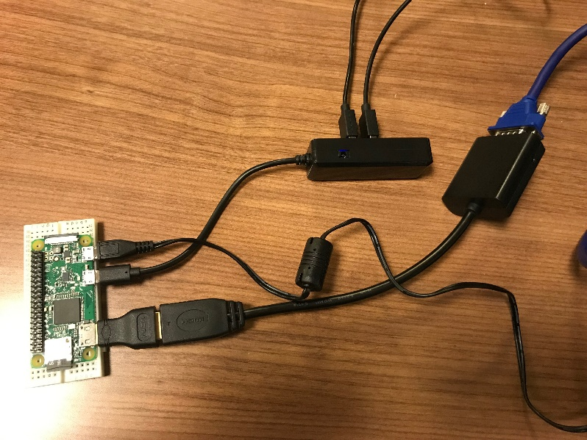

Figure 1 - Cable connections for installing operating system

## Mechanical Assembly and Connections

Here's the Raspberry Pi wired to with I2C:

* 3V3 to ADS1015, Pulse Sensor and LED’s VIN
* GND to ADS1015, Pulse Sensor and LED’s GND

The ADS1015 and Charliplex LED uses I2C communication protocol so,

* SCL to ADS1015, LED’s SCL
* SDA to ADS1015, LED’s SDA
* Then connect the pulse sensor to the ADC on channel A0 (make sure to check the channel in the code below).

Once I2C is detected we are ready for next step.

## Install and update python libraries on Raspberry

Now create a new file using nano editor by name it as a ".py" file as you you did earlier and write following code into it

* import board
* import busio
* import adafruit_is31fl3731
* display = adafruit_is31fl3731.Matrix(i2c)
* When the display initializes it will go through and clear each frame (there are 8 frames total) of the display. You might see the display momentarily flash and then turn off to a clear no pixel lit image.  
  You can control all of the board's pixels using the fill function. Send to this function a value from 0 to 255 where 0 is every LED pixel turned off and 255 is every LED pixel turned on to maximum brightness. For example to set all the pixels to half their brightness run:
* display.fill(127)

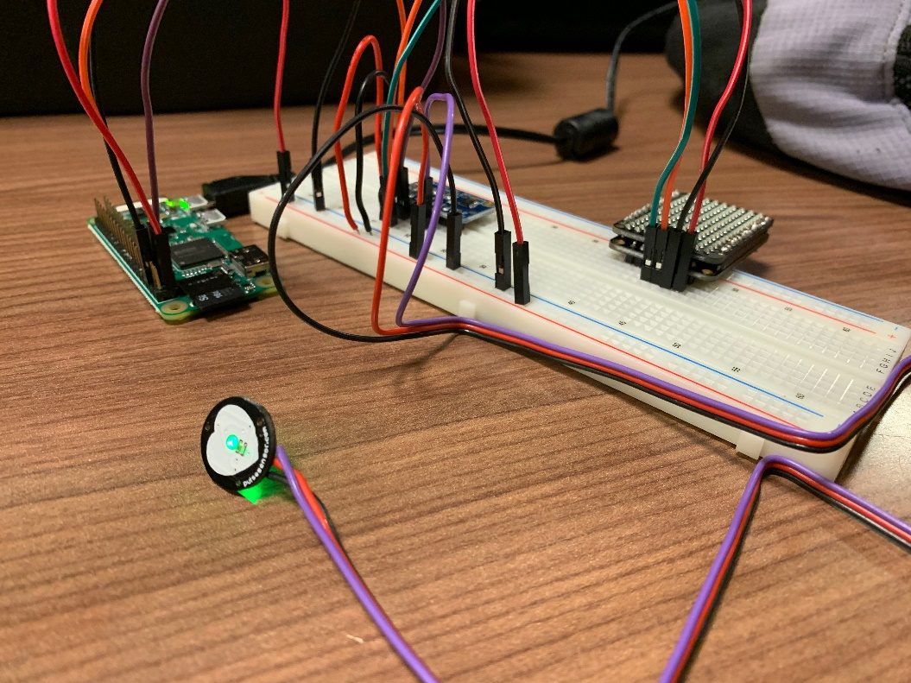

Figure 2 All the components joined together

## Soldering

Soldering the LED's matrix and driver together. This is required before any further step. Also solder headers to ADC and PCB.

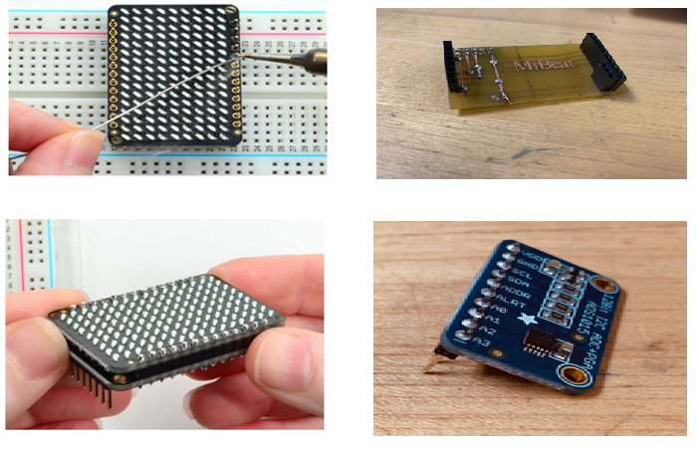

Figure 3 Various images of Soldering

Final look of soldered PCB attached to Raspberry Pi all sensors connected to it looks like this:

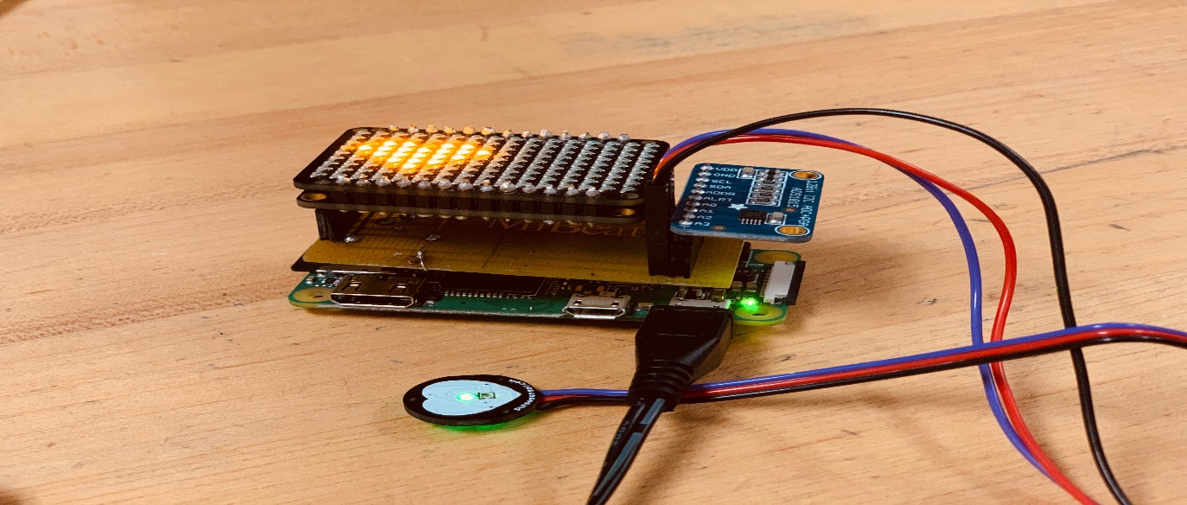

Figure 4 The final working project

## Enclosure

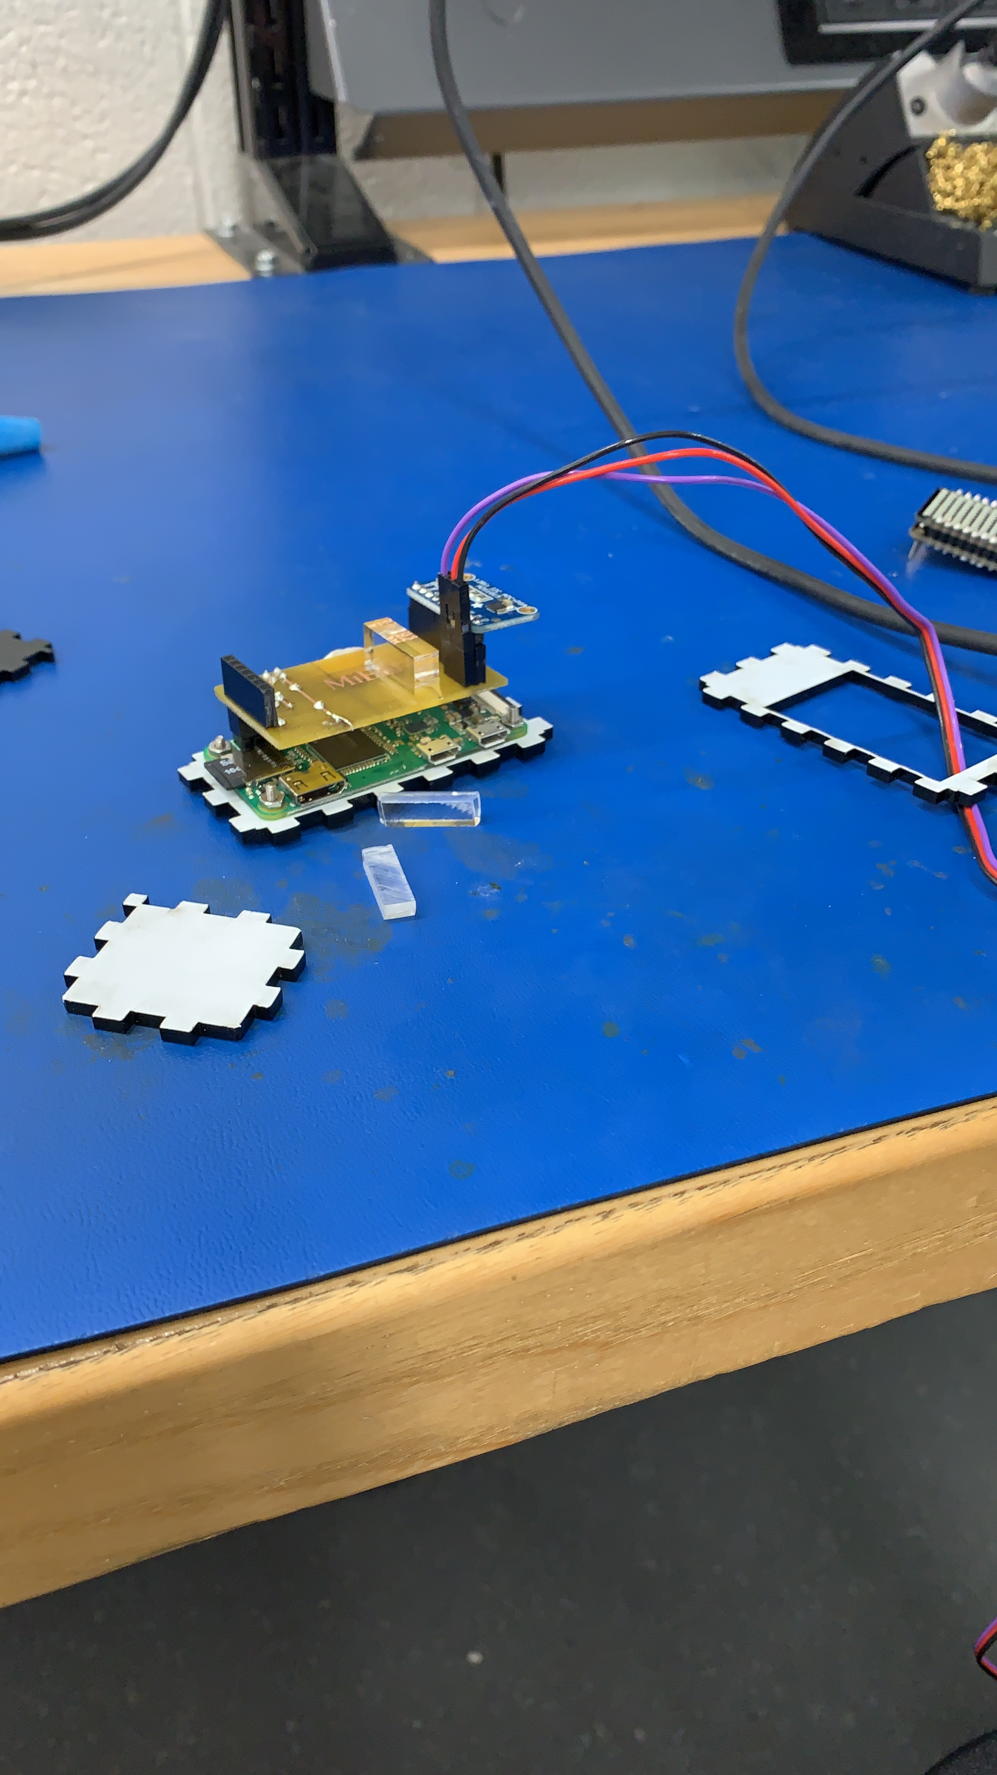

Figure Installation of Case under-progress

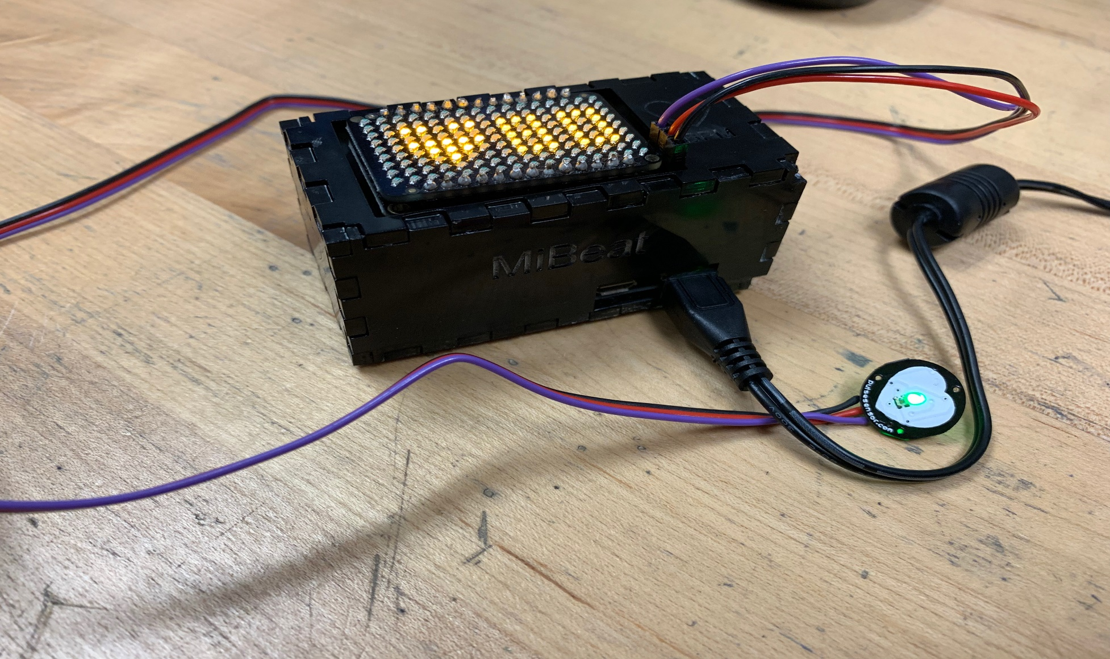

Figure Enclosed Hardware

## Testing

# Conclusion

The report discussed MiBeat, a wearable technology as a possible substitute to modern expensive devices which are already in market. It explained the fabrication, software & hardware requirements, working and future scope of the project. Our project’s focus was to find a solution for growing obesity and diseases due to lack of motion. Here is where the smartwear comes to play. This project also helped people with cardiovascular problems by helping them to take precautions if necessary. The hardware consists of a LED Matrix which displayed the status to the user, which also stored in a remote database. An android application retrieved this data and then utilized for any future use. The objective of this project is to help people who are struggling to stay fit and people with heart problems without any big expenses in expensive technology.

# References