**MainActivity.java**

**package** com.example.sahilpatel_n01390758_android;  
  
**import** androidx.annotation.RequiresApi;  
**import** androidx.appcompat.app.AppCompatActivity;  
**import** org.mariuszgromada.math.mxparser.*;  
**import** android.os.Build;  
**import** android.os.Bundle;  
**import** android.view.View;  
**import** android.widget.EditText;  
  
**import** java.util.ArrayList;  
  
**public class** MainActivity **extends** AppCompatActivity {  
  
 **private** EditText **display**;  
 ArrayList<Double> **tempfigure** = **new** ArrayList<Double>();  
 **double tempfigure1**;  
 **double memory1** = 0;  
 **boolean allowDots** = **true**;  
  
 @RequiresApi(api = Build.VERSION_CODES.***LOLLIPOP***)  
 @Override  
 **protected void** onCreate(Bundle savedInstanceState) {  
 **super**.onCreate(savedInstanceState);  
 setContentView(R.layout.***activity_main***);  
  
 **display** = findViewById(R.id.***textView***);  
 **display**.setShowSoftInputOnFocus(**false**);  
  
 **display**.setOnClickListener(**new** View.OnClickListener() {  
 @Override  
 **public void** onClick(View v) {  
 **if**(**"Enter a Value"**.equals(**display**.getText().toString())){  
 **display**.setText(**""**);  
 }  
 }  
 });  
 }  
 **private void** updateText(String strToAdd){  
 String oldStr = **display**.getText().toString();  
 **int** positionCursor = **display**.getSelectionStart();  
 String leftStr = oldStr.substring(0, positionCursor);  
 String rightStr = oldStr.substring(positionCursor);  
 **if**(getString(R.string.***display***).equals(**display**.getText().toString())){  
 **display**.setText(strToAdd);  
 **display**.setSelection(positionCursor+1);  
 }  
 **else**{  
 **display**.setText(String.*format*(**"%s%s%s"**, leftStr, strToAdd, rightStr));  
 **display**.setSelection(positionCursor+1);  
 }  
 }  
 **public void** ZeroBtn(View view){  
 updateText(**"0"**);  
 }  
 **public void** OneBtn(View view){  
 updateText(**"1"**);  
 }  
 **public void** TwoBtn(View view){  
 updateText(**"2"**);  
 }  
 **public void** ThreeBtn(View view){  
 updateText(**"3"**);  
 }  
 **public void** FourBtn(View view){  
 updateText(**"4"**);  
 }  
 **public void** FiveBtn(View view){  
 updateText(**"5"**);  
 }  
 **public void** SixBtn(View view){  
 updateText(**"6"**);  
 }  
 **public void** SevenBtn(View view){  
 updateText(**"7"**);  
 }  
 **public void** EightBtn(View view){  
 updateText(**"8"**);  
 }  
 **public void** piBtn(View view){  
 String oldStr = **display**.getText().toString();  
 **int** positionCursor = **display**.getSelectionStart();  
 String leftStr = oldStr.substring(0, positionCursor);  
 String rightStr = oldStr.substring(positionCursor);  
 **if**(getString(R.string.***display***).equals(**display**.getText().toString())){  
 **display**.setText(**"3.14"**);  
 **display**.setSelection(positionCursor+4);  
 }  
 **else**{  
 **display**.setText(String.*format*(**"%s%s%s"**, leftStr, **"3.14"**, rightStr));  
 **display**.setSelection(positionCursor+4);  
 }  
  
 }  
 **public void** NineBtn(View view){  
 updateText(**"9"**);  
 }  
 **public void** addBtn(View view){  
 updateText(**"+"**);  
 }  
 **public void** minusBtn(View view){  
 updateText(**"-"**);  
 }  
 **public void** divideBtn(View view){  
 updateText(**"/"**);  
 }  
 **public void** multiplyBtn(View view){  
 updateText(**"*"**);  
 }  
  
 **public void** percentageBtn(View view){  
 updateText(**"%"**);  
 }  
 **public void** expoBtn(View view){  
 updateText(**"^"**);  
 }  
 **public void** dotBtn(View view){  
  
 **if**(**allowDots** == **true**) {  
 updateText(**"."**);  
 }  
 **allowDots** = **false**;  
 }  
 **public void** clearBtn(View view){  
 **display**.setText(**""**);  
 }  
 **public void** memoryPlus(View view){  
 **tempfigure**.add(Double.*parseDouble*(**display**.getText().toString()));  
 **memory1**=**memory1**+**tempfigure**.get(0);  
 **tempfigure1**=0;  
 **tempfigure**.removeAll(**tempfigure**);  
 **display**.setText(**"0"**);  
 **if** (**memory1** >0) { **display**.setText(**"Memory saved"**);  
 }  
 }  
 **public void** memoryMinus(View view){  
 **tempfigure**.add(Double.*parseDouble*(**display**.getText().toString()));  
 **memory1**=**memory1** - **tempfigure**.get(0);  
 **tempfigure1**=0;  
 **tempfigure**.removeAll(**tempfigure**);  
 **display**.setText(**"0"**);  
 **if** (**memory1** >0) { **display**.setText(**"Memory minused"**);  
 }  
 }  
  
 **public void** memoryRecall(View view){  
 **display**.setText(**""**+**memory1**);  
 }  
  
 **public void** memoryClear(View view){  
 **memory1** = 0;  
 }  
 **public void** equalBtn(View view){  
 String userExp = **display**.getText().toString();  
 Expression exp = **new** Expression(userExp);  
 String result = String.*valueOf*(exp.calculate());  
 **display**.setText(result);  
 **display**.setSelection(result.length());  
 }  
}

**Colors.xml :-**

*<?***xml version="1.0" encoding="utf-8"***?>*<**resources**>  
 <**color name="purple_200"**>#FFBB86FC</**color**>  
 <**color name="purple_500"**>#FF6200EE</**color**>  
 <**color name="purple_700"**>#FF3700B3</**color**>  
 <**color name="teal_200"**>#FF03DAC5</**color**>  
 <**color name="teal_700"**>#FF018786</**color**>  
 <**color name="black"**>#FF000000</**color**>  
 <**color name="white"**>#FFFFFFFF</**color**>  
</**resources**>

**Circle.xml**

*<?***xml version="1.0" encoding="utf-8"***?>*<**selector xmlns:android="http://schemas.android.com/apk/res/android"**>  
 <**item**>  
 <**shape android:shape="rectangle"**>  
 <**corners android:radius="1000dp"**></**corners**>  
 <**solid android:color="#263238"**/>  
 </**shape**>  
 </**item**>  
</**selector**>

**Activity_main.xml:-**

*<?***xml version="1.0" encoding="utf-8"***?>*<**androidx.constraintlayout.widget.ConstraintLayout xmlns:android="http://schemas.android.com/apk/res/android"  
 xmlns:app="http://schemas.android.com/apk/res-auto"  
 xmlns:tools="http://schemas.android.com/tools"  
 android:layout_width="match_parent"  
 android:layout_height="match_parent"  
 tools:context=".MainActivity"**>  
  
 <**TableLayout  
 android:id="@+id/tableLayout"  
 android:layout_width="match_parent"  
 android:layout_height="wrap_content"  
 app:layout_constraintBottom_toBottomOf="parent"  
 app:layout_constraintTop_toTopOf="parent"  
 app:layout_constraintVertical_bias="0.95"**>  
  
 <**TableRow  
 android:layout_width="match_parent"  
 android:layout_height="match_parent"**>  
  
 <**Button  
 android:id="@+id/button27"  
 style="@style/Widget.AppCompat.Button.Borderless"  
 android:layout_width="0dp"  
 android:layout_height="70dp"  
 android:layout_margin="5dp"  
 android:layout_weight="1"  
 android:background="@drawable/circle"  
 android:backgroundTint="#DD2C00"  
 android:onClick="memoryClear"  
 android:text="@string/MemoryClear"  
 android:textColor="#ffffff"  
 android:textSize="22sp"** />  
  
 <**Button  
 style="@style/Widget.AppCompat.Button.Borderless"  
 android:layout_width="0dp"  
 android:layout_height="70dp"  
 android:layout_margin="5dp"  
 android:layout_weight="1"  
 android:background="@drawable/circle"  
 android:backgroundTint="#DD2C00"  
 android:onClick="memoryRecall"  
 android:text="@string/MemoryRecalll"  
 android:textColor="#ffffff"  
 android:textSize="22sp"** />  
  
 <**Button  
 android:id="@+id/button29"  
 style="@style/Widget.AppCompat.Button.Borderless"  
 android:layout_width="0dp"  
 android:layout_height="70dp"  
 android:layout_margin="5dp"  
 android:layout_weight="1"  
 android:background="@drawable/circle"  
 android:backgroundTint="#DD2C00"  
 android:onClick="memoryPlus"  
 android:text="@string/memoryPlus"  
 android:textColor="#ffffff"  
 android:textSize="22sp"** />  
  
 <**Button  
 android:id="@+id/button30"  
 style="@style/Widget.AppCompat.Button.Borderless"  
 android:layout_width="0dp"  
 android:layout_height="70dp"  
 android:layout_margin="5dp"  
 android:layout_weight="1"  
 android:background="@drawable/circle"  
 android:backgroundTint="#DD2C00"  
 android:onClick="memoryMinus"  
 android:text="@string/memoryMinus"  
 android:textColor="#ffffff"  
 android:textSize="22sp"** />  
 </**TableRow**>  
  
 <**TableRow  
 android:layout_width="match_parent"  
 android:layout_height="match_parent"**>  
  
 <**Button  
 android:id="@+id/buttonPlusMinus"  
 style="@style/Widget.AppCompat.Button.Borderless"  
 android:layout_width="0dp"  
 android:layout_height="70dp"  
 android:layout_margin="5dp"  
 android:layout_weight="1"  
 android:background="@drawable/circle"  
 android:onClick="clearBtn"  
 android:text="@string/clear"  
 android:textColor="#ffffff"  
 android:textSize="22sp"** />  
  
 <**Button  
 android:id="@+id/buttonPi"  
 style="@style/Widget.AppCompat.Button.Borderless"  
 android:layout_width="0dp"  
 android:layout_height="70dp"  
 android:layout_margin="5dp"  
 android:layout_weight="1"  
 android:background="@drawable/circle"  
 android:onClick="piBtn"  
 android:text="@string/pi"  
 android:textColor="#ffffff"  
 android:textSize="22sp"** />  
  
 <**Button  
 android:id="@+id/buttonExponent"  
 style="@style/Widget.AppCompat.Button.Borderless"  
 android:layout_width="0dp"  
 android:layout_height="70dp"  
 android:layout_margin="5dp"  
 android:layout_weight="1"  
 android:background="@drawable/circle"  
 android:onClick="expoBtn"  
 android:text="@string/exponent"  
 android:textColor="#ffffff"  
 android:textSize="22sp"** />  
  
 <**Button  
 android:id="@+id/buttonDivide"  
 style="@style/Widget.AppCompat.Button.Borderless"  
 android:layout_width="0dp"  
 android:layout_height="70dp"  
 android:layout_margin="5dp"  
 android:layout_weight="1"  
 android:background="@drawable/circle"  
 android:onClick="divideBtn"  
 android:text="@string/divide"  
 android:textColor="#ffffff"  
 android:textSize="22sp"** />  
  
  
 </**TableRow**>  
  
 <**TableRow  
 android:layout_width="match_parent"  
 android:layout_height="match_parent"**>  
  
 <**Button  
 android:id="@+id/buttonSeven"  
 style="@style/Widget.AppCompat.Button.Borderless"  
 android:layout_width="0dp"  
 android:layout_height="70dp"  
 android:layout_margin="5dp"  
 android:layout_weight="1"  
 android:background="@drawable/circle"  
 android:onClick="SevenBtn"  
 android:text="@string/seven"  
 android:textColor="#ffffff"  
 android:textSize="22sp"** />  
  
 <**Button  
 android:id="@+id/buttonEieght"  
 style="@style/Widget.AppCompat.Button.Borderless"  
 android:layout_width="0dp"  
 android:layout_height="70dp"  
 android:layout_margin="5dp"  
 android:layout_weight="1"  
 android:background="@drawable/circle"  
 android:onClick="EightBtn"  
 android:text="@string/eight"  
 android:textColor="#ffffff"  
 android:textSize="22sp"** />  
  
 <**Button  
 android:id="@+id/buttonNine"  
 style="@style/Widget.AppCompat.Button.Borderless"  
 android:layout_width="0dp"  
 android:layout_height="70dp"  
 android:layout_margin="5dp"  
 android:layout_weight="1"  
 android:background="@drawable/circle"  
 android:onClick="NineBtn"  
 android:text="@string/nine"  
 android:textColor="#ffffff"  
 android:textSize="22sp"** />  
  
 <**Button  
 android:id="@+id/buttonMultiply"  
 style="@style/Widget.AppCompat.Button.Borderless"  
 android:layout_width="0dp"  
 android:layout_height="70dp"  
 android:layout_margin="5dp"  
 android:layout_weight="1"  
 android:background="@drawable/circle"  
 android:onClick="multiplyBtn"  
 android:text="@string/multiply"  
 android:textColor="#ffffff"  
 android:textSize="22sp"** />  
 </**TableRow**>  
  
 <**TableRow  
 android:layout_width="match_parent"  
 android:layout_height="match_parent"**>  
  
 <**Button  
 android:id="@+id/buttonFour"  
 style="@style/Widget.AppCompat.Button.Borderless"  
 android:layout_width="0dp"  
 android:layout_height="70dp"  
 android:layout_margin="5dp"  
 android:layout_weight="1"  
 android:background="@drawable/circle"  
 android:onClick="FourBtn"  
 android:text="@string/four"  
 android:textColor="#ffffff"  
 android:textSize="22sp"** />  
  
 <**Button  
 android:id="@+id/buttonFive"  
 style="@style/Widget.AppCompat.Button.Borderless"  
 android:layout_width="0dp"  
 android:layout_height="70dp"  
 android:layout_margin="5dp"  
 android:layout_weight="1"  
 android:background="@drawable/circle"  
 android:onClick="FiveBtn"  
 android:text="@string/five"  
 android:textColor="#ffffff"  
 android:textSize="22sp"** />  
  
 <**Button  
 android:id="@+id/buttonSix"  
 style="@style/Widget.AppCompat.Button.Borderless"  
 android:layout_width="0dp"  
 android:layout_height="70dp"  
 android:layout_margin="5dp"  
 android:layout_weight="1"  
 android:background="@drawable/circle"  
 android:onClick="SixBtn"  
 android:text="@string/six"  
 android:textColor="#ffffff"  
 android:textSize="22sp"** />  
  
 <**Button  
 android:id="@+id/buttonSubstract"  
 style="@style/Widget.AppCompat.Button.Borderless"  
 android:layout_width="0dp"  
 android:layout_height="70dp"  
 android:layout_margin="5dp"  
 android:layout_weight="1"  
 android:background="@drawable/circle"  
 android:onClick="minusBtn"  
 android:text="@string/substract"  
 android:textColor="#ffffff"  
 android:textSize="22sp"** />  
 </**TableRow**>  
  
 <**TableRow  
 android:layout_width="match_parent"  
 android:layout_height="match_parent"**>  
  
 <**Button  
 android:id="@+id/buttonOne"  
 style="@style/Widget.AppCompat.Button.Borderless"  
 android:layout_width="0dp"  
 android:layout_height="70dp"  
 android:layout_margin="5dp"  
 android:layout_weight="1"  
 android:background="@drawable/circle"  
 android:onClick="OneBtn"  
 android:text="@string/one"  
 android:textColor="#ffffff"  
 android:textSize="22sp"** />  
  
 <**Button  
 android:id="@+id/buttonTwo"  
 style="@style/Widget.AppCompat.Button.Borderless"  
 android:layout_width="0dp"  
 android:layout_height="70dp"  
 android:layout_margin="5dp"  
 android:layout_weight="1"  
 android:background="@drawable/circle"  
 android:onClick="TwoBtn"  
 android:text="@string/two"  
 android:textColor="#ffffff"  
 android:textSize="22sp"** />  
  
 <**Button  
 android:id="@+id/buttonThree"  
 style="@style/Widget.AppCompat.Button.Borderless"  
 android:layout_width="0dp"  
 android:layout_height="70dp"  
 android:layout_margin="5dp"  
 android:layout_weight="1"  
 android:background="@drawable/circle"  
 android:onClick="ThreeBtn"  
 android:text="@string/three"  
 android:textColor="#ffffff"  
 android:textSize="22sp"** />  
  
 <**Button  
 android:id="@+id/buttonAdd"  
 style="@style/Widget.AppCompat.Button.Borderless"  
 android:layout_width="0dp"  
 android:layout_height="70dp"  
 android:layout_margin="5dp"  
 android:layout_weight="1"  
 android:background="@drawable/circle"  
 android:onClick="addBtn"  
 android:text="@string/add"  
 android:textColor="#ffffff"  
 android:textSize="22sp"** />  
 </**TableRow**>  
  
 <**TableRow  
 android:layout_width="match_parent"  
 android:layout_height="match_parent"**>  
  
 <**Button  
 android:id="@+id/buttonZero"  
 style="@style/Widget.AppCompat.Button.Borderless"  
 android:layout_width="0dp"  
 android:layout_height="61dp"  
 android:layout_margin="5dp"  
 android:layout_weight="1"  
 android:background="@drawable/circle"  
 android:onClick="ZeroBtn"  
 android:text="@string/zero"  
 android:textColor="#ffffff"  
 android:textSize="22sp"** />  
  
 <**Button  
 android:id="@+id/buttonPoint"  
 style="@style/Widget.AppCompat.Button.Borderless"  
 android:layout_width="0dp"  
 android:layout_height="70dp"  
 android:layout_margin="5dp"  
 android:layout_weight="1"  
 android:background="@drawable/circle"  
 android:onClick="dotBtn"  
 android:text="@string/point"  
 android:textColor="#ffffff"  
 android:textSize="22sp"** />  
  
  
  
 <**Button  
 android:id="@+id/percentage"  
 style="@style/Widget.AppCompat.Button.Borderless"  
 android:layout_width="0dp"  
 android:layout_height="70dp"  
 android:layout_margin="5dp"  
 android:layout_weight="1"  
 android:background="@drawable/circle"  
 android:backgroundTint="#DD2C00"  
 android:onClick="percentageBtn"  
 android:text="@string/percentage"  
 android:textColor="#ffffff"  
 android:textSize="22sp"** />  
 <**Button  
 android:id="@+id/buttonEquals"  
 style="@style/Widget.AppCompat.Button.Borderless"  
 android:layout_width="0dp"  
 android:layout_height="70dp"  
 android:layout_margin="5dp"  
 android:layout_weight="1"  
 android:background="@drawable/circle"  
 android:backgroundTint="#43a047"  
 android:onClick="equalBtn"  
 android:text="@string/equals"  
 android:textColor="#ffffff"  
 android:textSize="22sp"** />  
 </**TableRow**>  
 </**TableLayout**>  
  
 <**EditText  
 android:id="@+id/textView"  
 android:layout_width="0dp"  
 android:layout_height="wrap_content"  
 android:layout_marginTop="30dp"  
 android:text="@string/display"  
 app:layout_constraintEnd_toEndOf="parent"  
 app:layout_constraintHorizontal_bias="0.48"  
 app:layout_constraintStart_toStartOf="parent"  
 app:layout_constraintTop_toTopOf="parent"  
 android:autofillHints="false"  
 android:inputType="none"  
 tools:ignore="Label For"  
 android:textSize="36sp"  
 android:textAlignment="textEnd"  
 android:layout_gravity="end"** />  
  
</**androidx.constraintlayout.widget.ConstraintLayout**>

**String.xml:-**

<**resources**>  
 <**string name="app_name"**>SahilPatel_N01390758_Android</**string**>  
 <**string name="zero"**>0</**string**>  
 <**string name="one"**>1</**string**>  
 <**string name="two"**>2</**string**>  
 <**string name="three"**>3</**string**>  
 <**string name="four"**>4</**string**>  
 <**string name="five"**>5</**string**>  
 <**string name="six"**>6</**string**>  
 <**string name="seven"**>7</**string**>  
 <**string name="eight"**>8</**string**>  
 <**string name="nine"**>9</**string**>  
  
 <**string name="percentage"**>%</**string**>  
 <**string name="exponent"**>^</**string**>  
 <**string name="pi"**>π</**string**>  
 <**string name="divide"**>÷</**string**>  
 <**string name="multiply"**>×</**string**>  
 <**string name="add"**>+</**string**>  
 <**string name="substract"**>-</**string**>  
 <**string name="clear"**>C</**string**>  
 <**string name="point"**>.</**string**>  
 <**string name="equals"**>=</**string**>  
  
 <**string name="memoryPlus"**>M+</**string**>  
 <**string name="memoryMinus"**>M-</**string**>  
 <**string name="MemoryRecalll"**>MR</**string**>  
 <**string name="MemoryClear"**>MC</**string**>  
 <**string name="display"**>Enter a Value </**string**>  
  
  
</**resources**>

**Percentage:-**

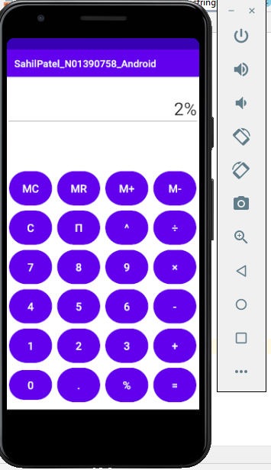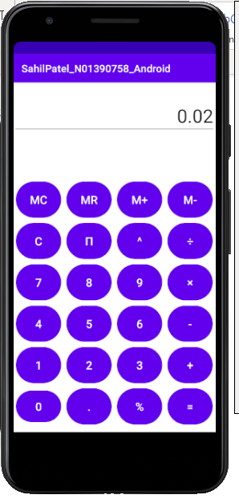

**Memory Function:-**

1. **Memory + & Memory Recall**

**Adding 2 in memory:- Adding 4 in memory Memory recall(2+4=6))**

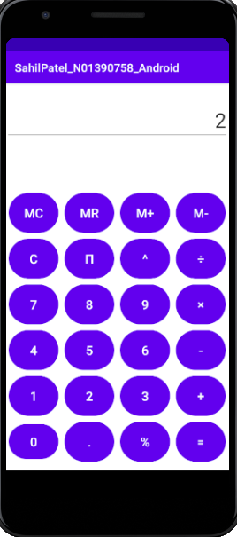 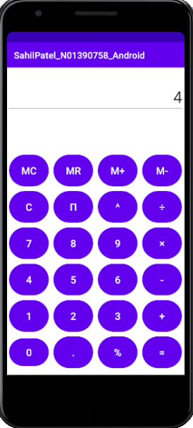 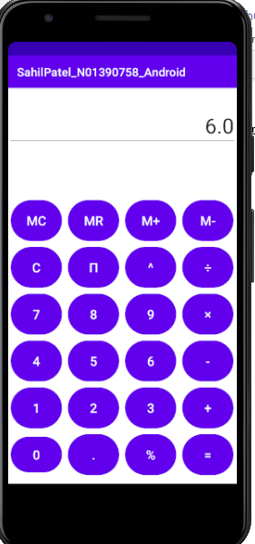

1. **Memory - & Memory Recall**

Adding 4 in memory First to substract next number M- number 2 memory recall it should be 4-2 =2

  

1. **Memory Clear:-**

**Now from the previous activity our memory is 2. If I press the Memory clear button memory becomes 0 and then I will press the clear button to clear the screen and then press the memory recall button to verify it is 0.**

 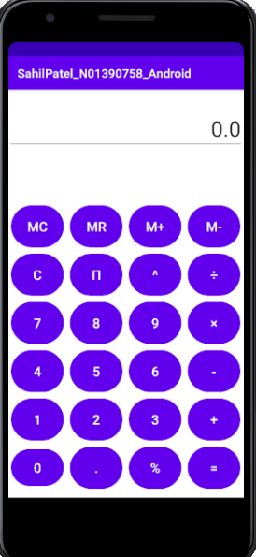

**NOTE:- I’ve also added the video of the complete working of my calculator, So please review it.**

**Thank you!**