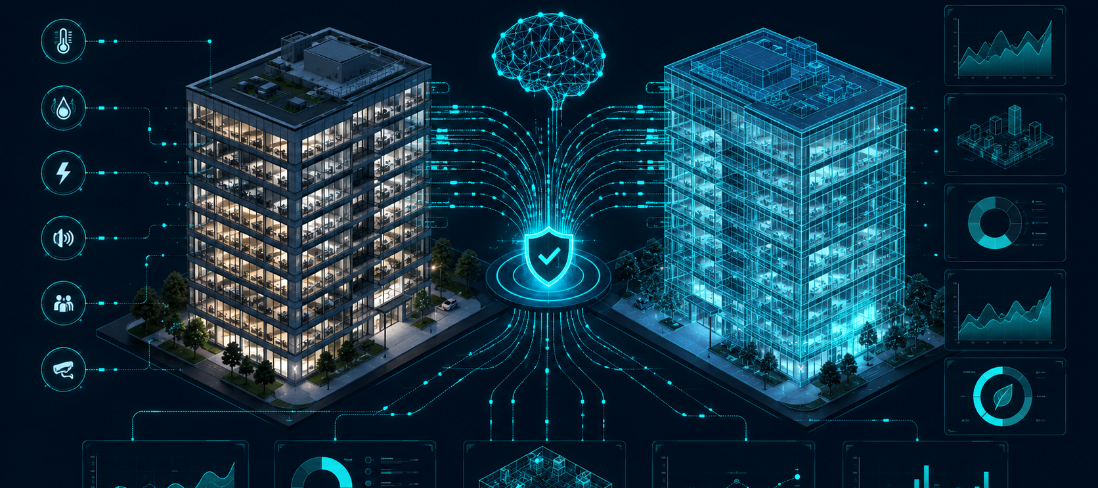
HONEYWELL ECO-LOOP BUILDING AGENTS

EcoPilot
System Architecture Document
A safety-constrained agentic digital twin for autonomous building energy optimization
PROJECT | EcoPilot
VERSION | 1.0
DATE | July 2026
PREPARED BY | EcoPilot Team
MEASURABLE • SAFE • EXPLAINABLE • FAULT-TOLERANT

1. Executive Summary
EcoPilot is a closed-loop building-control proof of concept built around two synchronized EnergyPlus simulations. The baseline twin runs the building's native schedules, while the controlled twin accepts runtime schedule overrides. Both twins use the same building model, weather file, and simulation horizon, making the measured difference attributable to the control strategy rather than to different test conditions.
An open-source LLM running through Ollama acts as a supervisory agent, not as an unrestricted numerical controller. The agent reads structured building state through Model Context Protocol tools, requests deterministic control candidates, validates the selected action, and queues an approved action. The EnergyPlus process independently rechecks the action before writing to any actuator.
ARCHITECTURAL THESIS
The LLM decides what strategy to pursue; deterministic code decides whether it is feasible, safe, and executable.

Design principles
- Measurability - synchronized baseline and controlled twins provide direct kWh and peak-demand evidence.
- Safety - comfort, IAQ, actuator bounds, and thermostat deadband are enforced as hard constraints.
- Explainability - every action contains a mode, reason, confidence, target values, and audit status.
- Fault tolerance - EnergyPlus never waits for the LLM; deterministic fallback and native-schedule rollback remain available.
- Reproducibility - configuration, telemetry, actions, logs, reports, and tests are retained in the repository.

Document map
Section | Focus
2-3 | Scope, design decisions, and the system architecture
4-5 | Components and closed-loop execution sequence
6-8 | MCP tools, optimization, safety, and recovery
9-11 | Prompt engineering, latency, logs, and observability
12-14 | Deployment, requirement traceability, and final validation

2. Scope and Key Design Decisions

Current proof-of-concept scope
EcoPilot controls schedule-based EnergyPlus actuators for cooling, heating, lighting, and ventilation when those exchange points are exposed by the chosen IDF. It observes facility and zone telemetry including power, cumulative electricity, peak demand, temperature, occupancy, humidity, PMV, and CO₂ where the model supports those signals.
Decision | Rationale
Two identical EnergyPlus twins | Creates a fair live baseline-versus-controlled comparison.
LLM as supervisor | Prevents hallucinated or malformed numerical values from reaching actuators.
MCP-only execution boundary | Makes every data read and action explicit, typed, and auditable.
SQLite communication bus | Decouples processes and preserves states, actions, and events.
Deterministic optimizer + safety shield | Keeps numerical ranking and hard constraints repeatable.
Short-lived action-bound tokens | Prevents modification, replay, and stale execution.
Runtime revalidation | Protects against state changes between approval and actuation.
Native-schedule fallback | Returns the building to a known-safe control policy.

3. System Architecture Overview
  - The communication bus decouples fast simulation callbacks from slower supervisory reasoning.
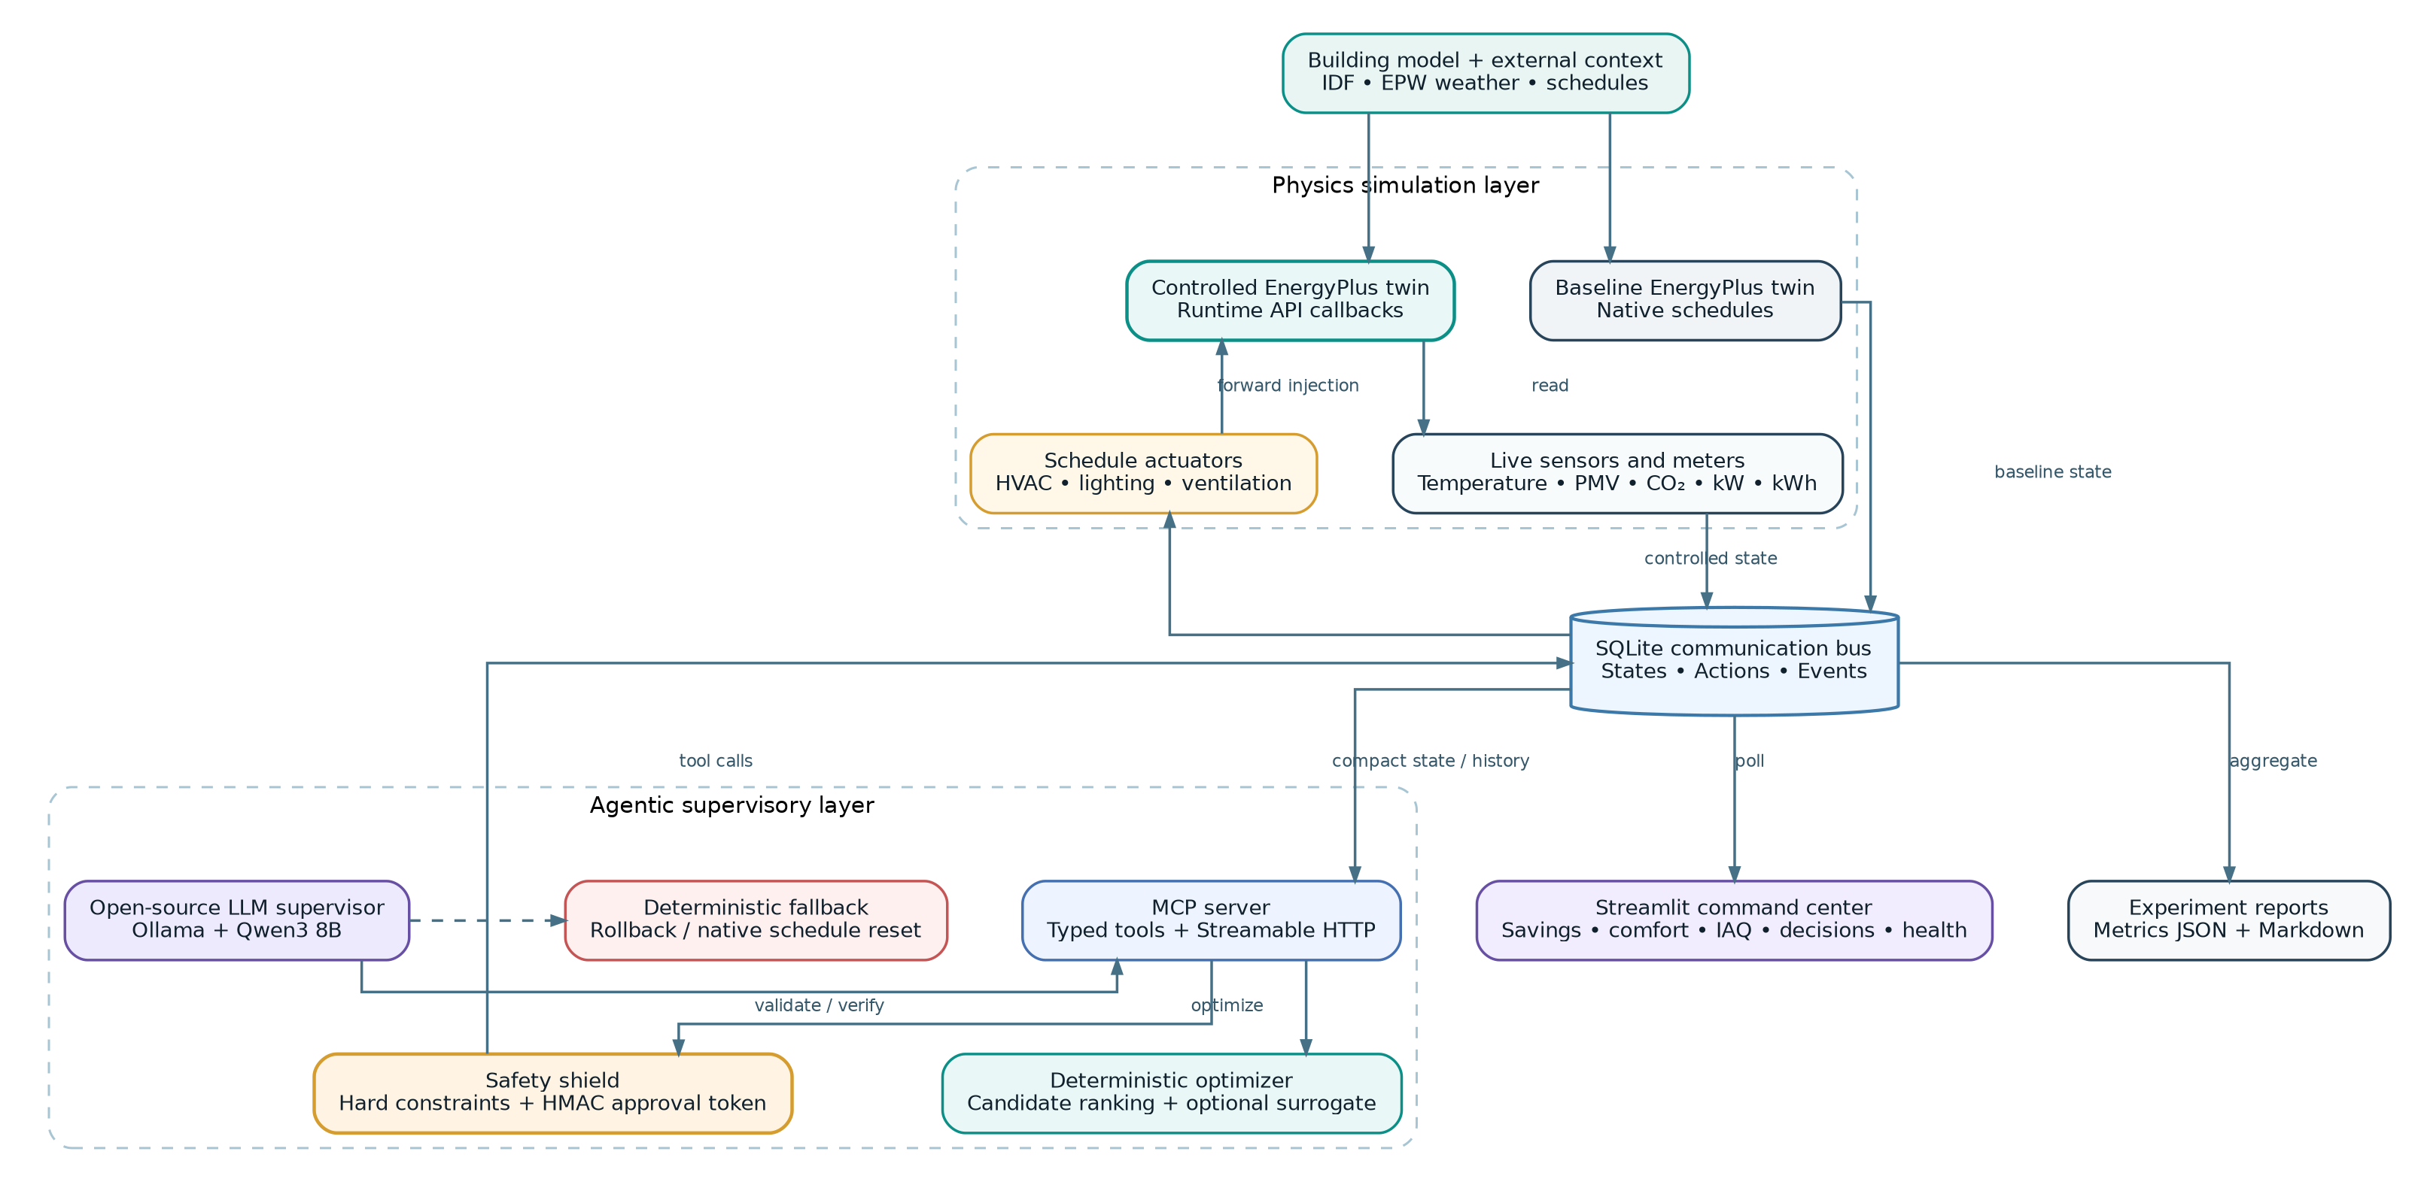
Figure 1. EcoPilot logical system architecture and major data/control paths.

End-to-end data path
- Start one baseline and one controlled EnergyPlus process using the same IDF, EPW, and simulation horizon.
- Read variables and meters after every completed zone timestep and publish a compact BuildingState.
- Let the agent discover MCP tools and read the latest controlled state, recent history, and baseline comparison.
- Generate and rank deterministic operating modes using predicted power and safety penalties.
- Validate the exact action and issue a short-lived token bound to its SHA-256 digest.
- Queue the approved action; dequeue and revalidate it inside the controlled EnergyPlus process.
- Apply schedule actuators for a bounded hold period, publish the resulting telemetry, and audit the lifecycle.

4. Component Architecture
Component | Responsibility | Implementation
Model preparation | Creates baseline/controlled IDFs and selects EPW. | `scripts/setup_models.py`, `energyplus/idf_parser.py`
Twin runners | Run baseline and controlled EnergyPlus processes. | `energyplus/runner.py`
Runtime callbacks | Load actions, apply controls, read state, complete hold periods. | `energyplus/callbacks.py`
Handle registry | Requests variables and discovers schedule actuator handles. | `energyplus/handle_registry.py`
Sensor / actuator layer | Builds telemetry and writes or resets schedule values. | `sensor_reader.py`, `actuator_writer.py`
SQLite bus | Persists states, actions, tokens, statuses, and events. | `core/storage.py`
MCP server | Publishes typed read, optimize, validate, apply, recovery, and report tools. | `mcp_server/`
Supervisory agent | Runs bounded tool loops through Ollama or deterministic mode. | `agent/orchestrator.py`
Optimizer / surrogate | Generates operating modes and ranks predicted outcomes. | `control/optimizer.py`, `surrogate.py`
Safety and fallback | Enforces constraints, tokens, comfort recovery, and rollback. | `constraints.py`, `safety_shield.py`, `fallback_controller.py`
Command center | Displays twin performance, zones, decisions, and health. | `dashboard/`
Experiment / reports | Launches processes and produces final metrics/report. | `experiments/`

5. Closed-Loop Runtime Sequence
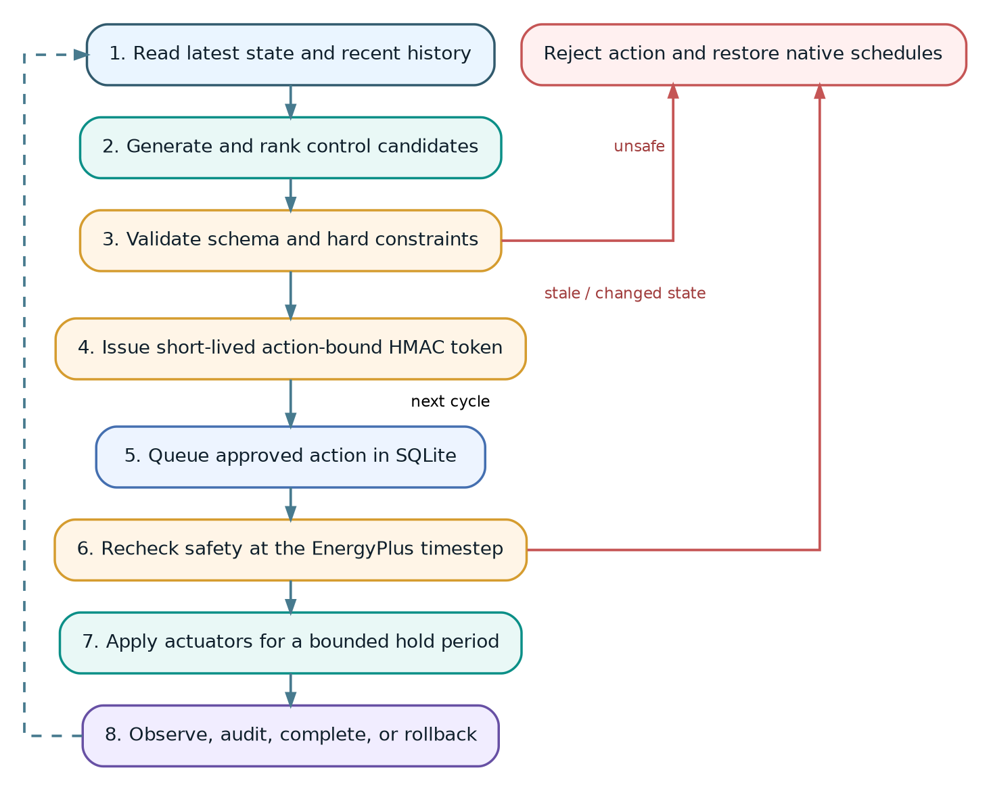
Figure 2. Safety-gated action lifecycle from observation to actuation and recovery.

Callback timing
Callback phase | Operations
Before zone timestep | Initialize handles, dequeue the next approved action, perform runtime safety recheck, and write schedule actuator values.
After zone reporting | Increment the simulation step, read sensors/meters, publish BuildingState, complete expired actions, and reset actuators.

NON-BLOCKING CONTROL
The EnergyPlus callback never waits for an LLM response. It only consumes actions that have already passed validation.

6. MCP Tool-Calling Architecture
The LLM cannot access EnergyPlus, SQLite, or model files directly. It must use eleven typed MCP tools, giving the system a clear and auditable execution boundary.
Group | Tools | Purpose
Model inspection | inspect_building_model_tool; discover_exchange_points_tool | Inspect zones, schedules, sensors, meters, and actuators.
State retrieval | get_live_building_state_tool; get_recent_history_tool; compare_with_baseline_tool | Provide current, historical, and comparative evidence.
Decision support | optimize_control_action_tool | Generate and rank deterministic candidates.
Safety / execution | validate_control_action_tool; apply_control_action_tool | Issue/verify a token and queue the exact approved action.
Recovery / diagnostics | rollback_last_action_tool; read_runtime_messages_tool | Restore native schedules and inspect bounded events.
Reporting | generate_final_report_tool | Calculate final metrics from both twins.

Normal supervisory cycle
read state -> read history -> compare -> optimize -> validate -> apply -> summarize

If the LLM does not complete safe actuation, the orchestrator automatically executes the deterministic supervisory cycle. This keeps the loop operational during incomplete tool use, timeout, model failure, or local inference unavailability.

7. Deterministic Optimization
Candidate modes include NORMAL, ECO, PEAK_LIMIT, PRECOOL, IAQ_RECOVERY, UNOCCUPIED_SETBACK, COMFORT_RECOVERY, and SAFE_FALLBACK. Candidates are generated from current occupancy, time, outdoor temperature, facility demand, temperature, PMV, and CO₂ conditions.
OBJECTIVE FUNCTION
Total score = predicted kW + comfort penalty + IAQ penalty + switching penalty. Hard comfort violations dominate the score.

The optional surrogate loads a HistGradientBoostingRegressor from `data/surrogate.joblib`. When no trained model is available, EcoPilot uses a deterministic heuristic based on the proposed cooling setpoint, lighting fraction, ventilation fraction, and current power. This allows the controller to run before model training while preserving an upgrade path for predictive control.

8. Safety, Security, and Recovery

Defense-in-depth control chain
- Pydantic validates BuildingState, ControlAction, candidate, and validation-result structures.
- The optimizer removes candidates that fail deterministic constraints.
- The MCP validation tool checks the selected action against the newest state.
- The safety shield issues an HMAC token containing the action digest and expiry step.
- The apply tool verifies signature, digest, expiry, and current constraints before queueing.
- The controlled EnergyPlus process validates the queued action again immediately before actuation.
- Each action has a bounded hold period and is completed or reset automatically.
- Malformed, stale, unsafe, or unauthorized actions are rejected and logged.

Default hard boundaries
Boundary | Default
Occupied temperature range | 21-26 °C
Absolute PMV limit | 0.7
CO₂ limit | 1,000 ppm
Heating setpoint range | 18-22 °C
Cooling setpoint range | 22-27 °C
Minimum thermostat deadband | 2 °C
Minimum action confidence | 0.50

Additional logic blocks reduced ventilation near the CO₂ threshold, unsafe warm/cold actions near comfort boundaries, and unauthorized unoccupied control. Low lighting and unusually low ventilation generate warnings for evaluator visibility.

9. Prompt Engineering and Latency Management

Tool-first prompt policy
- Never invent sensors, actuators, energy, occupancy, comfort, weather, or IAQ values.
- Read the newest state and recent history before choosing an action.
- Use the optimizer for numerical candidate generation; do not calculate unrestricted setpoints in natural language.
- Validate every action and use the exact returned approval token.
- Never modify the action after validation.
- Prefer rollback or no action when evidence is absent, stale, malformed, or unsafe.
- Treat comfort and IAQ as higher priority than energy savings.
- Keep the natural-language response brief and exclude raw logs from context.

Latency controls
Mechanism | Benefit
Process isolation | A slow or failed LLM cannot terminate either EnergyPlus twin.
Non-blocking callback | The simulation consumes already-approved actions and never waits for inference.
Configurable supervisory interval | Default wall-clock agent interval is 2 seconds.
Bounded tool loop | Default maximum is 8 tool rounds per cycle.
Compact state and bounded history | Reduces context length; recent-history default is 12 states.
Bounded action hold period | Prevents indefinite overrides and limits oscillation.
Deterministic fallback | Maintains safe operation when Ollama is unavailable.

10. Runtime Logs and Long-Context Management
Lengthy EnergyPlus output is deliberately separated from the agent prompt. The runtime monitor captures messages and progress, structured events are stored in SQLite, and process logs are written under `data/live/`. The diagnostic MCP tool returns only a bounded number of recent events and can filter by severity.
Evidence channel | Content | Consumer
Compact state | Latest facility/zone telemetry and active action. | Agent, optimizer, dashboard
Recent history | A bounded sequence of structured states. | Agent trend reasoning
Action audit | Approved, applied, completed, and rejected actions. | Dashboard and evaluators
Event stream | Warnings, errors, safety rejections, runtime progress. | Diagnostics and system health
Process files | Baseline, controlled, MCP, and agent logs. | Developer troubleshooting
Final metrics | Energy, peak, comfort, IAQ, action, warning, and error measures. | Report and presentation

CONTEXT DISCIPLINE
The LLM receives only the evidence needed for the current decision; complete logs remain available to tools, the dashboard, and the final report.

11. Data Model and Observability
Stream | Important fields | Use
states | run ID, mode, simulation step/time, BuildingState payload | Twin telemetry and performance curves
actions | action ID, source, created step, status, token, payload, applied step | Approval queue and full lifecycle audit
events | timestamp, severity, source, message, optional payload | Diagnostics, rejection reasons, and runtime health

Action status normally moves through approved -> applied -> completed; malformed or unsafe actions become rejected. The dashboard and report calculate energy saving, peak reduction, occupied comfort compliance, CO₂ compliance, applied/rejected actions, warnings, and errors from this common evidence base.

12. Deployment Topology
The experiment launcher starts the MCP server, supervisory agent, baseline twin, and controlled twin as separate subprocesses, waits for both simulations, generates the final report, and terminates support processes cleanly. The dashboard is started separately so it remains visible throughout the demonstration.
python -m experiments.run_scenarios
# Integration test without Ollama
python -m experiments.run_scenarios --deterministic-agent --realtime-delay 0.25
# Judge-facing command center
python -m streamlit run dashboard/app.py

13. Hackathon Requirements Traceability
Requirement | EcoPilot implementation | Status
High-fidelity EnergyPlus simulation | Two Runtime API twins using the same IDF and EPW. | Implemented
Open-source LLM | Local Ollama model; default Qwen3 8B. | Implemented
MCP server / agentic tools | Eleven typed tools over Streamable HTTP. | Implemented
Continuous feedback | Telemetry published after every zone timestep. | Implemented
Reasoning against comfort / demand | State/history tools plus optimizer penalties. | Implemented
AI-to-EnergyPlus control | Validated schedule actuator writes. | Verify final IDF handles
Automatic forward injection | Controlled callback consumes queued actions. | Implemented
Quantitative dashboard | Twin energy/demand, comfort, IAQ, audit, health. | Implemented
Self-correction and recovery | Fallback, recheck, expiry, native reset. | Implemented
Architecture report | This document and repository Markdown. | Complete
Three-minute demo video | Live twin, safe action, result, rejection, recovery. | Record after validation

14. Current PoC Limitations and Final Validation
- Verify cooling, heating, lighting, and ventilation handles in `data/live/exchange_points.json` for the final IDF.
- Confirm PMV inputs and `ZoneAirContaminantBalance` so comfort and CO₂ evidence are available and real.
- Run synchronized scenarios and replace all placeholder claims with final kWh and peak-demand metrics.
- Demonstrate malformed action, changed token, expired token, missing Ollama, and runtime-warning recovery.
- Train the optional surrogate only when sufficient rollout data exists; otherwise describe the heuristic honestly.
- Do not claim carbon-intensity or tariff optimization unless an external signal adapter is implemented and tested.
- Replace the default approval secret and keep paths, secrets, and raw stack traces out of the judge-facing UI.

15. Conclusion
EcoPilot combines a high-fidelity physics engine with an agentic supervisory layer while keeping numerical control and safety enforcement deterministic. The dual-twin design proves impact, the MCP boundary makes actions inspectable, the token and runtime-recheck chain prevents unsafe execution, and process isolation ensures that an LLM failure cannot stop the simulation. The resulting proof of concept is measurable, explainable, fault-tolerant, and aligned with the Eco-Loop Building Agents objective.
EcoPilot • EnergyPlus digital twins • MCP tool calling • Safety-gated forward control

