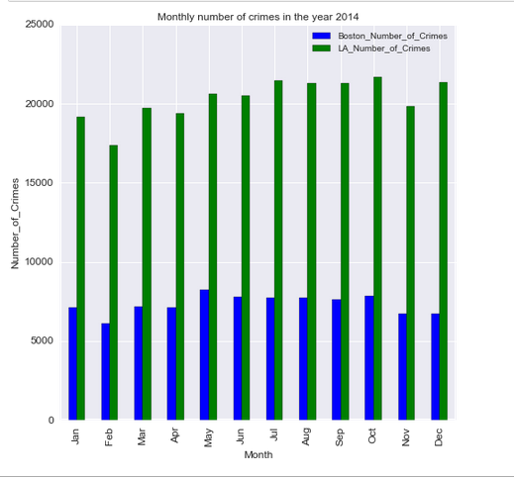

This graph clearly shows that Boston is a much safer city to live in as compared to LA and for every month, the number of crimes experienced for both the cities is pretty much constant.

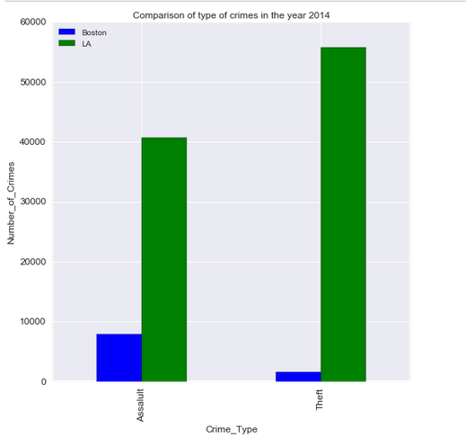

We have taken 2 most common type of crimes in both the cities and plotted the above graph. It is clearly visible that LA has much more crime rate for these crimes as compared to Boston.