For Regression Analysis, we divided the data for each area code and got the total number of crime for each crime type, time of the day and type of the day. The aim of our regression analysis was to find to out what are the most important factors for the total number of crimes occurring in an area and what are the factors favorable for an area to be safe.

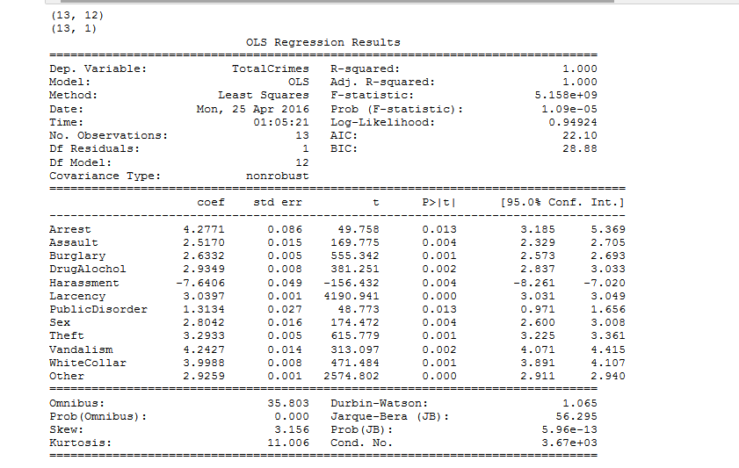

From the above results, we can see that the number of Harassment crimes has a negative correlation with the total number of crimes. This means the areas which have high number of Harassment crimes have a less total number of crimes.

Arrest and Vandalism have a high positive correlation as compared to other types. This implies the areas which have more Arrest and Vandalism crimes have more chances to be unsafe areas.

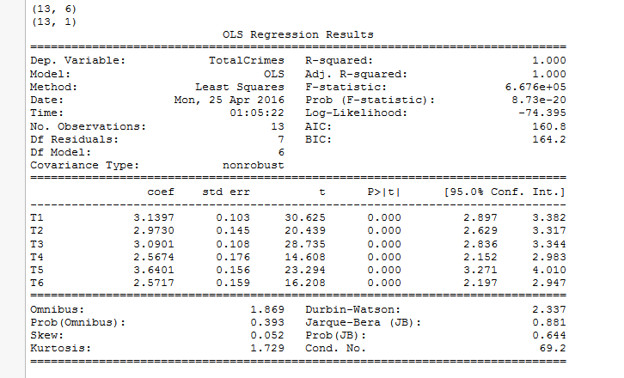

From the above results, we can see that the time T5 has a higher correlation as compared to other times. This implies if an area has more number of crimes during the time period 5pm to 9pm, then that area has more chances to be unsafe.

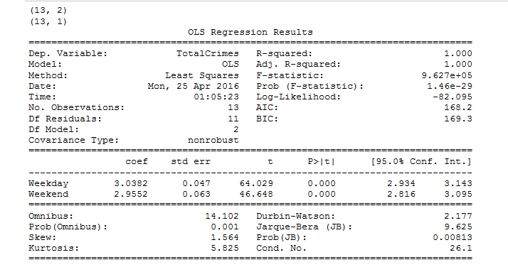

From the above results, we can see that number of crimes occurring on a weekday or a weekend have similar impact on the total number of crimes.

We have determined and area to be safe if it has less than 5% of the total number of crimes in the city.

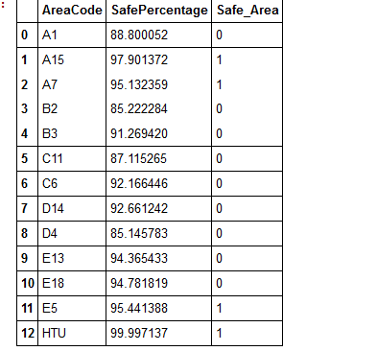

We can clearly see that the area having code ‘HTU’ is the safest of all areas in Boston. This comprises the below streets:

* PARK PLAZA
* BRAGDON ST
* STUART ST
* WASHINGTON ST
* COMMONWEALTH AV

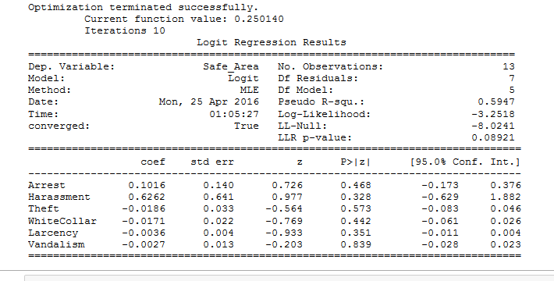

From the above Logistic Regression results, we can see that for the safe areas the only crime type that occurs in a significant number is Harassment.