PRACTICAL EXPERIMENT – 7
K-Means Clustering Using RapidMiner

Name: Sahil Setya
Class: D15A
Roll No.: 48
Subject: Data Analytics / Machine Learning Practical

Aim
To prepare and execute a RapidMiner workflow that clusters the Music Streaming Subscriber dataset into three groups using numerical user attributes, after handling missing values and applying Z-score normalization.

Theory
Clustering is an unsupervised learning technique that groups data records based on similarity without using predefined class labels.
K-Means is a clustering algorithm that assigns each record to the nearest cluster centroid. It repeatedly updates the centroids and cluster assignments until the process stabilizes. The value of k specifies the number of clusters.
In this experiment, the Music Streaming Subscriber dataset containing 500 records is used. Four numerical attributes are selected: age, listening hours per week, monthly logins, and tenure months. These features represent user profiles and listening behaviour.
Missing values can be replaced using the average of an attribute. Z-score normalization transforms numerical values based on their mean and standard deviation, helping features with different scales contribute more comparably to distance calculations.

Tools Required
Altair AI Studio (RapidMiner), Music_Streaming_Subscriber_Churn.csv, and the operators Retrieve, Select Attributes, Replace Missing Values, Normalize, and Clustering (k-Means).

Procedure
- Open Altair AI Studio and create a new blank process.
- Import Music_Streaming_Subscriber_Churn.csv into the Local Repository and add its Retrieve operator to the process.
- Add Select Attributes and retain the four numerical features: age, listening_hours_per_week, monthly_logins, and tenure_months.
- Add Replace Missing Values after Select Attributes. Configure the operator to replace missing numerical values using the average.
- Add Normalize after Replace Missing Values and select Z-transformation (Z-score normalization) for the selected numerical attributes.
- Add Clustering (k-Means) after Normalize. Set k = 3, max runs = 10, enable determine good start values, and use Numerical Measures with Euclidean Distance.
- Connect the two Clustering output ports to separate process result ports.
- Run the process and inspect the clustered ExampleSet and Cluster Model results.
- Open the visualization view and capture the scatter plot for the practical record.

Process Flow
Retrieve → Select Attributes → Replace Missing Values → Normalize → Clustering (k-Means, k = 3) → Results

RapidMiner Execution Evidence
The workflow was assembled and executed in Altair AI Studio. The selected attributes were processed through missing-value replacement and normalization before K-Means clustering was applied.
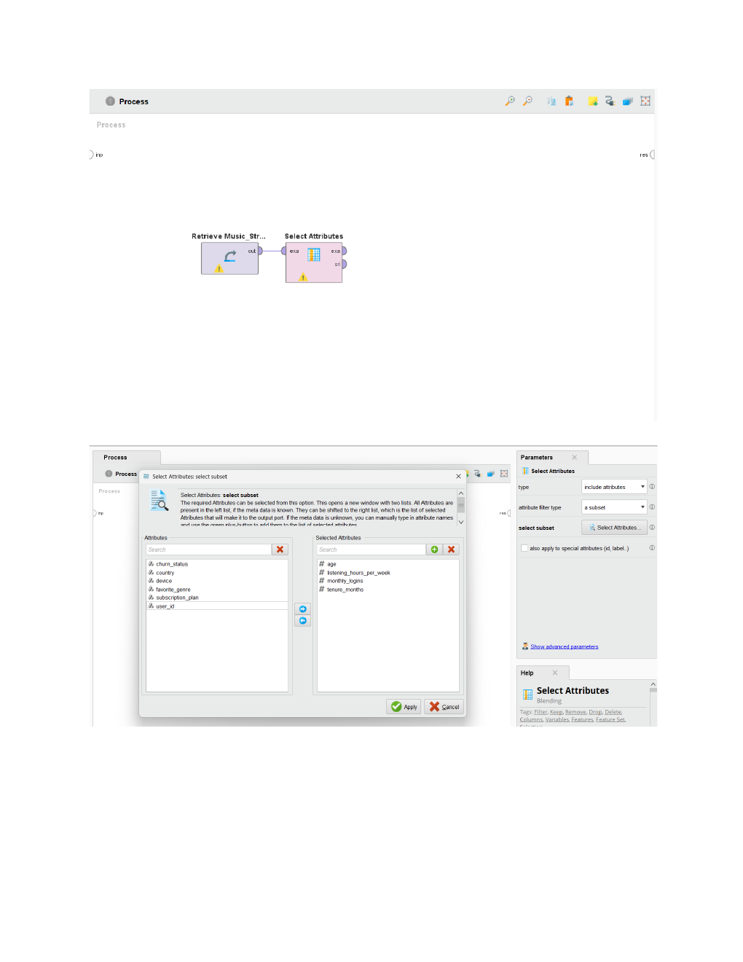
Figure 1. Attribute selection and preprocessing operator settings.
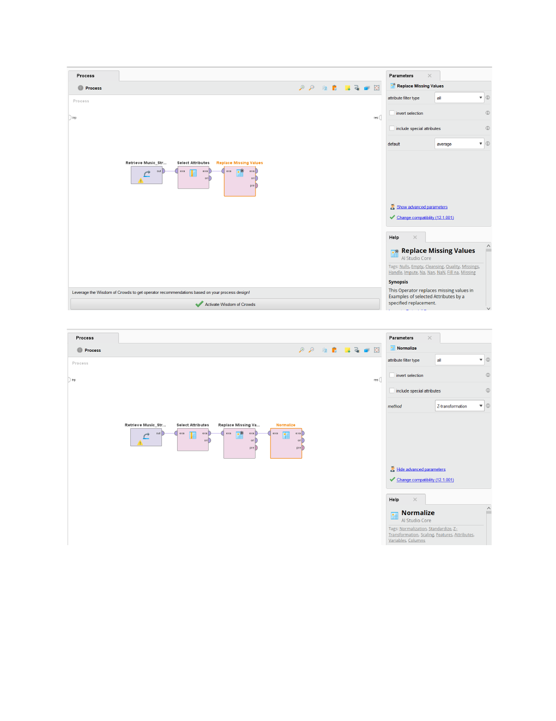
Figure 2. Replace Missing Values and Normalize operator settings.
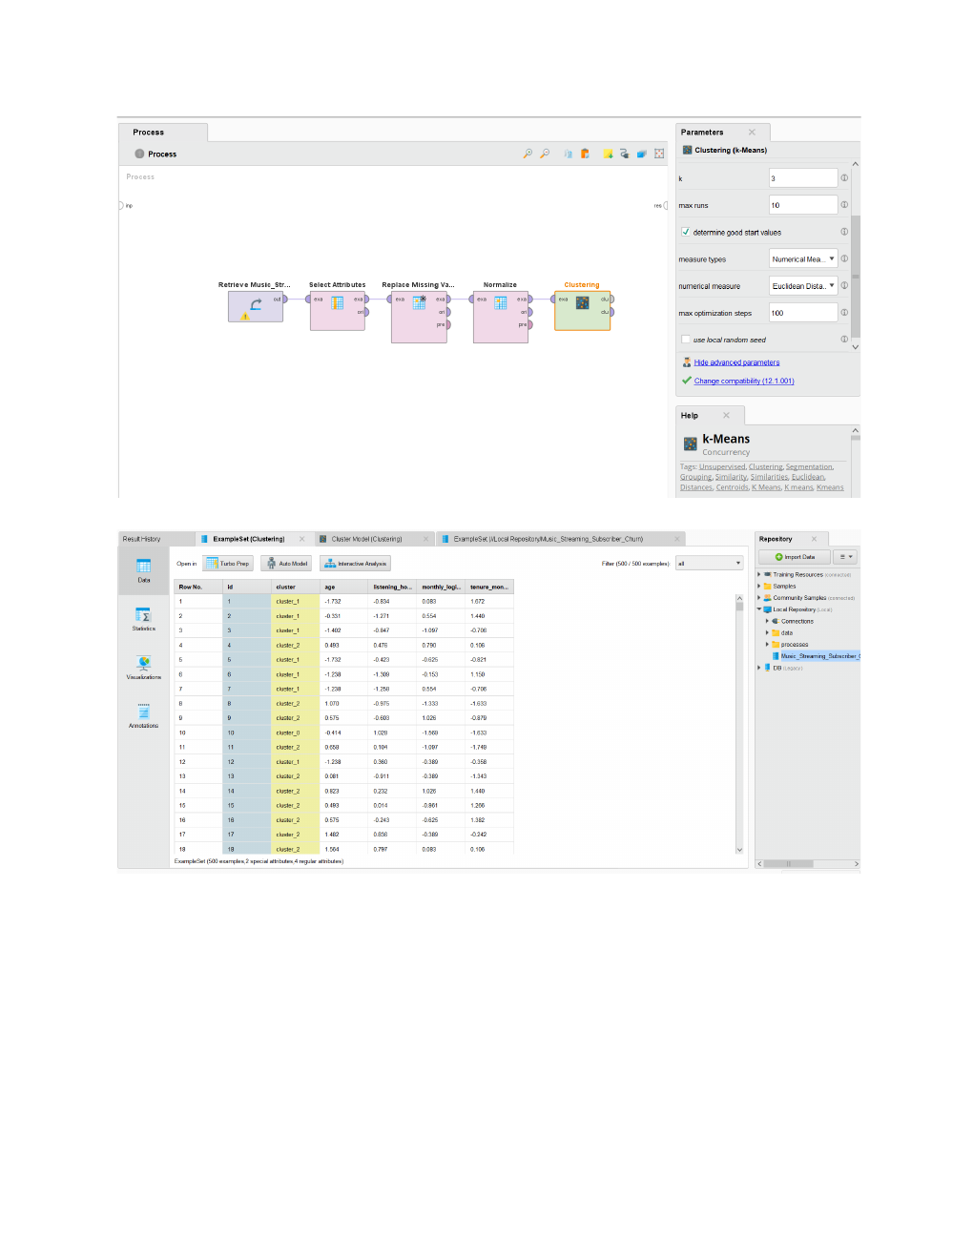
Figure 3. Completed K-Means workflow and clustered ExampleSet output.
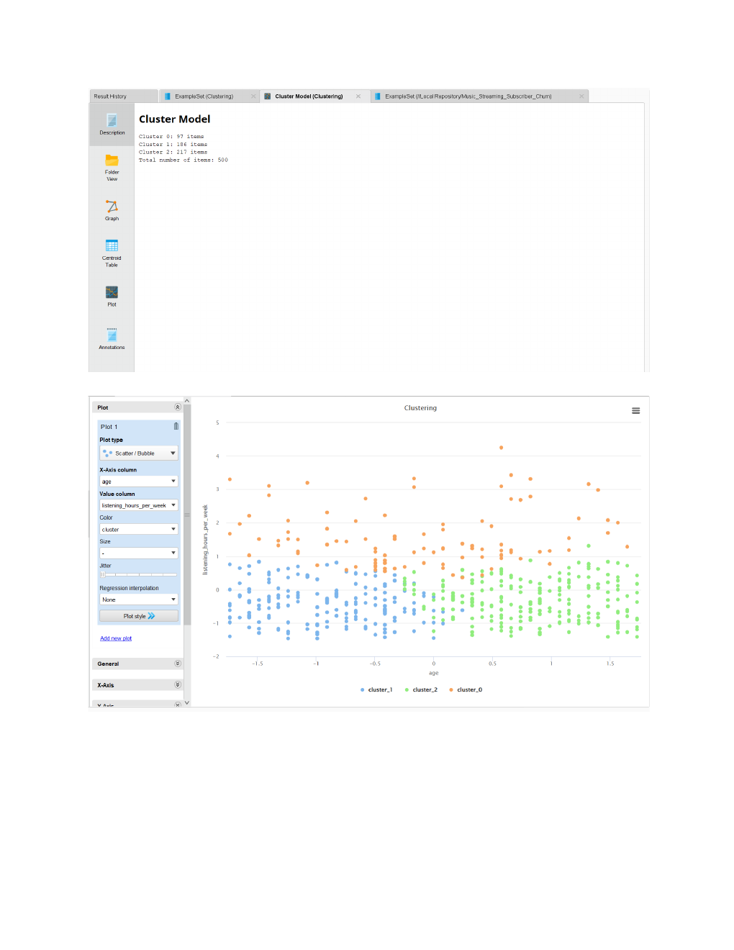
Figure 4. Cluster Model output and cluster visualization.

Cluster Model Output
The executed K-Means model assigned all 500 records to three clusters.
Cluster | Number of Users | Percentage
Cluster 0 | 97 | 19.4%
Cluster 1 | 186 | 37.2%
Cluster 2 | 217 | 43.4%
Total | 500 | 100%

Cluster Analysis
Cluster 2 is the largest group with 217 users (43.4%). Cluster 1 contains 186 users (37.2%), while Cluster 0 is the smallest group with 97 users (19.4%). The cluster assignment groups users according to the four selected standardized numerical attributes. The cluster counts alone do not establish the detailed behavioural profile of each group.

Inference
- K-Means clustering divided 500 music streaming users into three clusters.
- Cluster 0 contains 97 users (19.4%), Cluster 1 contains 186 users (37.2%), and Cluster 2 contains 217 users (43.4%).
- Cluster 2 is the largest group, while Cluster 0 is the smallest group.
- The four selected numerical features were normalized before clustering.
- The experiment demonstrates how users can be grouped based on age, listening hours per week, monthly logins, and tenure months.

Result
K-Means clustering was successfully implemented using Altair AI Studio (RapidMiner) on the Music Streaming Subscriber dataset. A total of 500 records were divided into three clusters using age, listening hours per week, monthly logins, and tenure months. The cluster distribution was 97, 186, and 217 users, respectively.

Conclusion
The experiment demonstrated how K-Means clustering can group music streaming users according to their numerical characteristics. RapidMiner provided a graphical workflow for selecting attributes, replacing missing values, normalizing data, and performing clustering. The results identified three groups and showed their distribution in the dataset.

