DMBI PRACTICAL
EXPERIMENT 03
Exploratory Data Analysis and Visualization

Name: Sahil Setya
Class: D15A
Roll No.: 48
Subject: DMBI

1. Aim
To perform Exploratory Data Analysis (EDA) and data visualization on a Music Streaming System dataset using Python.

2. Theory
Exploratory Data Analysis is used to inspect a dataset, summarize its important characteristics, identify patterns, and understand relationships among variables before further analysis.

Dataset Overview
The sample dataset contains 15 songs and six attributes: Song, Artist, Genre, Listening_Time_Minutes, Stream_Count, and User_Rating. The data is created in Python for this practical and is illustrative; it is not actual data from a streaming platform.

Significance of EDA
- Understand the structure and statistical summary of the data.
- Check missing values and duplicate records.
- Calculate central tendency and dispersion measures.
- Study relationships between numerical attributes using correlation.
- Visualize distributions, spread, and relationships through graphs.

3. Central Tendency
Mean is the average, median is the middle value after sorting, and mode is the most frequently occurring value. These measures were calculated for listening time and stream count.

Listening Time Minutes
Mean: 40.33 | Median: 40.00 | Mode: 25, 30, 35, 40, 45

Stream Count
Mean: 2366.67 | Median: 2200.00 | Mode: 900, 1100, 1200, 1500, 1600, 1800, 2000, 2200, 2500, 2700, 2800, 3200, 3500, 4000, 4500

4. Measures of Dispersion
Standard deviation and variance describe variability; range is maximum minus minimum; IQR is Q3 minus Q1 and represents the spread of the middle 50% of observations.
Attribute | Std. Deviation | Variance | Range | IQR
Listening Time Minutes | 14.07 | 198.10 | 50.00 | 17.50
Stream Count | 1084.08 | 1175238.10 | 3600.00 | 1450.00

5. Correlation Analysis
Correlation measures the direction and strength of a linear relationship between numerical attributes. Its value ranges from -1 to +1. The correlation matrix below was calculated for Listening Time, Stream Count, and User Rating.
Attribute | Listening Time | Stream Count | User Rating
Listening Time Minutes | 1.00 | 1.00 | 0.90
Stream Count | 1.00 | 1.00 | 0.91
User Rating | 0.90 | 0.91 | 1.00
Interpretation: Positive correlation means two variables tend to increase together, while negative correlation means one tends to decrease as the other increases. Correlation does not prove causation.

6. Data Visualization

6.1 Histogram of Listening Time
The histogram shows the frequency distribution of song listening times.
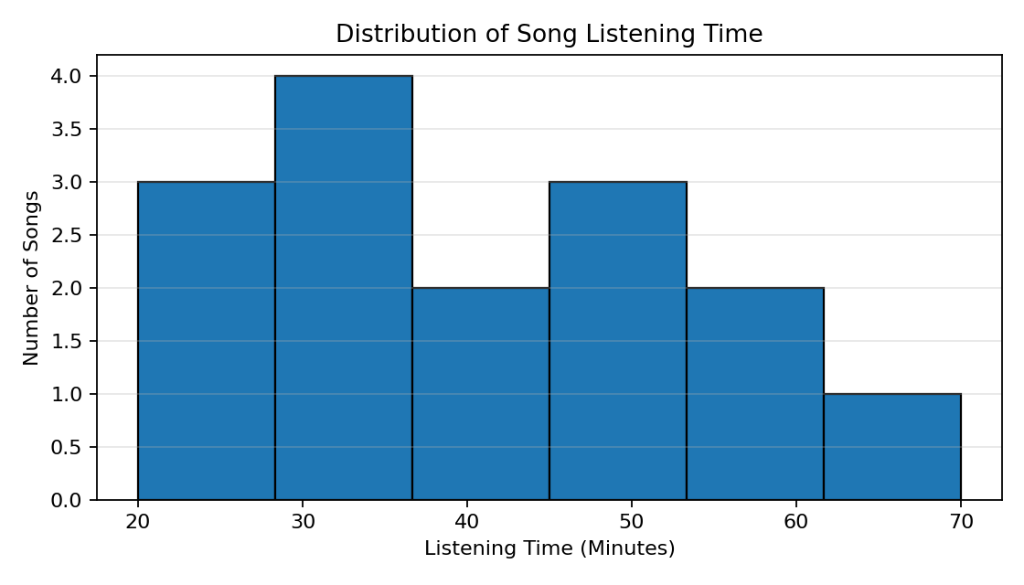

6.2 Boxplot of Stream Count
The boxplot displays the median, interquartile range, overall spread, and any potential outliers.
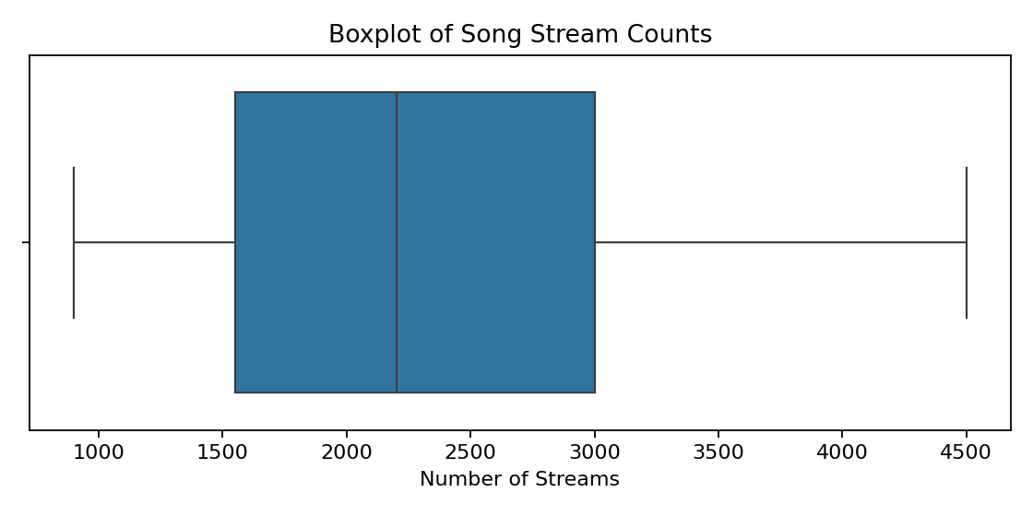

6.3 Correlation Heatmap
The heatmap presents correlation values using colours, making positive and negative relationships easier to compare.
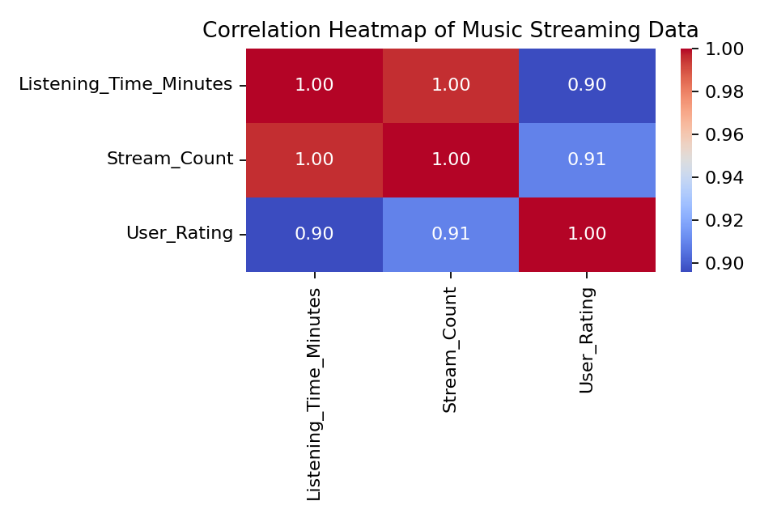

6.4 Scatter Plot: Listening Time vs Stream Count
Each point represents one song. The scatter plot helps visually inspect whether listening time and stream count move together.
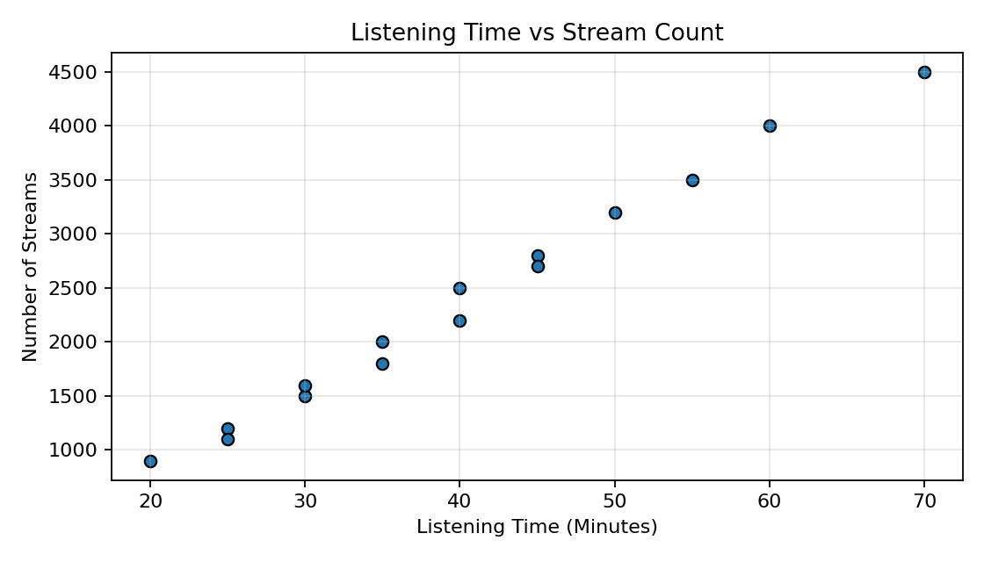

7. Procedure / Python Workflow
- Import pandas, NumPy, Matplotlib, and Seaborn.
- Create the sample Music Streaming DataFrame.
- Inspect rows, columns, data types, missing values, duplicates, and descriptive statistics.
- Calculate mean, median, mode, standard deviation, variance, range, and IQR.
- Generate the correlation matrix.
- Create a histogram, boxplot, heatmap, and scatter plot.

8. Screenshots Provided
The following pages are included from the screenshots PDF supplied with the request. They show a Music Streaming data-preparation workflow (including missing-value checks and duplicate checks). They are retained as supporting reference screenshots; the EDA charts above correspond to the sample dataset used in this Experiment 3 report.
Supporting screenshot page 1
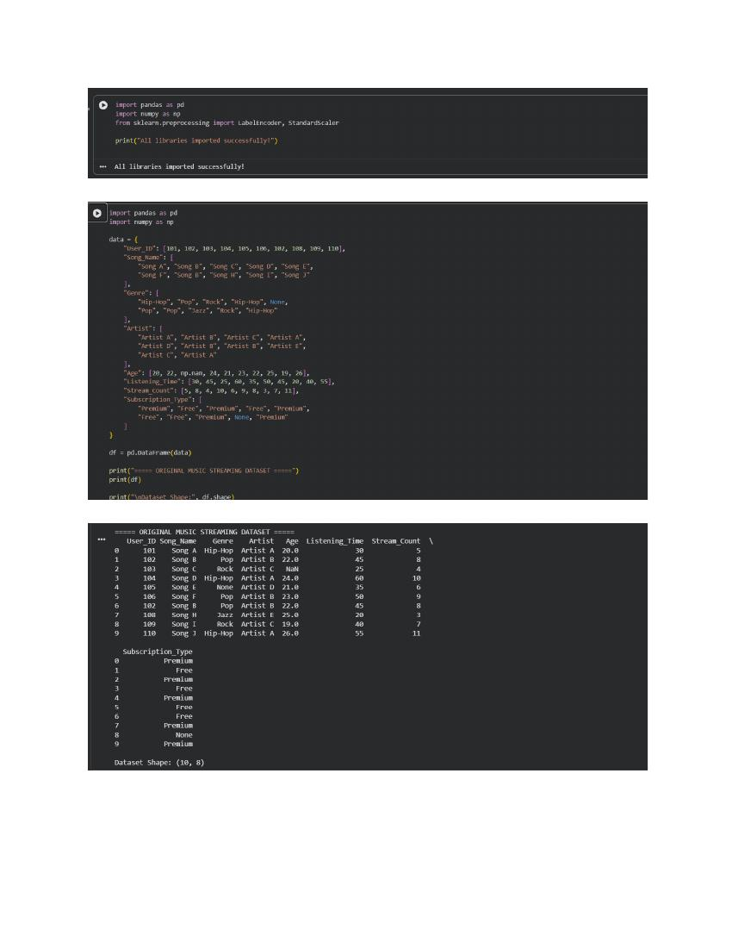
Supporting screenshot page 2
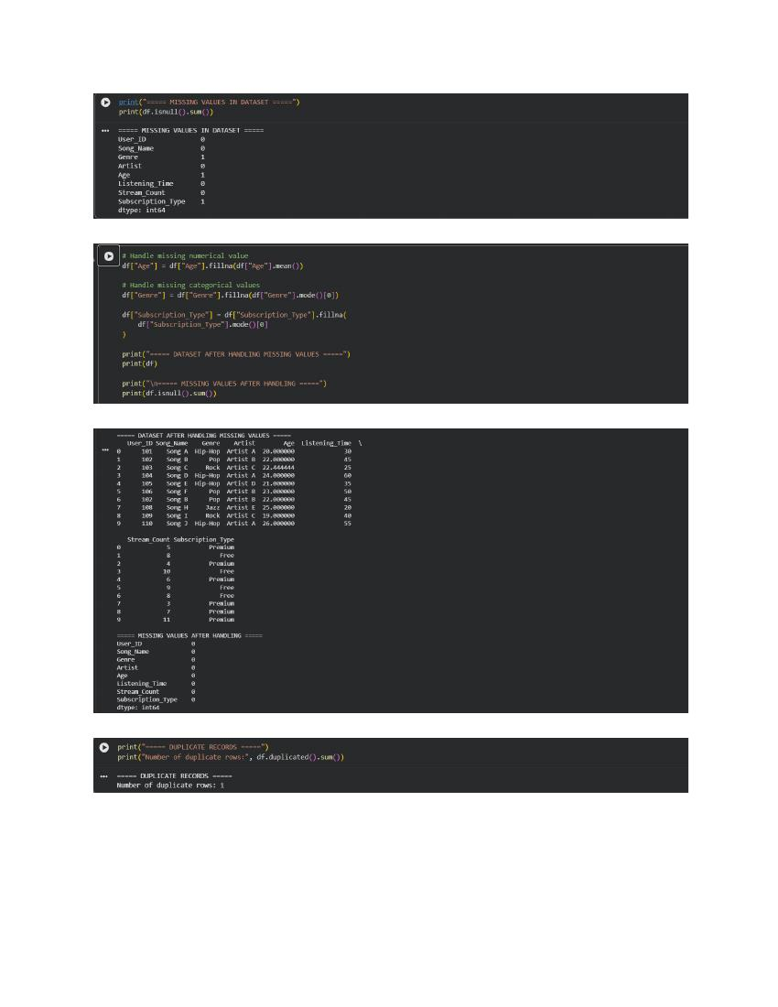
Supporting screenshot page 3
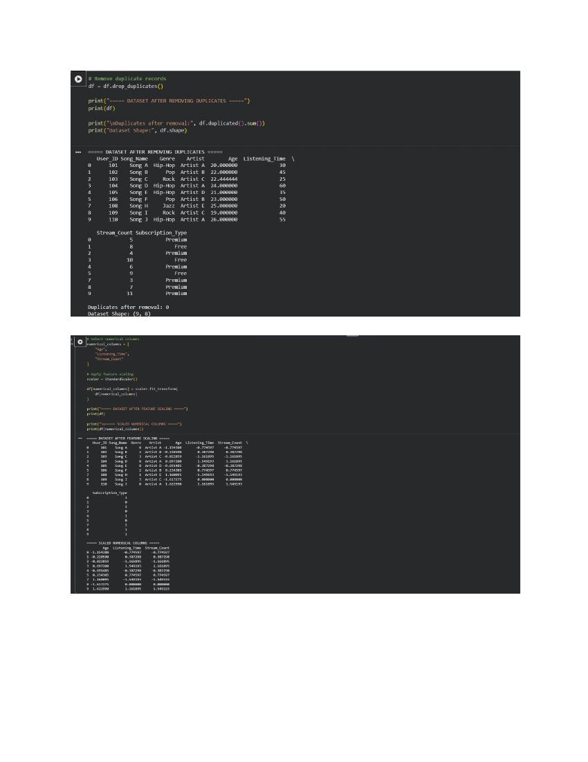
Supporting screenshot page 4
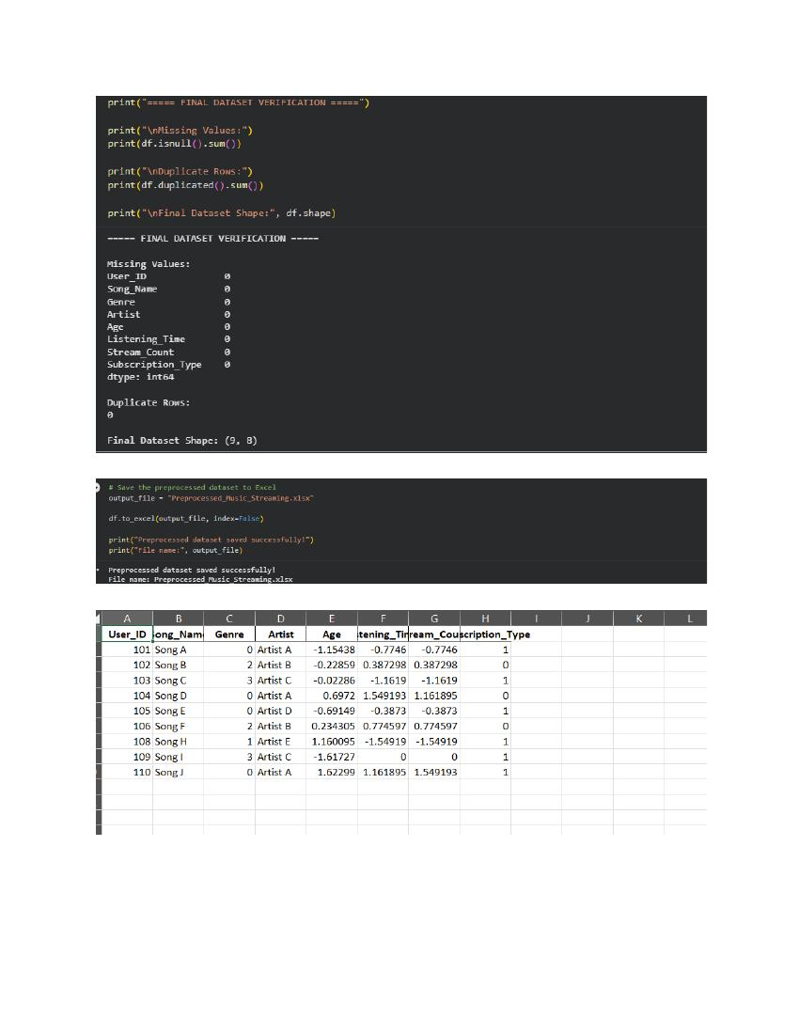

9. Result
Exploratory Data Analysis was performed on the Music Streaming sample dataset. Statistical summaries, dispersion measures, correlation analysis, and four visualizations were generated to inspect listening time, stream count, and user ratings.

10. Conclusion
The experiment demonstrated how EDA helps summarize and visualize music streaming data. Mean, median, and mode described typical values, while standard deviation, variance, range, and IQR measured spread. Correlation analysis and visualizations helped inspect possible relationships and patterns. The dataset used is a small illustrative sample, so conclusions should not be generalized to real streaming services.

11. Reference
Reference practical format: Experiment 03 – Exploratory Data Analysis and Visualization (provided PDF). The topic, dataset attributes, and examples in this report have been adapted to the Music Streaming System.

