DMBI PRACTICAL
EXPERIMENT 2
TO PERFORM DATA PREPROCESSING USING PYTHON

Submitted By
Name: Sahil Setya
Roll No.: 48
Class: D15A

Experiment Topic: Music Streaming Dataset
Academic Practical Report

Experiment 2: To Perform Data Preprocessing Using Python

Aim
To perform data preprocessing on an Online Music Streaming dataset using Python by handling missing values, removing duplicate records, encoding categorical data, and scaling numerical features.

Objectives
- Load and display a Music Streaming dataset using Python.
- Identify and handle missing values.
- Detect and remove duplicate records.
- Convert categorical attributes into numerical form.
- Scale numerical features using StandardScaler.
- Verify and export the cleaned dataset for further analysis.

Software / Tools Required
- Python 3.x
- Google Colab
- Pandas
- NumPy
- Scikit-learn
- Excel-compatible spreadsheet software

Theory
Data preprocessing is the process of converting raw data into a clean, consistent, and suitable format for analysis or machine learning. A Music Streaming dataset may contain incomplete information, repeated records, text-based categories, and numerical features with different ranges. These issues can reduce the quality of analysis, so preprocessing is performed before further use.
The main preprocessing operations used in this experiment are:
- Missing-value handling: numerical missing values are filled with the column mean, while categorical missing values are filled with the most frequent category (mode).
- Duplicate removal: repeated rows are detected and removed using Pandas.
- Categorical encoding: LabelEncoder converts text categories such as Genre and Subscription_Type into numerical labels.
- Feature scaling: StandardScaler standardizes Age, Listening_Time, and Stream_Count so that their values are on a comparable scale.
- Final verification and export: the processed data is checked for missing values and duplicates, then saved as an Excel file.

Dataset Description
The sample dataset represents music-streaming activity. It contains 10 initial records and 8 columns: User_ID, Song_Name, Genre, Artist, Age, Listening_Time, Stream_Count, and Subscription_Type. The dataset intentionally includes missing values and one duplicate record so that preprocessing steps can be demonstrated.

Python Program
import pandas as pd
import numpy as np
from sklearn.preprocessing import LabelEncoder, StandardScaler

data = {
"User_ID": [101, 102, 103, 104, 105, 106, 102, 108, 109, 110],
"Song_Name": ["Song A", "Song B", "Song C", "Song D", "Song E",
"Song F", "Song B", "Song H", "Song I", "Song J"],
"Genre": ["Hip-Hop", "Pop", "Rock", "Hip-Hop", None,
"Pop", "Pop", "Jazz", "Rock", "Hip-Hop"],
"Artist": ["Artist A", "Artist B", "Artist C", "Artist A",
"Artist D", "Artist B", "Artist B", "Artist E",
"Artist C", "Artist A"],
"Age": [20, 22, np.nan, 24, 21, 23, 22, 25, 19, 26],
"Listening_Time": [30, 45, 25, 60, 35, 50, 45, 20, 40, 55],
"Stream_Count": [5, 8, 4, 10, 6, 9, 8, 3, 7, 11],
"Subscription_Type": ["Premium", "Free", "Premium", "Free", "Premium",
"Free", "Free", "Premium", None, "Premium"]
}

df = pd.DataFrame(data)

print("===== ORIGINAL MUSIC STREAMING DATASET =====")
print(df)
print("\nDataset Shape:", df.shape)

# Check missing values
print("\n===== MISSING VALUES IN DATASET =====")
print(df.isnull().sum())

# Handle missing values
df["Age"] = df["Age"].fillna(df["Age"].mean())
df["Genre"] = df["Genre"].fillna(df["Genre"].mode()[0])
df["Subscription_Type"] = df["Subscription_Type"].fillna(
df["Subscription_Type"].mode()[0]
)

print("\n===== DATASET AFTER HANDLING MISSING VALUES =====")
print(df)
print("\n===== MISSING VALUES AFTER HANDLING =====")
print(df.isnull().sum())

# Check and remove duplicates
print("\n===== DUPLICATE RECORDS =====")
print("Number of duplicate rows:", df.duplicated().sum())

df = df.drop_duplicates()
print("\n===== DATASET AFTER REMOVING DUPLICATES =====")
print(df)
print("Duplicates after removal:", df.duplicated().sum())
print("Dataset Shape:", df.shape)

# Encode categorical columns
genre_encoder = LabelEncoder()
df["Genre"] = genre_encoder.fit_transform(df["Genre"])

subscription_encoder = LabelEncoder()
df["Subscription_Type"] = subscription_encoder.fit_transform(
df["Subscription_Type"]
)

print("\n===== ENCODED DATASET =====")
print(df)
print("Genre Encoding:", dict(zip(genre_encoder.classes_,
genre_encoder.transform(genre_encoder.classes_))))
print("Subscription Type Encoding:", dict(zip(
subscription_encoder.classes_,
subscription_encoder.transform(subscription_encoder.classes_)
)))

# Feature scaling
numerical_columns = ["Age", "Listening_Time", "Stream_Count"]
scaler = StandardScaler()
df[numerical_columns] = scaler.fit_transform(df[numerical_columns])

print("\n===== DATASET AFTER FEATURE SCALING =====")
print(df)
print("\n===== SCALED NUMERICAL COLUMNS =====")
print(df[numerical_columns])

# Final verification
print("\n===== FINAL DATASET VERIFICATION =====")
print("\nMissing Values:")
print(df.isnull().sum())
print("\nDuplicate Rows:")
print(df.duplicated().sum())
print("\nFinal Dataset Shape:", df.shape)

# Save preprocessed dataset
output_file = "Preprocessed_Music_Streaming.xlsx"
df.to_excel(output_file, index=False)
print("Preprocessed dataset saved successfully!")
print("File name:", output_file)

Expected Output and Screenshots
The following screenshots show the executed Google Colab cells and output for each stage of the experiment. The screenshots have been retained from the supplied PDF.
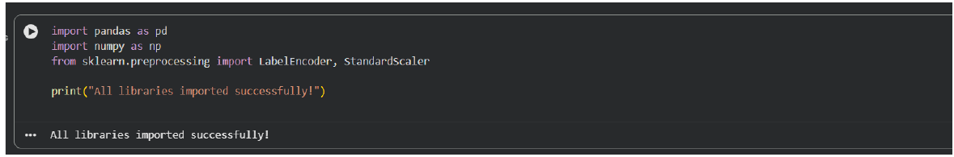
Figure 1: Importing the required Python libraries.

Figure 2: Creating and displaying the original Music Streaming dataset.

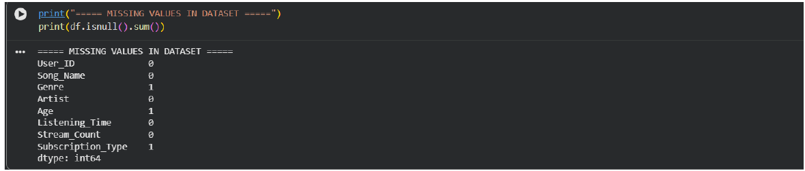
Figure 3: Identifying missing values in the dataset.
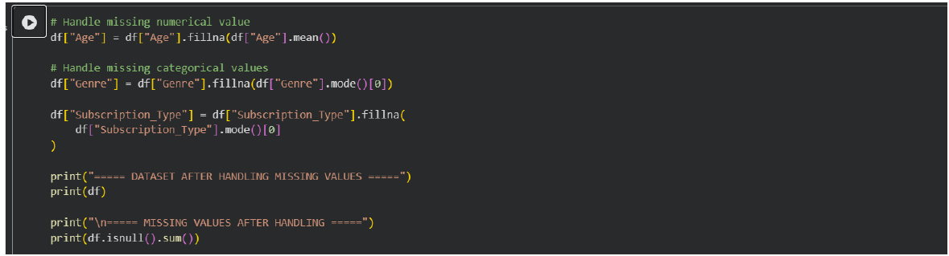
Figure 4: Handling missing values and verifying that no missing values remain.

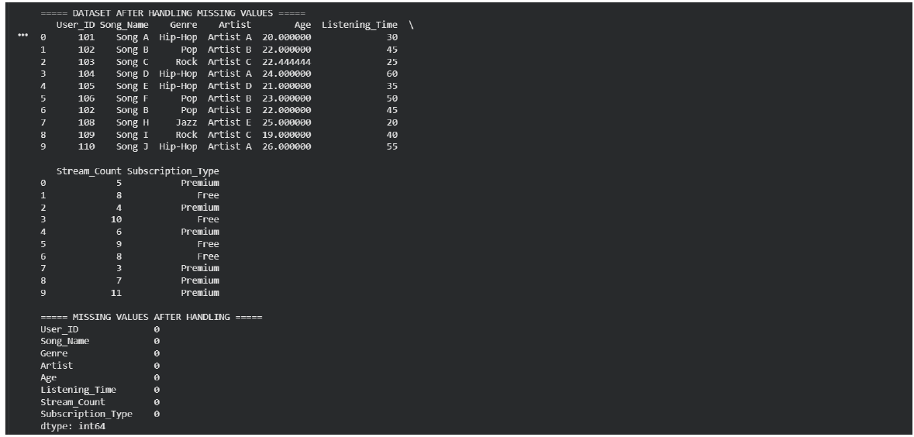
Figure 5: Checking duplicate records in the dataset.
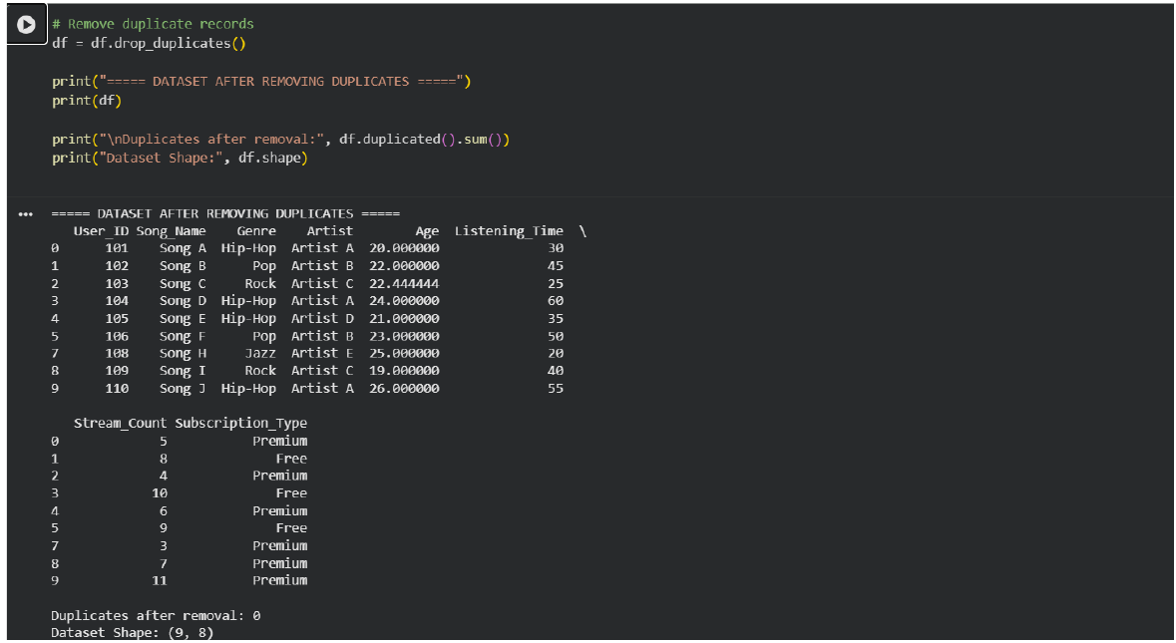
Figure 6: Removing duplicate records; the dataset is reduced to 9 rows.

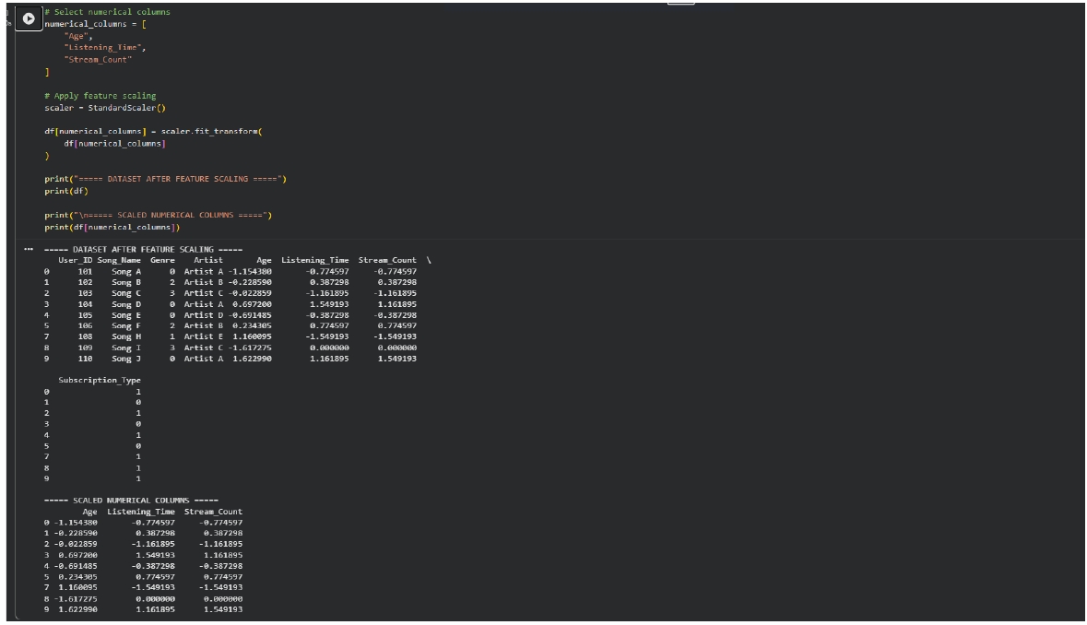
Figure 7: Applying StandardScaler to numerical features.
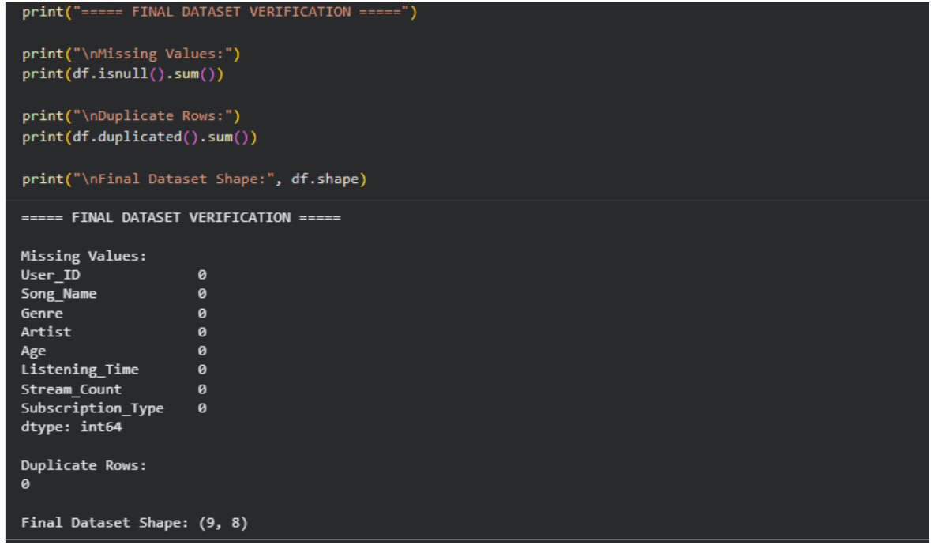
Figure 8: Final verification of missing values, duplicate rows, and dataset shape.

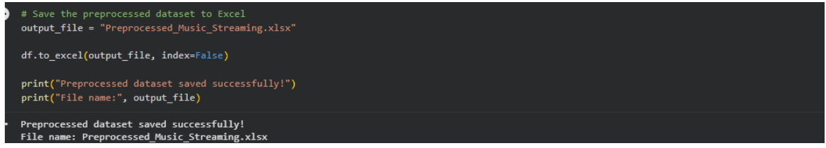
Figure 9: Saving the preprocessed dataset as an Excel file.
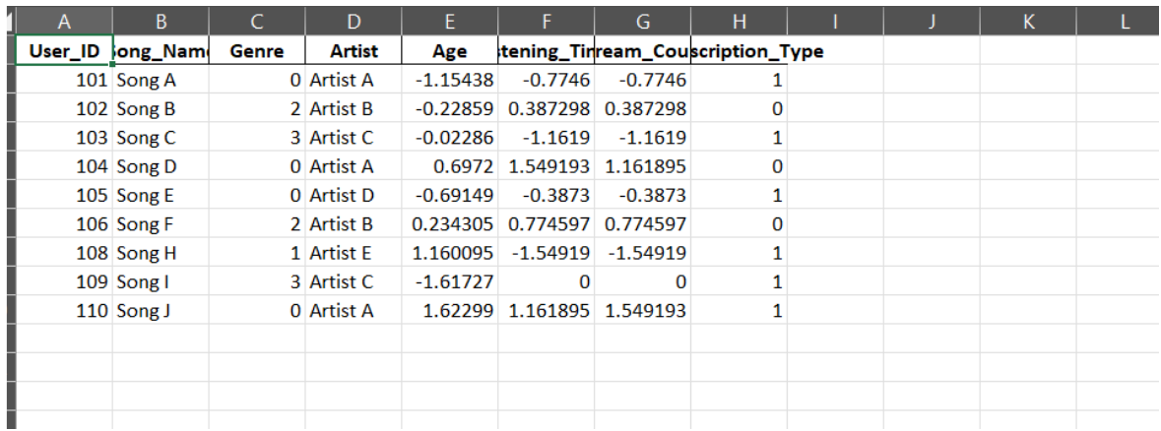
Figure 10: The final preprocessed dataset opened in a spreadsheet.

Conclusion
The Music Streaming dataset was successfully preprocessed using Python. Missing values were handled using the mean and mode, duplicate records were removed, categorical attributes were encoded into numerical values, and numerical features were standardized using StandardScaler. The final dataset contains 9 rows and 8 columns, with zero missing values and zero duplicate rows. The cleaned dataset was exported to Preprocessed_Music_Streaming.xlsx and is ready for further analysis.

Result
Thus, data preprocessing was successfully performed on the Online Music Streaming dataset using Pandas, NumPy, LabelEncoder, and StandardScaler. The processed dataset was verified and saved in Excel format.

