DMBI PRACTICAL
EXPERIMENT 05
Classification using Python (Decision Tree & Naïve Bayes) - Inbuilt vs. User-Defined Functions

Name: Sahil Setya
Class: D15A
Roll No.: 48
Subject: DMBI

1. Aim
To perform classification on the Music Streaming Subscriber Churn dataset using Python, implementing the Decision Tree and Naïve Bayes classifiers with inbuilt (direct library) calls and with user-defined functions, and to compare their performance.

2. Theory
Classification is a supervised learning technique in which a model learns from labelled training data and predicts the class of unseen records. Here the target is churn_status, which is either Retained or Churned.

Dataset Overview
The Music_Streaming_Subscriber_Churn dataset has 500 records and 10 columns: user_id, age, subscription_plan, listening_hours_per_week, monthly_logins, favorite_genre, device, country, tenure_months and churn_status. The dataset has no missing values. The data is illustrative and is not actual data from a streaming platform.

Decision Tree
A Decision Tree splits the data repeatedly on attribute tests chosen by a criterion such as Gini index or entropy (information gain). Leaf nodes give the predicted class, and limiting the maximum depth reduces overfitting.

Naïve Bayes
Naïve Bayes applies Bayes' theorem with the assumption that features are conditionally independent given the class. GaussianNB, used here, models each continuous feature with a normal distribution per class.

Inbuilt vs. User-Defined Functions
- Inbuilt: the scikit-learn classes (DecisionTreeClassifier, GaussianNB) are created, trained and evaluated directly in the script.
- User-defined: the same steps (create model, train, predict, display results) are packaged inside a function written by the user, which takes the train and test data and returns the trained model.

3. Procedure / Python Workflow
- Import pandas and NumPy, load the CSV file and inspect the first rows, shape, column names and missing values.
- Encode the categorical columns (subscription_plan, favorite_genre, device, country) and the target churn_status using LabelEncoder.
- Drop user_id and churn_status to form the features X, and use churn_status as the target y.
- Split the data 80:20 with train_test_split (random_state=42, stratified) and standardize the features with StandardScaler.
- Build the inbuilt Decision Tree (gini, max_depth=5) and evaluate it using accuracy, classification report and confusion matrix.
- Build the user-defined Decision Tree function (entropy, max_depth=5) and evaluate it in the same way.
- Build the inbuilt Naïve Bayes (GaussianNB) classifier and evaluate it.
- Build the user-defined Naïve Bayes function and evaluate it.
- Compare the accuracy of all four classifiers and identify the best one.

4. Code, Output and Observations

4.1 Loading and Inspecting the Dataset
The dataset is loaded with pandas, and the first rows, shape, column names and missing values are displayed.
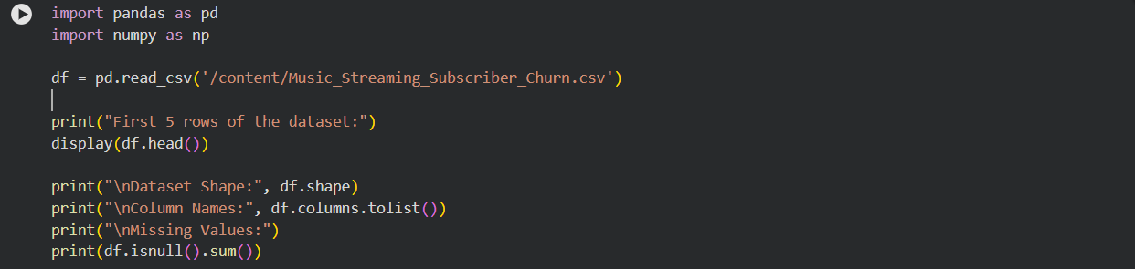

4.2 Dataset Output
The dataset has 500 rows and 10 columns, and there are no missing values in any column.
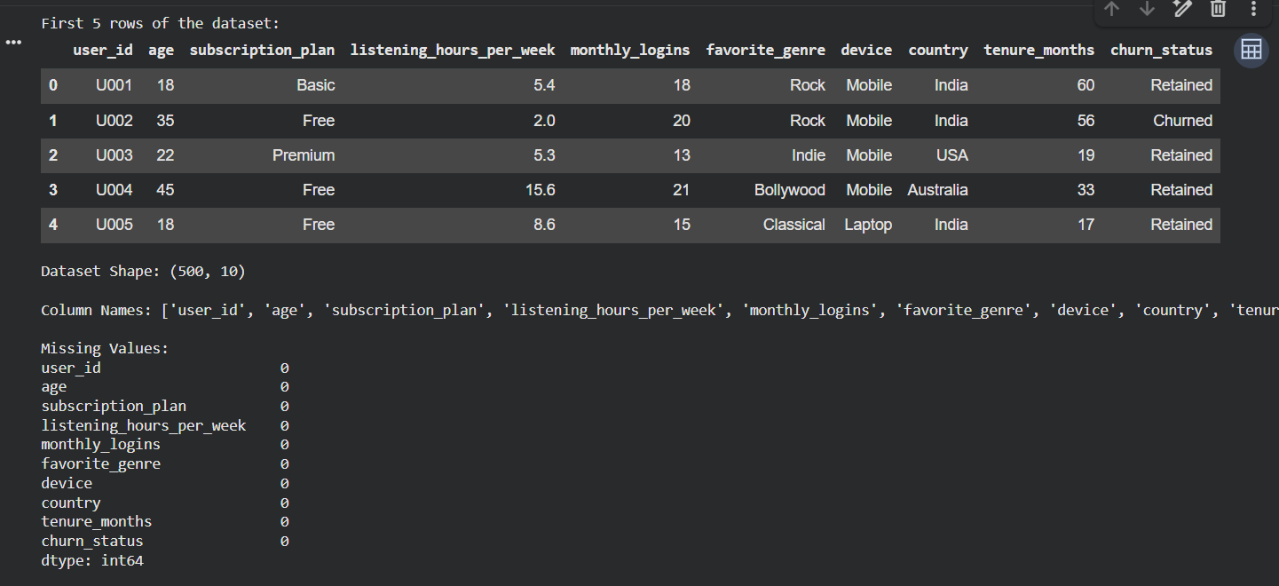

4.3 Data Preprocessing
Categorical columns are label-encoded, the data is split 80:20 and the features are standardized.
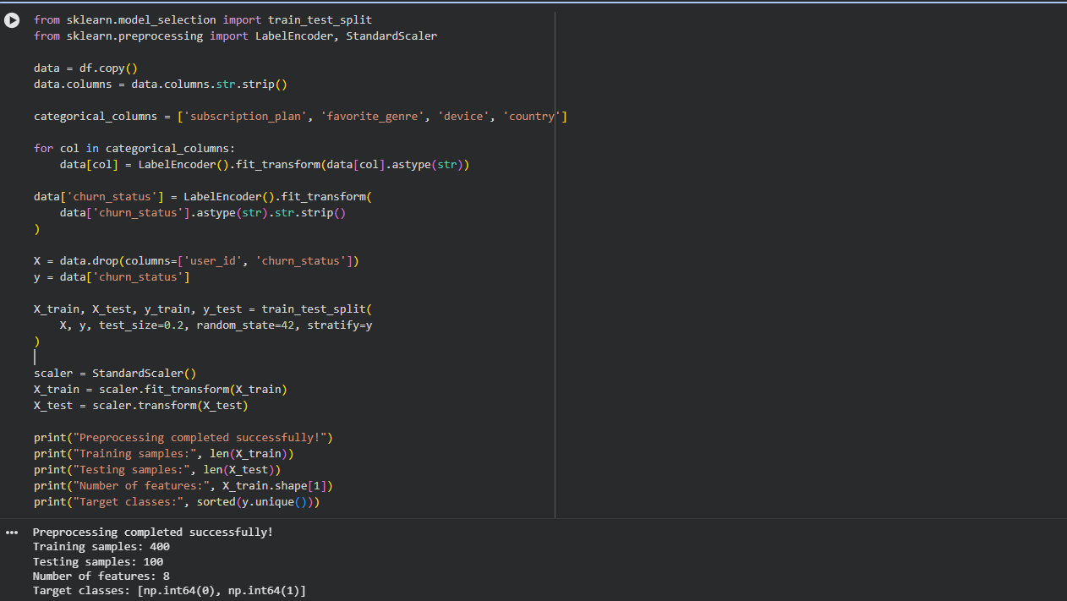
Output: 400 training samples, 100 testing samples, 8 features, and target classes 0 and 1.

4.4 Inbuilt Decision Tree: Code
DecisionTreeClassifier with criterion gini and max_depth 5, trained and evaluated directly.
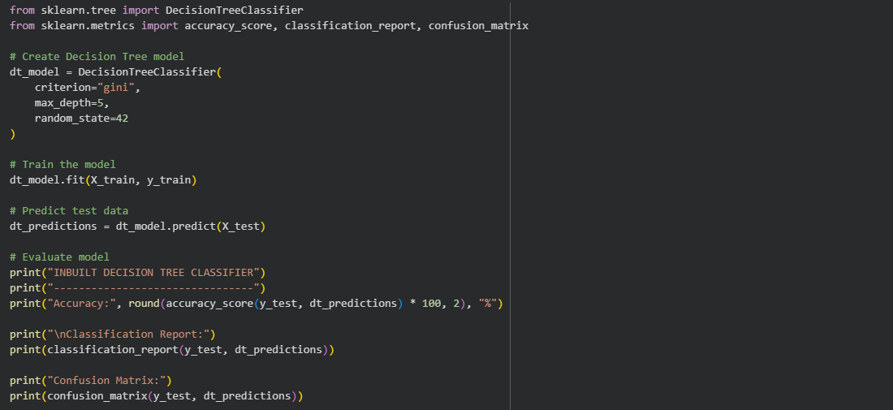

4.5 Inbuilt Decision Tree: Output
The inbuilt Decision Tree achieved an accuracy of 63.0%.
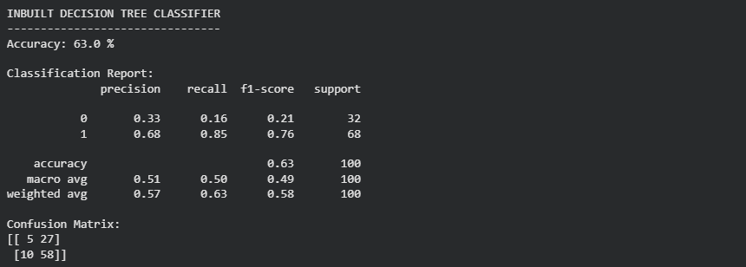

4.6 User-Defined Decision Tree: Code
The decision_tree_classifier function uses criterion entropy and max_depth 5, and returns the trained model.
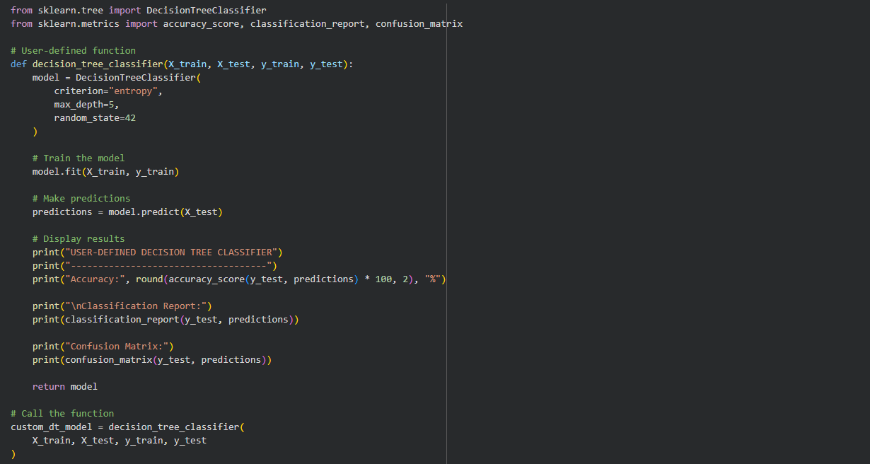

4.7 User-Defined Decision Tree: Output
The user-defined Decision Tree achieved an accuracy of 69.0%.
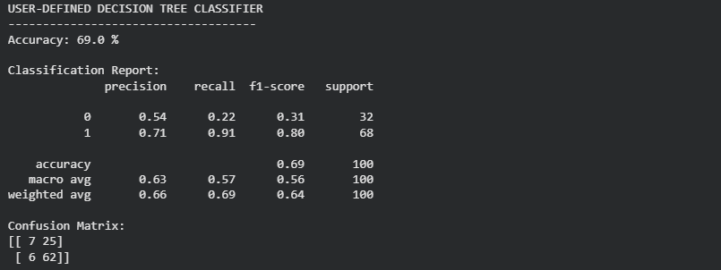

4.8 Inbuilt Naïve Bayes: Code
GaussianNB trained and evaluated directly.
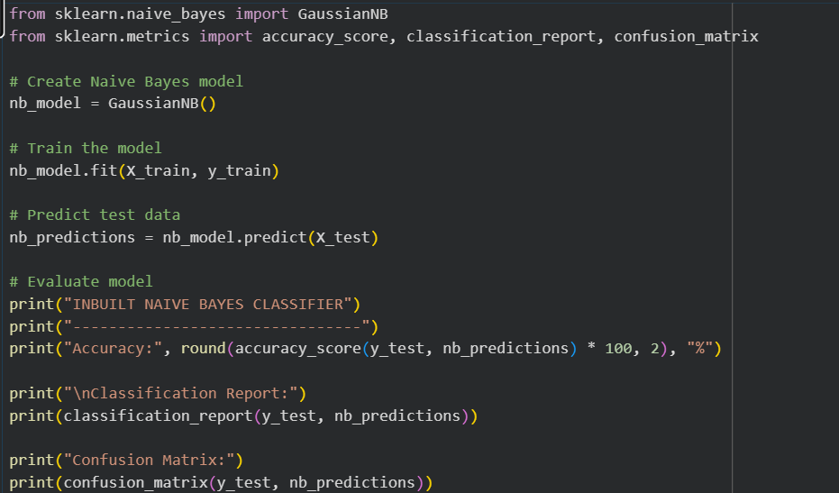

4.9 Inbuilt Naïve Bayes: Output
The inbuilt Naïve Bayes classifier achieved an accuracy of 69.0%.
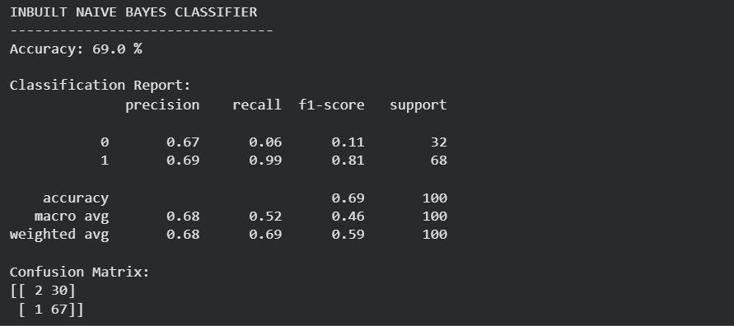

4.10 User-Defined Naïve Bayes: Code
The naive_bayes_classifier function creates, trains and evaluates GaussianNB and returns the model.
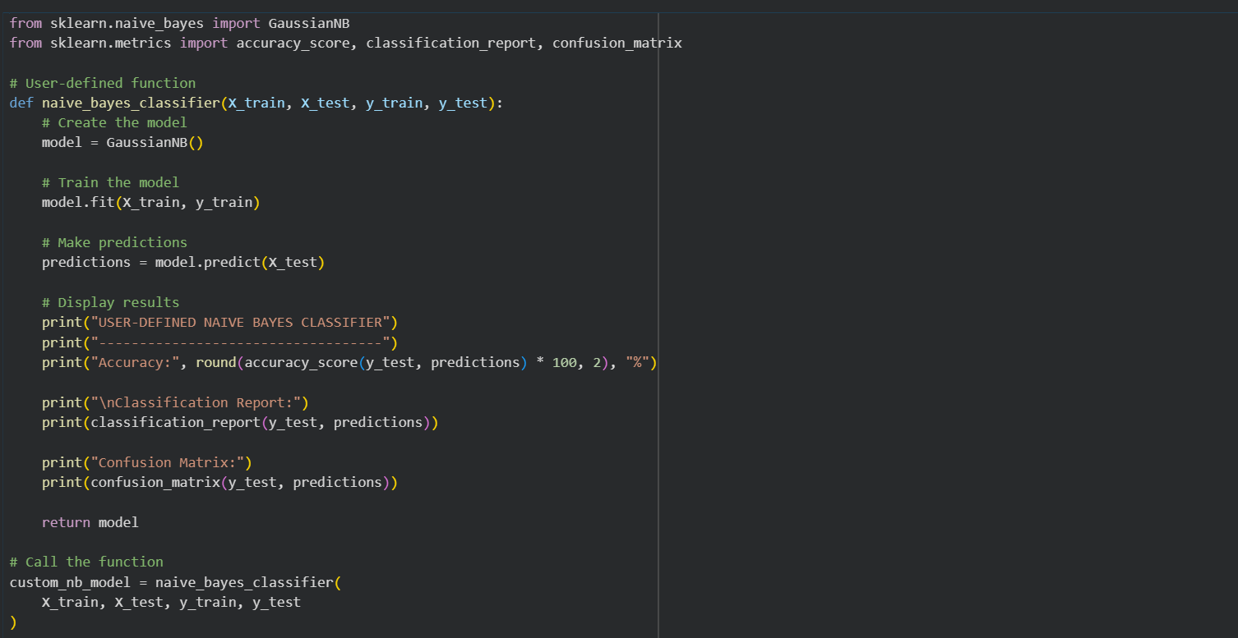

4.11 User-Defined Naïve Bayes: Output
The user-defined Naïve Bayes classifier achieved an accuracy of 69.0%.
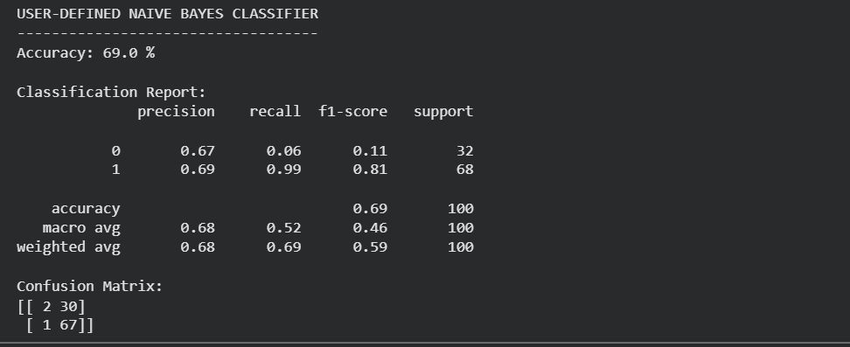

4.12 Classifier Comparison: Code
The accuracies of all four classifiers are collected in a DataFrame and the best classifier is selected.
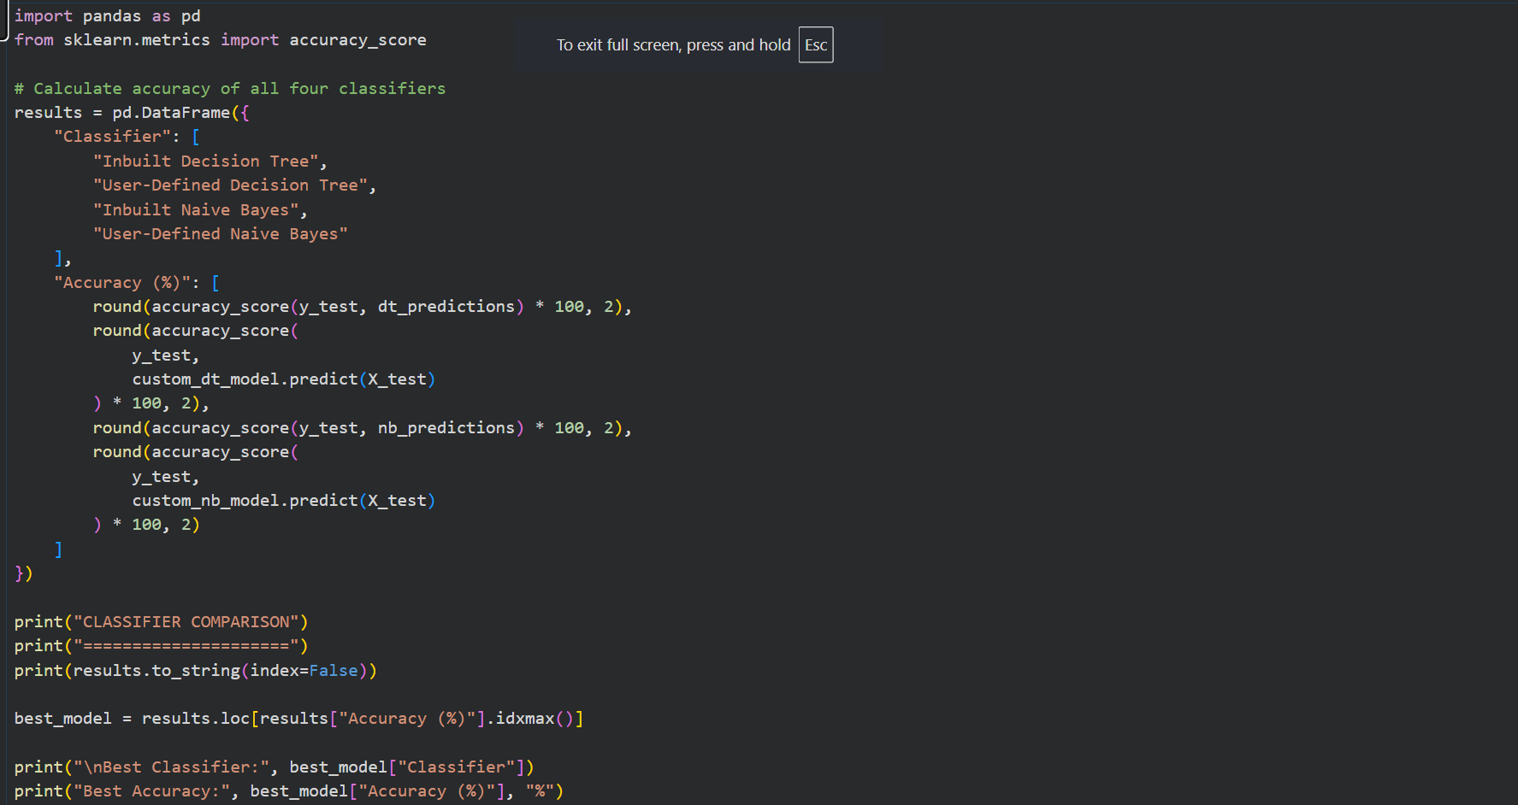

4.13 Classifier Comparison: Output
The user-defined Decision Tree is reported as the best classifier with an accuracy of 69.0%. The user-defined and inbuilt Naïve Bayes classifiers have the same accuracy, so the first model with the maximum accuracy is shown.
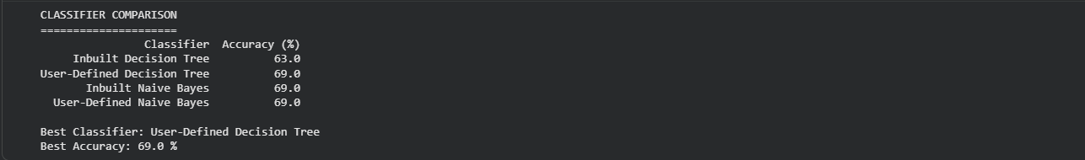

5. Results Comparison
Class 0 is Churned and class 1 is Retained (LabelEncoder assigns labels alphabetically). The test set has 100 records: 32 Churned and 68 Retained.
Classifier | Accuracy (%)
Inbuilt Decision Tree | 63.0
User-Defined Decision Tree | 69.0
Inbuilt Naïve Bayes | 69.0
User-Defined Naïve Bayes | 69.0

Classifier | Class | Precision | Recall | F1-score | Confusion Matrix
Inbuilt Decision Tree | 0 (Churned) | 0.33 | 0.16 | 0.21 | [[5, 27], [10, 58]]
 | 1 (Retained) | 0.68 | 0.85 | 0.76
User-Defined Decision Tree | 0 (Churned) | 0.54 | 0.22 | 0.31 | [[7, 25], [6, 62]]
 | 1 (Retained) | 0.71 | 0.91 | 0.80
Inbuilt Naïve Bayes | 0 (Churned) | 0.67 | 0.06 | 0.11 | [[2, 30], [1, 67]]
 | 1 (Retained) | 0.69 | 0.99 | 0.81
User-Defined Naïve Bayes | 0 (Churned) | 0.67 | 0.06 | 0.11 | [[2, 30], [1, 67]]
 | 1 (Retained) | 0.69 | 0.99 | 0.81

Interpretation
- The inbuilt and user-defined Naïve Bayes classifiers give identical results, because the user-defined function runs the same GaussianNB algorithm on the same data.
- The two Decision Trees differ (63.0% vs 69.0%) because they use different splitting criteria: gini for the inbuilt version and entropy for the user-defined version. A user-defined function does not change the accuracy by itself.
- All models predict the Retained class far better than the Churned class (churn recall is only 0.06 to 0.22), because the Retained class is about twice as large as the Churned class. Accuracy alone is therefore misleading.

6. Result
Decision Tree and Naïve Bayes classifiers were implemented in Python on the Music Streaming Subscriber Churn dataset with an 80:20 train-test split. The accuracies obtained were 63.0% (inbuilt Decision Tree), 69.0% (user-defined Decision Tree), 69.0% (inbuilt Naïve Bayes) and 69.0% (user-defined Naïve Bayes).

7. Conclusion
The experiment showed how classification models can be built with inbuilt library functions and wrapped in user-defined functions for reuse. Naïve Bayes gave the same result both ways, and the Decision Tree result depended on the chosen criterion rather than on the function style. All models were weak at detecting churned users because of class imbalance. The dataset is a small illustrative sample, so the conclusions should not be generalized to real streaming services.

8. Reference
Reference practical format: Experiment 03 - Exploratory Data Analysis and Visualization. The topic, dataset and examples in this report have been adapted to classification on the Music Streaming Subscriber Churn dataset using Python (scikit-learn).

