DMBI PRACTICAL
EXPERIMENT 06
Implementation of K-Means Clustering Using Python

Name: Sahil Setya
Class: D15A
Roll No.: 48
Subject: DMBI

1. Aim
To implement K-Means clustering in Python on the Music Streaming Subscriber Churn dataset, choose the number of clusters using the Elbow Method, and evaluate and interpret the resulting clusters.

2. Theory
Clustering is an unsupervised learning technique that groups similar records together without using a class label. K-Means partitions the data into K clusters by repeatedly assigning each record to its nearest centroid and then recomputing each centroid as the mean of its cluster, until the assignments stop changing.

Dataset Overview
The Music_Streaming_Subscriber_Churn dataset has 500 records and 10 columns: user_id, age, subscription_plan, listening_hours_per_week, monthly_logins, favorite_genre, device, country, tenure_months and churn_status. Four numerical features (age, listening_hours_per_week, monthly_logins and tenure_months) are used for clustering. The data is illustrative and is not actual data from a streaming platform.

Elbow Method
K-Means is run for a range of K values and the inertia (sum of squared distances of records to their cluster centroid) is plotted against K. The point where the curve starts to flatten suggests a suitable number of clusters.

Evaluation Metrics
- Inertia: total within-cluster squared distance; lower means tighter clusters.
- Silhouette Score: ranges from -1 to +1; higher means better separated clusters.
- Davies-Bouldin Index: average similarity between clusters; lower is better.

3. Procedure / Python Workflow
- Import pandas, NumPy, Matplotlib, Seaborn, StandardScaler, KMeans, silhouette_score and davies_bouldin_score.
- Load the dataset and inspect its shape, first rows and column names.
- Select the numerical features, check for missing values, fill any with the median, and standardize them with StandardScaler.
- Run K-Means for K = 1 to 10, record the inertia and plot the Elbow graph.
- Apply K-Means with the chosen K = 3 (random_state=42, n_init=10) and add the cluster labels to the dataset.
- Calculate the Silhouette Score, inertia and Davies-Bouldin Index.
- Visualize the clusters with a scatter plot of two standardized features.
- Analyze each cluster using feature means and the number of users, and plot the cluster sizes.

4. Code, Output and Observations

4.1 Importing Libraries
The required libraries are imported.
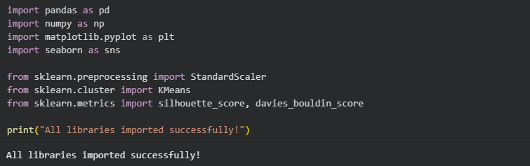

4.2 Loading the Dataset
The dataset loads successfully with 500 rows and 10 columns.
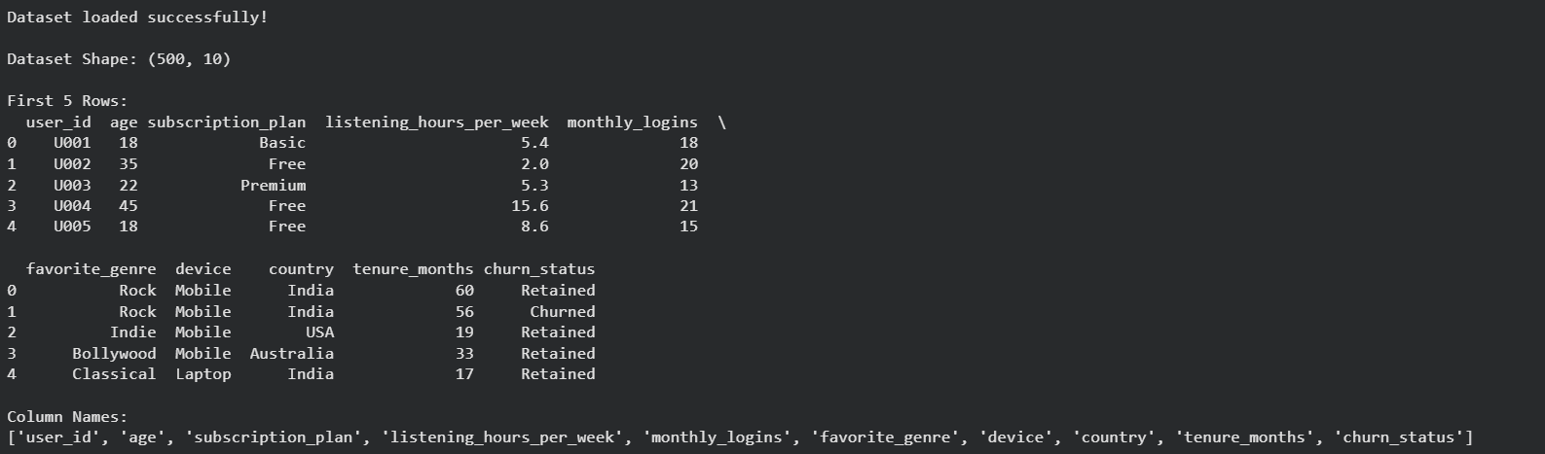

4.3 Feature Selection and Preprocessing
Four numerical features are selected, missing values are checked and the features are standardized.
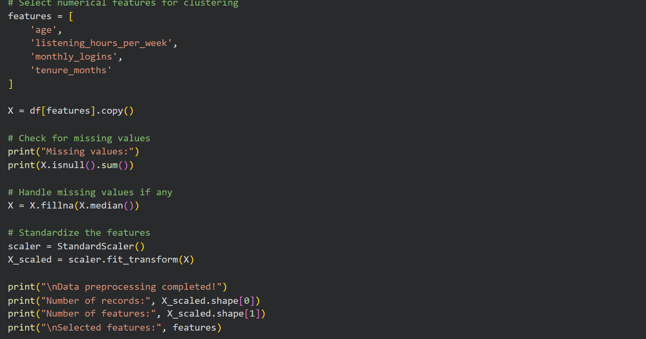

4.4 Preprocessing Output
There are no missing values. All 500 records and the 4 selected features are retained.
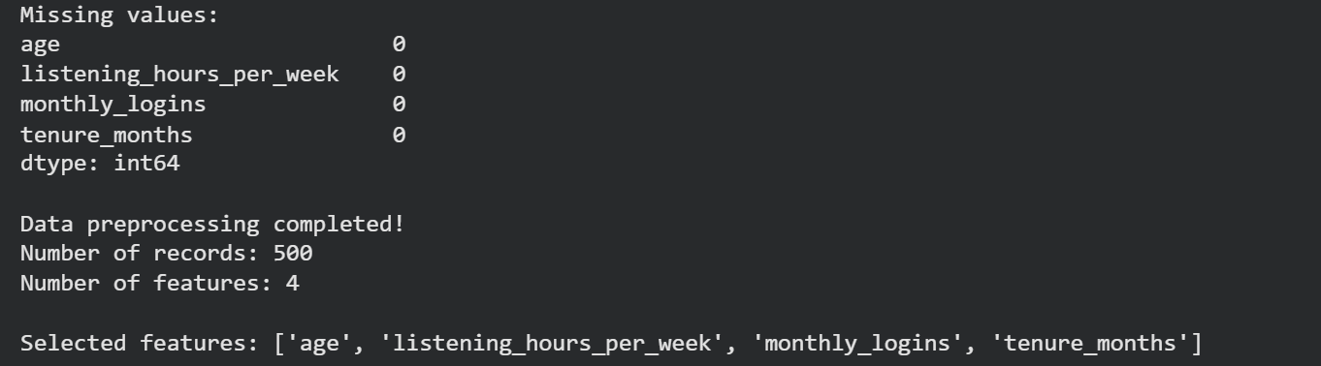

4.5 Elbow Method: Code
Inertia is calculated for K = 1 to 10 and plotted.
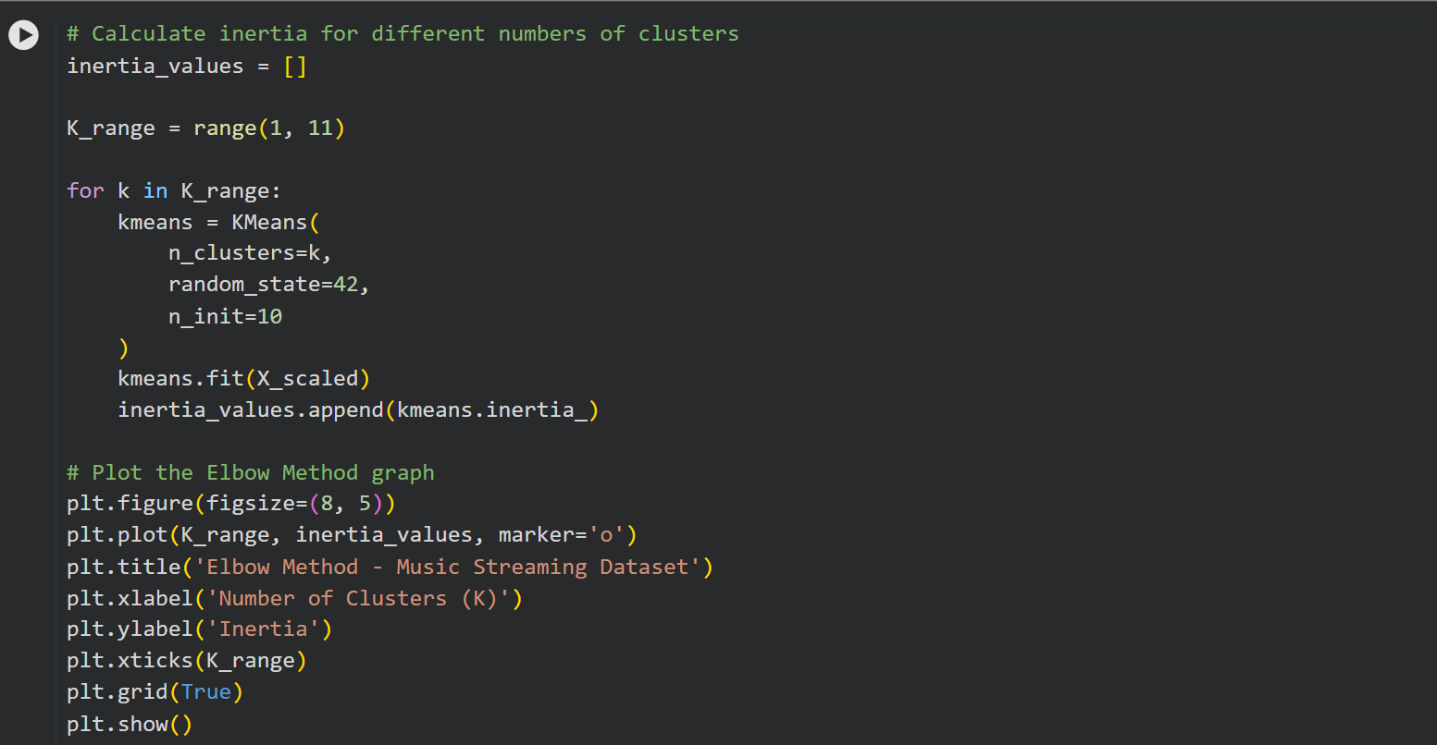

4.6 Elbow Method: Graph
The inertia falls steadily as K increases and the curve bends gradually rather than sharply. K = 3 is chosen for the clustering.
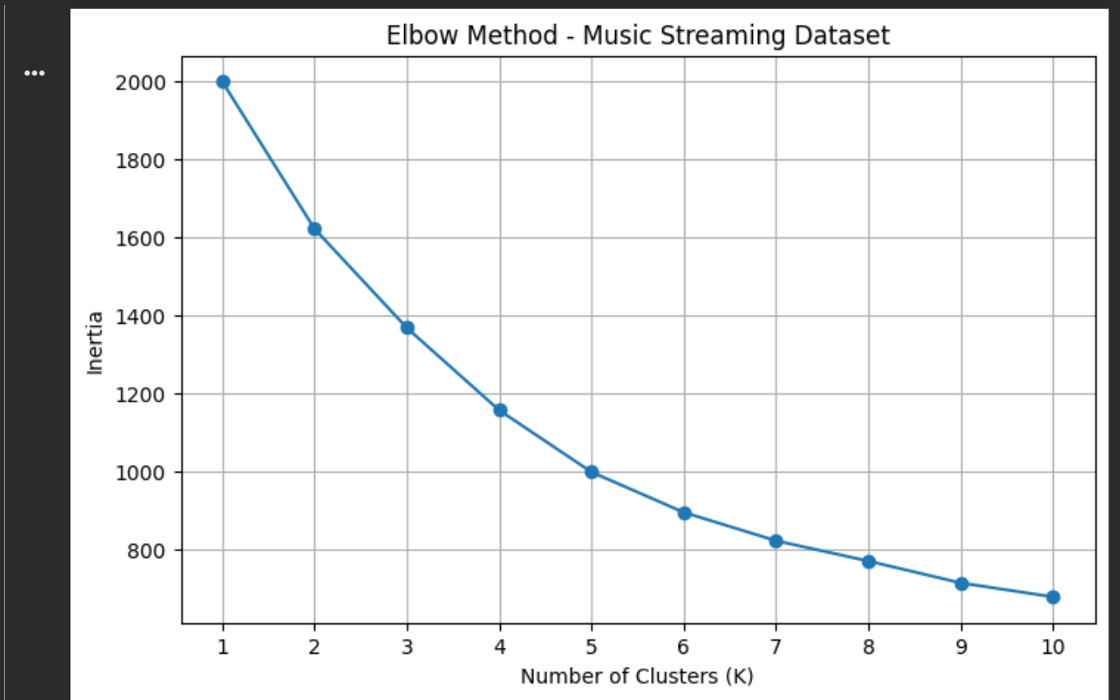

4.7 Applying K-Means (K = 3): Code
K-Means is fitted with 3 clusters and the cluster labels are added to the dataset.
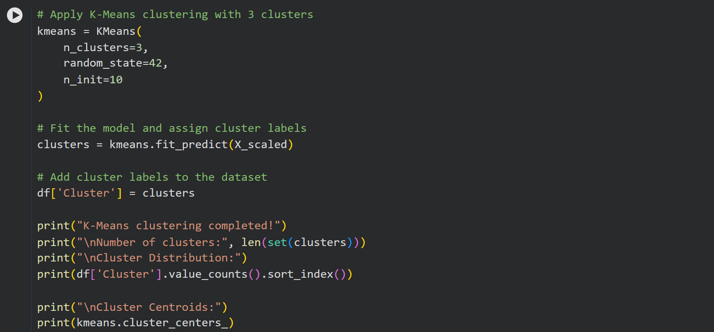

4.8 K-Means Output
The three clusters contain 212, 181 and 107 users, and the standardized centroids are displayed.
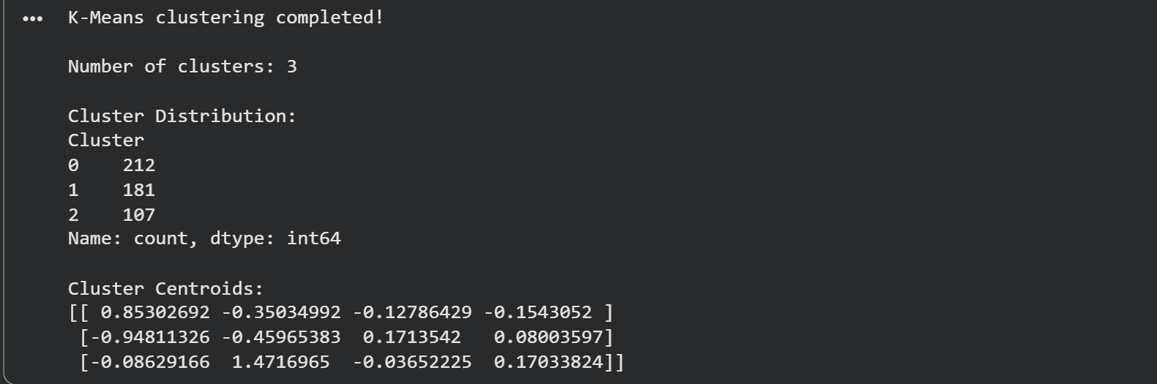

4.9 Clustering Evaluation
The Silhouette Score, inertia and Davies-Bouldin Index are calculated.
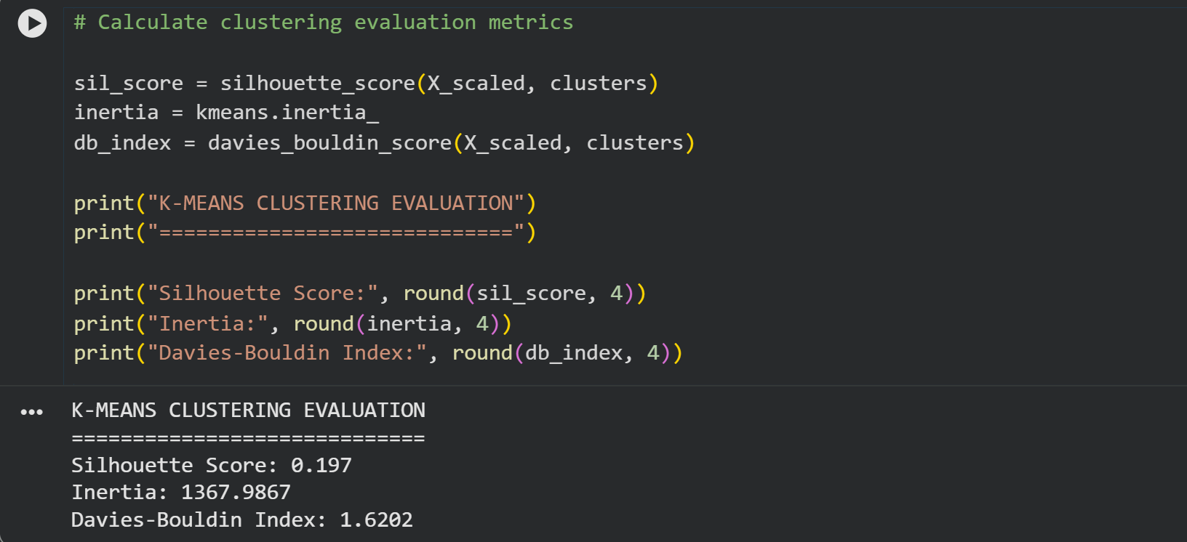

4.10 Cluster Visualization: Code
A scatter plot of standardized listening hours per week against standardized monthly logins, coloured by cluster.
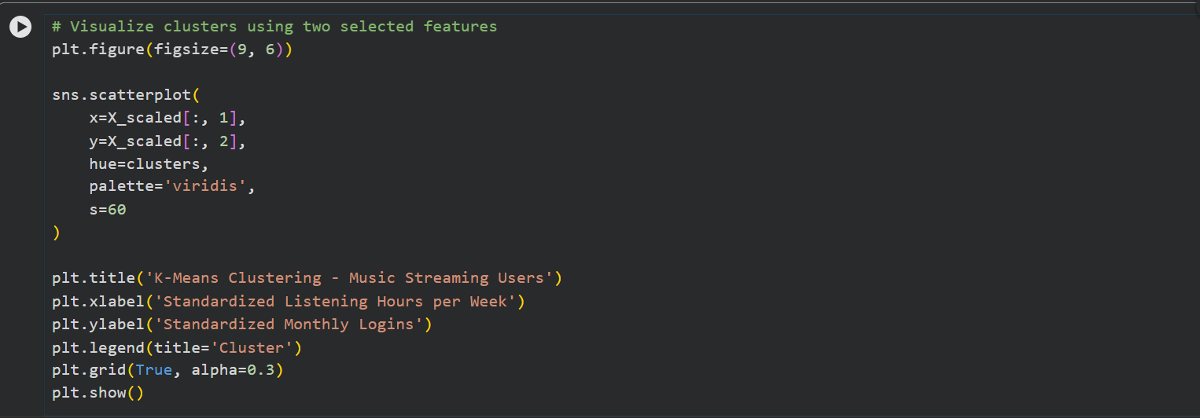

4.11 Cluster Visualization: Plot
Cluster 2 (yellow) lies mostly at higher listening hours, while clusters 0 and 1 overlap considerably in this two-feature view.
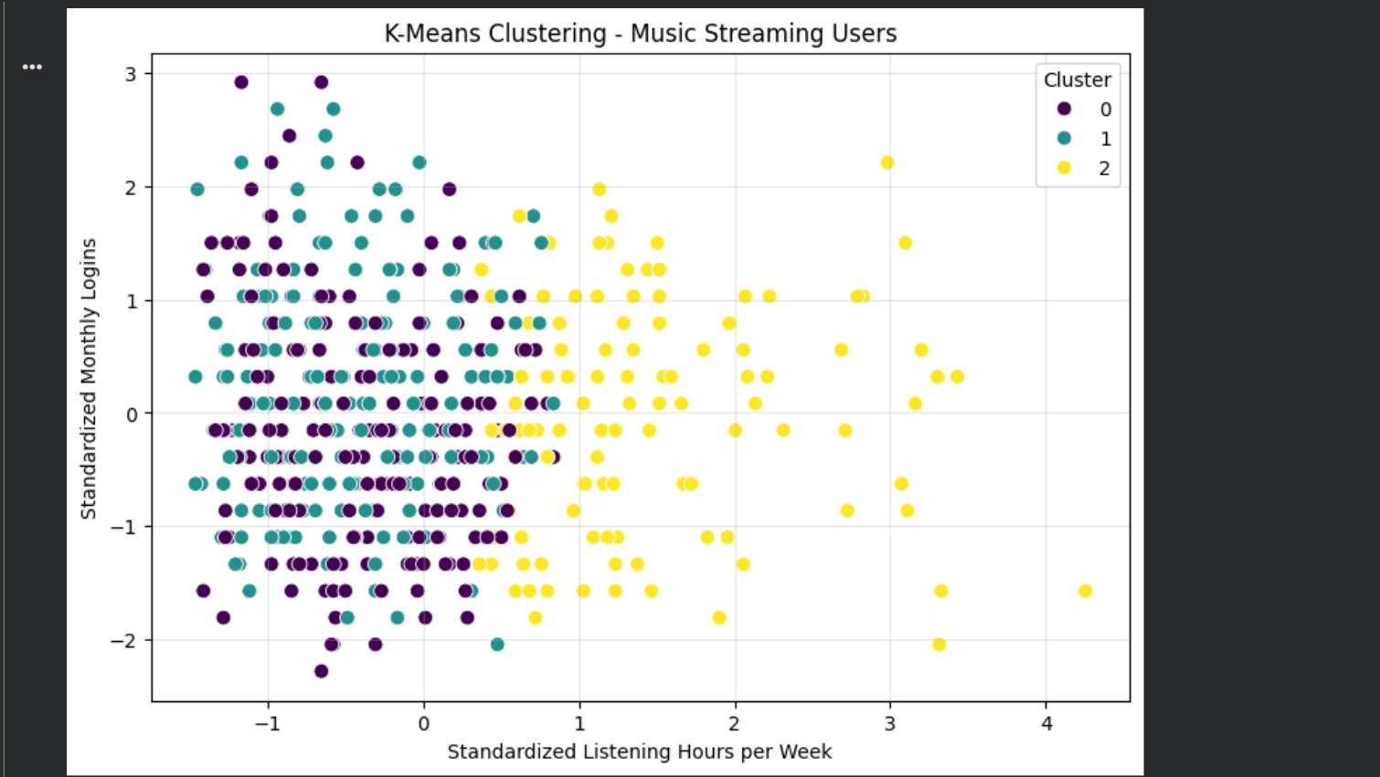

4.12 Cluster-wise Analysis: Code
The mean of each feature and the number of users are calculated for every cluster, and the cluster sizes are plotted.
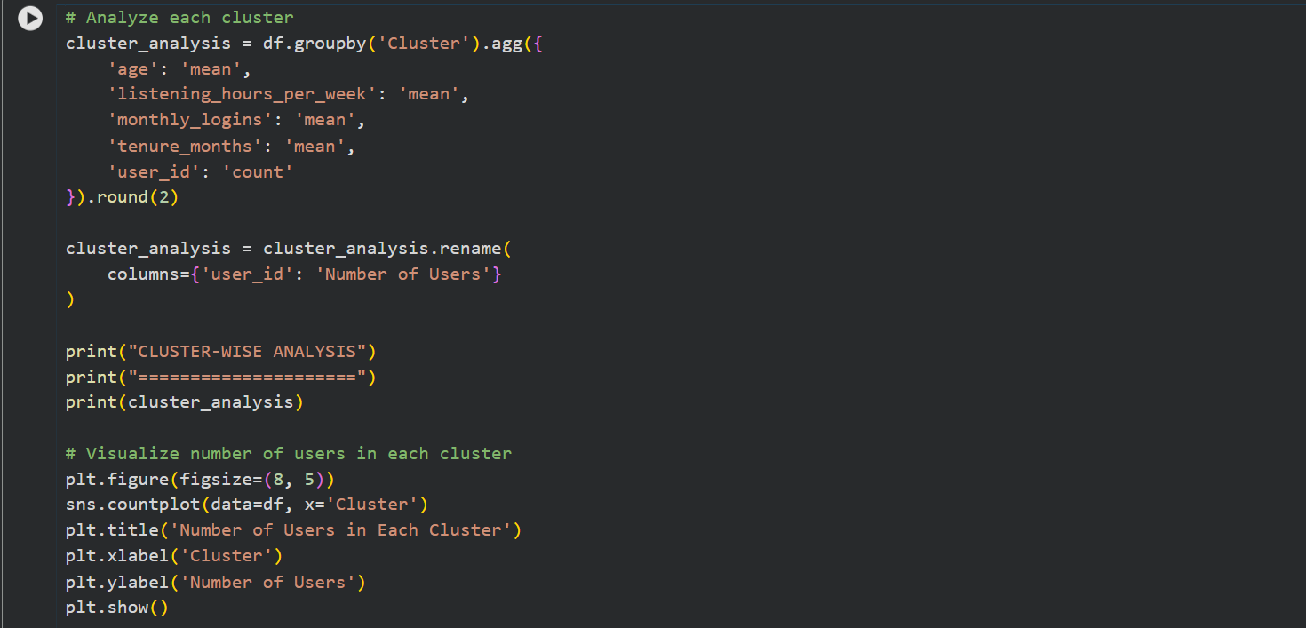

4.13 Cluster-wise Analysis: Output
Feature means and number of users for each cluster.
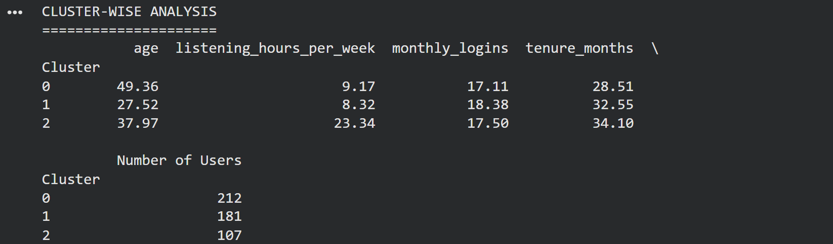

4.14 Number of Users in Each Cluster
Cluster 0 is the largest (212 users) and cluster 2 is the smallest (107 users).
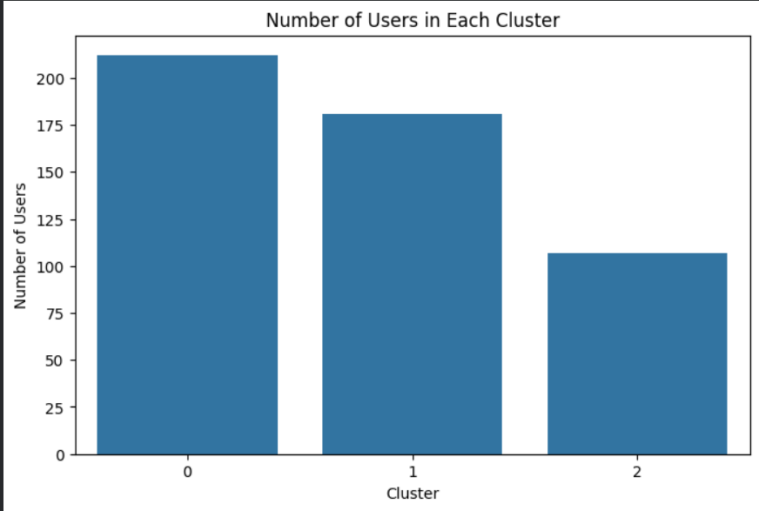

4.15 Final Evaluation Summary
The evaluation metrics are calculated again for the final model and displayed.
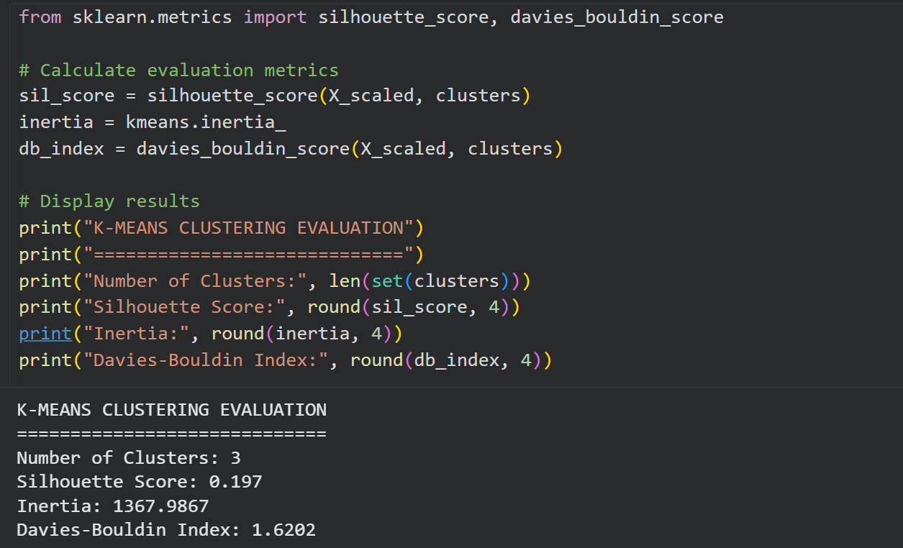

5. Results and Cluster Interpretation
Metric | Value
Number of clusters (K) | 3
Silhouette Score | 0.197
Inertia | 1367.9867
Davies-Bouldin Index | 1.6202

Cluster | Avg. Age | Avg. Listening Hours / Week | Avg. Monthly Logins | Avg. Tenure (Months) | Number of Users
0 | 49.36 | 9.17 | 17.11 | 28.51 | 212
1 | 27.52 | 8.32 | 18.38 | 32.55 | 181
2 | 37.97 | 23.34 | 17.50 | 34.10 | 107

Interpretation
- Cluster 0: older users (average age about 49) with moderate listening and the shortest average tenure.
- Cluster 1: younger users (average age about 28) with moderate listening and the highest number of monthly logins.
- Cluster 2: heavy listeners (about 23 hours per week) of middle age, with the longest average tenure; it is the smallest group.
- The Silhouette Score of 0.197 is low, so the clusters overlap and are only weakly separated. This matches the scatter plot, where clusters 0 and 1 overlap.

6. Result
K-Means clustering with K = 3 was implemented on the Music Streaming Subscriber Churn dataset using four standardized features. The clusters contain 212, 181 and 107 users, with a Silhouette Score of 0.197, inertia of 1367.9867 and Davies-Bouldin Index of 1.6202.

7. Conclusion
The experiment demonstrated K-Means clustering with the Elbow Method, evaluation metrics and cluster-wise analysis. The users were grouped mainly by age and listening hours, giving older moderate listeners, younger regular users and heavy listeners. The low Silhouette Score shows that the groups are not sharply separated, so the segments should be treated as approximate. The dataset is a small illustrative sample, so the conclusions should not be generalized to real streaming services.

8. Reference
Reference practical format: Experiment 03 - Exploratory Data Analysis and Visualization. The topic, dataset and examples in this report have been adapted to K-Means clustering on the Music Streaming Subscriber Churn dataset using Python (scikit-learn).

