DMBI PRACTICAL
EXPERIMENT 04
Classification Using RapidMiner - Decision Tree & Naïve Bayes

Name: Sahil Setya
Class: D15A
Roll No.: 48
Subject: DMBI

1. Aim
To perform classification on a Music Streaming Subscriber Churn dataset using the Decision Tree and Naïve Bayes algorithms in RapidMiner (Altair AI Studio), and to compare their performance.

2. Theory
Classification is a supervised data mining technique in which a model is trained on labelled data to predict the class of new, unseen records. In this experiment the class label is the churn status of a music streaming subscriber (Retained or Churned).

Dataset Overview
The dataset Music_Streaming_Subscriber_Churn contains 500 examples (subscribers) with attributes such as user_id, age, subscription_type, listening hours, monthly logins, favorite_genre, device, country and tenure, along with the churn label. The data is illustrative and is not actual data from a streaming platform.

Decision Tree
A Decision Tree is a tree-structured classifier in which internal nodes test an attribute, branches represent test outcomes and leaf nodes give the predicted class. Splits are chosen using a criterion such as gain ratio, and pruning is applied to avoid overfitting.

Naïve Bayes
Naïve Bayes is a probabilistic classifier based on Bayes' theorem. It assumes that attributes are conditionally independent given the class, and predicts the class with the highest posterior probability.

RapidMiner Operators Used
- Retrieve: loads the Music_Streaming_Subscriber_Churn dataset from the Local Repository.
- Set Role: assigns the churn attribute as the label.
- Split Data: partitions the data into training and testing sets.
- Decision Tree / Naïve Bayes: learns the classification model from the training set.
- Apply Model: applies the trained model to the testing set.
- Performance: computes accuracy, precision, recall and the confusion matrix.

3. Procedure / RapidMiner Workflow
- Import the Music_Streaming_Subscriber_Churn dataset into the Local Repository and view it in the Results perspective.
- Drag the dataset into the Design view using the Retrieve operator.
- Add the Set Role operator and set the churn attribute as the label.
- Add the Split Data operator with partition ratios 0.8 and 0.2 (80% training, 20% testing).
- Connect the training partition to the Decision Tree operator and set its parameters.
- Add Apply Model and Performance operators, run the process and note the confusion matrix and accuracy.
- Replace the Decision Tree with the Naïve Bayes operator, run the process again and record the results.
- Compare the performance of the two models.

4. Screenshots and Observations

4.1 Dataset in RapidMiner
The Music_Streaming_Subscriber_Churn dataset loaded in Altair AI Studio (500 examples).
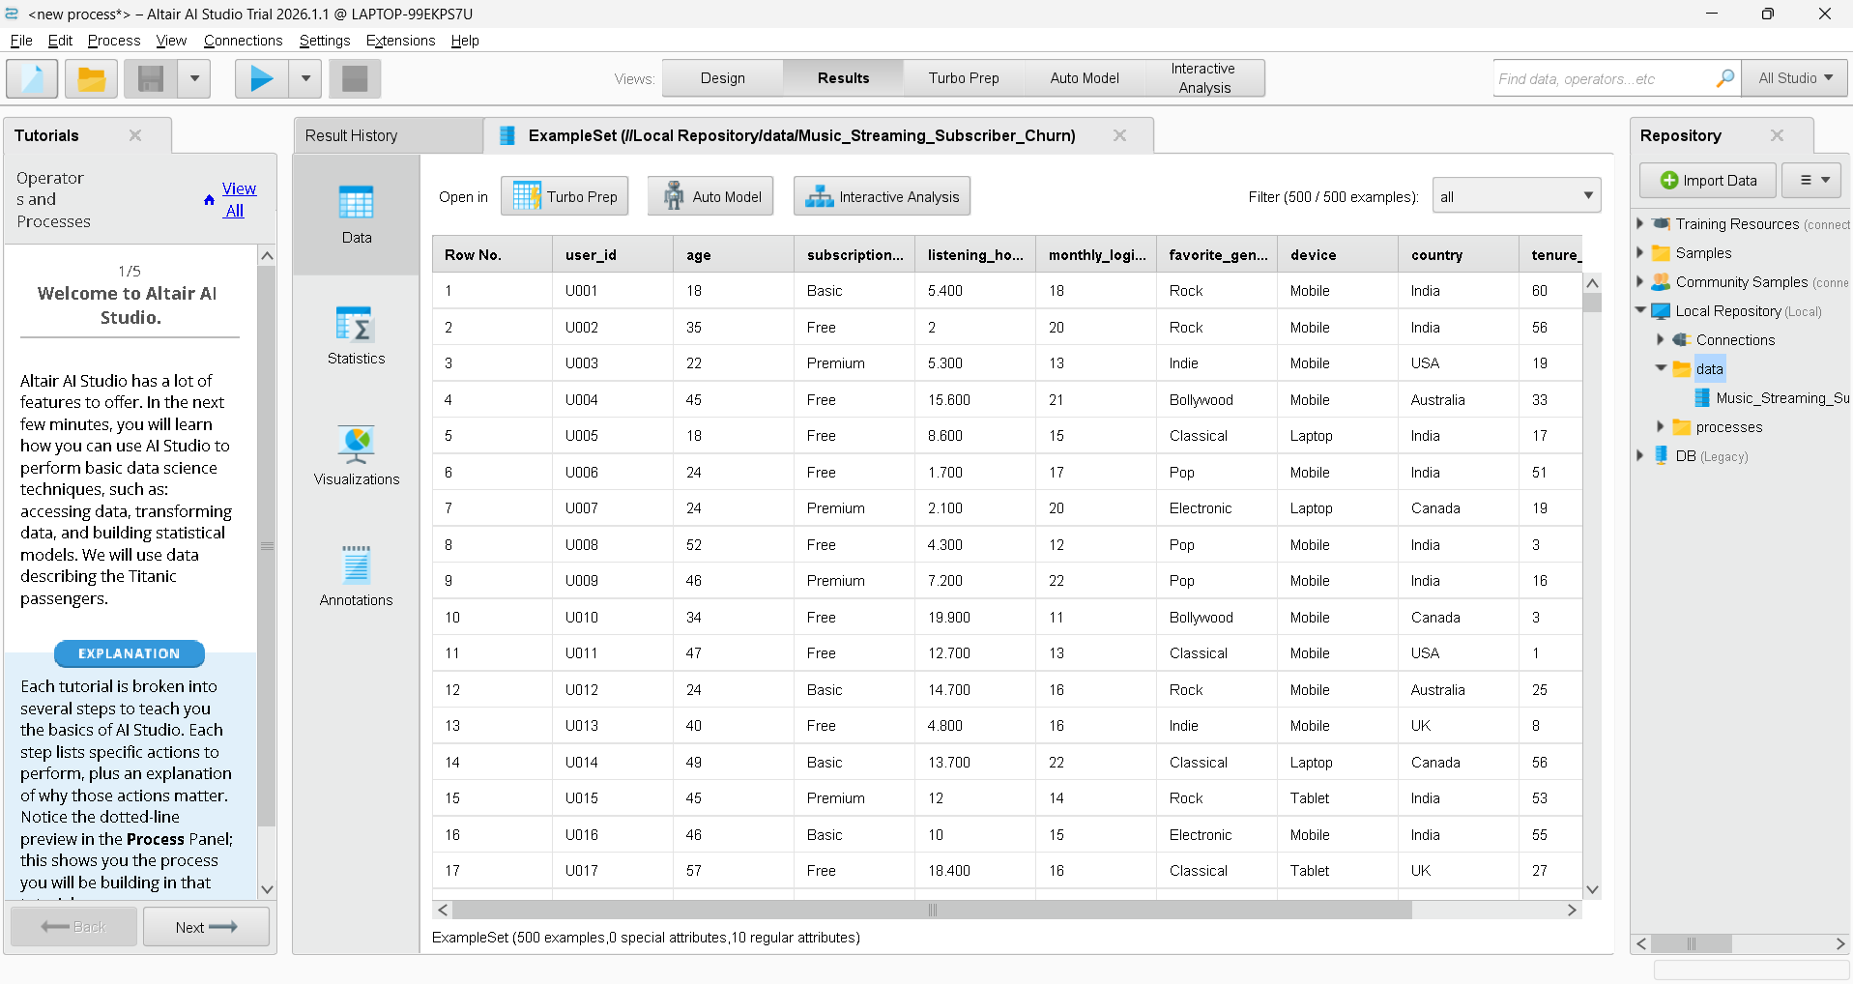

4.2 Retrieve, Set Role and Split Data
The dataset is retrieved, the label role is set, and the data is passed to the Split Data operator.
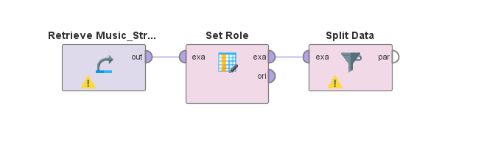

4.3 Split Data Partition Ratio
The partitions parameter is set to 0.8 and 0.2, giving 80% of the records for training and 20% for testing.
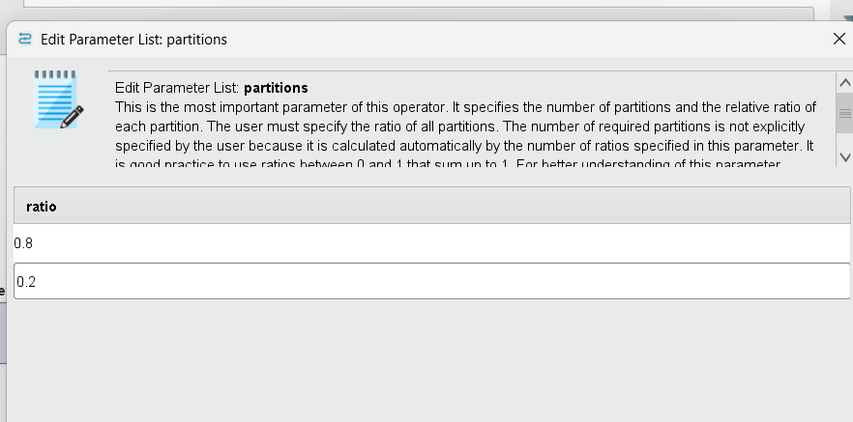

4.4 Decision Tree Operator Added
The training partition is connected to the Decision Tree operator.
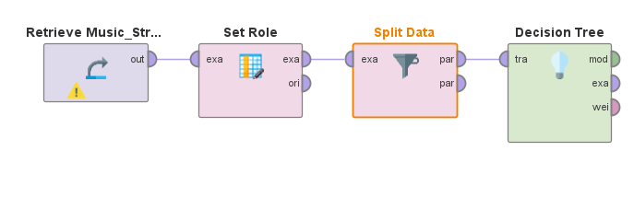

4.5 Decision Tree Parameters
Criterion: gain ratio; maximal depth: 7; apply pruning: enabled (confidence 0.1); apply prepruning: enabled; minimal gain: 0.01; minimal leaf size: 2.
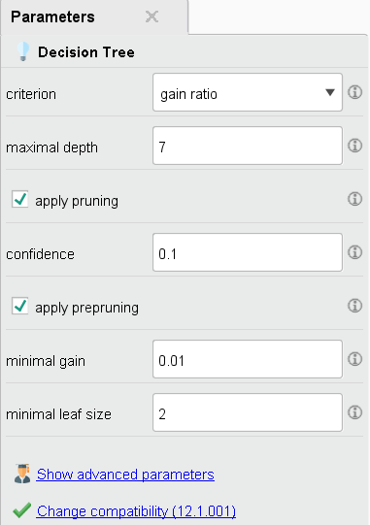

4.6 Apply Model Operator Added
The testing partition and the trained model are connected to the Apply Model operator.
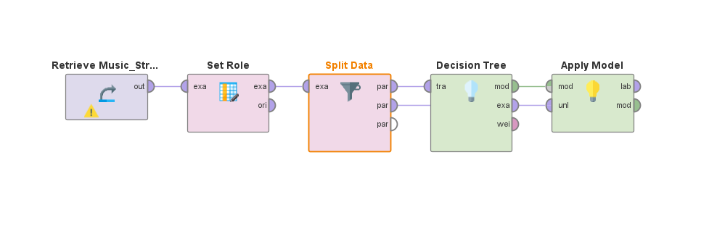

4.7 Decision Tree: Complete Process
The Performance operator is added to evaluate the Decision Tree predictions.
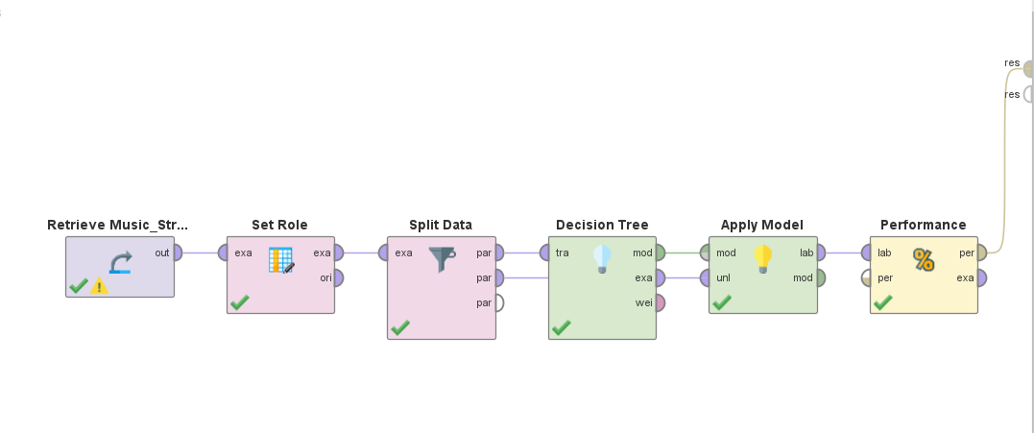

4.8 Decision Tree: Performance (Confusion Matrix)
The Decision Tree model achieved an accuracy of 66.00% on the 100 test records.
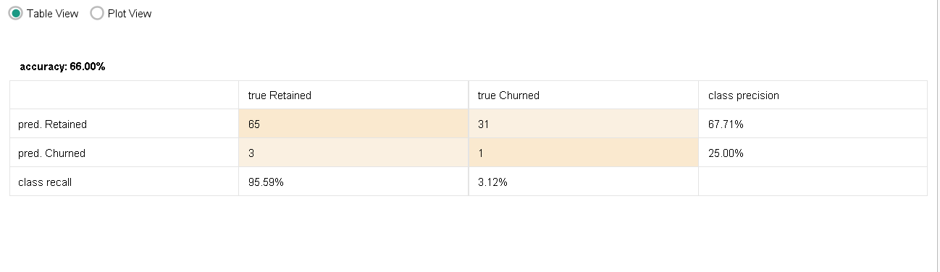

4.9 Naïve Bayes: Complete Process
The Decision Tree operator is replaced with Naïve Bayes, keeping the rest of the process unchanged.
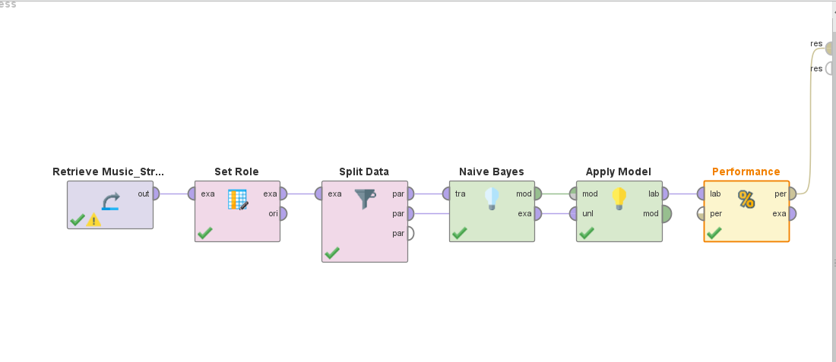

4.10 Naïve Bayes: Performance (Confusion Matrix)
The Naïve Bayes model achieved an accuracy of 53.00% on the same test records.
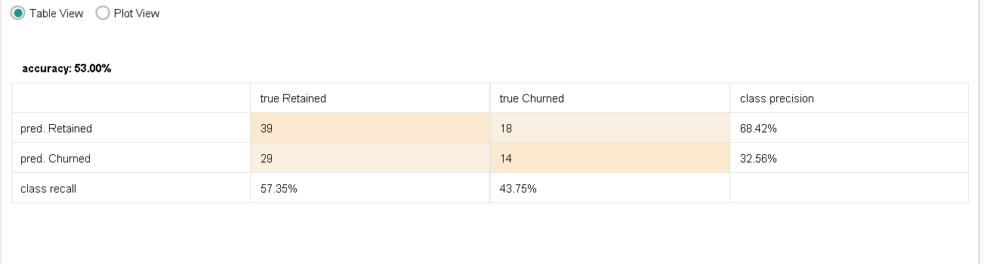

5. Results Comparison
Confusion matrix values on the testing set (100 records):
Model | Accuracy | Retained Precision | Churned Precision | Retained Recall | Churned Recall
Decision Tree | 66.00% | 67.71% | 25.00% | 95.59% | 3.12%
Naïve Bayes | 53.00% | 68.42% | 32.56% | 57.35% | 43.75%

Model | True Retained, Pred. Retained | True Churned, Pred. Retained | True Retained, Pred. Churned | True Churned, Pred. Churned
Decision Tree | 65 | 31 | 3 | 1
Naïve Bayes | 39 | 18 | 29 | 14

Interpretation
- The Decision Tree has the higher overall accuracy (66.00% vs 53.00%), but it mostly predicts Retained, so it identifies only 3.12% of the churned users.
- Naïve Bayes has lower accuracy but a much better churn recall (43.75%) and churn precision (32.56%), so it detects churners more effectively.
- Accuracy alone is misleading here because the Retained class is much larger than the Churned class.

6. Result
Classification was performed on the Music Streaming Subscriber Churn dataset in RapidMiner using the Decision Tree and Naïve Bayes algorithms with an 80:20 train-test split. The Decision Tree achieved an accuracy of 66.00% and Naïve Bayes achieved an accuracy of 53.00%.

7. Conclusion
The experiment demonstrated how classification models are built, applied and evaluated in RapidMiner. The Decision Tree gave higher accuracy, while Naïve Bayes was better at identifying churned subscribers. The choice of model therefore depends on the goal: overall accuracy or detecting churn. The dataset is a small illustrative sample, so the conclusions should not be generalized to real streaming services.

8. Reference
Reference practical format: Experiment 03 - Exploratory Data Analysis and Visualization. The topic, dataset and examples in this report have been adapted to classification on the Music Streaming Subscriber Churn dataset using RapidMiner.

