PRACTICAL EXPERIMENT – 8
Association Rule Mining (FP-Growth) Using RapidMiner

Name: Sahil Setya
Class: D15A
Roll No.: 48
Subject: Data Analytics / Machine Learning Practical

Aim
To prepare and execute a RapidMiner workflow that discovers frequent itemsets and association rules from the categorical attributes of the Music Streaming Subscriber dataset using the FP-Growth algorithm and the Create Association Rules operator.

Theory
Association rule mining is an unsupervised data mining technique that discovers interesting relationships, or co-occurrence patterns, between items in a dataset. A rule has the form A → B, where A is the premise (antecedent) and B is the conclusion (consequent).
The strength of a rule is measured using support and confidence. Support is the fraction of all records that contain both the premise and the conclusion. Confidence is the fraction of records containing the premise that also contain the conclusion. In RapidMiner, the LaPlace value is an additional measure that corrects confidence for rules supported by few records.
FP-Growth (Frequent Pattern Growth) efficiently finds all frequent itemsets using a compact FP-tree data structure, without generating a large number of candidate itemsets. Because FP-Growth works on binary (true/false) attributes, nominal attributes must first be converted to binominal form using the Nominal to Binominal operator. The Create Association Rules operator then generates rules from the frequent itemsets that satisfy the minimum confidence threshold.
In this experiment, five categorical attributes of the Music Streaming Subscriber dataset are used: churn_status, country, device, favorite_genre, and subscription_plan.

Tools Required
Altair AI Studio (RapidMiner), Music_Streaming_Subscriber_Churn.csv, and the operators Retrieve, Select Attributes, Nominal to Binominal, FP-Growth, and Create Association Rules.

Procedure
- Open Altair AI Studio and create a new blank process.
- Import Music_Streaming_Subscriber_Churn.csv into the Local Repository and add its Retrieve operator to the process.
- Add Select Attributes, choose the option “a subset”, and retain the five nominal attributes: churn_status, country, device, favorite_genre, and subscription_plan. The numerical attributes (age, listening_hours_per_week, monthly_logins, tenure_months) and user_id are excluded.
- Add Nominal to Binominal after Select Attributes with the attribute filter type set to “all”, so that every selected attribute is converted into binominal form.
- Add FP-Growth after Nominal to Binominal. Set the minimum requirement to support and configure the min support threshold to obtain the frequent itemsets.
- Add Create Association Rules and connect the frequent itemsets (fre) output of FP-Growth to its input. Set the criterion to confidence with min confidence = 0.6.
- Connect the output ports of Create Association Rules to the process result ports.
- Run the process and inspect the generated association rules in the results view.

Process Flow
Retrieve → Select Attributes → Nominal to Binominal → FP-Growth → Create Association Rules → Results

RapidMiner Execution Evidence
The workflow was assembled and executed in Altair AI Studio. The nominal attributes were selected, converted to binominal form, mined for frequent itemsets using FP-Growth, and then used to generate association rules.
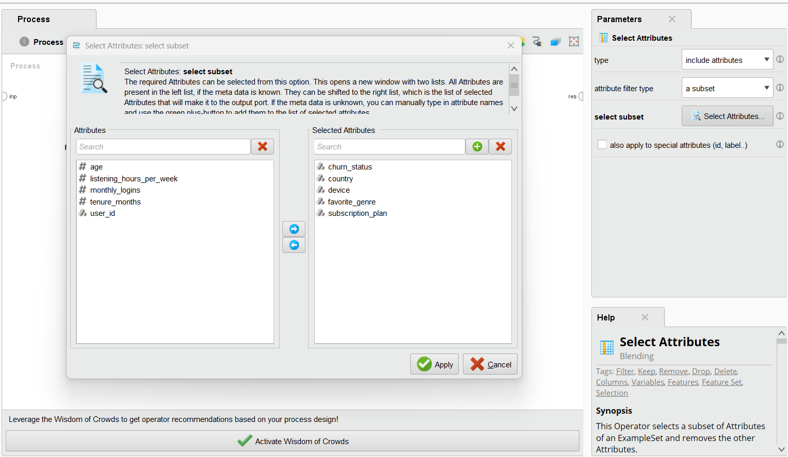
Figure 1. Select Attributes operator – selecting the five nominal attributes.
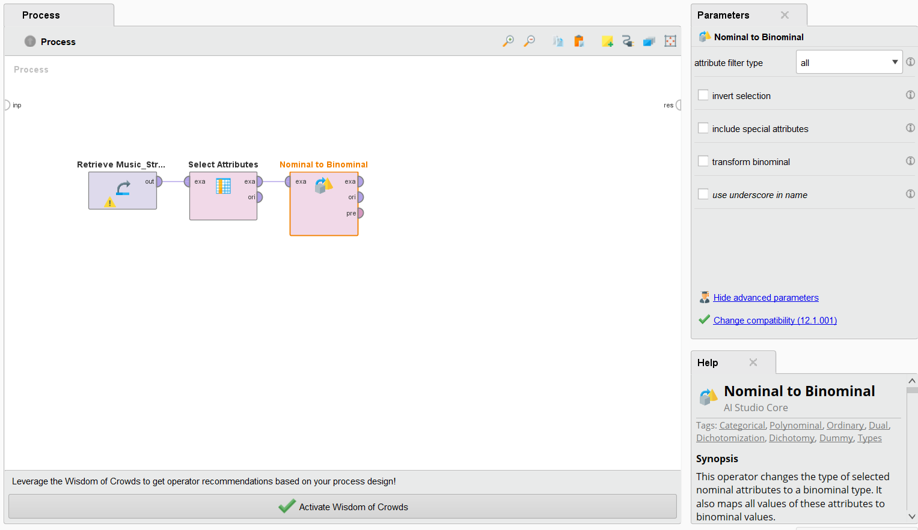
Figure 2. Nominal to Binominal operator added to the process.
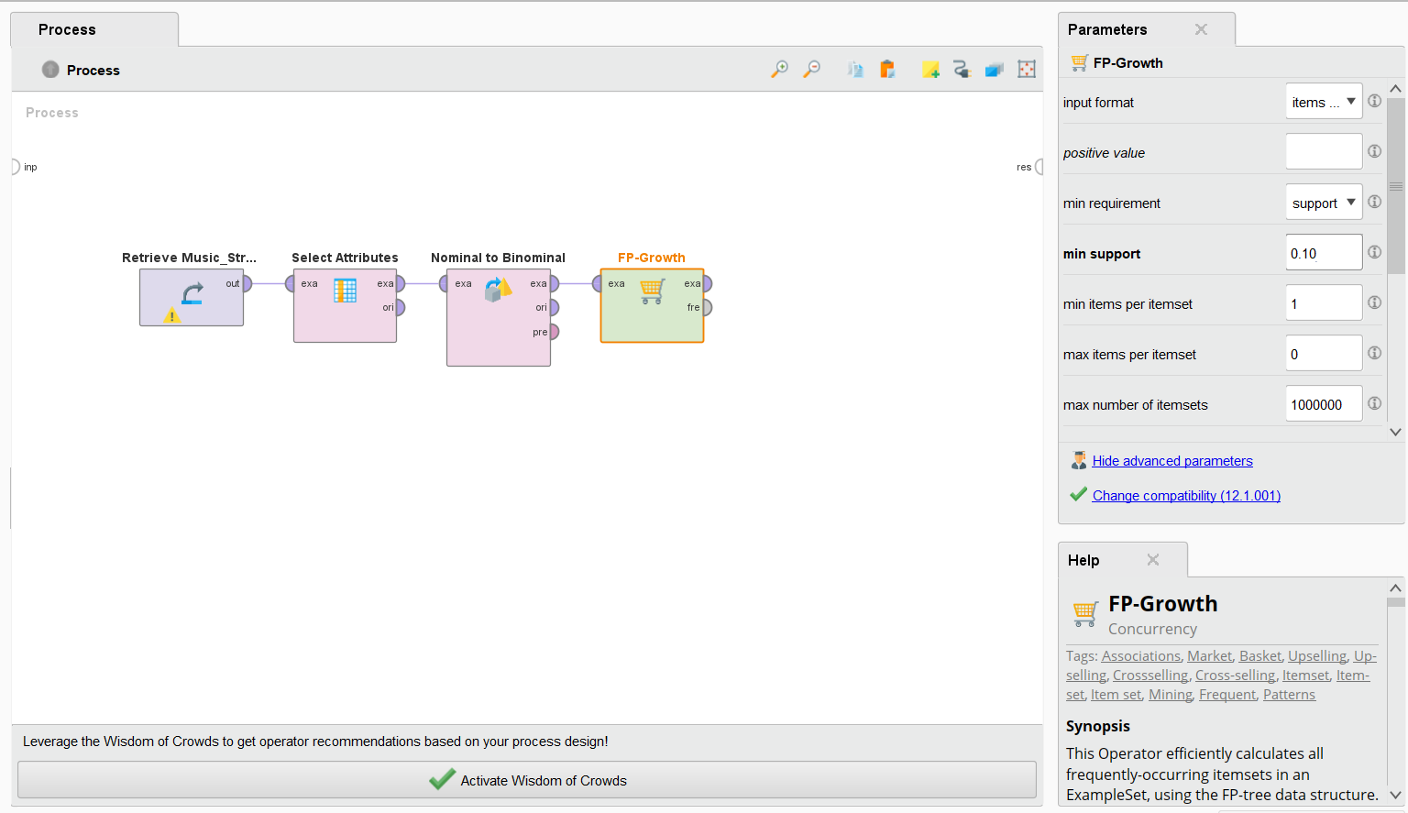
Figure 3. FP-Growth operator and its parameters.
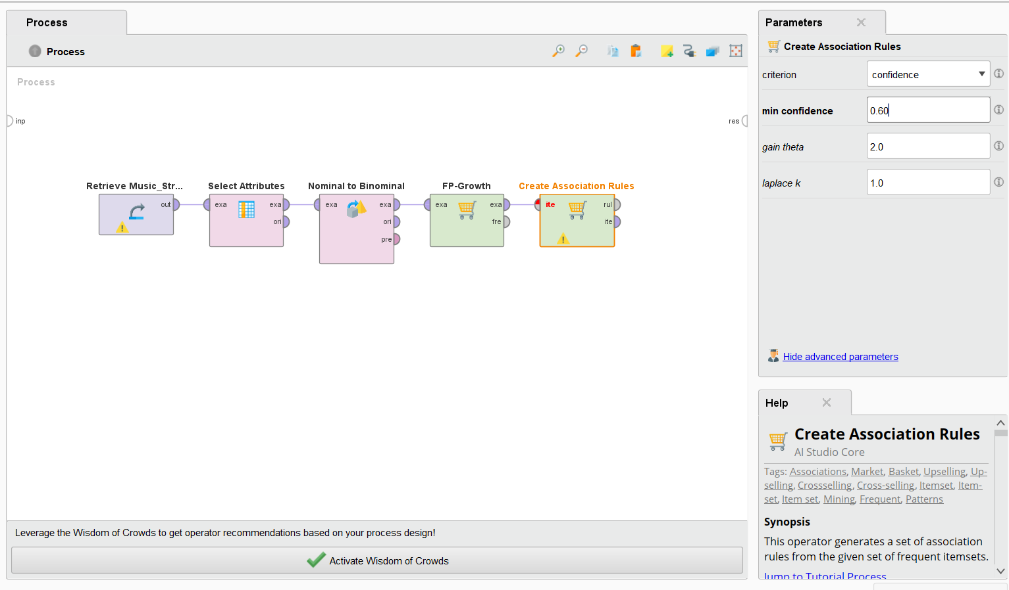
Figure 4. Create Association Rules operator with criterion = confidence and min confidence = 0.6.
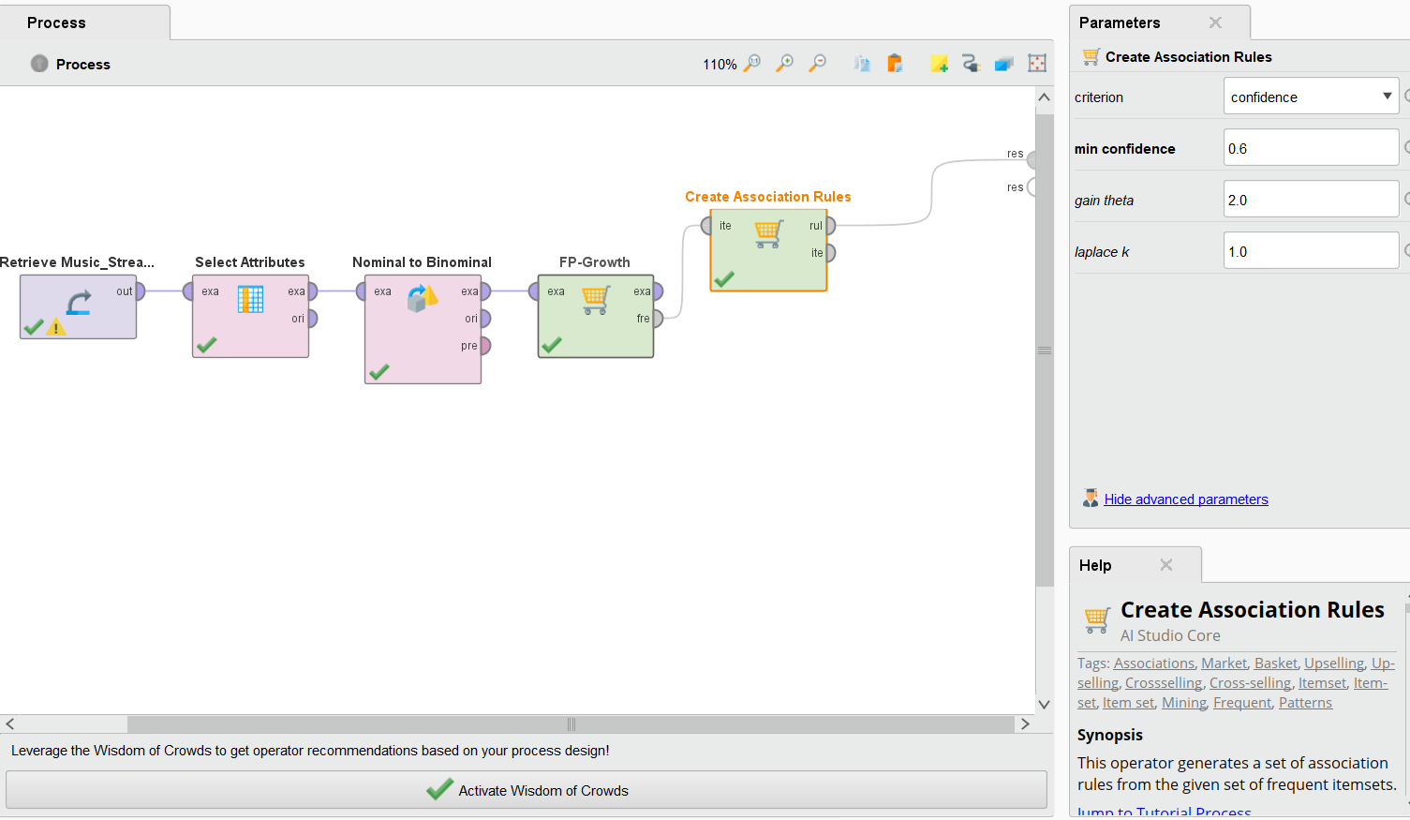
Figure 5. Completed and executed association rule mining workflow.
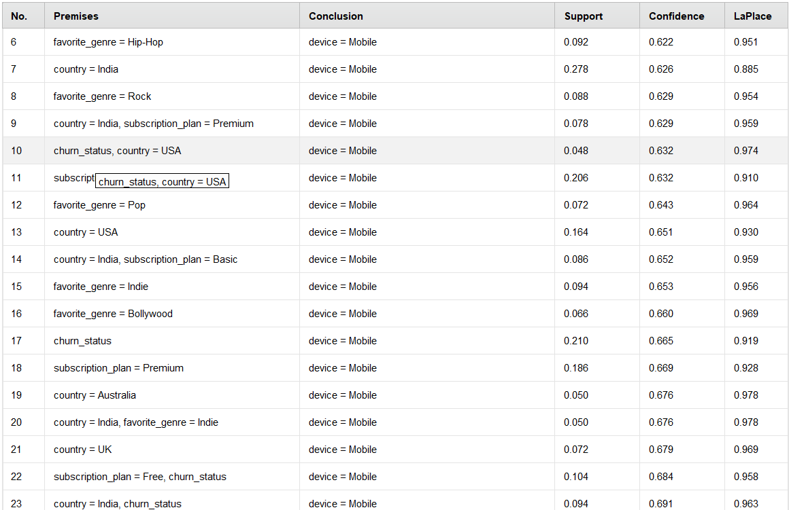
Figure 6. Generated association rules (rules 6 to 23) with support, confidence, and LaPlace values.
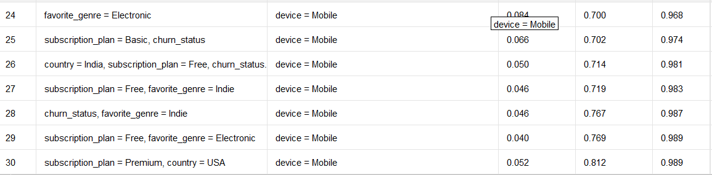
Figure 7. Generated association rules (rules 24 to 30).

Association Rules Output
The Create Association Rules operator produced the rules shown in Figures 6 and 7. In every rule shown, the conclusion is device = Mobile. The table below lists the rules with the highest confidence values.
No. | Premises | Conclusion | Support | Confidence | LaPlace
30 | subscription_plan = Premium, country = USA | device = Mobile | 0.052 | 0.812 | 0.989
29 | subscription_plan = Free, favorite_genre = Electronic | device = Mobile | 0.040 | 0.769 | 0.989
28 | churn_status, favorite_genre = Indie | device = Mobile | 0.046 | 0.767 | 0.987
27 | subscription_plan = Free, favorite_genre = Indie | device = Mobile | 0.046 | 0.719 | 0.983
26 | country = India, subscription_plan = Free, churn_status | device = Mobile | 0.050 | 0.714 | 0.981
25 | subscription_plan = Basic, churn_status | device = Mobile | 0.066 | 0.702 | 0.974
24 | favorite_genre = Electronic | device = Mobile | 0.084 | 0.700 | 0.968
23 | country = India, churn_status | device = Mobile | 0.094 | 0.691 | 0.963

The rule with the highest support among those shown is rule 7 (country = India → device = Mobile) with support 0.278 and confidence 0.626.

Association Rule Analysis
All rules generated have a confidence of at least 0.6, as set by the minimum confidence parameter. The strongest rule shown is subscription_plan = Premium and country = USA → device = Mobile, with a confidence of 0.812, meaning that about 81% of the Premium users from the USA use a mobile device. Users who prefer Free plans with Electronic or Indie music, and churned users who prefer Indie music, also show confidence values of about 0.72 to 0.77 for mobile usage.
Single-attribute rules such as country = India (support 0.278, confidence 0.626) cover a larger share of the dataset but with lower confidence, while the combined-attribute rules have higher confidence but lower support. The high LaPlace values (0.88 to 0.99) indicate that the rules are reasonably reliable. Since support and confidence only describe co-occurrence, they do not by themselves prove that one attribute causes the other.

Inference
- FP-Growth and Create Association Rules were used to discover relationships among the categorical attributes of the music streaming users.
- Nominal attributes had to be converted to binominal form before frequent itemset mining could be applied.
- Every rule shown in the output has device = Mobile as its conclusion, indicating that mobile is the dominant device among the discovered patterns.
- The strongest rule shown is Premium plan and country = USA → device = Mobile with confidence 0.812 and LaPlace 0.989.
- Rules with more attributes in the premise tend to have higher confidence but lower support.

Result
Association rule mining was successfully implemented using Altair AI Studio (RapidMiner) on the Music Streaming Subscriber dataset. Frequent itemsets were generated using FP-Growth, and association rules were created with a minimum confidence of 0.6. The rules revealed strong associations between user attributes such as country, subscription plan, favorite genre, and churn status with the use of mobile devices, the highest confidence being 0.812.

Conclusion
The experiment demonstrated how association rules can be mined from categorical user data. RapidMiner provided a graphical workflow for selecting attributes, converting them to binominal form, finding frequent itemsets with FP-Growth, and generating rules using support, confidence, and LaPlace measures. The results showed that mobile is strongly associated with several combinations of country, subscription plan, favorite genre, and churn status.

