PROJECT REPORT

ON

***“Resource Requisition Automation Tool”***

**Submitted by**

Trishla Khabya

Semester XII

Session Jan-May 2019

**Under the Guidance of**

Mrs. Kirti Vijayvargiya

Dissertation Submitted in Partial fulfillment of the

Requirement for the Award of the Degree of

MCA (6 years)

In

International Institute of Professional Studies

Devi Ahilya Vishwavidyalaya, Indore, M.P.

**DECLARATION**

I hereby declare that the project entitled “Resource Requisition Automation Tool” which is submitted by me for the partial fulfillment of the degree of Masters of Computer Application of International Institute of Professional Studies, Devi Ahilya Vishwavidyalaya ,Indore, comprises of the work that I have learned during my Internship at Cognizant Pvt...Ltd under the guidance of Mr. Sanket Chaudhari). All the information furnished in this project report is based on my own intensive work and is genuine.

Signature of Student

Date:

Place: Indore (M.P)

(i)

**CERTIFICATE**

This is to certify that the dissertation on “Resource Requisition Automation Tool” submitted by “Trishla Khabya” in partial fulfillment of the degree of Masters of Computer Application of International Institute of Professional Studies, Devi Ahilya Vishwavidyalaya, Indore, comprises of the work that I have learned during my Internship at Cognizant Pvt. Ltd. Where I worked as a part of the project.

**Signature and Name of the Mentor [Cognizant]**

**Ms. Shilpa Mahajani (Project Manager- Academy Campus Champ)**

**Signature and Name of the Project Manager [Cognizant]**

**Mr. Sanket Chaudhari (Sr. Manager)**

**Signature and Name of the Mentor [Cognizant]**

**Mr. Arjun Ghosh (Associate)**

**Signature and Name of the External Examiner**

**Signature and Name of the Internal Examiner**

(ii)

**ACKNOWLEDGEMENT**

For the successful completion of this project, I'd extend a sincere thanks to our project guide as well as trainer **Ms. Priti Gonewar** who has been there with us while building the complete code from scratch. Without her guidance and teaching, it'd have been impossible of us to create the project.

I'm also grateful to our batch owners and people who've helped us out in every way possible, Ms. **Shilpa Mahajani, Mr. Mohit Kariya, Mr. Gerard Thomas** **and Ms. Komal Sanjay Pawar**. Without them, internship at such a huge company would have not been completed successfully. They ensured our smooth functioning and handled all the quirks and doubts while the sessions which helped us a lot in order to calmly finish the project.

I'd like to express my sincere thanks to a few of the faculties from my college for giving us such an amazing opportunity to work through the college semester in order to get a corporate experience and education and enhance my personal as well as professional skills.

**Director** Dr. Anand Sapre

**Program Incharge** Mr. Jugendra Dongre

**Batch Mentor** Dr. Vivek Shrivastav, Mr. Basant Namdeo

**Project Guide** Mrs. Kirti Vijayvargiya

I feel proud and privileged in expressing my deep sense of gratitude to all those who have helped me in presenting this project. I would be falling in my endeavor if I do not place my acknowledgement.

(iii)

**Training Certificate/ Letter of Recommendation**

This is to certify that Ms. Trishla Khabya has attended Industrial training program on “Resource Requisition Automation Tool” in Cognizant Technology Services from 19th Jan 2019 to 30 April 2019.

During the above period we found her hardworking and result oriented. She worked as a part of team during her tenure. We take this opportunity to thank her and wish her all the best for future

Sincerely,

Ms. Shilpa Mahajani

Project Manager-Academy Campus Champ

Cognizant Technology Solution.

(iv)

**TABLE OF CONTENTS**

Declaration…...……………………………………………………………………...(i)

Certificate……..…….……………………………………………………………….(ii)

Acknowledgement…………………...………………………………………….......(iii)

Letter of Recommendation…………………………………………………………..(iv)

**1. INTRODUCTION 1-8**

## 1.1. DESCRIPTION 1

## 1.2. PROCESS ARCHITECTURE 1

## 1.3. TECHNOLOGIES USED 2-8

## 1.3.1. JAVA 2-3

## 1.3.2. SPRING 3-4

## 1.3.3. JSP 4-5

## 1.3.4. ECLIPSE IDE 5

## 1.3.5. RDBMS 6-7

## 1.3.6. MYSQL DATABASE 7-8

## 1.3.1. MAVEN 8

## 1.3.1. APACHE TOMCAT 8

**2. PROFILE OF THE PROBLEM 9**

**3. EXISTING SYSTEM 10-12**

**3.1 INTRODUCTION 10**

**3.2 EXISTING SOFTWARE 10**

**3.3 DFD FOR THE PROPOSED SYSTEM 10-12**

**3.4 WHAT’S NEW IN THE SYSTEM TO BE DEVELOPED 12**

**4. PROBLEM ANALYSIS 13-14**

**4.1 PROBLEM DEFINITION 13**

**4.2 FEASIBILITY ANALYSIS 13**

**4.2.1 TECHNICAL FEASIBILITY 13-14**

**5. SOFTWARE REQUIREMENT ANALYSIS 14-16**

**5.1 INTRODUCTION 14**

**5.2 GENERAL DESCRIPTION 14**

**5.3 FUNCTIONAL REQUIREMENTS 15**

**5.4 NON-FUNCTIONAL REQUIREMENTS 15-16**

**6. DESIGN 17-32**

**6.1 SYSTEM DESIGN FLOW DIAGRAM 17**

**6.2 DESIGN NOTATIONS 18-19**

**6.3 USE CASE DIAGRAM 20**

**6.4 FLOW CHARTS 21-24**

**6.4.1 LOGIN 21**

**6.4.2 L1 ASSESSMENT 22**

**6.4.3 L2 ASSESSMENT 22**

**6.4.4 HR ASSESSMENT 23**

**6.4.5 UPDATE CANDIDATE 24**

**6.5 E-R DIAGRAM 25**

**6.6 DATA DICTIONARY 26-27**

**6.6.1 EMPLOYEE 26**

**6.6.2 CANDIDATE 26**

**6.6.3 RESULT 27**

**6.7 DETAILED DESIGN 28-32**

**7. TESTING 33-35**

**7.1 FUNCTIONAL TESTING 33**

**7.2 LEVELS OF TESTING 33**

**7.3 TESTING THE PROJECT 34-35**

**8. IMPLEMENTATION 36-37**

**8.1 CONVERSION PLAN 36**

**8.2 POST IMPLEMENTATION OF PROJECT AND MAINTAINANCE 37**

**9. PROJECT LEGACY 37**

**9.1 CURRENT STATE OF PROJECT 37**

**9.2 REMAINING AREAS OF CONCERN 37**

**9.3 TECHNICAL AND MANAGERIAL LESSONS LEARNT 37**

**10. USER MANUAL 38-39**

**10.1 REGISTER 38**

**10.2 LOGIN 38**

**10.3 ADD CANDIDATE 38**

**10.4 UPDATE CANDIDATE 39**

**10.5 VIEW CANDIDATE 39**

**11. USER INTERFACE SCREENSHOTS 40-42**

**12. BIBLIOGRAPHY 43**

**1. INTRODUCTION**

**1.1 DESCRIPTION**

Resource Requisition Automation Tool is a web application based project that will provide facilities to HR and employees to update the details of candidates and their assessments. Through this project we are aiming to cut down the cost of entering details of candidates in spreadsheets manually. This will help in increasing the efficiency and concurrent management of candidate details. This web application will help in automating the requisition tracking process and will thus save efforts for team who manually do these in spreadsheets.

Features of the application

1. As everything is available in database one can edit into any system and thus system dependency is resolved.
2. CVs associated with each candidate can be easily downloaded making it more convenient.
3. Exporting of candidate data from database into excel sheet.
4. Updating of results based on different tests and interviews.

**1.2 Process Architecture**

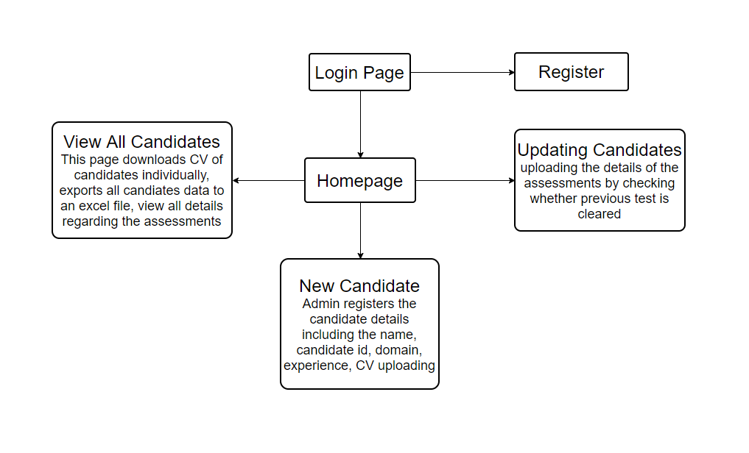Figure 1: Process Architecture

1

**1.3 Technologies Description**

Technologies and tools that are used to build this project are: -

**1.3.1 JAVA**

Java is a high-level programming language originally developed by Sun Microsystems and released in 1995. Java runs on a variety of platforms, such as Windows, Mac OS, and the various versions of UNIX. Java is guaranteed to be **Write Once, Run Anywhere.**

Java is −

1. **Object Oriented** − In Java, everything is an Object. Java can be easily extended since it is based on the Object model.
2. **Platform Independent** − Unlike many other programming languages including C and C++, when Java is compiled, it is not compiled into platform specific machine, rather into platform independent byte code. This byte code is distributed over the web and interpreted by the Virtual Machine (JVM) on whichever platform it is being run on.
3. **Simple** − Java is designed to be easy to learn. If you understand the basic concept of OOP Java, it would be easy to master.
4. **Secure** − With Java's secure feature it enables to develop virus-free, tamper-free systems. Authentication techniques are based on public-key encryption.
5. **Architecture-neutral** − Java compiler generates an architecture-neutral object file format, which makes the compiled code executable on many processors, with the presence of Java runtime system.
6. **Portable** − Being architecture-neutral and having no implementation dependent aspects of the specification makes Java portable. Compiler in Java is written in ANSI C with a clean portability boundary, which is a POSIX subset.
7. **Robust** − Java makes an effort to eliminate error prone situations by emphasizing mainly on compile time error checking and runtime checking.
8. **Multithreaded** − With Java's multithreaded feature it is possible to write programs that can perform many tasks simultaneously. This design feature allows the developers to construct interactive applications that can run smoothly.

2

1. **Interpreted** − Java byte code is translated on the fly to native machine instructions and is not stored anywhere. The development process is more rapid and analytical since the linking is an incremental and light-weight process.
2. **High Performance** − With the use of Just-In-Time compilers, Java enables high performance.
3. **Distributed** − Java is designed for the distributed environment of the internet.
4. **Dynamic** − Java is considered to be more dynamic than C or C++ since it is designed to adapt to an evolving environment. Java programs can carry extensive amount of run-time information that can be used to verify and resolve accesses to objects on run-time.

**1.3.2 SPRING**

Spring is a lightweight framework. It can be thought of as a framework of frameworks because it provides support to various frameworks such as Struts, Hibernate, Tapestry, EJB, JSF etc. The framework, in broader sense, can be defined as a structure where we find solution of the various technical problems.

The Spring framework comprises several modules such as IOC, AOP, DAO, Context, ORM, WEB MVC etc. We will learn these modules in next page. Let's understand the IOC and Dependency Injection first.

The core features of the Spring Framework can be used in developing any Java application, but there are extensions for building web applications on top of the Java EE platform. Spring framework targets to make J2EE development easier to use and promotes good programming practices by enabling a POJO-based programming model.

Following is the list of few of the great benefits of using Spring Framework −

1. Spring enables developers to develop enterprise-class applications using POJOs. The benefit of using only POJOs is that you do not need an EJB container product such as an application server but you have the option of using only a robust servlet container such as Tomcat or some commercial product.
2. Spring is organized in a modular fashion. Even though the number of packages and classes are substantial, you have to worry only about the ones you need and ignore the rest.

3

1. Spring does not reinvent the wheel, instead it truly makes use of some of the existing technologies like several ORM frameworks, logging frameworks, JEE, Quartz and JDK timers, and other view technologies.
2. Testing an application written with Spring is simple because environment-dependent code is moved into this framework. Furthermore, by using JavaBeanstyle POJOs, it becomes easier to use dependency injection for injecting test data.
3. Spring's web framework is a well-designed web MVC framework, which provides a great alternative to web frameworks such as Struts or other over-engineered or less popular web frameworks.
4. Spring provides a convenient API to translate technology-specific exceptions (thrown by JDBC, Hibernate, or JDO, for example) into consistent, unchecked exceptions.
5. Lightweight IoC containers tend to be lightweight, especially when compared to EJB containers, for example. This is beneficial for developing and deploying applications on computers with limited memory and CPU resources.
6. Spring provides a consistent transaction management interface that can scale down to a local transaction (using a single database, for example) and scale up to global transactions (using JTA, for example).

**1.3.3 JSP**

Java Server Pages (JSP) is a server-side programming technology that enables the creation of dynamic, platform-independent method for building Web-based applications. JSP have access to the entire family of Java APIs, including the JDBC API to access enterprise databases.

JavaServer Pages (JSP) is a technology for developing Webpages that supports dynamic content. This helps developers insert java code in HTML pages by making use of special JSP tags, most of which start with <% and end with %>.

A JavaServer Pages component is a type of Java servlet that is designed to fulfill the role of a user interface for a Java web application. Web developers write JSPs as text files that combine HTML or XHTML code, XML elements, and embedded JSP actions and commands.

Using JSP, you can collect input from users through Webpage forms, present records from a database or another source, and create Webpages dynamically.

4

JSP tags can be used for a variety of purposes, such as retrieving information from a database or registering user preferences, accessing JavaBeans components, passing control between pages, and sharing information between requests, pages etc.

**Advantages of JSP**

Following table lists out the other advantages of using JSP over other technologies −

### **vs. Active Server Pages (ASP)**

The advantages of JSP are twofold. First, the dynamic part is written in Java, not Visual Basic or other MS specific language, so it is more powerful and easier to use. Second, it is portable to other operating systems and non-Microsoft Web servers.

### **vs. Pure Servlets**

It is more convenient to write (and to modify!) regular HTML than to have plenty of println statements that generate the HTML.

### **vs. Server-Side Includes (SSI)**

SSI is really only intended for simple inclusions, not for "real" programs that use form data, make database connections, and the like.

### **vs. JavaScript**

JavaScript can generate HTML dynamically on the client but can hardly interact with the web server to perform complex tasks like database access and image processing etc.

### **vs. Static HTML**

Regular HTML, of course, cannot contain dynamic information.

**1.3.4 ECLIPSE IDE**

Eclipse is an [integrated development environment](https://en.wikipedia.org/wiki/Integrated_development_environment) (IDE) used in [computer programming](https://en.wikipedia.org/wiki/Computer_programming), and is the most widely used Java IDE. It contains a base [workspace](https://en.wikipedia.org/wiki/Workspace) and an extensible [plug-in](https://en.wikipedia.org/wiki/Plug-in_(computing)) system for customizing the environment. Eclipse is written mostly in [Java](https://en.wikipedia.org/wiki/Java_(programming_language)) and its primary use is for developing Java applications

5

**1.3.5 RDBMS**

A database is a separate application that stores a collection of data. Each database has one or more distinct APIs for creating, accessing, managing, searching and replicating the data it holds.

Other kinds of data stores can be used, such as files on the file system or large hash tables in memory but data fetching and writing would not be so fast and easy with those types of systems.

So nowadays, we use relational database management systems (RDBMS) to store and manage huge volume of data. This is called relational database because all the data is stored into different tables and relations are established using primary keys or other keys known as foreign keys.

**Relational Database Management System (RDBMS)** is a software that:

1. Enables you to implement a database with tables, columns and indexes.
2. Guarantees the Referential Integrity between rows of various tables.
3. Updates the indexes automatically.
4. Interprets an SQL query and combines information from various tables.

**RDBMS TERMINOLOGY: -**

Before I proceed to explain MySQL database system, let's revise few definitions related to database.

1. **Database:** A database is a collection of tables, with related data.
2. **Table:** A table is a matrix with data. A table in a database looks like a simple spreadsheet.
3. **Column:** One column (data element) contains data of one and the same kind, for example the column postcode.
4. **Row:** A row (= tuple, entry or record) is a group of related data, for example the data of one subscription.

6

1. **Redundancy:** Storing data twice, redundantly to make the system faster.
2. **Primary Key:** A primary key is unique. A key value cannot occur twice in one table. With a key, you can find at most one row.
3. **Foreign Key:** A foreign key is the linking pin between two tables.
4. **Compound Key:** A compound key (composite key) is a key that consists of multiple columns, because one column is not sufficiently unique.
5. **Index:** An index in a database resembles an index at the back of a book.
6. **Referential Integrity:** Referential Integrity makes sure that a foreign key value always points to an existing row.

**1.3.6 MYSQL DATABASE**

MySQL is a fast, easy-to-use RDBMS being used for many small and big businesses. MySQL is developed, marketed, and supported by MySQL AB, which is a Swedish company. MySQL is becoming so popular because of many good reasons:

1. MySQL is released under an open-source license. So you have nothing to pay to use it.
2. MySQL is a very powerful program in its own right. It handles a large subset of the functionality of the most expensive and powerful database packages.
3. MySQL uses a standard form of the well-known SQL data language.
4. MySQL works on many operating systems and with many languages including PHP, PERL, C, C++, JAVA, etc.
5. MySQL works very quickly and works well even with large data sets.

7

MySQL is very friendly to PHP, the most appreciated language for web development.

1. MySQL supports large databases, up to 50 million rows or more in a table. The default file size limit for a table is 4GB, but you can increase this (if your operating system can handle it) to a theoretical limit of 8 million terabytes (TB).
2. MySQL is customizable. The open-source GPL license allows programmers to modify the MySQL software to fit their own specific environments.
   * 1. **MAVEN**

**Maven** is a build automation tool used primarily for Java projects.

Maven addresses two aspects of building software: first, it describes how software is built, and second, it describes its dependencies. Unlike earlier tools like Apache Ant, it uses conventions for the build procedure, and only exceptions need to be written down. An XML file describes the software project being built, its dependencies on other external modules and components, the build order, directories, and required plug-ins. It comes with pre-defined targets for performing certain well-defined tasks such as compilation of code and its packaging.

Maven dynamically downloads Java libraries and Maven plug-ins from one or more repositories such as the Maven 2 Central Repository, and stores them in a local cache.[[3]](https://en.wikipedia.org/wiki/Apache_Maven#cite_note-maven2repo-3) This local cache of downloaded artifacts can also be updated with artifacts created by local projects. Public repositories can also be updated.

**1.3.8 APACHE TOMCAT**

**Apache Tomcat**, often referred to as **Tomcat Server**, is an open-source [Java Servlet Container](https://en.wikipedia.org/wiki/Servlet_container) developed by the [Apache Software Foundation](https://en.wikipedia.org/wiki/Apache_Software_Foundation) (ASF). Tomcat implements several [Java EE](https://en.wikipedia.org/wiki/Java_Platform,_Enterprise_Edition) specifications including Java Servlet, [Java Server Pages](https://en.wikipedia.org/wiki/JavaServer_Pages) (JSP), and [Web Socket](https://en.wikipedia.org/wiki/WebSocket), and provides a "pure [Java](https://en.wikipedia.org/wiki/Java_(programming_language))" [HTTP](https://en.wikipedia.org/wiki/Hypertext_Transfer_Protocol) [web server](https://en.wikipedia.org/wiki/Web_server) environment in which [Java](https://en.wikipedia.org/wiki/Java_(programming_language)) code can run.

Tomcat is developed and maintained by an open community of developers under the auspices of the [Apache Software Foundation](https://en.wikipedia.org/wiki/Apache_Software_Foundation), released under the [Apache License](https://en.wikipedia.org/wiki/Apache_License) 2.0 license, and is [open-source software](https://en.wikipedia.org/wiki/Open-source_software).

8

**2. PROFILE OF THE PROBLEM**

The purpose of this application is to fulfill the requirements of HR and employees involved in the process of requisition. Today on a single application based platform, where on could add new candidate and update their details. An employee could check the how many assessments a candidate have cleared and download the report of all candidate instantaneously.

Initially, one need to handle all this tedious task in file based system. They need to maintain different files to track the record of which candidate have cleared which test and save that to a file. If anyone else wanted to know the information, he need to find the point of contact and request them for the suitable candidate. This was a very heavy task to carry, as one need to be in his system only where the file is present, he couldn’t make any edit on the go. The file also become a single point failure, if at any instant the file is corrupted or lost. It will be a very expensive task to contact each candidate and feed the information or could get the previously saved file from any other employee.  
  
From this project we are aiming to cut short from all this issue and provide automation in complete process of requisition. Through the use of this application any eligible employee could add a new candidate and feed their fundamental details of candidate’s domain, experience and the cv of the selected candidates for viewing for the approval.   
  
Later, if any candidate have cleared any assessments they could update the same in the centralized database, by this one is not needed to contact the person handling, but could see all the list of candidate in his system on the go. The enriched UI feature also make it intuitive to use will be a great experience from the traditional file based system.  
  
Also we allow to download the current standing of all the candidate in an excel document which will be very handy to filter any candidate according to the requirement anytime.

9

**3. EXISTING SYSTEM**

**3.1 INTRODUCTION**

Currently, data is scattered in different sheets and handled manually. It is an expensive task to update details and maintaining the records of candidates’ CV coherently. Being the sheet, at single point failure, means at any instance if sheet is lost or misplaced then all the data is lost and is tedious task to recollect that information.

**3.2 EXISTING SOFTWARE**

There is no existing software for the Resource Requisition Automation Tool.

**3.3 DFD FOR PROPOSED SYSTEM**

**CONTEXT LEVEL DFD (LEVEL 0)**

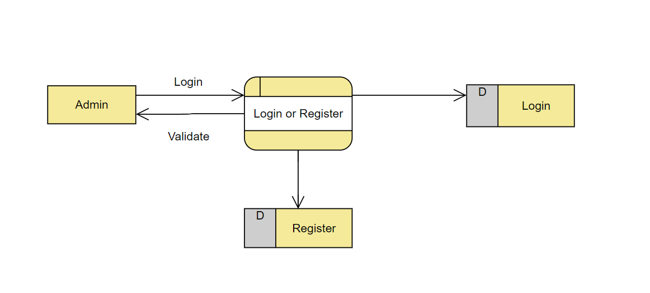

Figure 2 : Context level DFD (Level 0)

10

**FIEST LEVEL DFD**

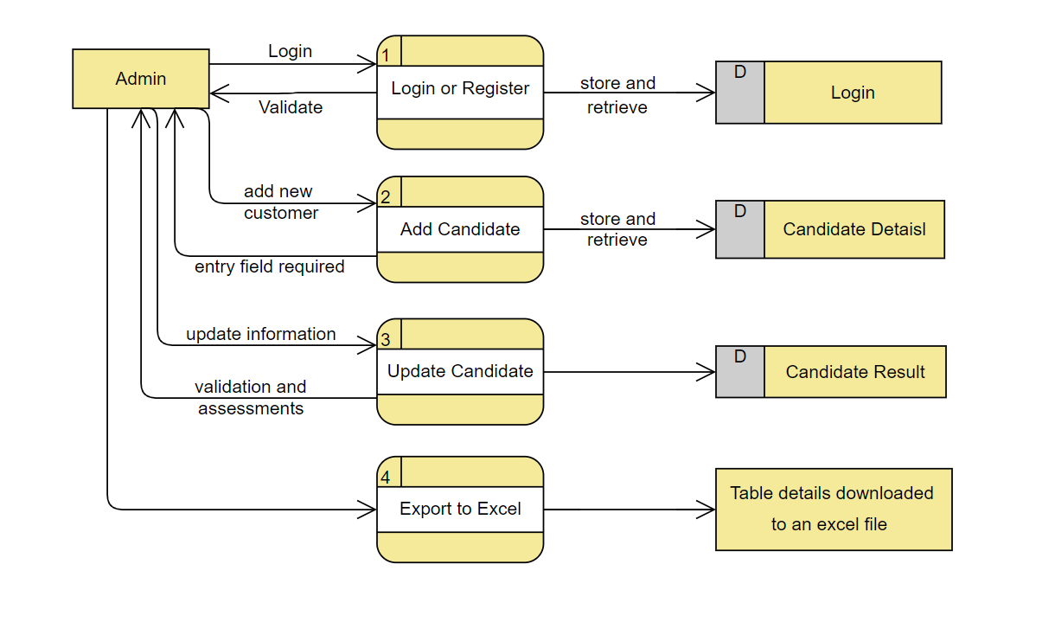

Figure 3: First Level DFD

11

**SECOND LEVEL DFD**

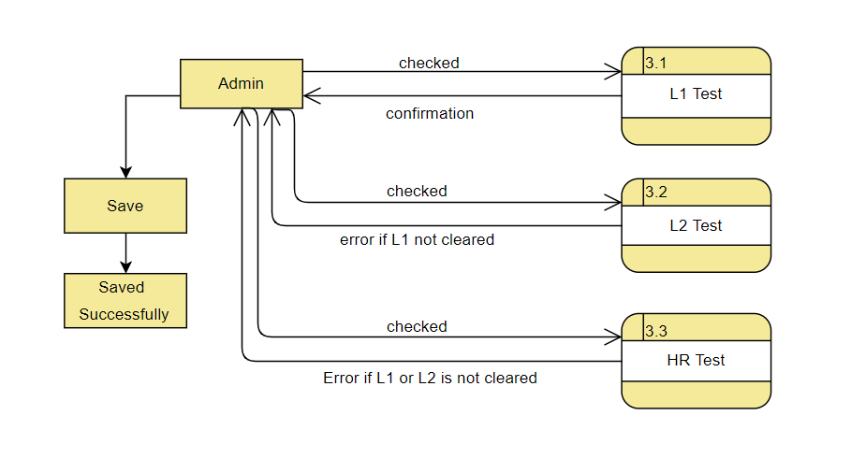

Figure 4: Second Level DFD

**3.4 WHAT’S NEW IN THE SYSTEM TO BE DEVELOPED**

The new system provides option for updating the candidate information online along with uploading their CVs. Using this application, actors could feed the information regarding their assessments of L1, L2 and HR interviews. It resolves the dirty read problem in case if multiple actors update the candidate records then this system avoid the concurrent updating of candidate results.

12

**4. PROBLEM ANALYSIS**

**4.1 PRODUCT DEFINITION**

**Product Name**: Resource Requisition Automation Tool

**Product Objective:** Aims at providing facilities to HR and employees to update details of candidates and their assessments.

**Language Used:**

**Front End**: JAVA

**Back End**: MySql

**4.2 FEASIBILITY ANALYSIS**

The feasibility for the project is done on the basis of the parameters like time required,

workers needed, hardware and software requirements, cost involved in the building of

this application. We check whether developing the project is beneficial.

Resources that are required to build up this project and make the testing system live

on the internet are:

Time – There are about 2-2.5 months to build up this project, starting from mid- February

2019 to end of April 2019.

Workers – The team must consist of the members skilled in coding of Java and must

be familiar with the concepts of Software Development.

This project was found to be completely feasible after the analysis done on the basis

of the above mention parameters.

**4.2.1 TECHNICAL FEASIBILITY**

The application is to be developed using JAVA Spring MVC Framework and MySQL. The pros and cons of the language were considered carefully so, to decide whether it is technically feasible to develop the website in JAVA or not.

* Spring Framework is lightweight.
* It works well with databases, excel sheet, Files, etc.

13

* Spring provides their own container for managing the bean lifecycle.
* This is another top feature of Spring framework where application dependencies are satisfied by the framework itself. Framework creates the object in runtime and satisfies application dependencies.
* Spring enables the developers to develop enterprise applications using POJOs (Plain Old Java Object). The benefit of developing the applications using POJO is, that we do not need to have an enterprise container such as an application server but we have the option of using a robust servlet container.

MySQL has been chosen over the other possibilities with the following reasoning:

* MySQL is license free for registered charities.
* MySQL can handle 50,000,000 + records.
* MySQL is an ideal database type to create a prototype of an e-commerce web site.
* The MySQL database can be easily upgraded to MS SQL at later date.

There are some cons too. But, the pros overweigh the cons and as we need to develop the project in optimal time and resources available. We conclude that the project is technically feasible.

**5. Software Requirement Analysis**

**5.1 Introduction**

The introduction of the Software Requirements Specification (SRS) provides an overview of the entire SRS with purpose, scope, definitions, acronyms, abbreviations, references and overview of the SRS.

**Scope**

This project is organization specific project and has been specially designed for Unites Parcel Service(UPS) which is business unit of Cognizant Technology Solution.

**5.2 General Description**

The application provides an interface for employees and HR to fill details of candidates along with their CV. Along with this, employees can update the information regarding assessments of L1, L2 and HR interviews. Also, records of candidates present in database can be fetched into excel sheet.

14

* 1. **Specific Requirements**

1. Employees/HR register into the application.
2. Employees log in and add records of candidate.
3. Employees can upload CV of each candidate.
4. Employees update the results of candidates based on different level of tests and interviews.
5. Perform exporting of candidate records from database to excel sheet.
6. Viewing all candidate details regarding assessments.

**5.4 Non-Functional Requirements**

**Usability**

**Graphical User Interface**

1. The system shall provide a uniform look and feel between all the web pages.
2. The candidate details are shown in tabular format.
3. Different buttons to navigate to different pages.
4. Enriched UI using checkboxes for clearing the tests.
5. Respective buttons for downloading CV of individual candidate.
6. Button to export database record into excel sheet.

**Performance**

1. The product shall be based on web and has to run from a web server.
2. The product shall take initial load time depending on internet connection strength which also depends on the media from which the product is run.
3. The performance shall depend upon hardware components of the client/customer

15

**Design Constraints**

Standard Development Tools

The system shall be built using a standard web page development tool like Eclipse

Web Based Product

1. There are minimum memory requirements.
2. The computers must be equipped with web browsers such as Internet explorer.
3. The product must be stored in such a way that allows the client easy access to it.
4. Response time for loading the product should take no longer than five minutes.
5. A general knowledge of basic computer skills is required to use the product

**Hardware Requirements**

1. RAM 4GB
2. Hard Disk 100GB
3. I/O devices Keyboard, mouse and monitor.

**Software Requirements**

1. Operating System- Windows
2. Technology -JAVA
3. Back-end Tool –MYSQL

16

**6. DESIGN**

**6.1 SYSTEM DESIGN FLOW DIAGRAM**

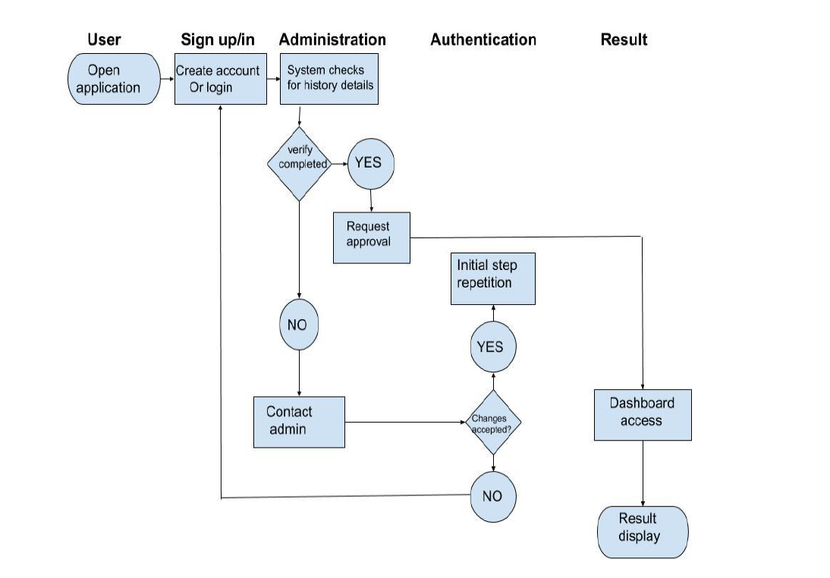

Figure 5: System design flow diagram

17

**6.2 DESIGN NOTATIONS**

**6.2.1 NOTATIONS FOR USE-CASE DIAGRAM**

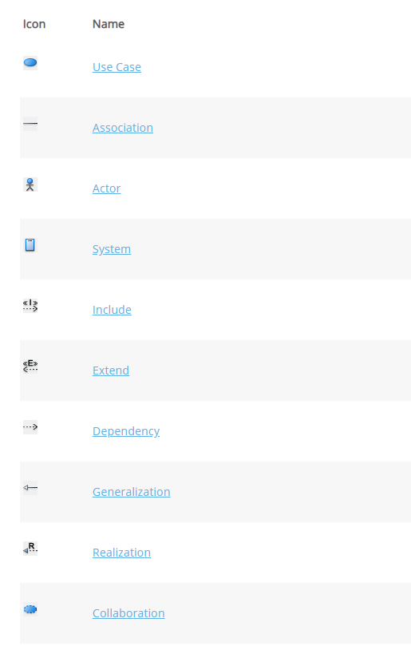

Figure 6: Use Case Diagram Notations

18

**6.2.2 E-R DIAGRAM NOTATIONS**

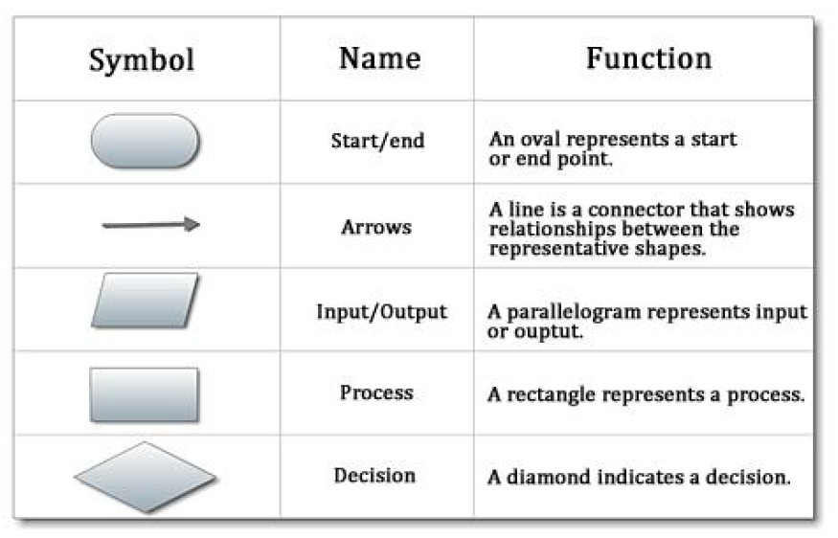

Figure 7: E-R Diagram Notations

19

**6.3 USE CASE DIAGRAM**

**Administrator:**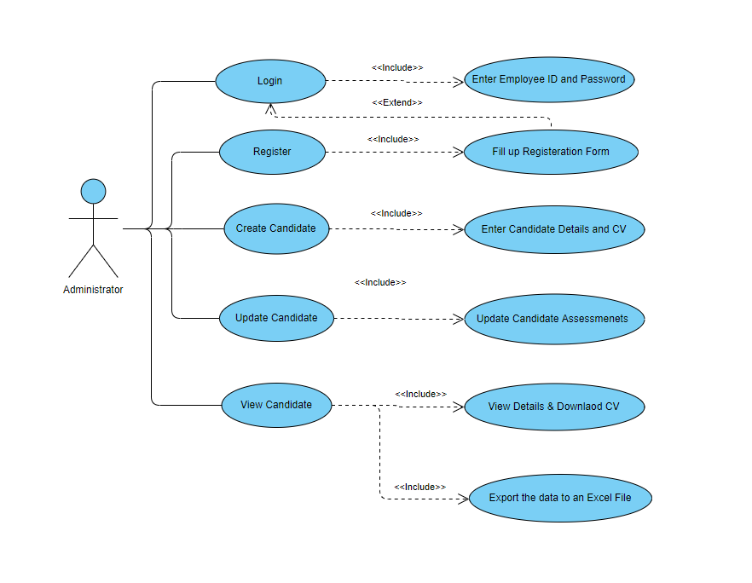

Figure 8: Administrator Use-Case Diagram

20

**6.4 FLOW CHARTS**

**6.4.1 LOGIN**

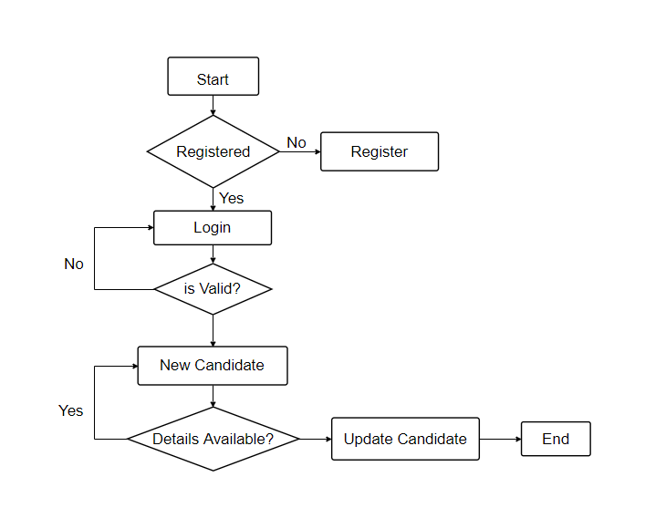

Figure 9: Login Flow Chart

21

**6.4.2 L1 ASSESSMENT**

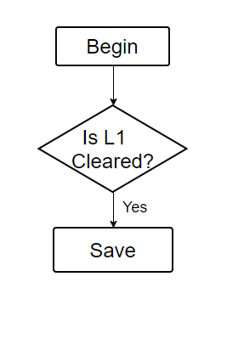

Figure 10: L1 Assessment Flow Chart

**6.4.3 L2 ASSESSMENT**

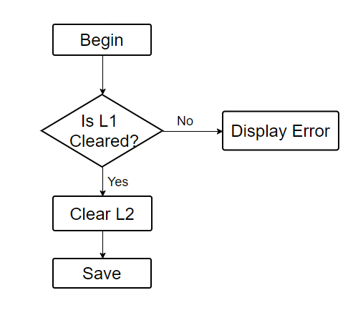

Figure 11: L2 Assessment Flow Chart

22

**6.4.4 HR ASSESSMENT**

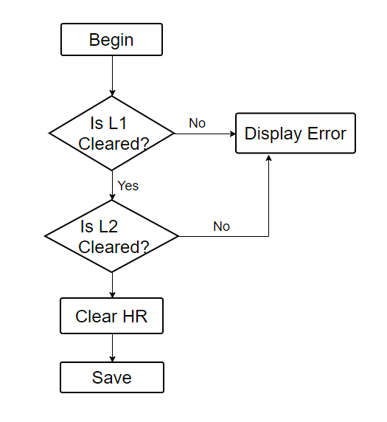

Figure 12: HR Flow Chart

23

**6.4.5 UPDATE CANDIDATE**



Figure 13: Update Candidate Flow Chart

24

**6.5 E-R DIAGRAM**

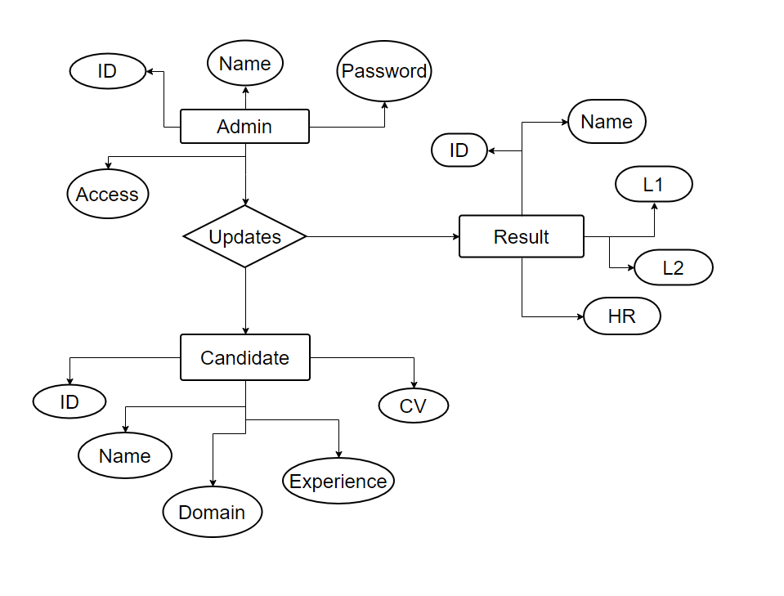

Figure 14: E-R Diagram

25

**6.6 DATA DICTIONARY**

**6.6.1 EMPLOYEE**

Table 1: Employee Data Dictionary

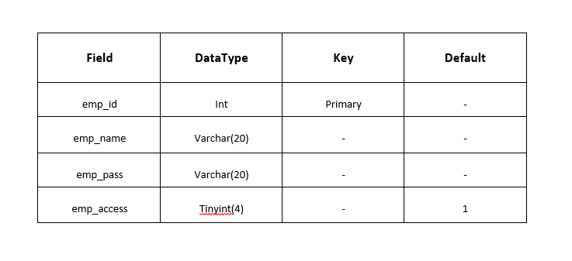

**6.6.2 CANDIDATE**

Table 2: Candidate Data Dictionary

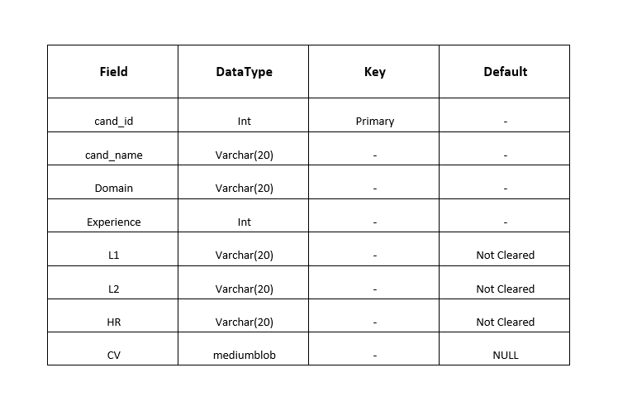

26

**6.6.3 RESULT**

Table 3: Result Data Dictionary

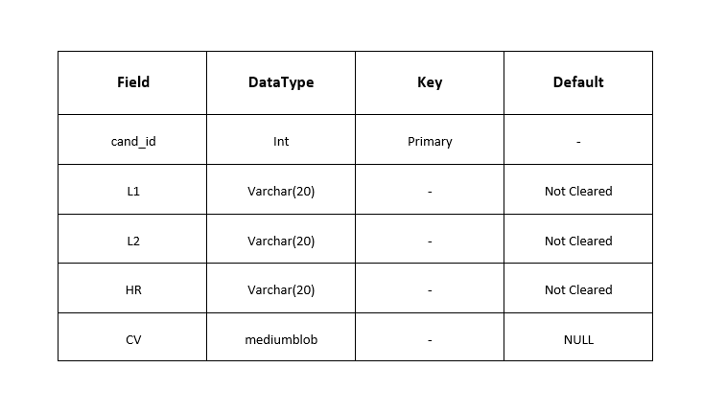

27

**6.7 DETAILED DESIGN**

**Admin**

**Use Case: REGISTER ON THE WEBSITE**

Table 4: Website Registration Design Case

|  |  |
| --- | --- |
| **Name** | **Register on the Website** |
| Brief Description | This use case helps the Administrator to register on the site . |
| **Actor** | Administrator |
| Secondary actor | None |
| Flow of Events | Basic Flow |
|  | 1. Administrator clicks on Register Link on the Home Page.  2. Registration Page opens wherein the customer has-to enter his Full name, Employee ID, desired password and confirm password.  3. If all the data is valid, then the actor is redirected to the log in page. |
|  | **Alternate Flow** |
|  | 1. If entered data is not valid or if all mandatory fields are not filled, then system displays same page with error message alerts. |
| |  |  | | --- | --- | | **Pre-Condition** |  | |  |  | | The user must not be already registered in the website |
| **Post condition** | User’s information be updated with the database |

28

**Use Case: LOGIN**

Table 5: Login Design Case

|  |  |
| --- | --- |
| **Name** | **Log in** |
| **Brief Description** | This use case helps the registered admin to login to the web app and access the services provided by the interface like adding candidates and updating their information. |
| **Actor** | Admin |
| **Secondary Actor** | None |
| **Flow of Events** | Basic Flow |
|  | 1. System displays Login page.  2. Customer enters his/her login credentials i.e.; employee ID and password.  3. System validates login data and directs the customer to his respective interface. |
|  | **Alternate Flow** |
|  | 1If login data is not valid, system displays same page with error messages. |
| **Pre-Condition** | User must be registered on the interface already. User information should be available with database. |
| **Post Condition** | User’s session starts with the system. |

29

**Use Case: Add Candidates**

Table 6: Add Candidate Design Case

|  |  |
| --- | --- |
| **NAME** | **Add Candidates** |
| **Brief Description** | This use case helps the admin to add a new candidate into the database of any domain, experience and respective candidate cv is mandatory. |
| **Actor** | Administrator |
| **Secondary Actor** | NA |
| **Flow of Events** | Basic Flow |
|  | 1. Administrator logs in. Login is authenticated.  2. Administrator clicks on Add Candidate Button.  3. Administrator will have to fill a form wherein he fills in the name of the candidate, candidate ID, domain, experience and CV of the candidate. |
|  | **Alternate Flow** |
|  | 1. If all details are not specified, error messages are shown. |
| **Pre-condition** | The administrator must be logged in |
| **Post-condition** | The new candidate is update in the web application. |

30

**Use Case: Update Candidate Details**

Table 7: Update Candidate Design Case

|  |  |
| --- | --- |
| **Name** | **Update Candidate Details** |
| **Brief Description** | This use case helps the administrator to update the information regarding the candidate assessments and HR interviews. |
| **Actor** | Administrator |
| **Secondary Actor** | None |
| **Flow of Events** | **Basic flow** |
|  | 1. A table containing the candidate details is being displayed which contains checkboxes for their L1, L2 and HR rounds. 2. Any candidates that have cleared any test, the admin need to check the corresponding checkboxes and enter the save button assigned beside respective candidates. |
|  | **Alternate Flow** |
|  | 1. If the candidate has not cleared the L1 assessments and admin check it’s L2 assessments it will throw an error, stating the candidate need to clear it’s L1 test first and L2 checkbox will not get checked. 2. Similarly, for clearing HR round, one need to clear the L1 and L2 assessments otherwise HR checkbox would not get checked |
| **Pre-condition** | The candidate must be there in database and administrator must be logged in. |
| **Post-condition** | The candidate information is successfully updated in the database. |

31

**Use Case: View All Candidates**

Table 8: View All Candidate Design Case

|  |  |
| --- | --- |
| **NAME** | **View All Candidates** |
| **Actor** | Administrator |
| **Secondary Actor** | None |
| **Flow of Events** | **Basic Flow** |
|  | 1. This page shows the static table of all the candidates and their information of their assessments if they are cleared or not cleared. 2. The admin could not edit in this page, so if he need to do any amendments, he need to go to the **Update Candidate Details** page. 3. The Administrator could also download the table into the system in an excel file, by clicking the export to Excel button present in the page. |
|  | **No Alternate Flow** |
| **Pre-condition** | The candidate must be there in database and administrator must be logged in. |
| **Post-condition** | A excel file is downloaded in the system containing the same details the database has at that instance. |

32

**7. TESTING**

During testing the programs to be tested are executed with set of test cases and the output of program for the test cases is evaluated to determine if the program is performing as expected. Testing forms is the first in determining errors in the program.

Once programs were tested individually then the system as a whole was tested. During testing the system is used experimentally to ensure that the software does not fail i.e. it will run according to its specification. The program executed to check for any syntax and logical errors. The errors are corrected and test is made to determine whether the program is doing what it is supposed to do.

**7.1 FUNCTIONAL TESTING**

Functional testing involves five steps:

1. The identification of functions that the software is expected to perform

2. The creation of input data based on the function’s specifications

3. The determination of output based on the function’s specifications

4. The execution of the test case

5. The comparison of actual and expected outputs

**7.2 LEVELS OF TESTING**

There are four types of testing which can be implemented, which are as follows:

1. Unit Testing
2. Integration Testing
3. System Testing
4. Acceptance Testing

In Unit Testing, we tested individual components like each controls for the validations to ensure that they operate correctly.

The next level is called Integration Testing. In this many units tested modules are combined into subsystems, which are then tested. The goal here is to see if the modules can be integrated properly. This testing activity can be considered testing the design.

In System Testing, we tested whether system elements have been properly integrated and perform allocated functions to detect the errors that may result from unanticipated interactions between sub-system and system components.

Finally, in Acceptance Testing, we tested whether the system is accepted for operational use.

33

**7.3 TESTING THE PROJECT**

Resource Requisition Automation Tool is an application that provides the functionality of of handling the file based system in an easy and efficient way and for this the major testing has been done only to authenticate the user so that the data integrity is maintained and no misuse of the data takes place.

The testing of the project has been done for the username and password entered at the login or signup page. If the user gets the access to the account of other user than this lacks the privacy of other users. So this has been carefully tested.

The testing of this has been done on the following was and certain test cases are presented

in the following table.

Table 9: Test Case Table

|  |  |  |  |  |
| --- | --- | --- | --- | --- |
| **TC01** | On register page enter valid employee id and password should be matched again | The password must follows the pattern specified (1Uppercasse, 1Lowercase, 1Numeric, and 1 Special character of length 8), and employee Id should be of 6 digit only | After the validation is all successful, the actor would be forwarded to the log in page | Pass |
| **TCO2** | On login page Enter valid Username and  Password. Then submit. | The credentials should match with database. Otherwise it will give error message. Then it will redirect it to the home page of RRAT. | After matching username and password it will forward it to the next page. | Pass |

34

|  |  |  |  |  |
| --- | --- | --- | --- | --- |
| **TC03** | On the page of adding new candidates, the credentials also carry certain validation like the id of the candidate must be 6 digit long, and all the rest fields of the page is required | There should be no existing candidate with the same employee id, and the experience and domain of the candidate must be selected. The cv file is mandated to be a pdf format only. | After successfully filling the details of the candidate and selecting the cv file. The candidate is added into the database and the page is refreshed. | Pass |
| **TC04** | On the page of editing the details of the candidate regarding their assessments of L1 and l2 and HR interview. The admin could check the checkboxes of respective assessments to clear or unclear any candidate for the respective test. One could also search the candidate based on domain, experience, id or name. | The chronology of the test is maintained. i.e. if the admin tries to clear the L2 assessment of the candidate who have not yet cleared their L1 assessment the page will throw an error stating that the candidate need to clear its L1 assessments. Similarly, for HR round candidate need to clear their L1 and L2 test. | As per the updated data, the information of candidate is now updated in the database , | Pass |
| **TC05** | In the next page, the admin could see the static value of the database. Here he could not edit the details of the candidate but only see that which candidate has cleared or not cleared. The admin could also filter the table on the basis of domain of the employee. He could also export the data present in the database into an excel file. | He could filter the table if he wanted to see the employee of JAVA/ .NET domain, he could. | The admin could also download the excel file which contain the same details as in the database. If he desire to change any detail of any candidate he need to go to the candidate detail lpage of the web application, | pass |

35

**8. IMPLEMENTATION**

**PROCESS MODEL USED BY US**

**Spiral model**

The Spiral model originally proposed by Boehm, is an evolutionary software process

model that couples the iterative nature of prototyping with the controlled & systematic

aspects of the linear sequential model. It provides the potential for rapid development

of incremental version of the software.

Using the spiral model software is developed in a series of incremental releases. A

spiral model is divided into a number of framework activities also called task regions.

A spiral model contains six task regions:

**1. Customer Communication:** Tasks required to establish effective communication

between developer & customer.

**2. Planning:** Tasks required to define resources, timeline & other project related

information.

**3. Risk analysis:** Task required to access.

**4. Engineering:** Tasks required to build one or more representation of the application.

**5. Construction & release:** Task required to construct, test, install & provide user

support (e.g., documentation & Training)

**6. Customer evaluation:** Tasks required to obtain customer feedback based on

evolution of the software representation created during the engineering stage &

implemented during the installation stage.

**8.1 CONVERSION PLAN**

To make this project live, i.e., to build application file for the project followed:

1. Installation of Eclipse IDE.
2. Select a server at which you will host your web application.
3. Once Eclipse is set, you need to create the maven project and select the suitable web-app.
4. Select the Database which will serve the purpose of the application accordingly.
5. We need to give the right to the admin who could change the database table and details.
6. After all the business logic Is successfully written and implemented. The project is live!

36

**8.2 POST IMPLEMENTATION OF PROJECT AND MAINTAINANCE**

The Post Implementation Review (PIR) is conducted after a project has been

completed. The purpose of the PIR is to evaluate how successfully the project

objectives have been met and how effective the project management practices were in

keeping the project on track.

In our project the all objectives met to the requirements and it is more affective as

user wants. According to the user requirements the project functionality and

objectives are made according to his.

It is generally found that systems that are easy to use, require less manpower, saves

the data entry and well received by people. But still the following points have to

consider.

1. How have systems changed the way in which operations were performed?

2. How have systems changed the timeliness of information and reports user

received?

**9. PROJECT LEGACY**

**9.1 CURRENT STATE OF PROJECT**

The current status of our project is that all modules like login, home page, add new candidate page, edit details page, view all candidate page of the project are completed and their design,

coding and testing are done. The application is completely developed and tested.

**9.2 REMAINING AREAS OF CONCERN**

There are still, after a lots of efforts, the areas of concern in the project. To make smart

features uploading the CV and enhancing the way the files are downloaded either be cv or excel file from web app to the system. To reduce the loading time of modules.

**9.3 TECHNICAL AND MANAGERIAL LESSONS LEARNT**

We have learnt a lot of things while developing the project.

1. Working with the Eclipse IDE.

2. Working with server side tasks.

3. Creating AJAX and JQuery function calls and other functions using them.

4. Exporting of database to an excel sheet.

5. Creating and managing databases using MYSQL and using it in Spring MVC.

6. Working in a team and co-ordination among them.

7. Problem Analysis and problem solving with the team mates.

37

**10. USER MANUAL**

**10.1 REGISTER**

1. Run the application.

2. Login Screen will appear on the desktop. Click on Register here or Signup Button.

3. Enter the valid credentials of the employee registration form including the employee id, password, employee name.

4. These are validated with certain validations and on successful validation the user gets redirected to the login page for login.

**10.2 LOGIN**

1. Run the application.

2. If you are a registered user then enter the credentials with which you have created the account.

3. The credentials include the employee id and password.

4. These are validated from the data from the database.

5. On Successful validation user gets redirected to the homepage.

**10.3 ADD CANDIDATE**

1. Run the application.

2. Login with valid credential.

3. User gets directed to the add candidate page on successful login.

4. A candidate for is shown for adding the details of the candidate including the candidate name, candidate ID, domain, experience.

5. After filling these details click on upload CV and submit button.

6. A popup window appears to let user select a CV which should be of PDF format.

7. If all details are correct then candidate gets added and employee gets redirected to the update candidate page.

38

**10.4 UPDATE CANDIDATE**

1. Run the application.

2. Login with valid credential.

3. User gets directed to the add candidate page on successful login.

4. Click on the update candidate button on the left panel of the screen.

5. The data for each candidate is shown in the form of a list along with the checkboxes of the L1, L2 and HR assessments.

6. User can filter the data from the search box given at the top of the screen.

7. If the L1 is checked and save button clicked then data gets saved for that candidate and updated in the database.

8. If the L2 is checked and save button clicked then a pre-condition is checked if the candidat has cleared the L1 assessment or not. If the L1 is not cleared, then the error message is shown else the data gets saved for that candidate and updated in the database.

9. If the HR is checked and save button clicked then two pre-conditions are checked if the candidate has cleared the L1 assessment and L2 assessments or not. If the L1 is not cleared, then the error message is shown, if L1 is cleared but L2 not cleared then also the error message is shown else the data gets saved for that candidate and updated in the database.

**10.5 VIEW CANDIDATE**

1. Run the application.

2. Login with valid credential.

3. User gets directed to the add candidate page on successful login.

4. Click on the view candidate button on the left panel of the screen.

5. A list of candidates along with the details of the assessments cleared or not are shown. Also there is a button against each row of candidate for downloading the CV.

6. If the CV download button is clicked then the CV of that particular candidate is fetched from the database and shown in a new window.

6. An export to excel button is also shown on the screen which is used to fetch all the data from the database and extract it to an excel file. That excel file is downloaded and shown in a new window.

39

**11. USER INTERFACE SCREENSHOTS**

**Register Page**

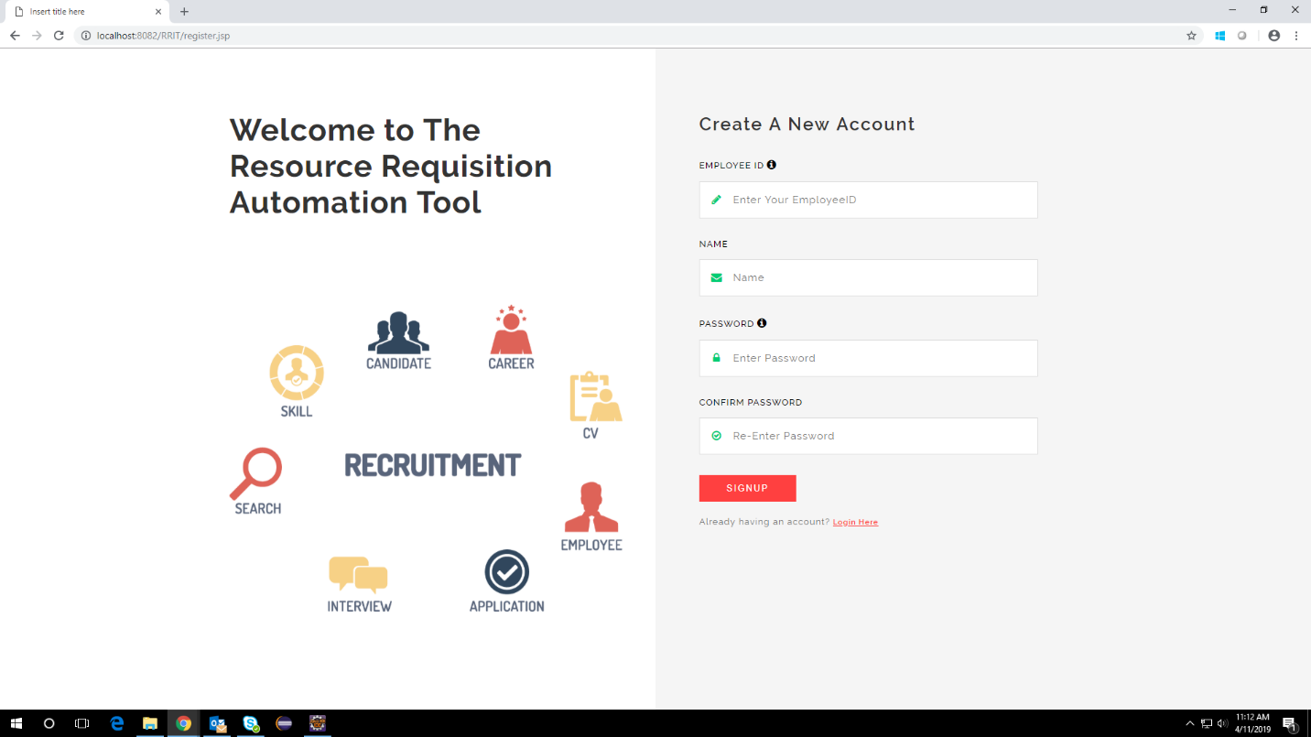

Figure 15: Register Page

40

**Login**

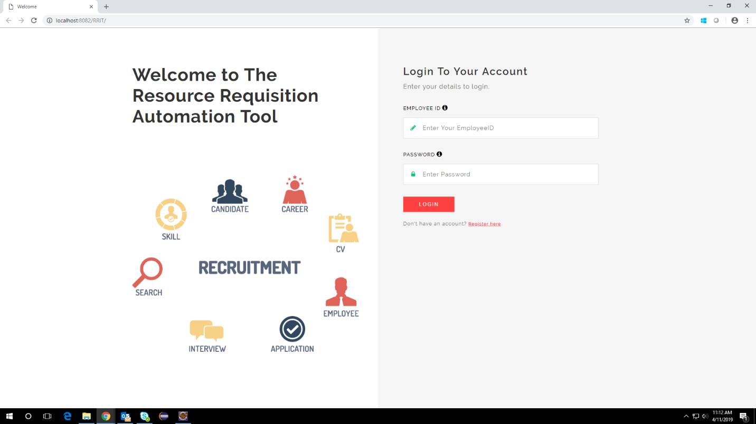

Figure 16: Login Page

**Add Candidate**

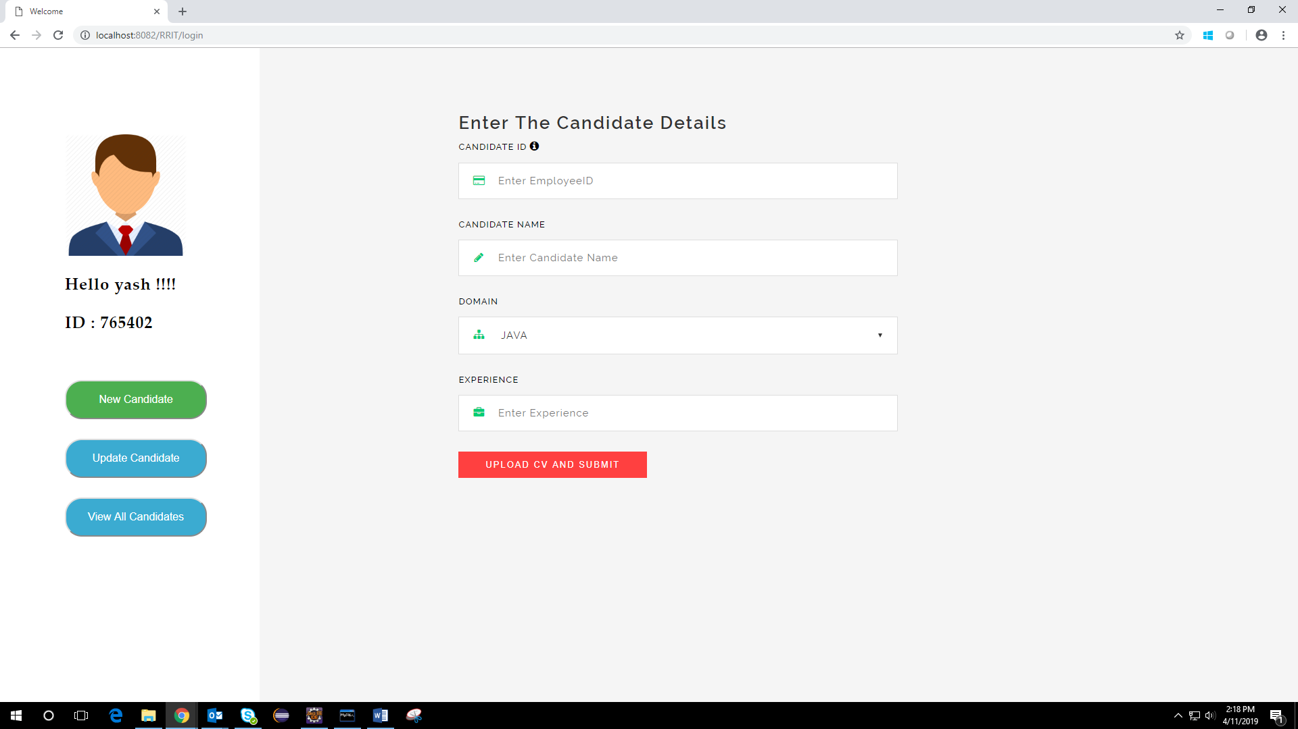

Figure 17: Add Candidate Page

41

**Update candidate**

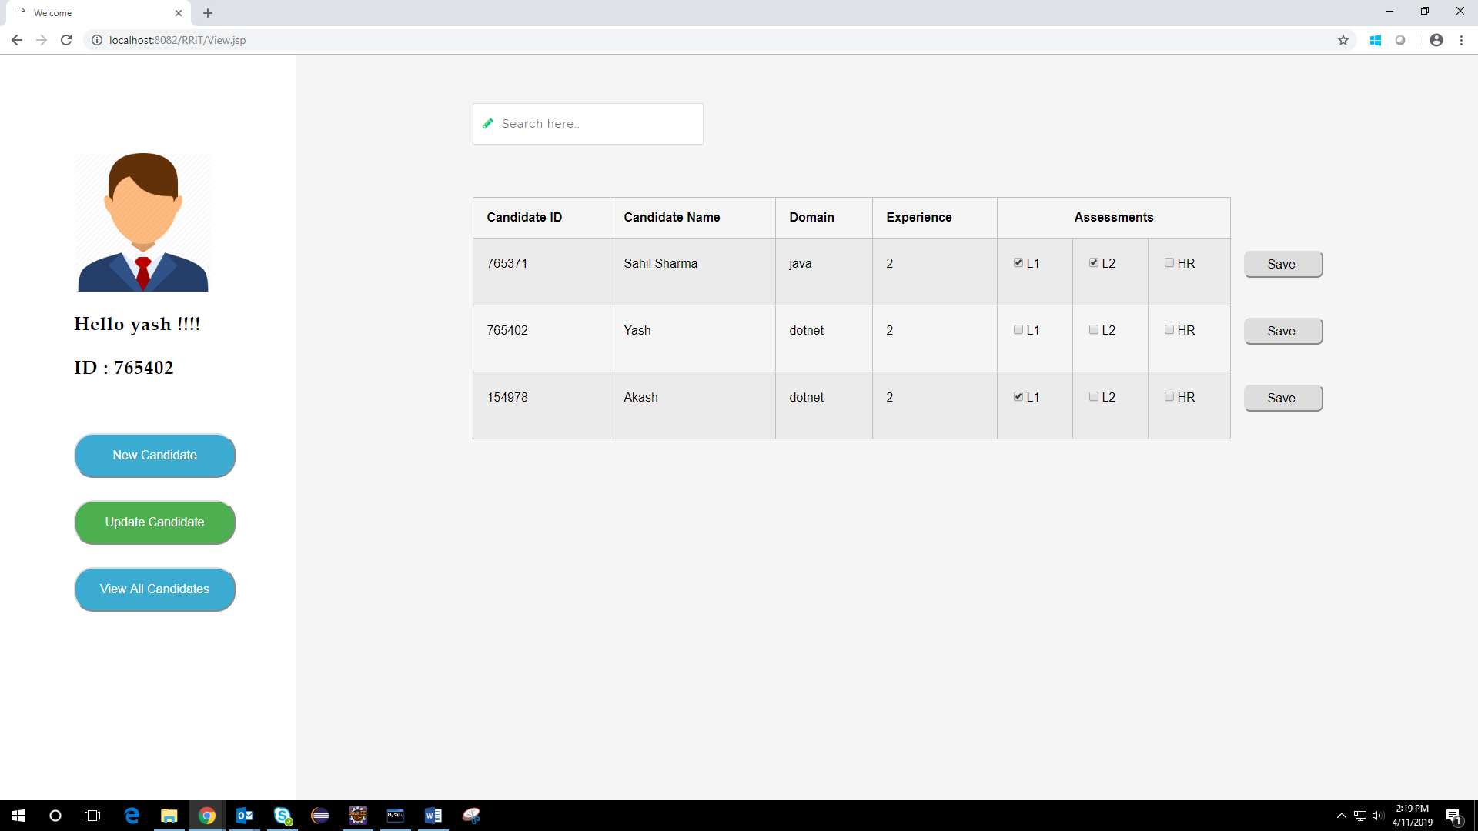

Figure 18: Update Candidate Page

**View candidate**

\

C 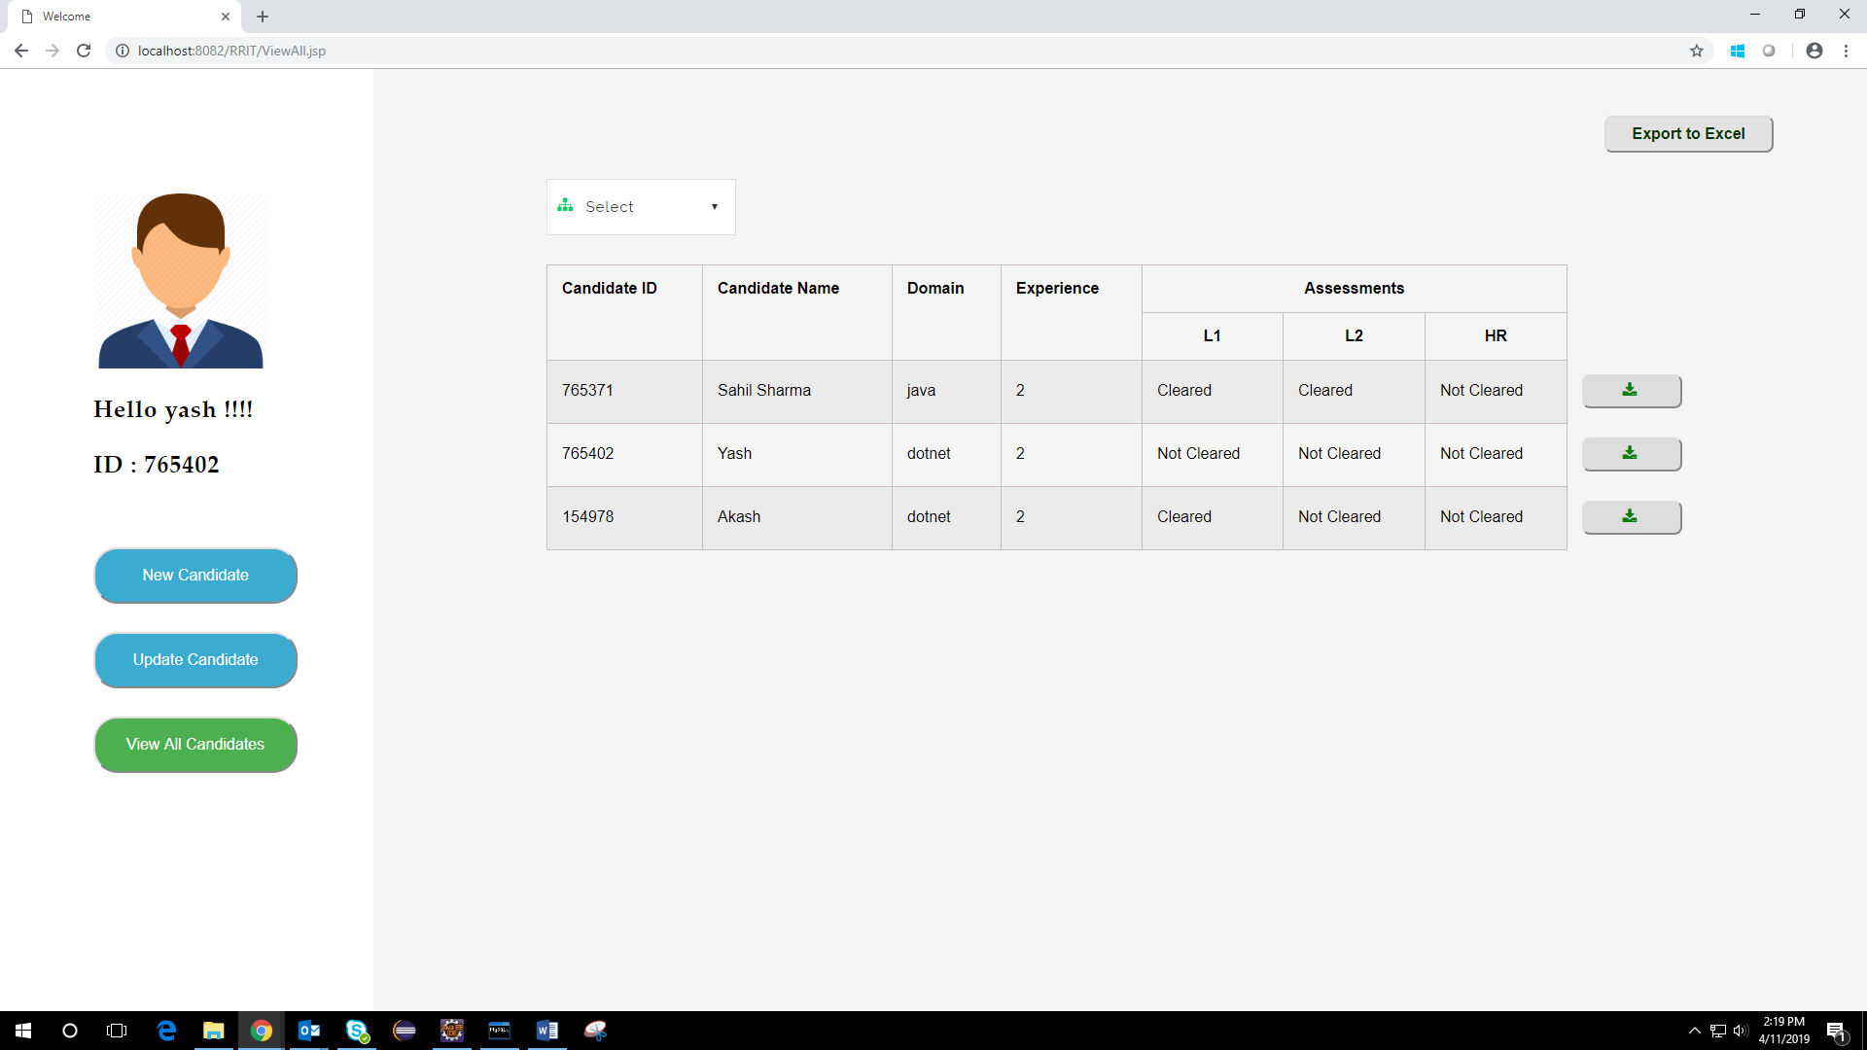

Figure 19: View Candidate Page

42

**12. BIBLIOGRAPHY**

1. <https://spring.io/docs/reference>
2. <https://stackoverflow.com/questions/tagged/SpringMVC>
3. <https://www.w3schools.com/jquery/>
4. <https://poi.apache.org/>
5. <https://www.javatpoint.com/spring-mvc-crud-example>
6. <https://coderanch.com/f/7/Servlets>

43