Linked List:-it consists of a data part and a node

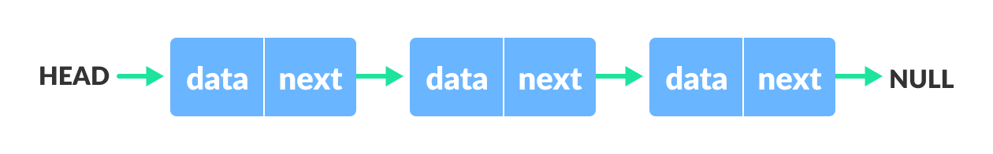

1. Singly Linked List:-It is the most common types .each node has data and pointer to the next node



1. Doubly Linked list:-We add a pointer to the previous node and,so that we can go either to way

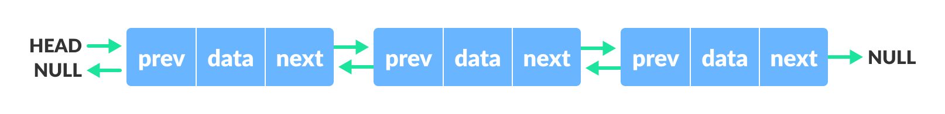

1. Circular Linked List:-In which last node is linked with the first element.This form a loops

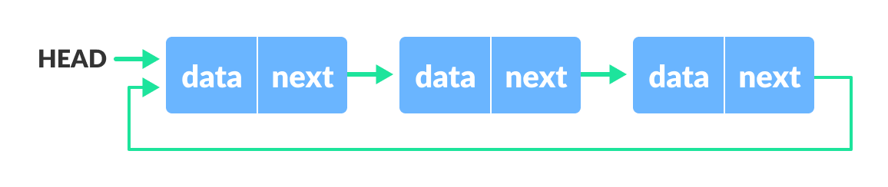

1. Stack:-A stack is linear data structure which follow the LIFO principle the main operation in stack are push() and pop()

IsEmpty():- check stack is empty

IsFull():- check stack is full

Peek():-get the value of top element

1. Queue:- A stack is linear data structure which follow the FIFO principle the main operation in queue

Enque():- insertion

Dequeue():deletion

1. Linear Search:-

LinearSearch(Array A, Value x)

1. Set I to 1
2. If i>n then go to step 7
3. If A[i]=x then go to step 6
4. Set I to i+1
5. Go to step 2
6. Print element x found at index i go to step 8
7. Print element not found

7 Binary Search:-

Do until the pointer low and high meet each other

Mid=(low+high)/2

If(x==arr[mid])

Return mid

else if(x>arr[mid])

low=mid+1

else

mid=low +1