Lab Assignment-01

ROLL: 2005535 | NAME: SAHIL SINGH | DATE: 12/01/22

**QUES 1: Create a table STUDENT with the following attributes and data given:**

STUDENT (StudentId, Last, First, Street, City, State, Zip, StartTerm, BirthDate, FacultyId, MajorId, Phone)

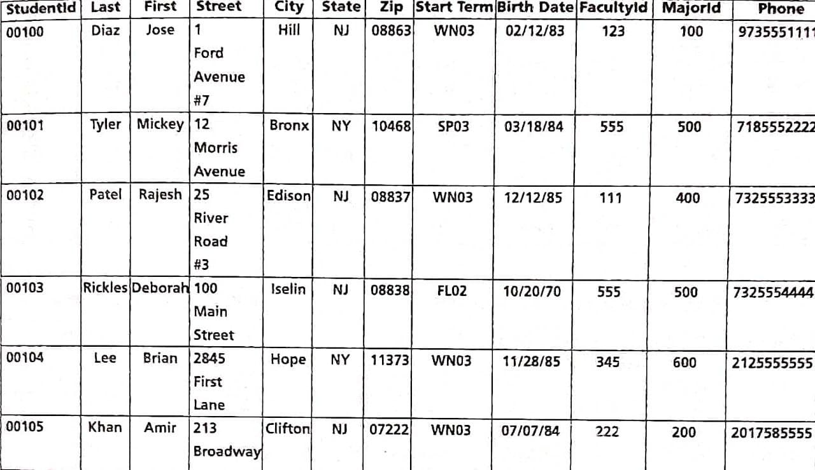

**SOLUTION:**

**SQL>** create table student (studentid varchar(5), last varchar(10), first varchar(10), street varchar(35),city varchar(10), state varchar(2), zip varchar(5), startterm varchar(4), birthdate date, facultyid number(3), majorid number(3), phone number(10));

**SQL>** desc student;

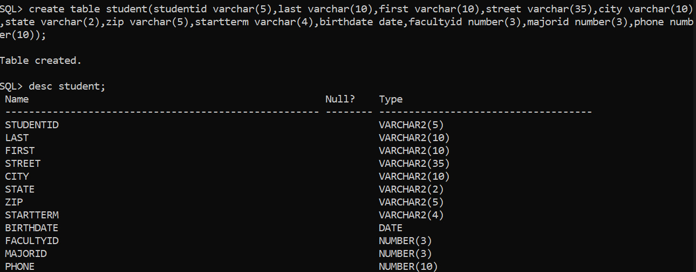

**SQL>** insert into student values ('00100', 'Diaz', 'Jose', '1 Ford Avenue #7', 'Hill', 'NJ', '08863', 'WN03', '12-feb-1983', 123, 100, 9735551111);

**SQL>** insert into student values ('00101', 'Tyler', 'Mickey', '12 Morris Avenue', 'Bronx', 'NY', '10468', 'SP03', '18-mar-1984', 555, 500, 7185552222);

**SQL>** insert into student values ('00102', 'Patel', 'Rajesh', '25 River Road #3', 'Edison', 'NJ', '08837', 'WN03', '12-dec-1985', 111, 400, 7325553333);

**SQL>** insert into student values ('00103', 'Rickles', 'Deborah', '100 Main Street', 'Iselin', 'NJ', '08838', 'FL02', '20-oct-1970', 555, 500, 7325554444);

**SQL>** insert into student values ('00104', 'Lee', 'Brian', '2845 First Lane', 'Hope', 'NY', '11373', 'WN03', '28-nov-1985', 345, 600, 2125555555);

**SQL>** insert into student values ('00105', 'Khan', 'Amir', '213 Broadway', 'Clifton', 'NJ', '07222', 'WN03', '07-jul-1984', 222, 200, 2017585555);

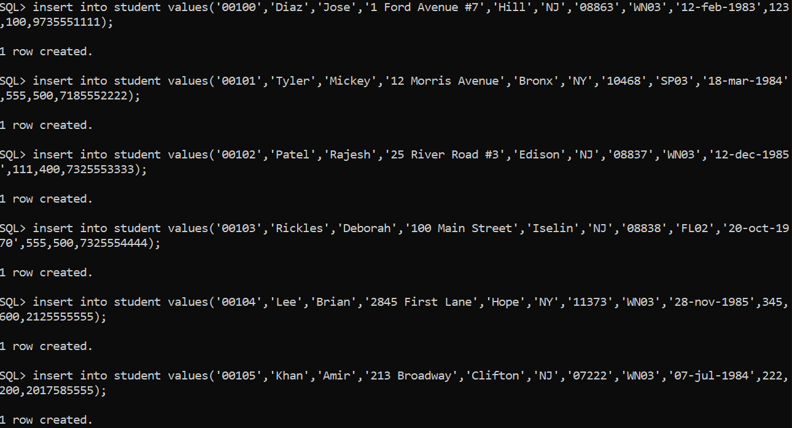

**SQL>** select * from student;



