Lab Assignment-10

ROLL: 2005535 | NAME: SAHIL SINGH | DATE: 21/04/22

QUES 1: Write a PL/SQL block to create a explicit cursor using For Loop and display the employees who have salary greater than 4800.

SOLUTION:

DECLARE

var_record employees%ROWTYPE;

CURSOR cur IS SELECT * FROM employees WHERE salary > 4800;

BEGIN

OPEN cur;

LOOP

FETCH cur INTO var_record;

EXIT WHEN cur%NOTFOUND;

DBMS_OUTPUT.PUT_LINE('Name: ' || var_record.first_name || chr(9)||' Salary: '|| var_record.salary);

END LOOP;

CLOSE cur;

END;

/

OUTPUT:

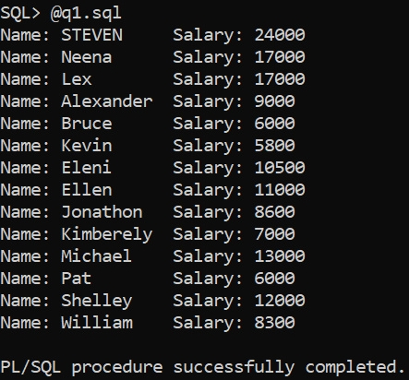

QUES 2: Write a PL/SQL block to create a cursor based records and display the total number of rows present in the table.

SOLUTION:

DECLARE

CURSOR cur IS SELECT employee_id,first_name,last_name,salary FROM employees;

var_record cur%ROWTYPE;

BEGIN

OPEN cur;

LOOP

FETCH cur INTO var_record;

EXIT WHEN cur%NOTFOUND;

DBMS_OUTPUT.PUT_LINE('Employees Details : '||' '||var_record.employee_id ||' '||var_record.first_name||' '||var_record.last_name);

END LOOP;

DBMS_OUTPUT.PUT_LINE('Total number of rows : '||cur%ROWCOUNT);

CLOSE cur;

END;

/

OUTPUT:

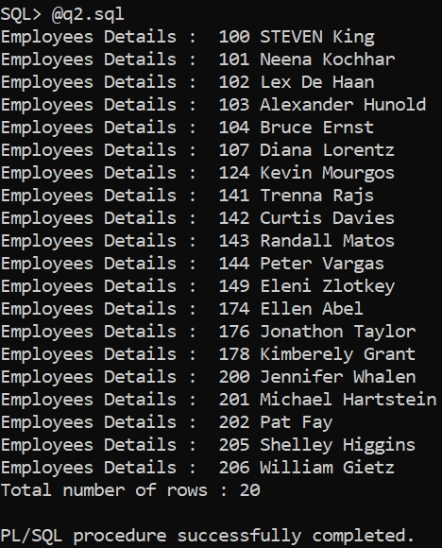

QUES 3: Write a PL/SQL block to create a cursor in nested loops and display the records department wise.

SOLUTION:

DECLARE

CURSOR cur IS SELECT * FROM departments WHERE manager_id IS NOT NULL ORDER BY department_name;

var_record cur%ROWTYPE;

--Declaration of departments cursor and record variable.

CURSOR cur2 (cur_no departments.department_id%TYPE) IS SELECT * FROM employees WHERE department_id = cur_no;

var_record2 cur2%ROWTYPE;

--Declaration of employees cursor and record variable.

BEGIN

OPEN cur;

LOOP

FETCH cur INTO var_record;

EXIT WHEN cur%NOTFOUND;

DBMS_OUTPUT.PUT_LINE('----------------------------------');

DBMS_OUTPUT.PUT_LINE('Department Name : '||var_record.department_name);

DBMS_OUTPUT.PUT_LINE('----------------------------------');

OPEN cur2(var_record.department_id);

LOOP

FETCH cur2 INTO var_record2;

EXIT WHEN cur2%NOTFOUND;

DBMS_OUTPUT.PUT_LINE('Employees Details : '||var_record2.employee_id||' '||var_record2.first_name||' '||var_record2.last_name||' '||var_record2.salary);

END LOOP;

CLOSE cur2;

END LOOP;

CLOSE cur;

END;

/

OUTPUT:

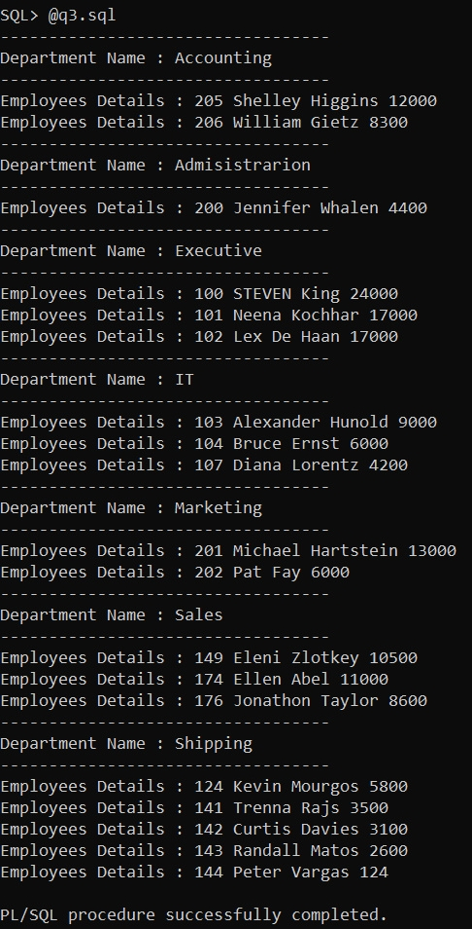

QUES 4: Declare a cursor c1 to retrieve the last name, salary, hire date, and job class for the employee whose employee ID is 120.

SOLUTION:

DECLARE

var_record employees%ROWTYPE;

cursor c1 IS SELECT * FROM employees WHERE employee_id = 124;

BEGIN

OPEN c1;

LOOP

FETCH c1 INTO var_record;

EXIT WHEN c1%NOTFOUND;

DBMS_OUTPUT.PUT_LINE('Last Name: ' || var_record.last_name || chr(9) || ' Salary: ' || var_record.salary || ' Hire Date: ' || var_record.hire_date || ' Job Class: ' || var_record.job_id);

END LOOP;

CLOSE c1;

END;

/

OUTPUT:



