Lab Assignment-02

ROLL: 2005535 | NAME: SAHIL SINGH | DATE: 12/01/22

**QUES 1: Practice SQL Fundamental Commands on the table shown below:**

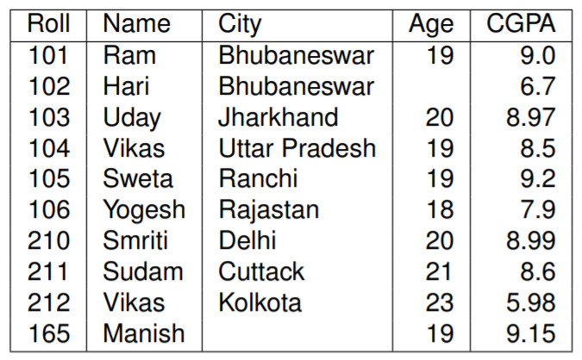

**SOLUTION:**

**TABLE CREATION:**

SQL> insert into student_table values(101,'Ram','Bhubaneswar',19,9.0);

SQL> insert into student_table(Roll,Name,City,CGPA) values(102,'Hari','Bhubaneswar',6.7);

SQL> insert into student_table values(103,'Uday','Jharkhand',20,8.97);

SQL> insert into student_table values(104,'Vikas','Uttar Pradesh',19,8.5);

SQL> insert into student_table values(105,'Sweta','Ranchi',19,9.2);

SQL> insert into student_table values(106,'Yogesh','Rajasthan',18,7.9);

SQL> insert into student_table values(210,'Smriti','Delhi',20,8.99);

SQL> insert into student_table values(211,'Sundam','Cuttack',21,8.6);

SQL> insert into student_table values(212,'Vikas','Kolkata',23,5.98);

SQL> insert into student_table(Roll,Name,Age,CGPA) values(165,'Manish',19,9.15);

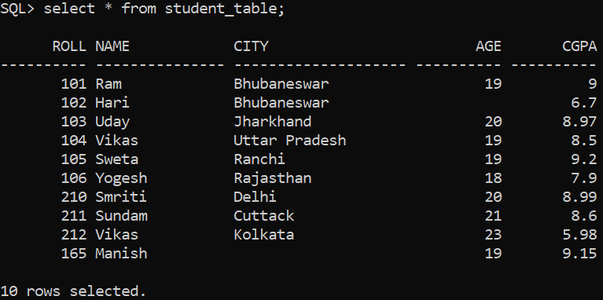

**SELECT STATEMENT:**

SQL> select Roll,CGPA from student_table;

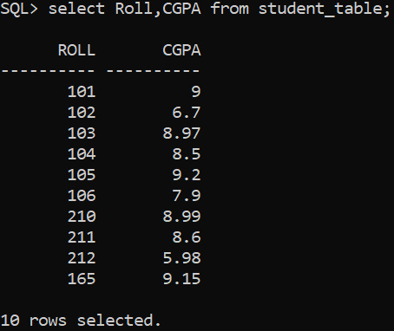

**DISPLAYING DISTINCT ROWS:**

SQL> select distinct city from student_table;

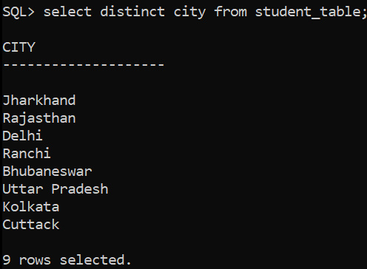

**USE OF ARITHEMATIC EXPRESSIONS:**

SQL> select Name,Age,Age+3 from student_table;

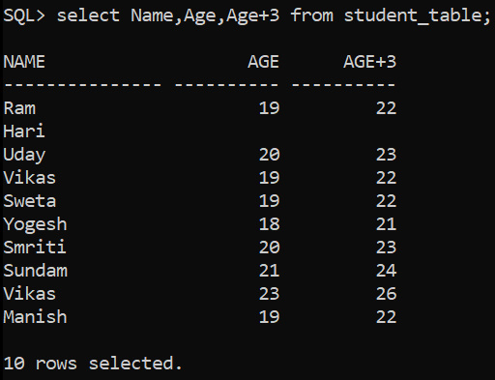

**USE OF ALIAS:**

SQL> select Name,Age,Age+3 "Passing Age" from student_table;

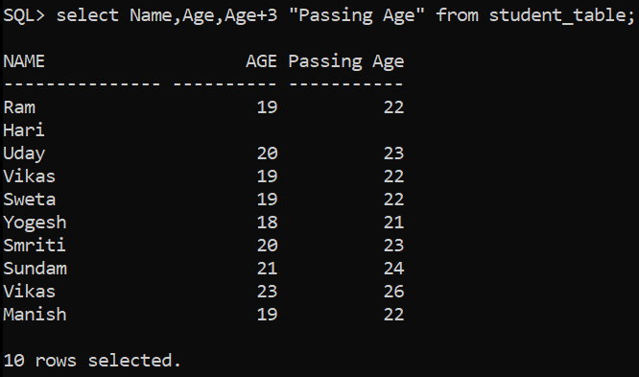

**CONCATENATION:**

SQL> select Name||' '||City from student_table;

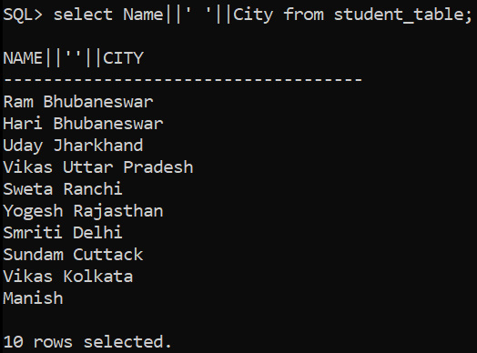

SQL> select Name||' '||City as "Address" from student_table;

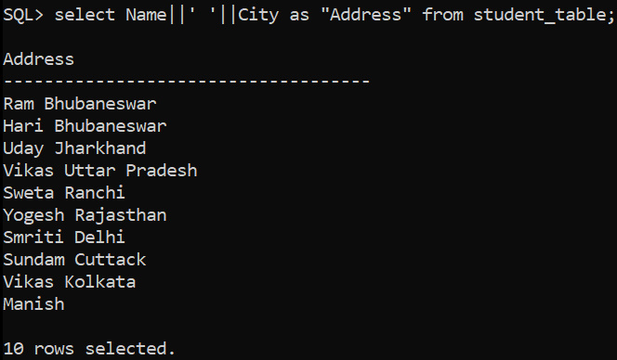

**SELECTING SPECIFIC RECORDS:**

SQL> select * from student_table where City='Bhubaneswar';

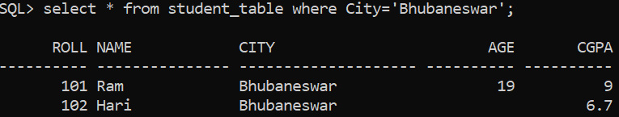

**RELATIONAL OPERATORS:**

SQL> select * from student_table where Age>ANY(20,23,19);

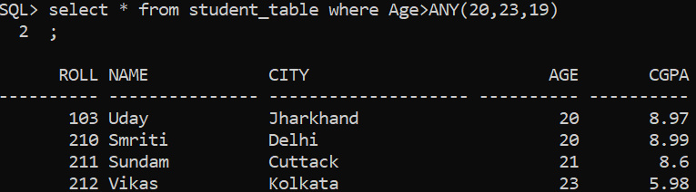

SQL> select * from student_table where Age>ALL(20,18);

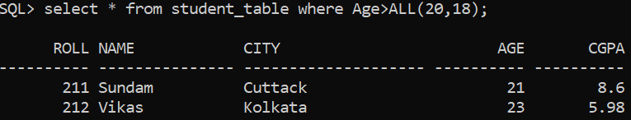

SQL> select * from student_table where Age>=ALL(20,18);

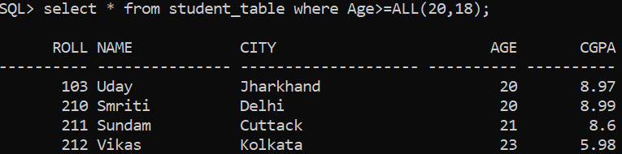

**LOGICAL OPERATORS:**

SQL> select * from student_table where City='Bhubaneswar' AND Age=19;

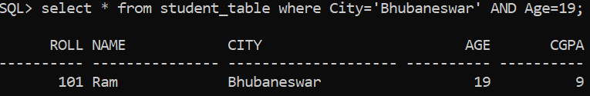

SQL> select * from student_table where NOT(Age=20 OR Age=21);

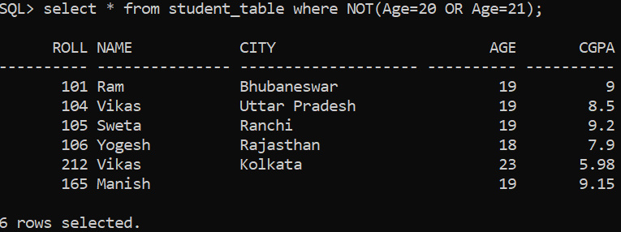

**LIKE OPERATOR:**

SQL> select * from student_table where Name LIKE 'S%';

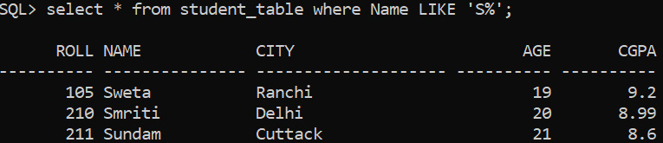

SQL> select * from student_table where Name LIKE 'S____';

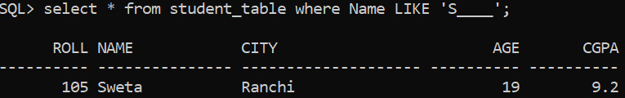

SQL> select * from student_table where Name LIKE '%i%';

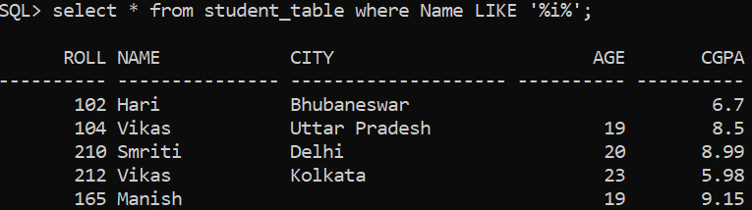

SQL> select * from student_table where Name LIKE '_i%';

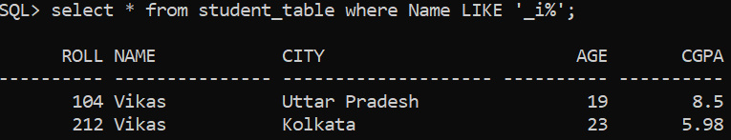

**SPECIAL OPERATORS:**

SQL> select * from student_table where City IN('Delhi','Cuttack','Ranchi');

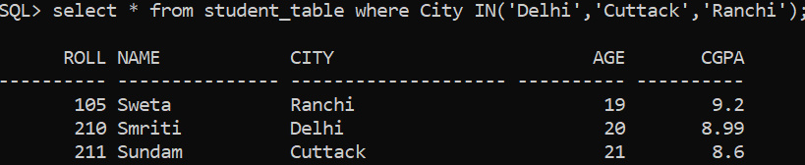

SQL> select * from student_table where Age BETWEEN 20 AND 22;

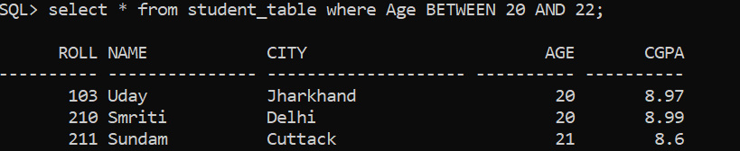

SQL> select Name from student_table where Age IS NULL;

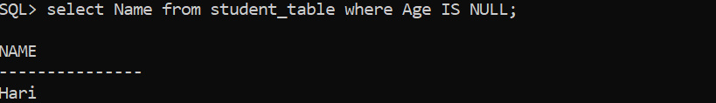

**ORDER BY CLAUSE USING COLUMN NAME:**

SQL> select * from student_table ORDER BY Age;

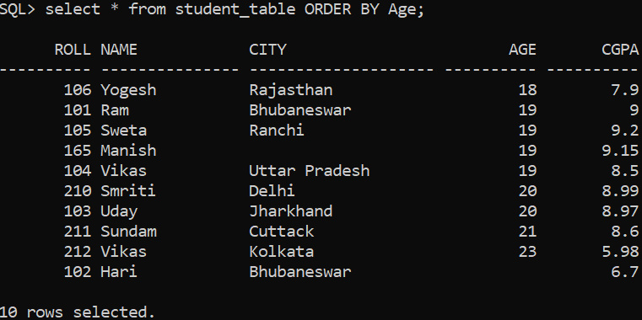

SQL> select * from student_table ORDER BY CGPA,Age DESC;

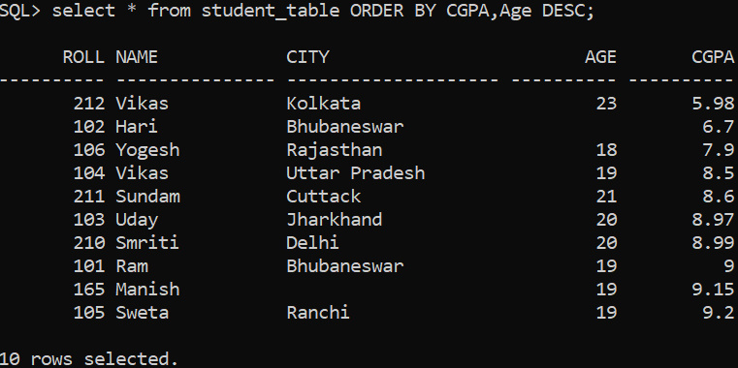

**ORDER BY CLAUSE USING COLUMN NUMBER:**

SQL> select * from student_table ORDER BY 3;

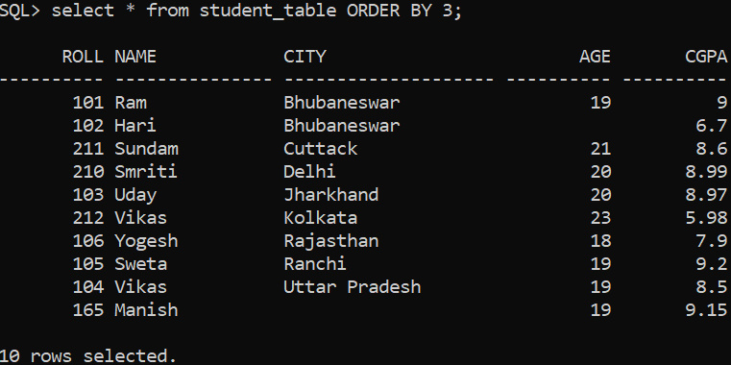

SQL> select * from student_table ORDER BY 4;

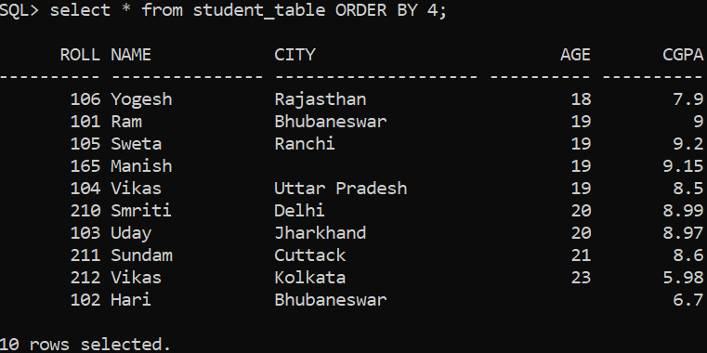

**ADDING A NEW COLUMN:**

SQL> alter table student_table add(Address NUMBER(20));

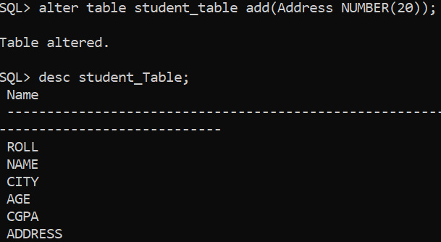

**MODIFYING AN EXISTING COLUMN:**

SQL> alter table student_table modify(Address varchar2(20));

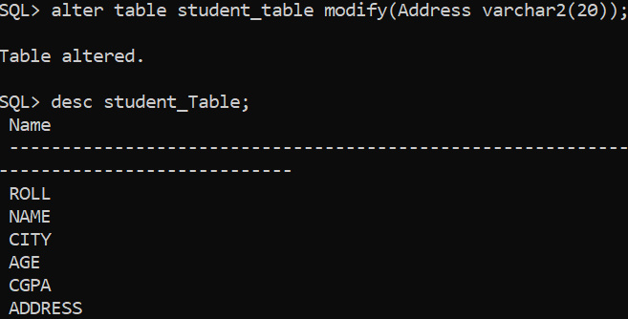

**DROPPING A COLUMN:**

SQL> alter table student_table drop column Address;

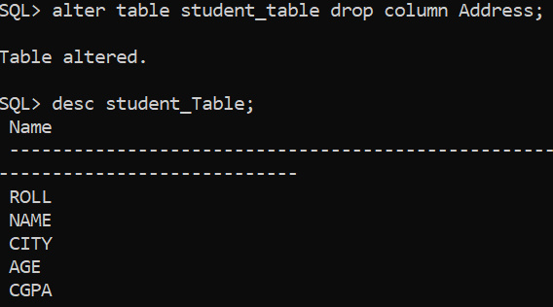

**RENAMING A COLUMN:**

SQL> alter table student_table rename column Roll to ID;

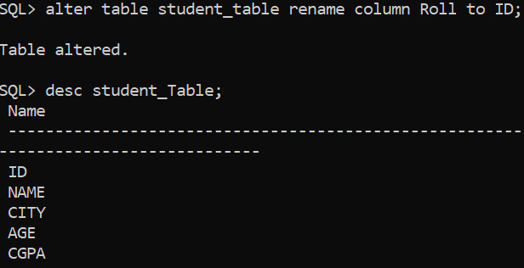

**UPDATE STATEMENT:**

SQL> update student_table SET branch='CSE' where Roll=101;

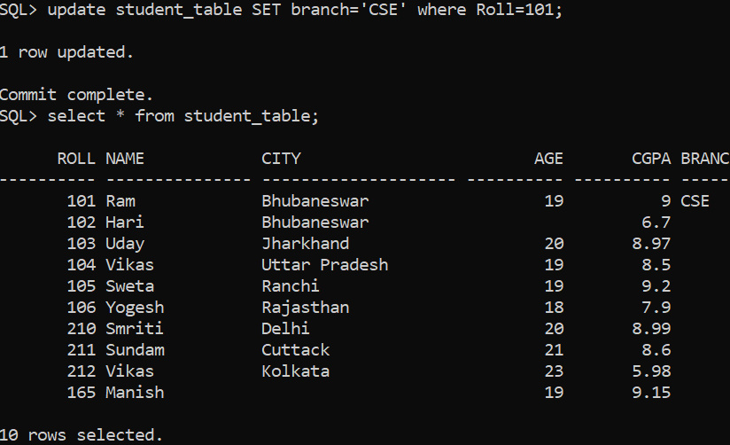

**DROP COMMAND:**

SQL> drop table student_table;

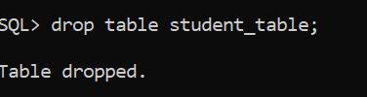

**TRUNCATE COMMAND:**

SQL> truncate table student_table;

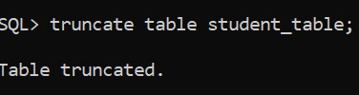

**DELETE COMMAND:**

SQL> delete from student_table where Roll=101;

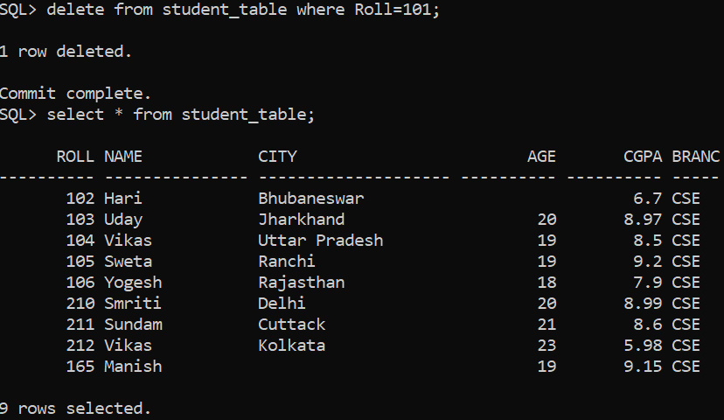

SQL> delete from student_table;

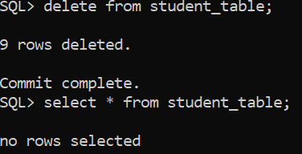

**RENAME COMMAND:**

SQL> rename student_table to student_table1;

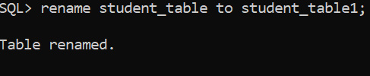

**VIEWING ALL USER OBJECTS:**

SQL> select * from tab;

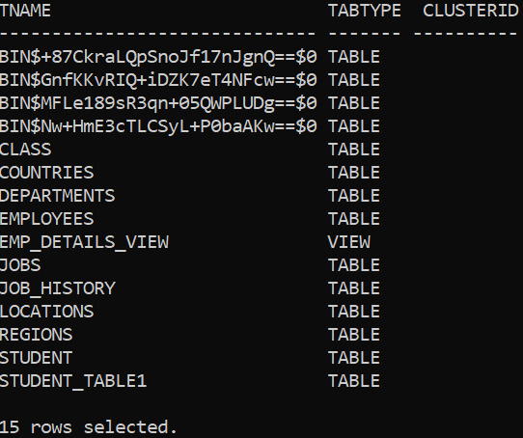

**VIEWING ALL USER TABLES:**

SQL> select table_name from user_tables;

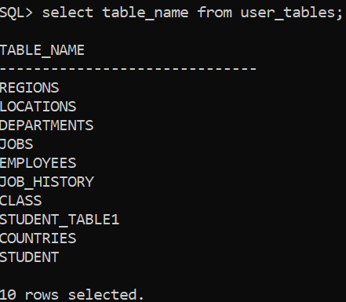

**CREATE TABLE FROM ANOTHER TABLE:**

SQL> create table Person(Roll,Name,Age) as select Roll,Name,Age from student_table1;

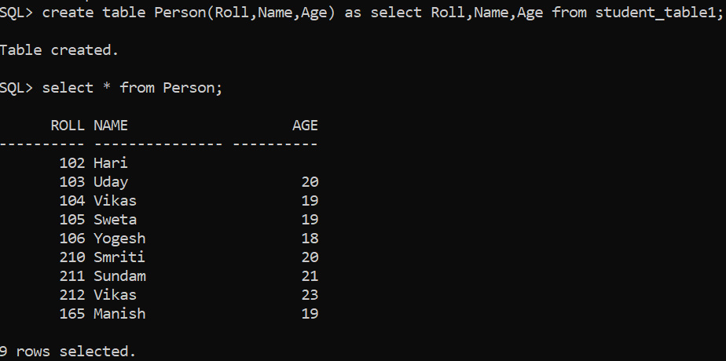

**INSERTING DATA INTO A TABLE FROM ANOTHER TABLE:**

SQL> insert into Person select Roll,Name,Age from student_table where Roll=103;

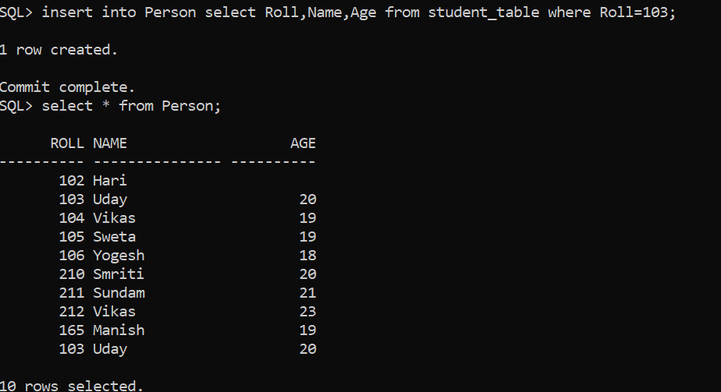

SQL> insert into Person select Roll,Name,Age from student_table;

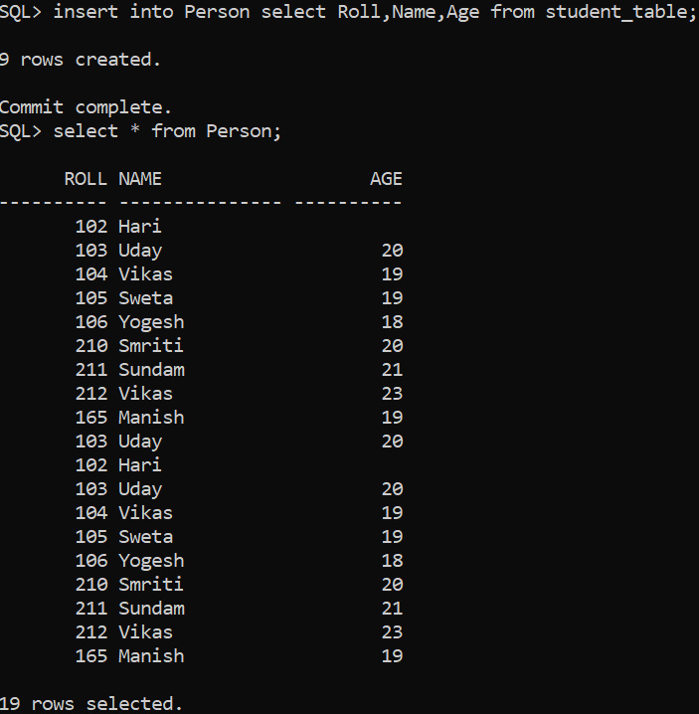

**ROWID:**

SQL> select ROWID, Roll from student_table;

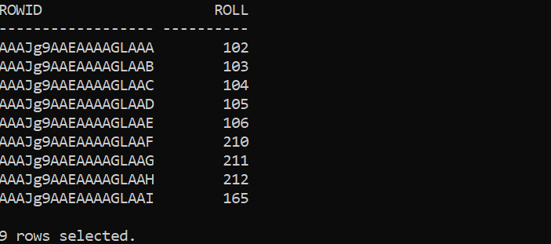

SQL> delete from student_table where ROWID='AAAJg9AAEAAAAGLAAI';



