Lab Assignment-03

ROLL: 2005535 | NAME: SAHIL SINGH | DATE: 02/02/22

QUES 1: Create the following tables.

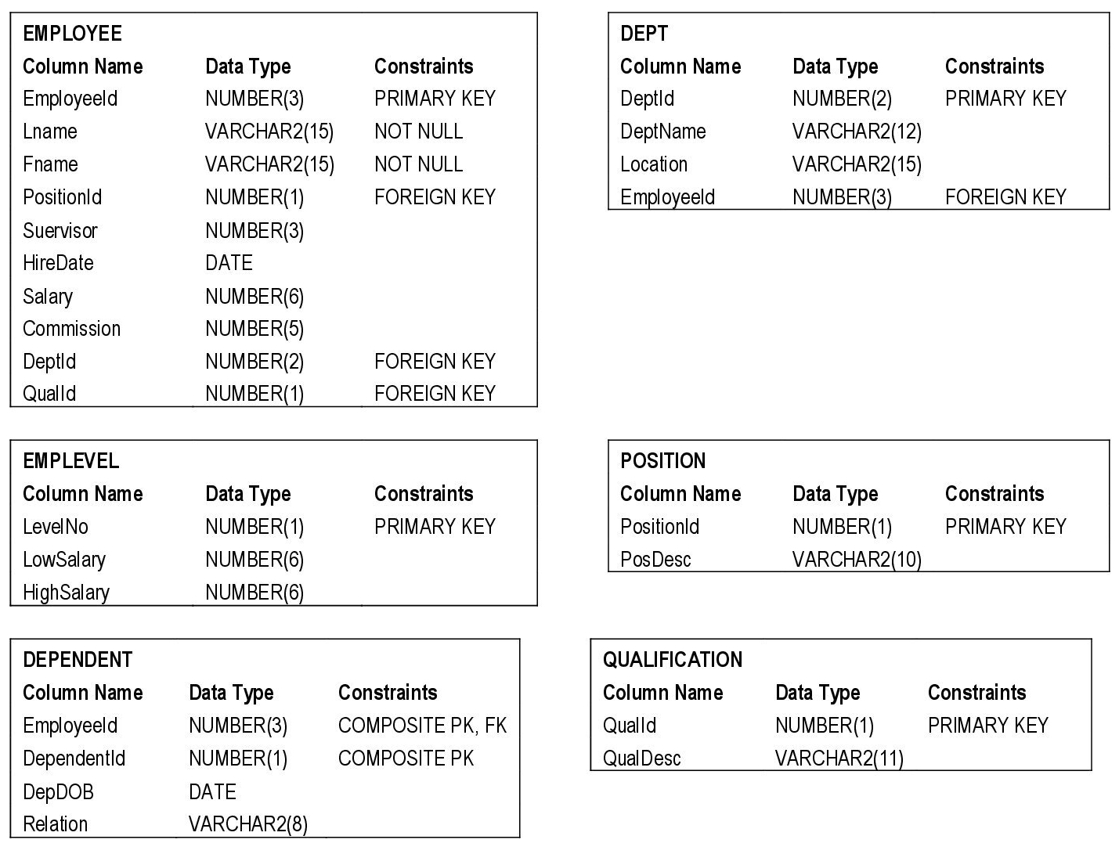

SOLUTION:

Tables Creations with Primary Key Constraints:

SQL> create table qualification(

2 QualId number(1) constraint qualification_QualId_pk PRIMARY KEY,

3 QualDesc varchar2(11));

SQL> create table position(

2 PositionId number(1) constraint position_PositionId_pk PRIMARY KEY,

3 PosDesc varchar2(10));

SQL> create table dept(

2 DeptId number(2) constraint dept_DeptId_pk PRIMARY KEY,

3 DeptName varchar2(12),

4 Locatin varchar2(15),

5 EmployeeId number(3));

SQL> create table emplevel(

2 LevelNo number(1) constraint emplevel_LevelNo_pk primary key,

3 LowSalary number(6),

4 HighSalary number(6));

SQL> create table dependent(

2 EmployeeId number(3),

3 DependentId number(1),

4 DepDOB date,

5 Relation varchar2(8));

SQL> create table employee(Employeeid number(3) constraint employee_Employeeid_pk primary key,

2 Lname varchar2(15) constraint employee_Lname_nn not null,

3 Fname varchar2(15) constraint employee_Fname_nn not null,

4 Positionid number(1),

5 Supervisor number(3),

6 Hiredate date,

7 salary number(6),

8 commision number(5),

9 Deptid number(2),

10 Qualid number(1));

Use of Alter Commands to add composite and foreign keys in the tables created:

SQL> Alter table Dependent

2 ADD CONSTRAINT CompKey_empdep PRIMARY KEY(EmployeeId,DependentId);

SQL> alter table Dept add constraint Dept_Employeeid_fk foreign key(Employeeid) references

2 Employee(Employeeid);

SQL> alter table Employee add constraint Employee_Positionid_fk foreign key(Positionid) references

2 Position(Positionid);

SQL> alter table Employee add constraint Employee_Deptid_fk foreign key(Deptid) references

2 Dept(Deptid);

SQL> alter table Employee add constraint Employee_Qualid_fk foreign key(Qualid) references

2 Qualification(Qualid);

Displaying Constraints of each table:

SQL> select constraint_name, table_name from user_constraints where table_name='QUALIFICATION';

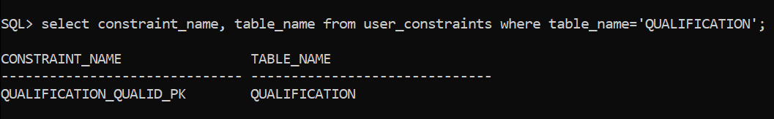

SQL> select constraint_name, table_name from user_constraints where table_name='POSITION';

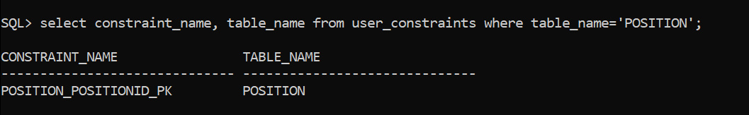

SQL> select constraint_name, table_name from user_constraints where table_name='DEPT';

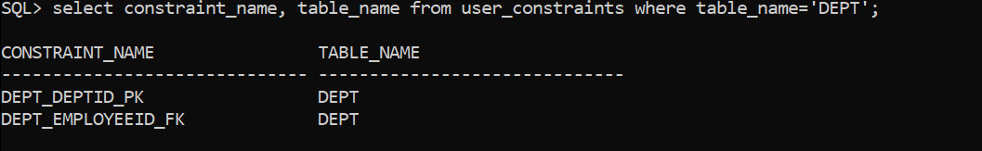

SQL> select constraint_name, table_name from user_constraints where table_name='EMPLEVEL';

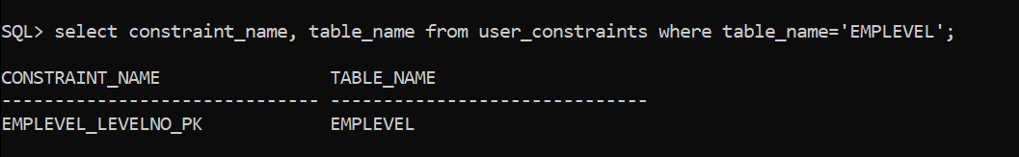

SQL> select constraint_name, table_name from user_constraints where table_name='DEPENDENT';

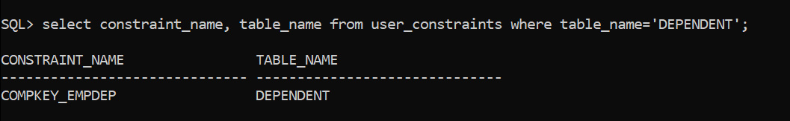

SQL> select constraint_name, table_name from user_constraints where table_name='EMPLOYEE';



