Lab Assignment-03

ROLL: 2005535 | NAME: SAHIL SINGH | DATE: 02/02/22

QUES 1: Insert the following values in the tables created.

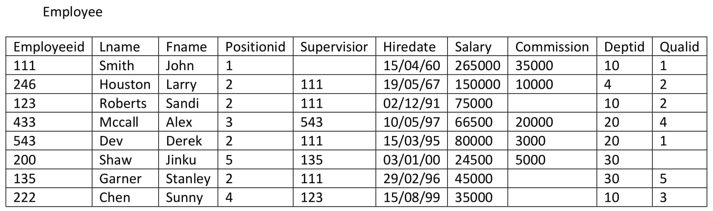

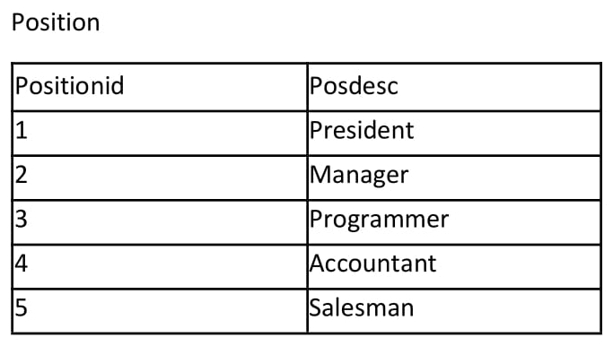 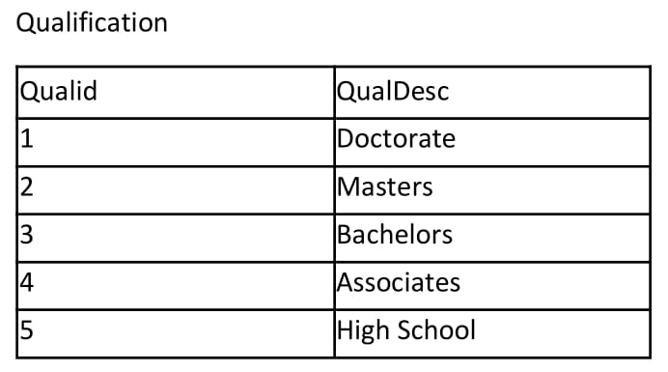

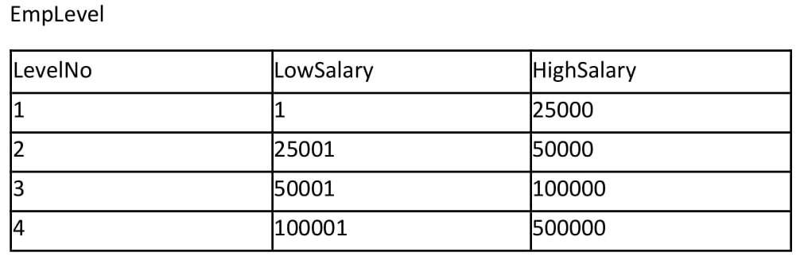

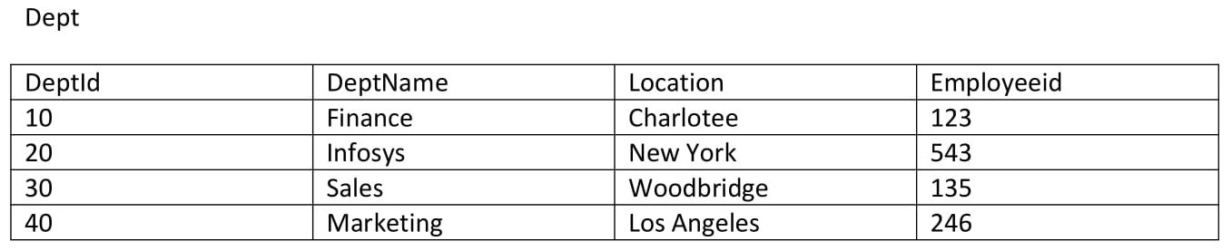

SOLUTION:

Data Insertion:

(EMPLOYEE TABLE)

SQL> insert into Employee values(111, 'Smith', 'John', 1, NULL, '15-Apr-60', 265000, 35000, 10, 1);

SQL> insert into Employee values(246, 'Houston', 'Larry', 2, 111, '19-May-67', 150000, 10000, 40, 2);

SQL> insert into Employee values(123, 'Roberts', 'Sandi', 2, 111, '02-Dec-91', 75000, NULL, 10, 2);

SQL> insert into Employee values(433, 'Mccall', 'Alex', 3, 543, '10-May-97', 66500, 20000, 20, 4);

SQL> insert into Employee values(543, 'Dev', 'Derek', 2, 111, '15-Mar-95', 80000, 3000, 20, 1);

SQL> insert into Employee values(200, 'Shaw', 'Jinku', 5, 135, '03-Jan-00', 24500, 5000, 30, 5);

SQL> insert into Employee values(135, 'Garner', 'Stanley', 2, 111, '29-Feb-96', 45000, NULL, 30, 5);

SQL> insert into Employee values(222, 'Chen', 'Sunny', 4, 123, '15-Sep-99', 35000, NULL, 10, 3);

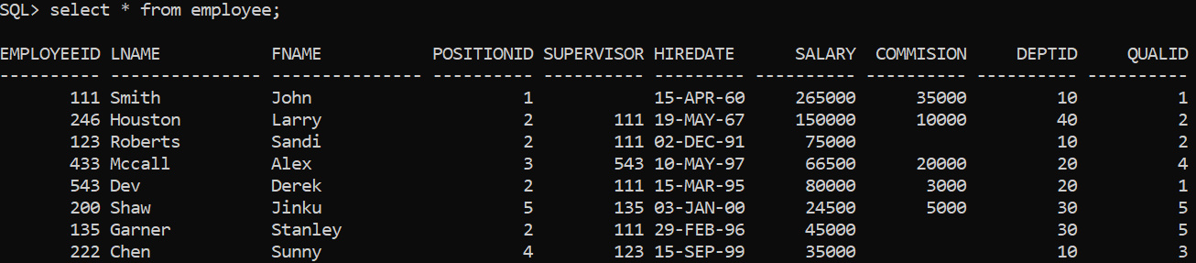

(EMPLEVEL TABLE)

SQL> insert into Emplevel values(1, 1, 25000);

SQL> insert into Emplevel values(2, 25001, 50000);

SQL> insert into Emplevel values(3, 50001, 100000);

SQL> insert into Emplevel values(4, 100001, 500000);

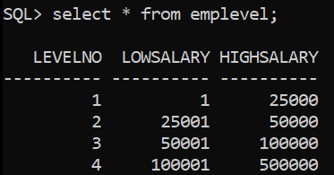

(DEPENDENT TABLE)

SQL> insert into Dependent values( 543, 1, '28-Sep-1958', 'Spouse');

SQL> insert into Dependent values( 543, 2, '14-Oct-88', 'Son');

SQL> insert into Dependent values( 200, 1, '10-Jun-76', 'Spouse');

SQL> insert into Dependent values( 222, 1, '04-Feb-75', 'Spouse');

SQL> insert into Dependent values( 222, 2, '23-Oct-97', 'Son');

SQL> insert into Dependent values( 222, 3, '10-Sep-99', 'Daughter');

SQL> insert into Dependent values(111, 1, '12-Dec-45', 'Spouse');

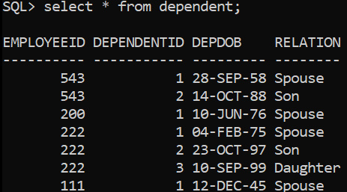

(DEPT TABLE)

SQL> insert into Dept values(10, 'Finance', 'Charlotte', 123);

SQL> insert into Dept values(20, 'Infosys', 'New York', 543);

SQL> insert into Dept values(30, 'Sales', 'Woodbridge', 135);

SQL> insert into Dept values(40, 'Marketing', 'Los Angeles', 246);

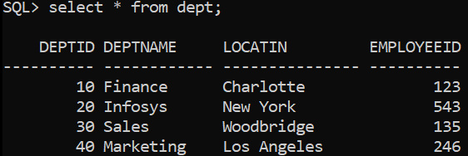

(POSITION TABLE)

SQL> insert into Position values(1,'President');

SQL> insert into Position values(2,'Manager');

SQL> insert into Position values(3,'Programmer');

SQL> insert into Position values(4,'Accountant');

SQL> insert into Position values(5,'Salesman');

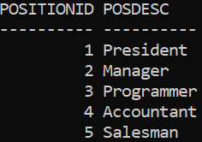

(QUALIFICATION TABLE)

SQL> insert into Qualification values(1,'Doctorate');

SQL> insert into Qualification values(2, 'Masters');

SQL> insert into Qualification values(3, 'Bachelors');

SQL> insert into Qualification values(4, 'Associates');

SQL> insert into Qualification values(5, 'High School');



