Lab Assignment-05

ROLL: 2005535 | NAME: SAHIL SINGH | DATE: 19/02/22

QUES : Insert the values in the EMP table and run the following queries.

1. List the emps those are having five characters in their names.

2. List the emps those are having four chars and third char must be ‘r’

3. List the emps whose names having a character set ‘ll’ together

4. List the empno, ename, sal, dname, loc, deptno, job of all emps

5. working at CHICAGO or working for ACCOUNTING dept wit ann sal > 28000, but the

sal should not be = 3000 or 2800 who doesn’t belongs to the Mgr and whose no is

having a digit ‘7’ or ‘8’ in 3rd position in the asc order of deptno and desc order of job.

6. List the dept details where at least two emps are working.

7. Display dname, grade, no of emps where atleast two emps are ‘CLERKS’

8. List the no of emps in each dept where the number is more than 3.

9. List the names of depts. Where at least 3 emps are working in each dept.

10. List first 50% of chars of ename in lower case and remaining are upper case.

11. List the emps whose 10% of sal is equal to year of Joining List the emps whose first 2 chars from hiredate = last 2 chars of salary.

12. List the emps whose deptno is available in his salary.

13. List the emps who joined in the month of ‘DEC’

14. List the enames who are retiring after ’31-DEC-89’ the max job period is 20Y.

15. List the emps whose sal contain 3 digits

SOLUTION:

Table Creation:

(EMPLOYEES TABLE)

SQL> create table employees(employee_id number(6) not null, first_name varchar2(20),last_name varchar2(20) not null, email varchar2(25) not null, phone_number varchar2(20), hire_date date not null, job_id varchar2(10) not null, salary number(8,2), commission_pct number(2,2), manager_id number(6), department_id number(4));

(DEPARTMENTS TABLE)

SQL> create table departments(department_id number(4) not null, department_name varchar2(30) not null, manager_Id number(6), location_id number );

Data Insertion:

(EMPLOYEES TABLE)

SQL> INSERT INTO EMPLOYEES(EMPLOYEE_ID, FIRST_NAME, LAST_NAME, EMAIL, PHONE_NUMBER, HIRE_DATE, JOB_ID, SALARY, MANAGER_ID, DEPARTMENT_ID) VALUES(100, 'STEVEN', 'King', 'SKING', '515.123.4567', '17-JUN-87', 'AD_PRES', 24000, 90);

SQL> INSERT INTO EMPLOYEES(EMPLOYEE_ID, FIRST_NAME, LAST_NAME, EMAIL, PHONE_NUMBER, HIRE_DATE, JOB_ID, SALARY, MANAGER_ID, DEPARTMENT_ID) VALUES(101, 'Neena', 'Kochhar', 'NKOCHHAR', '515.123.4568', '21-SEP-89', 'AD_VP', 17000, 100, 90);

SQL> INSERT INTO EMPLOYEES(EMPLOYEE_ID, FIRST_NAME, LAST_NAME, EMAIL, PHONE_NUMBER, HIRE_DATE, JOB_ID, SALARY, MANAGER_ID, DEPARTMENT_ID) VALUES(102, 'Lex', 'De Haan', 'LDEHAAN', '515.123.4569', '13-JAN-93', 'AD_VP', 17000, 100, 90);

SQL> INSERT INTO EMPLOYEES(EMPLOYEE_ID, FIRST_NAME, LAST_NAME, EMAIL, PHONE_NUMBER, HIRE_DATE, JOB_ID, SALARY, MANAGER_ID, DEPARTMENT_ID) VALUES(103, 'Alexander', 'Hunold', 'AHUNOLD', '590.423.4567', '03-JAN-90', 'IT_PROG', 9000, 102, 60);

SQL> INSERT INTO EMPLOYEES(EMPLOYEE_ID, FIRST_NAME, LAST_NAME, EMAIL, PHONE_NUMBER, HIRE_DATE, JOB_ID, SALARY, MANAGER_ID, DEPARTMENT_ID) VALUES(104, 'Bruce', 'Ernst', 'BERNST', '590.423.4568', '21-MAY-91', 'IT_PROG', 6000, 103, 60);

SQL> INSERT INTO EMPLOYEES(EMPLOYEE_ID, FIRST_NAME, LAST_NAME, EMAIL, PHONE_NUMBER, HIRE_DATE, JOB_ID, SALARY, MANAGER_ID, DEPARTMENT_ID) VALUES(107, 'Diana', 'Lorentz', 'DLORENTZ', '590.423.5567', '07-FEB-99', 'IT_PROG', 4200, 103, 60);

SQL> INSERT INTO EMPLOYEES(EMPLOYEE_ID, FIRST_NAME, LAST_NAME, EMAIL, PHONE_NUMBER, HIRE_DATE, JOB_ID, SALARY, MANAGER_ID, DEPARTMENT_ID) VALUES(124, 'Kevin', 'Mourgos', 'KMOURGOS', '650.123.5234', '16-NOV-99', 'ST_MAN', 5800, 100, 50);

SQL> INSERT INTO EMPLOYEES(EMPLOYEE_ID, FIRST_NAME, LAST_NAME, EMAIL, PHONE_NUMBER, HIRE_DATE, JOB_ID, SALARY, MANAGER_ID, DEPARTMENT_ID) VALUES(141, 'Trenna', 'Rajs', 'TRAJS', '650.121.8009', '17-OCT-95', 'ST_CLERK', 3500, 124, 50);

SQL> INSERT INTO EMPLOYEES(EMPLOYEE_ID, FIRST_NAME, LAST_NAME, EMAIL, PHONE_NUMBER, HIRE_DATE, JOB_ID, SALARY, MANAGER_ID, DEPARTMENT_ID) VALUES(142, 'Curtis', 'Davies', 'CDAVIES', '650.121.2994', '29-JAN-97', 'ST_CLERK', 3100, 124, 50);

SQL> INSERT INTO EMPLOYEES(EMPLOYEE_ID, FIRST_NAME, LAST_NAME, EMAIL, PHONE_NUMBER, HIRE_DATE, JOB_ID, SALARY, MANAGER_ID, DEPARTMENT_ID) VALUES(143, 'Randall', 'Matos', 'RMATOS', '650.121.2874', '15-MAR-98', 'ST_CLERK', 2600, 124, 50);

SQL> INSERT INTO EMPLOYEES(EMPLOYEE_ID, FIRST_NAME, LAST_NAME, EMAIL, PHONE_NUMBER, HIRE_DATE, JOB_ID, SALARY, MANAGER_ID, DEPARTMENT_ID) VALUES(144, 'Peter', 'Vargas', 'PVARGAS', '650.212.2004', '09-JUL-98', '2500', 124, 50, 50);

SQL> INSERT INTO EMPLOYEES(EMPLOYEE_ID, FIRST_NAME, LAST_NAME, EMAIL, PHONE_NUMBER, HIRE_DATE, JOB_ID, SALARY, MANAGER_ID, DEPARTMENT_ID) VALUES(149, 'Eleni', 'Zlotkey', 'EZLOTKEY', '011.44.1344.429018', '29-JAN-00', 'SA_MAN', 10500, 100, 80);

SQL> INSERT INTO EMPLOYEES(EMPLOYEE_ID, FIRST_NAME, LAST_NAME, EMAIL, PHONE_NUMBER, HIRE_DATE, JOB_ID, SALARY, MANAGER_ID, DEPARTMENT_ID) VALUES(174, 'Ellen', 'Abel', 'EABEL', '011.44.1644.429267', '11-MAY-96', 'SA_REP', 11000, 149, 80);

SQL> INSERT INTO EMPLOYEES(EMPLOYEE_ID, FIRST_NAME, LAST_NAME, EMAIL, PHONE_NUMBER, HIRE_DATE, JOB_ID, SALARY, MANAGER_ID, DEPARTMENT_ID) VALUES(176, 'Jonathon', 'Taylor', 'JTAYLOR', '011.44.1644.429265', '24-MAY-98', 'SA_REP', 8600, 149, 80);

SQL> INSERT INTO EMPLOYEES(EMPLOYEE_ID, FIRST_NAME, LAST_NAME, EMAIL, PHONE_NUMBER, HIRE_DATE, JOB_ID, SALARY, COMMISSION_PCT, MANAGER_ID) VALUES(178, 'Kimberely', 'Grant', 'KGRANT', '011.44.1644.429263', '24-MAY-99', 'SA_REP', 7000, .15, 149);

SQL> INSERT INTO EMPLOYEES(EMPLOYEE_ID, FIRST_NAME, LAST_NAME, EMAIL, PHONE_NUMBER, HIRE_DATE, JOB_ID, SALARY, MANAGER_ID, DEPARTMENT_ID) VALUES(200, 'Jennifer', 'Whalen', 'JWHALEN', '515.123.4444', '17-SEP-87', 'AD_ASST', 4400, 101, 10);

SQL> INSERT INTO EMPLOYEES(EMPLOYEE_ID, FIRST_NAME, LAST_NAME, EMAIL, PHONE_NUMBER, HIRE_DATE, JOB_ID, SALARY, MANAGER_ID, DEPARTMENT_ID) VALUES(201, 'Michael', 'Hartstein', 'MHARTSTE', '515.123.5555', '17-FEB-96', 'MK_MAN', 13000, 100, 20);

SQL> INSERT INTO EMPLOYEES(EMPLOYEE_ID, FIRST_NAME, LAST_NAME, EMAIL, PHONE_NUMBER, HIRE_DATE, JOB_ID, SALARY, MANAGER_ID, DEPARTMENT_ID) VALUES(202, 'Pat', 'Fay', 'PFAY', '603.123.6666', '17-AUG-97', 'MK_REP', 6000, 201, 20);

SQL> INSERT INTO EMPLOYEES(EMPLOYEE_ID, FIRST_NAME, LAST_NAME, EMAIL, PHONE_NUMBER, HIRE_DATE, JOB_ID, SALARY, MANAGER_ID, DEPARTMENT_ID) VALUES(205, 'Shelley', 'Higgins', 'SHIGGINS', '515.123.8080', '07-JUN-94', 'AC_MGR', 12000, 101, 110);

SQL> INSERT INTO EMPLOYEES(EMPLOYEE_ID, FIRST_NAME, LAST_NAME, EMAIL, PHONE_NUMBER, HIRE_DATE, JOB_ID, SALARY, MANAGER_ID, DEPARTMENT_ID) VALUES(206, 'William', 'Gietz', 'WGIETZ', '515.123.8181', '07-JUN-94', 'AC_ACCOUNT', 8300, 205, 110);

SQL> UPDATE EMPLOYEES SET COMMISSION_PCT=.2 WHERE EMPLOYEE_ID=149;

SQL> UPDATE EMPLOYEES SET COMMISSION_PCT=.3 WHERE EMPLOYEE_ID=174;

SQL> UPDATE EMPLOYEES SET COMMISSION_PCT=.2 WHERE EMPLOYEE_ID=176;

SQL> UPDATE EMPLOYEES SET COMMISSION_PCT=.15 WHERE EMPLOYEE_ID=178;

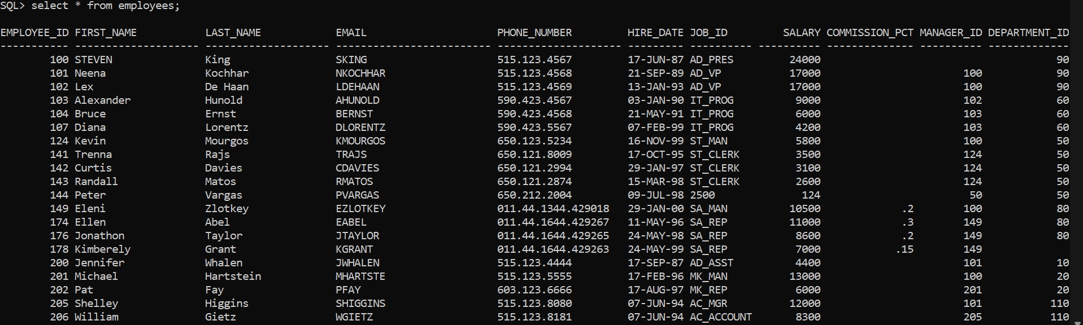

(DEPARTMENTS TABLE)

SQL> insert into departments values(10, 'Admisistrarion', 200,1700);

SQL> insert into departments values(20, 'Marketing', 201,1800);

SQL> insert into departments values(50, 'Shipping', 124,1500);

SQL> insert into departments values(60, 'IT', 103,1400);

SQL> insert into departments values(80, 'Sales', 149,2500);

SQL> insert into departments values(90, 'Executive', 100,1700);

SQL> insert into departments values(110, 'Accounting', 205,1700);

SQL> insert into departments (department_id, department_name, location_id) values(190, 'Contracting', 1700);

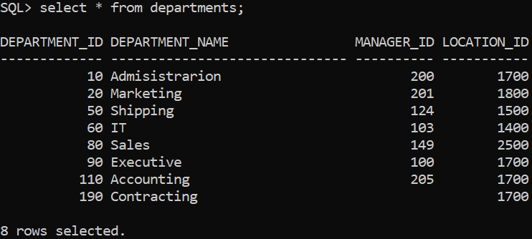

List the emps those are having five characters in their names.

SQL> SELECT * FROM employees WHERE length(first_name) = 5;

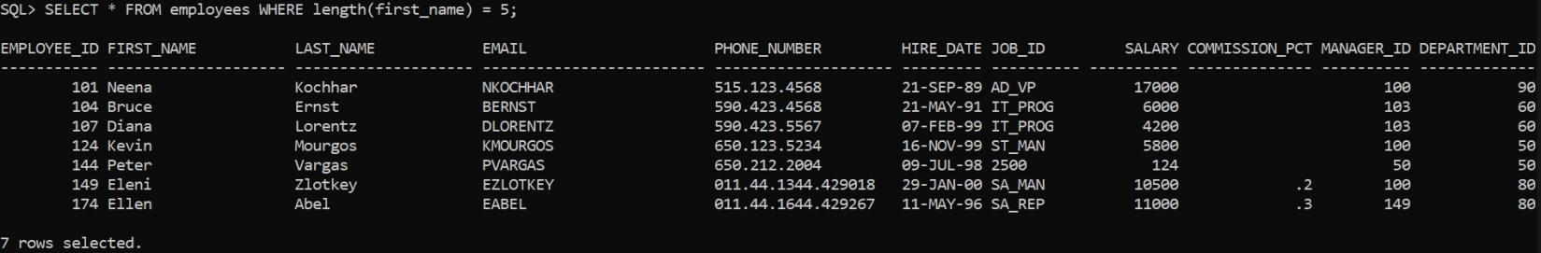

List the emps those are having four chars and third char must be ‘r’

SQL> SELECT * FROM employees WHERE length(first_name) = 5 and last_name like ’__r%’;



List the emps whose names having a character set ‘ll’ together.

SQL> SELECT * FROM employees where first_name LIKE ’%ll%’;

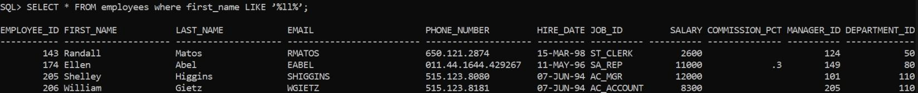

List the empno, ename, sal, dname, loc, deptno, job of all emps working at CHICAGO or working for ACCOUNTING dept wit ann sal > 28000, but the sal should not be = 3000 or 2800 who doesn’t belongs to the Mgr and whose no is having a digit ‘7’ or ‘8’ in 3rd position in the asc order of deptno and desc order of job.

SQL> select E.employee_id, E.first_name, E.last_name, E.salary, E.department_id, D.department_name, D.location_id, E.job_id from employees E, departments D where (D.location_id = 1500 or D.department_name = 'ACCOUNTING') and E.department_id = D.department_id and E.employee_id in (select E.employee_id from employees E where (12*E.salary) > 28000 and E.salary not in (3000,2800) and E.job_id !='MANAGER' and ( E.employee_id like '__7%' or E.employee_id like '__8%')) order by E.department_id asc, E.job_id desc;



List the dept details where at least two emps are working.

SQL> select department_id ,count(*) from employees group by department_id having count(*) >= 2;

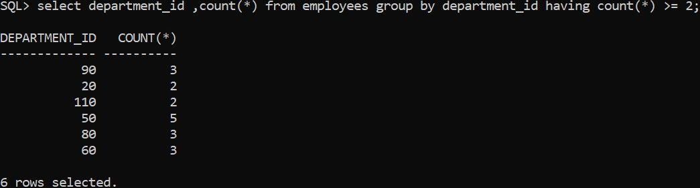

Display dname, grade, no of emps where atleast two emps are ‘CLERKS’

SQL> select d.department_name, j.grade_level,count(*) from employees e, departments d, job_grades j, jobs b where e.department_id = d.department_id and b.job_title = 'CLERK' and e.salary between b.min_salary and b.max_salary group by d.department_name, j.grade_level having count(*) >= 2;



List the no of emps in each dept where the number is more than 3.

SQL> select department_id,count(*) from employees group by department_id having count(*) > 3;

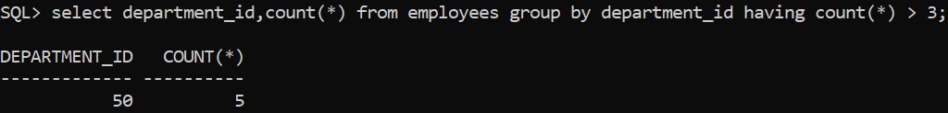

List the names of depts. Where at least 3 emps are working in each dept.

SQL> select d.department_name,count(*) from employees e, departments d where e.department_id = d.department_id group by d.department_name having count(*) <= 3;

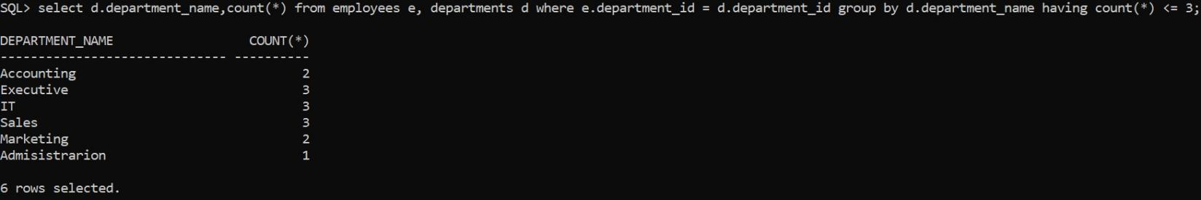

List first 50% of chars of ename in lower case and remaining are upper case.

SQL> select lower( substr(first_name, 1, round(length(first_name)/2) ) ) || substr(first_name, round( length(first_name)/2) + 1, length(first_name) ) from employees;

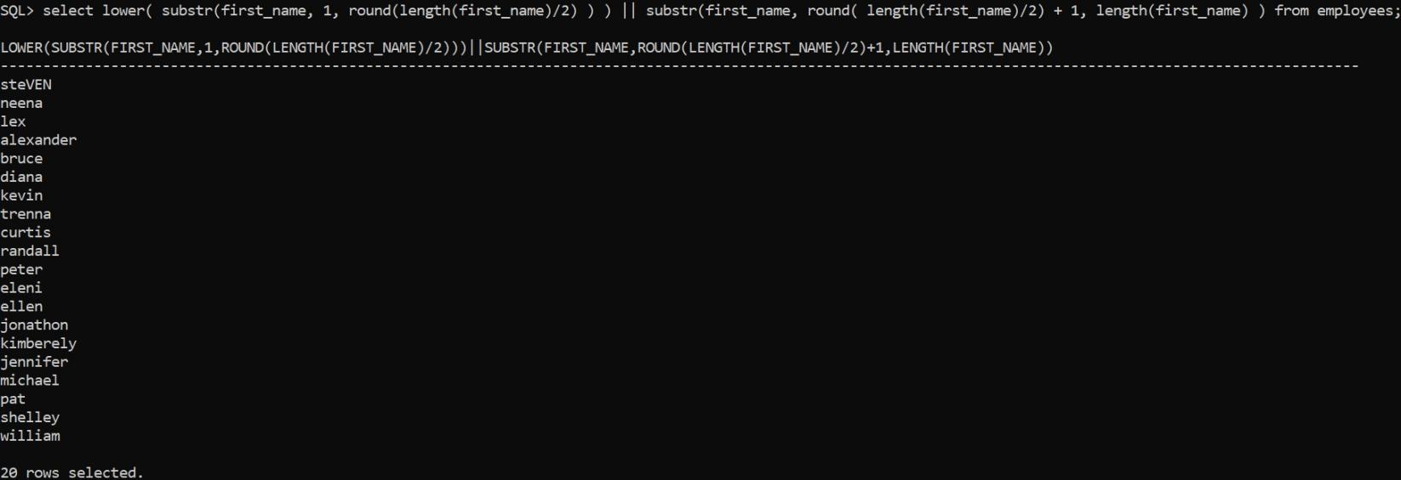

List the emps whose 10% of sal is equal to year of Joining List the emps whose first 2

chars from hiredate = last 2 chars of salary.

SQL> select * from employees where substr(hire_date,1,2) = substr(salary, length(salary)-1, length(salary));



List the emps whose deptno is available in his salary.

SQL> select * from employees where instr(salary,department_id) > 0;



List the emps who joined in the month of ‘DEC’.

SQL> select * from employees where to_char(hire_date,'MONTH') like 'DEC%';



List the enames who are retiring after ’31-DEC-89’ the max job period is 20Y.

SQL> select first_name,last_name from employees where add_months(hire_date, 240) > to_date(’31-DEC-89’, ’DD-MON-RR’);

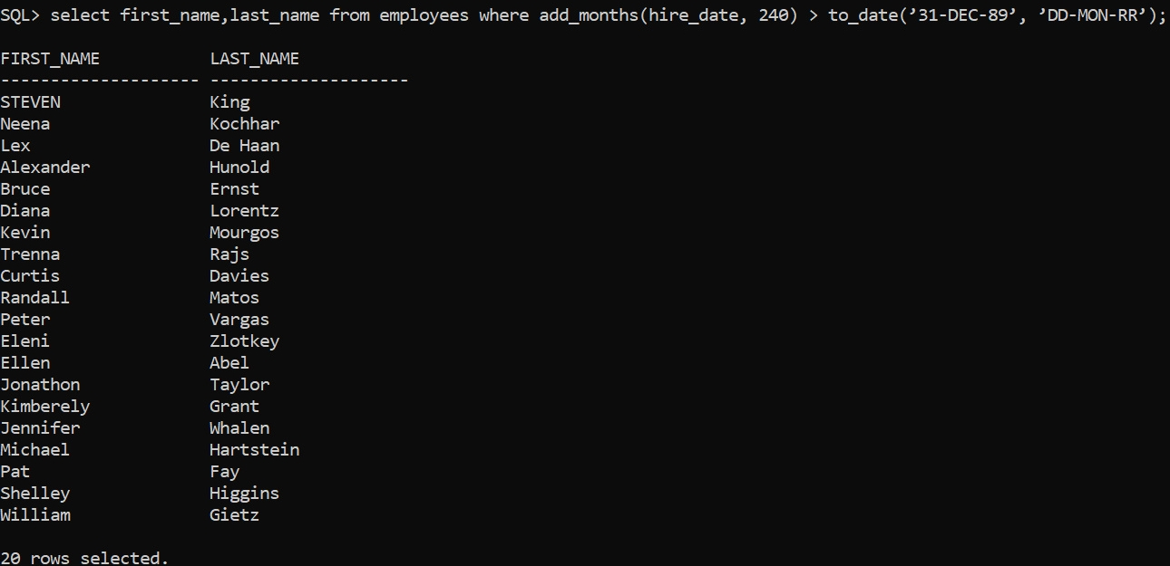

List the emps whose sal contain 3 digits.

SQL> select * from employees where length(salary) = 3;



-----------------------------------------------------------------------------------------