Lab Assignment-06

ROLL: 2005535 | NAME: SAHIL SINGH | DATE: 23/03/22

QUES : Run the following queries.

1. List the details of the depts along with empno, ename or without the emps.

2. List the details of the emps whose salaries more than the employee Kevin.

3. List the emps whose mgr name is ‘Jones’ and also list their manager name.

4. List the emps name, job, salary,grade and dname except ‘Clerk’ and sort on the basis of highest salary.

5. List the names of depts , where at least 3 emps are working in each dept

6. Find out the no of emps whose salary is > their Manager salary

7. List those emps whose sal is odd value

8. Produce the following output from EMP.

a. Employee

SMITH(clerk)

ALLEN(Salesman)

9. Write a query to return the day of the week for any date entered in format ‘DD-MM-YY’

10. List those managers who are getting less than his emps salary.

SOLUTION:

List the details of the depts along with empno, ename or without the emps.

SQL> select * from employees e, departments d where e.department_id(+)=d.department_id;

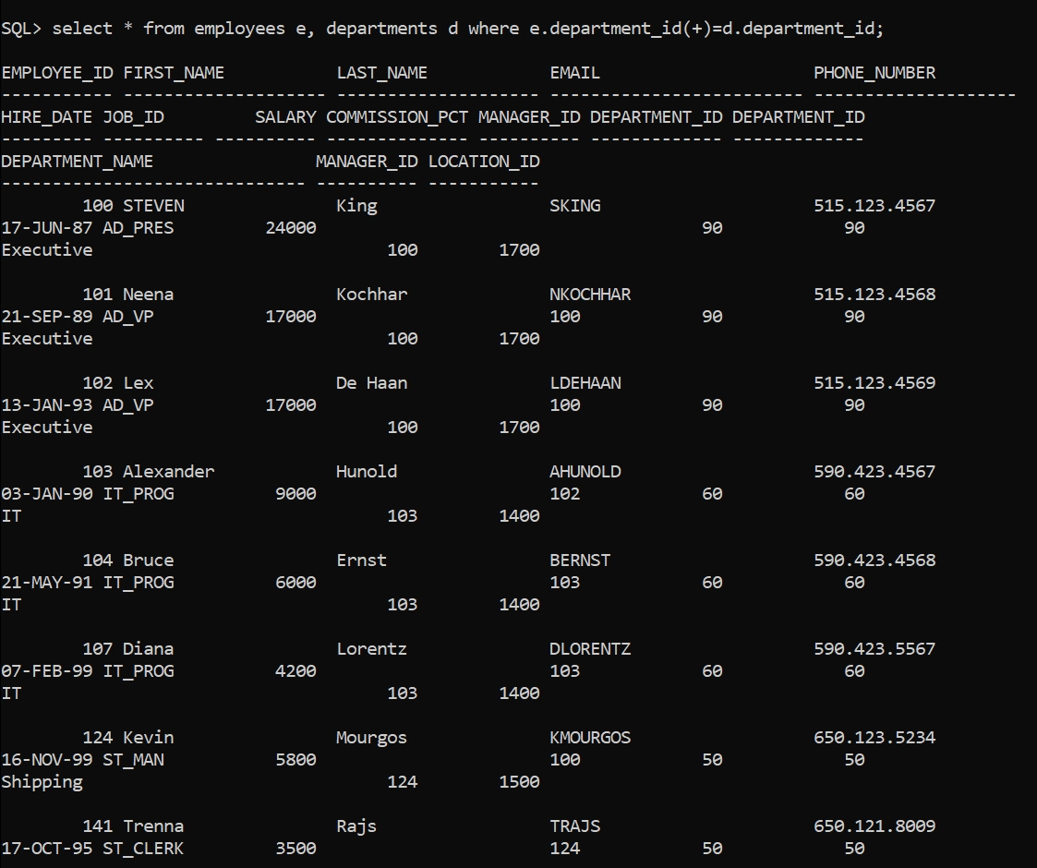

List the details of the emps whose salaries more than the employee Kevin.

SQL> select e.* from employees e, employees w where e.salary > w.salary and w.first_name='Kevin';

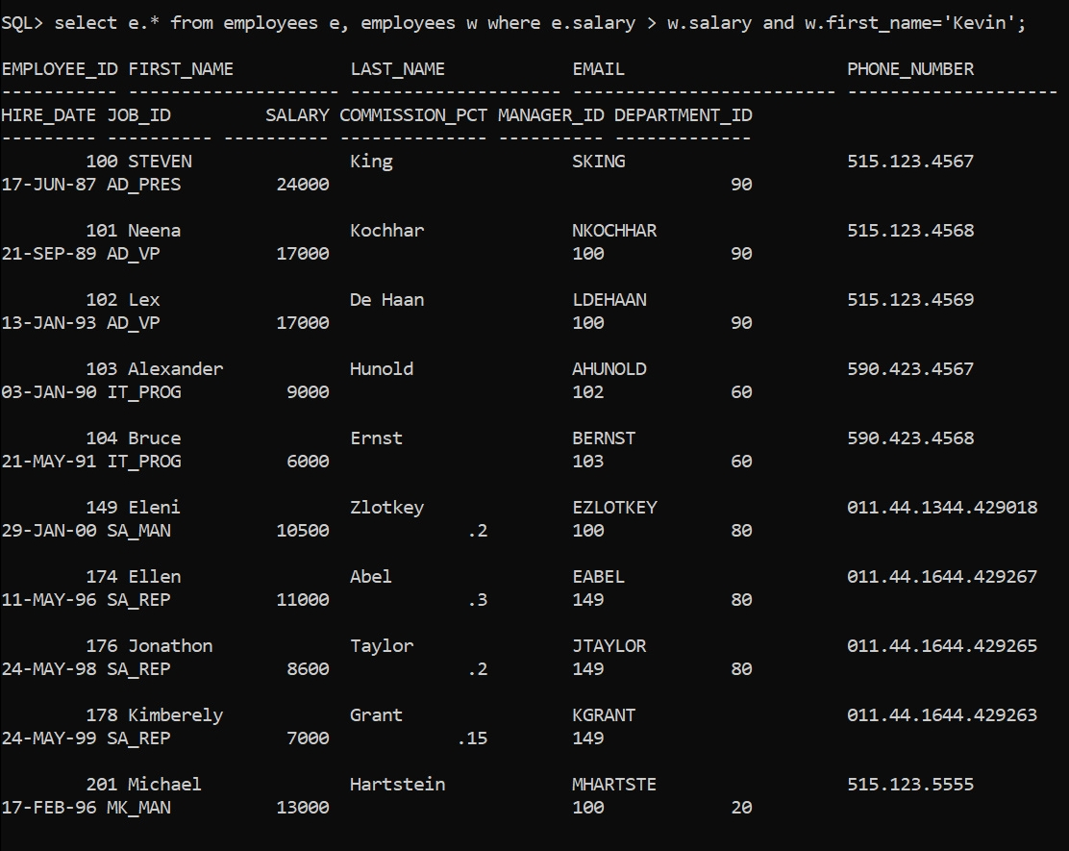

List the emps whose mgr name is ‘Jones’ and also list their manager name.

SQL> select e.* from employees e, employees w where e.manager_id=w.employee_id and w.first_name='Jones';



List the emps name, job, salary,grade and dname except ‘Clerk’ and sort on the basis of highest salary.

SQL> select e.first_name, e.job_id, e.salary, j.grade_level, d.department_name from employees e, departments d, job_grades j where e.department_id=d.department_id and e.salary between j.lowest_sal and j.higest_sal and e.job_id not in ('st_clerk') order by e.salary desc;

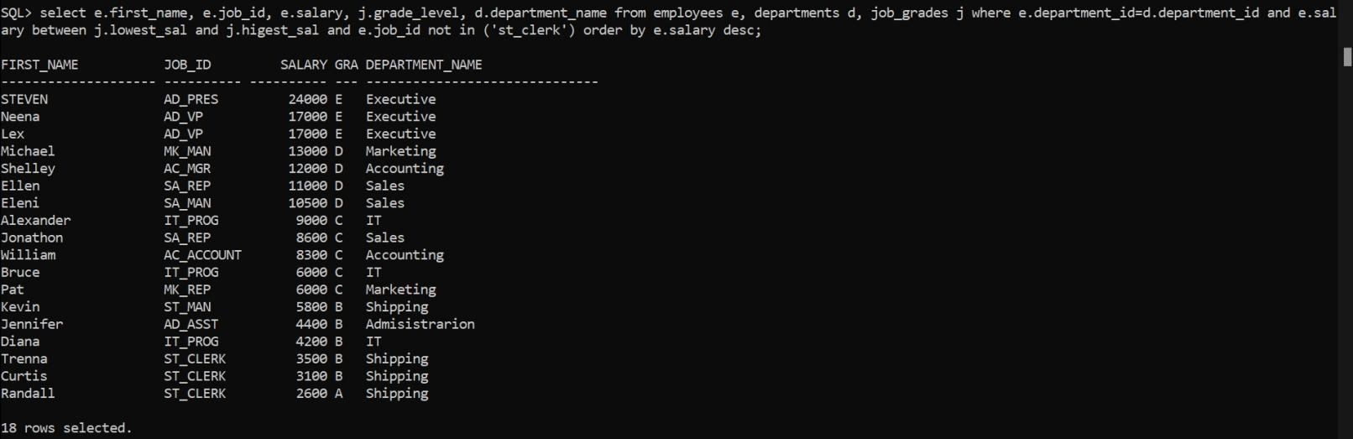

List the names of depts , where at least 3 emps are working in each dept

SQL> select d.department_name, count(*) as total_count from employees e, departments d where e.department_id=d.department_id group by d.department_name having count(*)>=3;

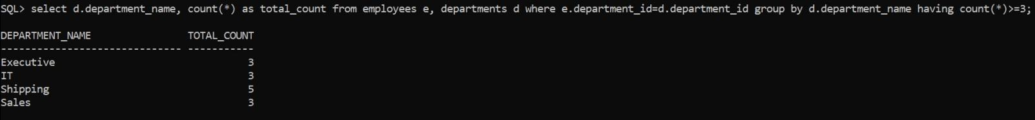

Find out the no of emps whose salary is > their Manager salary

SQL> select count(*) as total_count from employees e, employees w where e.manager_id=w.employee_id and e.salary>w.salary;

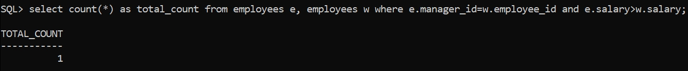

List those emps whose sal is odd value

SQL> select * from employees where mod(salary,2)=1;

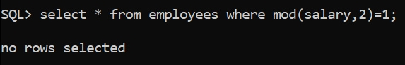

Produce the following output from EMP.

a. Employee

SMITH(clerk)

ALLEN(Salesman)

SQL> select first_name || '('||job_id||')' as "Employee_Name(Job_Id)" from employees;

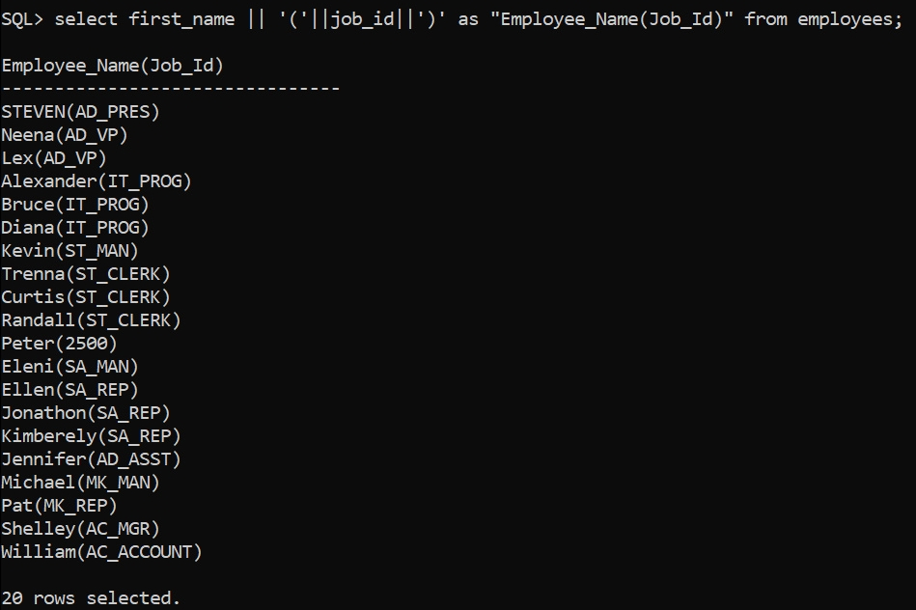

Write a query to return the day of the week for any date entered in format ‘DD-MM-YY’

SQL> select to_char(to_date('&input_date','dd-mm-yy'),'day') as day from dual;

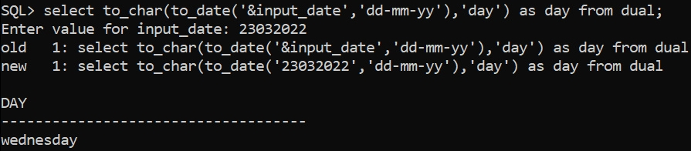

List those managers who are getting less than his emps salary.

SQL> select distinct w.first_name, w.salary from employees e,employees w where e.manager_id=w.employee_id and w.salary<e.salary;



-----------------------------------------------------------------------------------------