Lab Assignment-07

ROLL: 2005535 | NAME: SAHIL SINGH | DATE: 30/03/22

QUES: Run the following queries.

1. List the emps whose Sal is > the total remuneration of the SALESMAN.

2. List the emps who are Senior to ‘BLAKE’ working at CHICAGO & BOSTON.

3. List the emps of Grade 3,4 belongs to the dept ACCOUNTING and RESEARCH whose sal is more than ALLEN and exp more than SMITH in the asc order of Exp.

4. List the emps whose jobs same as ALLEN Or SMITH.

5. Write a Query to display the details of emps whose Sal is same as of a) Employee Sal of Emp1 table. b) ¾ Sal of any Mgr of Emp2 table. c) The Sal of any sales person with exp of 5 yrs belongs to the sales dept of emp3 table. d) Any Grade 2 employees of Emp4 table. e) Any Grade 2 and 3 employee working for SALES dept or OPERATIONS dept joined in 89.

6. List the jobs of Deptno 10 those are not found in dept 20.

7. Find the details of highest paid employee.

8. Find the highest paid employee of sales dept.

9. List the most recently hired emp of grade 3 belongs to the Loc CHICAGO.

10. List the emps who are senior to most recently hired emp who is working under Mgr KING

SOLUTION:

List the emps whose Sal is > the total remuneration of the SALESMAN.

SQL> select * from emp where sal >(select sum(sal+comm) from emp where job = 'SALESMAN');

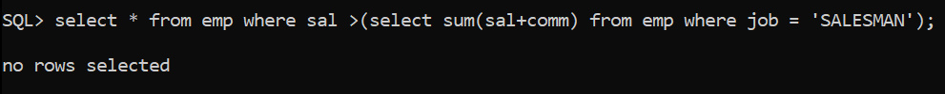

List the emps who are Senior to ‘BLAKE’ working at CHICAGO & BOSTON.

SQL> select * from emp e ,dept d where d.loc in ('CHICAGO','BOSTON') and e.deptno = d.deptno and e.hiredate <(select e.hiredate from emp e where e.ename = 'BLAKE');



List the emps of Grade 3,4 belongs to the dept ACCOUNTING and RESEARCH whose sal is more than ALLEN and exp more than SMITH in the asc order of Exp.

SQL> select * from emp e where e.deptno in (select d.deptno from dept d where d.dname in ('ACCOUNTING','RESEARCH') ) and e.sal >(select sal from emp where ename = 'ALLEN') and e.hiredate <( select hiredate from emp where ename = 'SMITH') and e.empno in (select e.empno from emp e ,salgrade s where e.sal between s.losal and s.hisal and s.grade in (3,4) ) order by e.hiredate desc;



List the emps whose jobs same as ALLEN Or SMITH.

SQL> select * from Emp where job in (select distinct job from emp where ename in ('ALLEN','SMITH')) and ename not in ('ALLEN','SMITH');

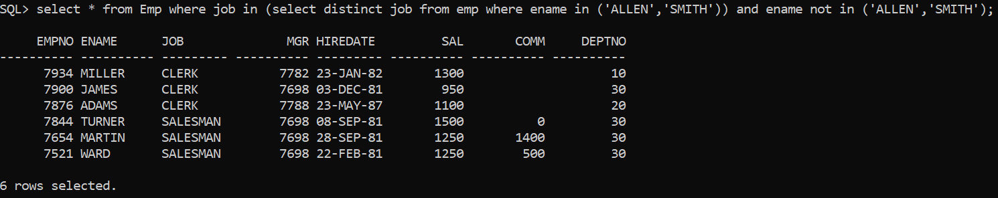

Write a Query to display the details of emps whose Sal is same as of a) Employee Sal of Emp1 table. b) ¾ Sal of any Mgr of Emp2 table. c) The Sal of any sales person with exp of 5 yrs belongs to the sales dept of emp3 table. d) Any Grade 2 employees of Emp4 table. e) Any Grade 2&amp;3 employee working for SALES dept or OPERATIONS dept joined in 89.

SQL> select * from emp where sal in (select sal from emp);

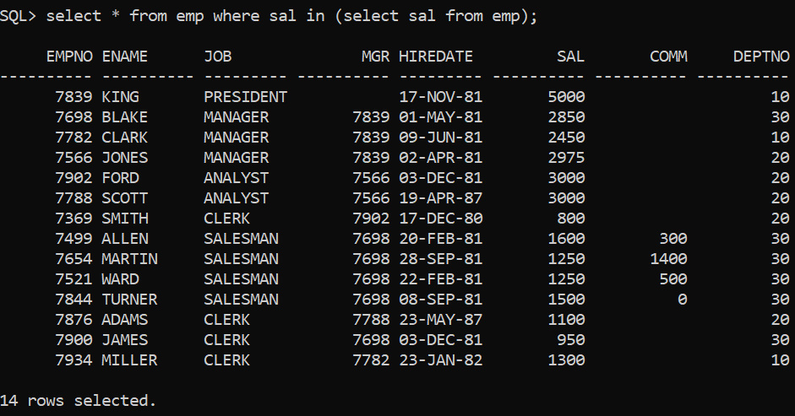

SQL> select * from emp where sal in (select sal from emp) and sal in (select sal*3 from emp where job='MANAGER');



SQL> select * from emp where sal in (select sal from emp) and sal in (select sal from emp where months_between(sysdate,hiredate)/12 > 5);

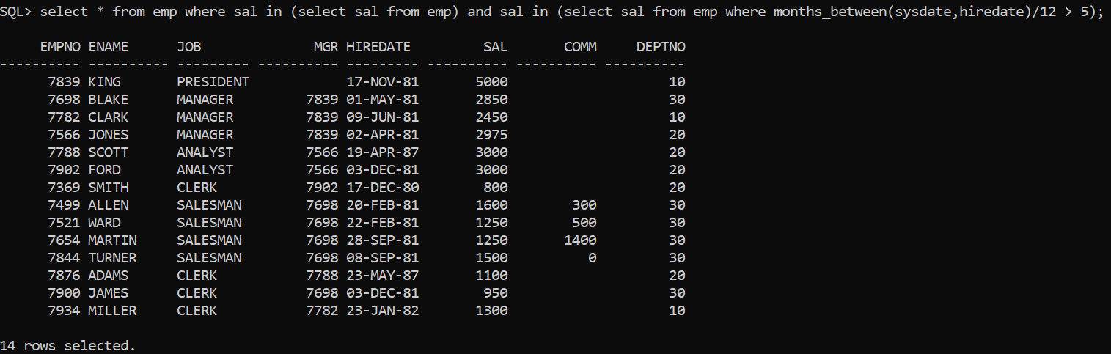

SQL> select * from emp where sal in (select sal from emp) and sal in (select sal from emp ,salgrade where grade=2 and sal between losal and hisal);

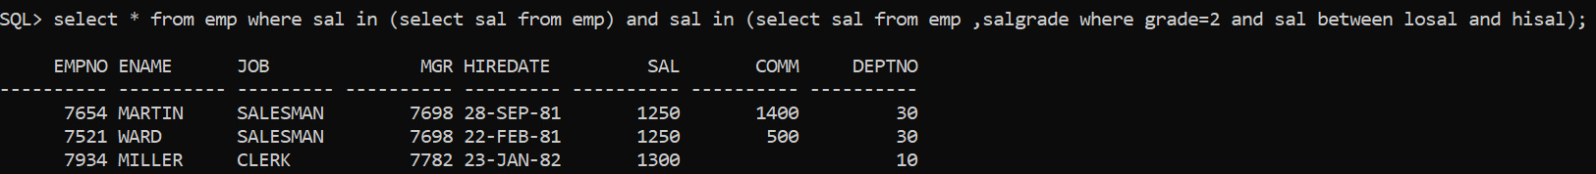

SQL> select * from emp where sal in (select sal from emp) and sal in (select sal from Emp,salgrade,dept where grade in(2,3) and dname in ('SALES','OPERATIONS') and hiredate like '%89' and sal between losal and hisal and emp.deptno=dept.deptno);



List the jobs of Deptno 10 those are not found in dept 20.

SQL> select e.job from emp e where e.deptno = 10 and e.job not in (select job from emp where deptno = 20);

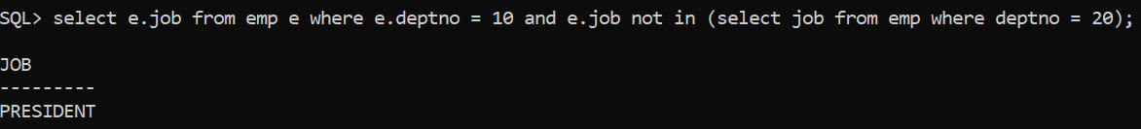

Find the details of highest paid employee

SQL> select * from emp where sal in (select max(sal) from emp);

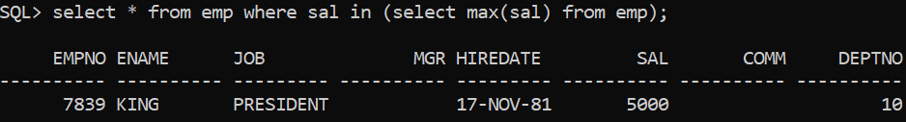

Find the highest paid employee of sales dept.

SQL> select * from emp where sal in (select max(sal) from emp where deptno in (select d.deptno from dept d where d.dname = 'SALES'));



List the most recently hired emp of grade 3 belongs to the Loc CHICAGO.

SQL> select * from emp e where e.deptno in ( select d.deptno from dept d where d.loc = 'CHICAGO') and e.hiredate in (select max(hiredate) from emp where empno in (select empno from emp e,salgrade s where e.sal between s.losal and s.hisal and s.grade = 3));



List the emps who are senior to most recently hired emp who is working under Mgr KING

SQL> select * from emp where hiredate < (Select max(hiredate) from emp) and mgr=(select empno from emp where ename=’KING’);



