Lab Assignment-08

ROLL: 2005535 | NAME: SAHIL SINGH | DATE: 06/04/22

QUES 1: Create a view as Emp_view which has Empid, jobid, managerid, departmentid, locationid, countryid, firstname, lastname, salary, commissionpct, departmentname.

2. Insert one record in that view and check whether it is affecting the table or not and delete that data and check.

3. create a sequence as seq1 which will start from 100 to 900 increment by 1. Implement that sequence in table.

SOLUTION:

Create a view as Emp_view which has Empid, jobid, managerid, departmentid, locationid, countryid, firstname, lastname, salary, commissionpct, departmentname.

SQL> select * from emp;

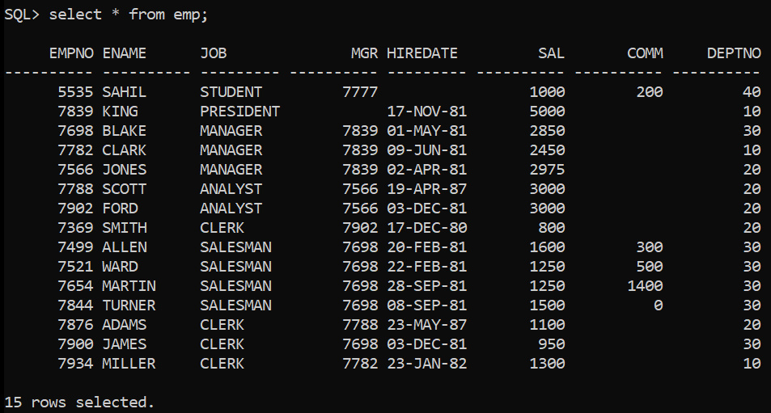

SQL> create view emp_view as select empno, job, mgr, sal, comm, ename, deptno from emp;

SQL> select * from emp_view;

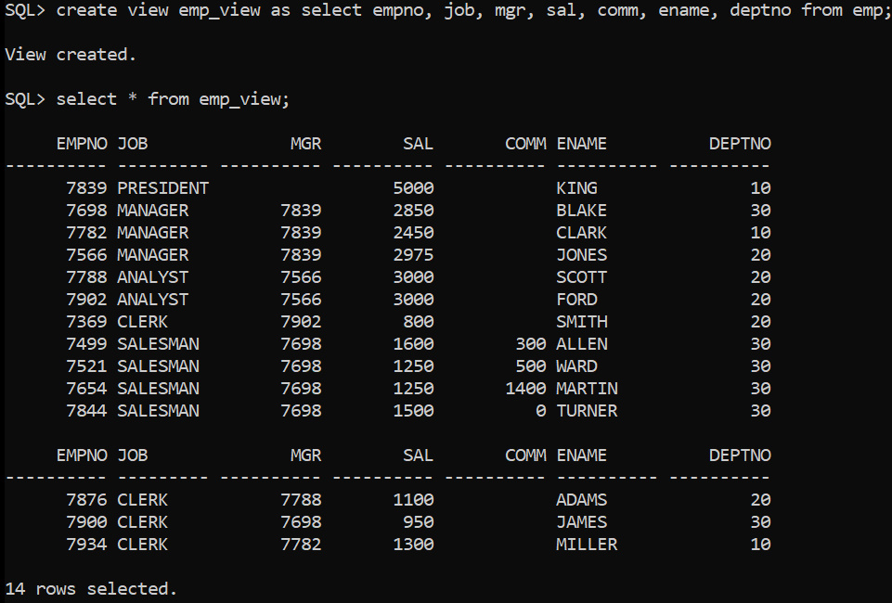

Insert one record in that view and check whether it is affecting the table or not and delete that data and check.

SQL> insert into emp_view values(5535, 'STUDENT', 7777, 1000, 200, 'SAHIL', 40);

SQL> select * from emp_view;

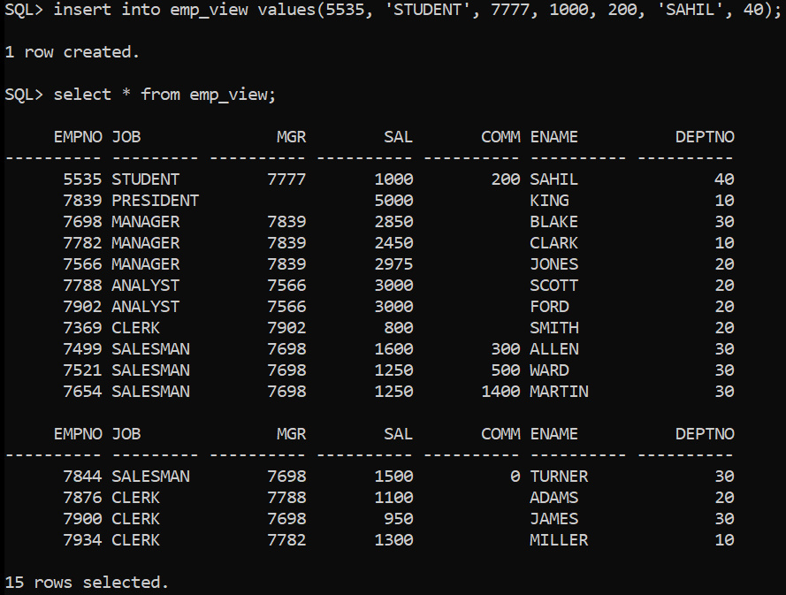

SQL> delete from emp where ename ='SAHIL';

SQL> select * from emp_view;

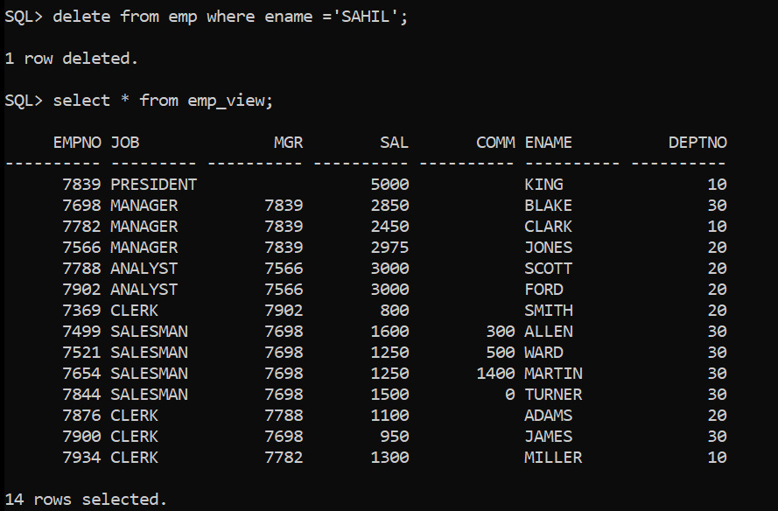

SQL> select * from emp;

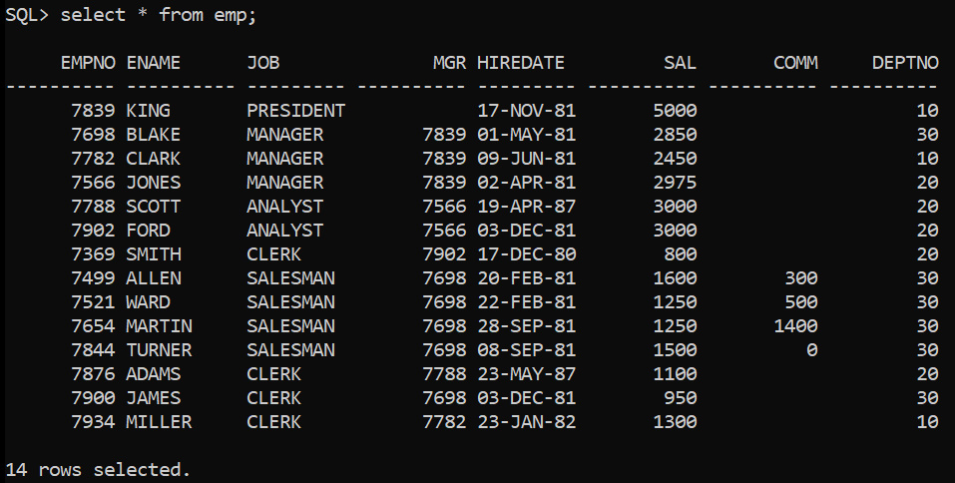

Create a sequence as seq1 which will start from 100 to 900 increment by 1. Implement that sequence in table.

SQL> create sequence seq1 increment by 1 start with 100 maxvalue 900 nocache;

SQL> select * from user_sequences where sequence_name = 'SEQ1';

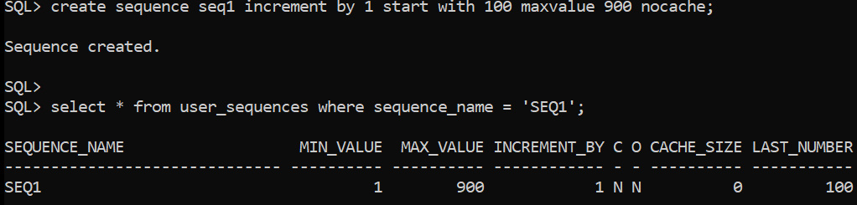

SQL> select * from student2;

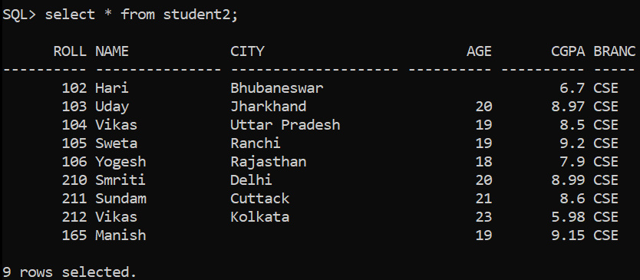

SQL> insert into student2 (roll, name) values(SEQ1.nextval, 'Sahil');

SQL> insert into student2 (roll, name) values(SEQ1.nextval, 'Singh');

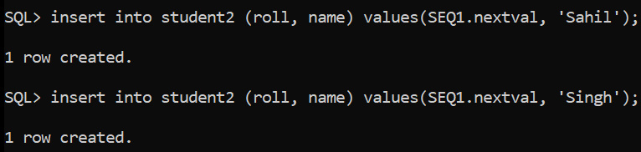

SQL> select * from student2;



