Lab Assignment-09

ROLL: 2005535 | NAME: SAHIL SINGH | DATE: 13/04/22

QUES 1: Write a PL/SQL block to calculate the incentive of an employee whose ID is 110.

SOLUTION:

declare

incentive employees.commission_pct%type;

salary1 employees.salary%type;

var1 employees.salary%type;

begin

select commission_pct, salary into incentive, salary1 from employees where employee_id=&emp_id;

dbms_output.put_line('Incentive is '||incentive);

var1:=salary1*incentive;

salary1:=var1+salary1;

dbms_output.put_line('Salary is '||salary1);

end;

OUTPUT:

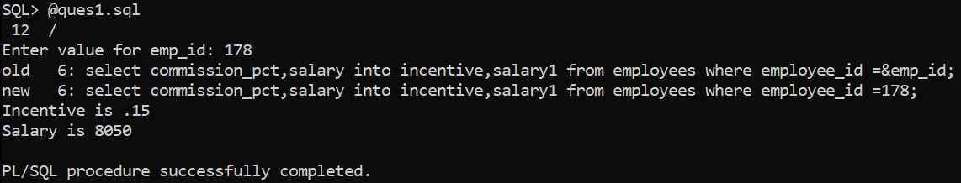

QUES 2: Write a plsql block to find the area of a circle.

SOLUTION:

declare

radius int;

area int;

begin

radius:=&radius;

area:=3.14*radius*radius;

dbms_output.put_line('Area of circle: '||area);

end;

OUTPUT:

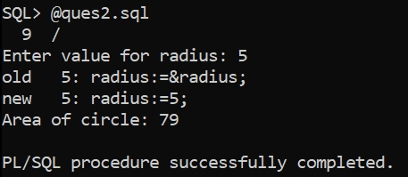

QUES 3: Write a plsql program to display smallest number among three user defined numbers.

SOLUTION:

declare

n1 int;

n2 int;

n3 int;

begin

n1:=&n1;

n2:=&n2;

n3:=&n3;

if(n1<n2 and n1<n3) then

dbms_output.put_line(n1||' is the smallest');

elsif(n2<n1 and n2<n3) then

dbms_output.put_line(n2||' is the smallest');

else

dbms_output.put_line(n3||' is the smallest');

end if;

end;

OUTPUT:

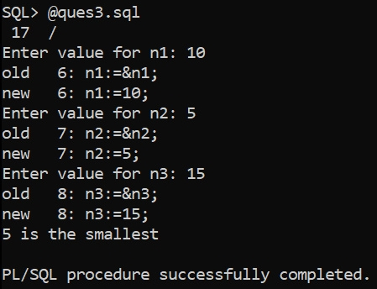

QUES 4: Write a function to find out the sum of square of each digit for a given number.

SOLUTION:

declare

num int :=0;

i int;

s int :=0;

r int;

begin

num:=&num;

while num > 0 loop

r:=MOD(num, 10);

s:=s+(r*r);

num:=floor(num/10);

end loop;

dbms_output.put_line('The sum of digits is '||s);

end;

OUTPUT:

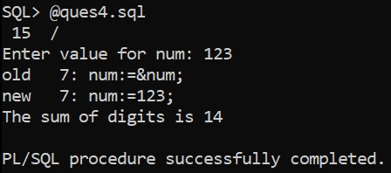

QUES 5: Write a PL/SQL program to check whether a number is even or odd.

SOLUTION:

declare

x int;

begin

x := &x;

if mod(x,2) = 0 then

dbms_output.put_line('Even Number');

else

dbms_output.put_line('Odd Number');

end if;

end;

OUTPUT:

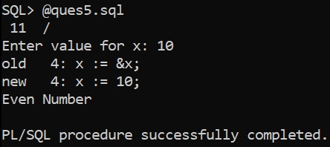

QUES 6: Write a PL/SQL program to check whether a date falls on weekend i.e. SATURDAY or SUNDAY.

SOLUTION:

declare

dt Date;

str varchar2(10);

begin

dt:='&date';

str:=to_char(dt,'DAY');

if str not in ('SATURDAY', 'SUNDAY') then

dbms_output.put_line('Week Day');

else

dbms_output.put_line('Weekend');

end if;

end;

OUTPUT:



