Lab Assignment-01

ROLL: 2005535 | NAME: SAHIL SINGH | DATE: 04/01/22

**Linux/Unix Commands**

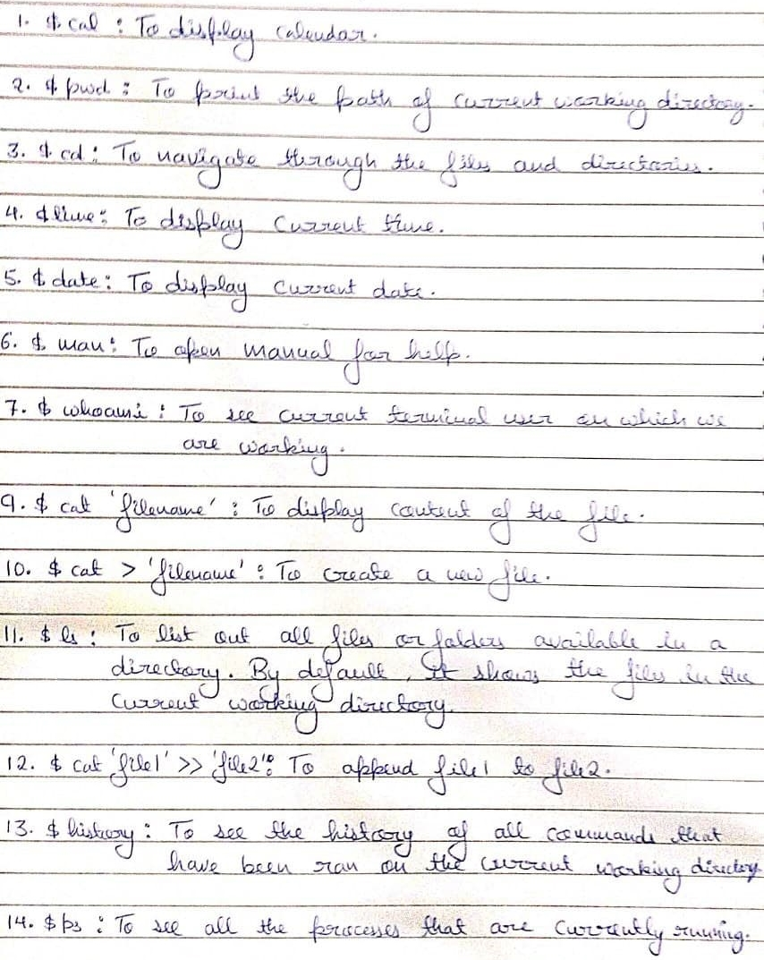

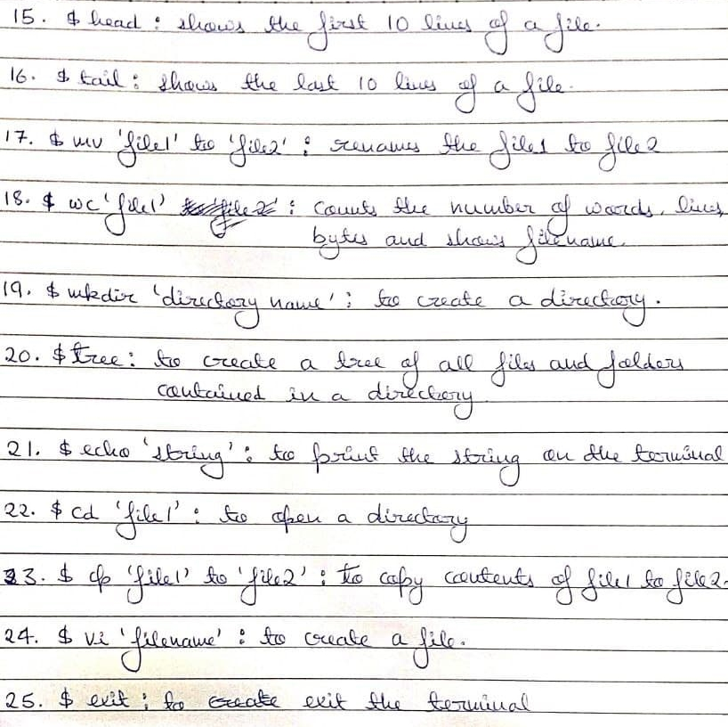

Lab Assignment-02

ROLL: 2005535 | NAME: SAHIL SINGH | DATE: 11/01/22

**QUES 1: A) Create the file names under the directories as mentioned in the figure and write some relevant data into the files.**

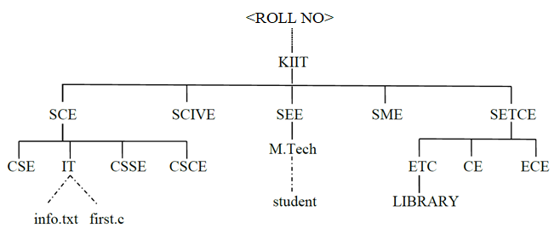

**N.B. The names under solid lines are assumed as directories and dotted lines as file names.**

SOLUTION:

$ mkdir 2005535

$ cd 2005535

/2005535$ mkdir KIIT

/2005535$ cd KIIT

/2005535/KIIT$ mkdir SCE SCIVE SEE SME SETCE

/2005535/KIIT$ cd SCE

/2005535/KIIT/SCE$ mkdir CSE IT CSSE CSCE

/2005535/KIIT/SCE$ cd IT

/2005535/KIIT/SCE/IT$ cat>info.txt

This is a test file for Assignment 1

File name is info.txt

^C

/2005535/KIIT/SCE/IT$ cat>first.c

#include <stdio.h>

void main()

{

printf("First.c file");

}

^C

/2005535/KIIT/SCE/IT$ cd ..

/2005535/KIIT/SCE$ cd ..

/2005535/KIIT$ cd SEE

/2005535/KIIT/SEE$ mkdir M.Tech

/2005535/KIIT/SEE$ cd M.Tech

/2005535/KIIT/SEE/M.Tech$ cat>student

Test file

File name is student

^C

/2005535/KIIT/SEE/M.Tech$ cd ..

/2005535/KIIT/SEE$ cd ..

/2005535/KIIT/SCE$ cd ..

/2005535/KIIT$ cd SETCE

/2005535/KIIT/SETCE$ mkdir ETC CE ECE

/2005535/KIIT/SETCE$ cd ETC

/2005535/KIIT/SETCE/ETC$ mkdir LIBRARY

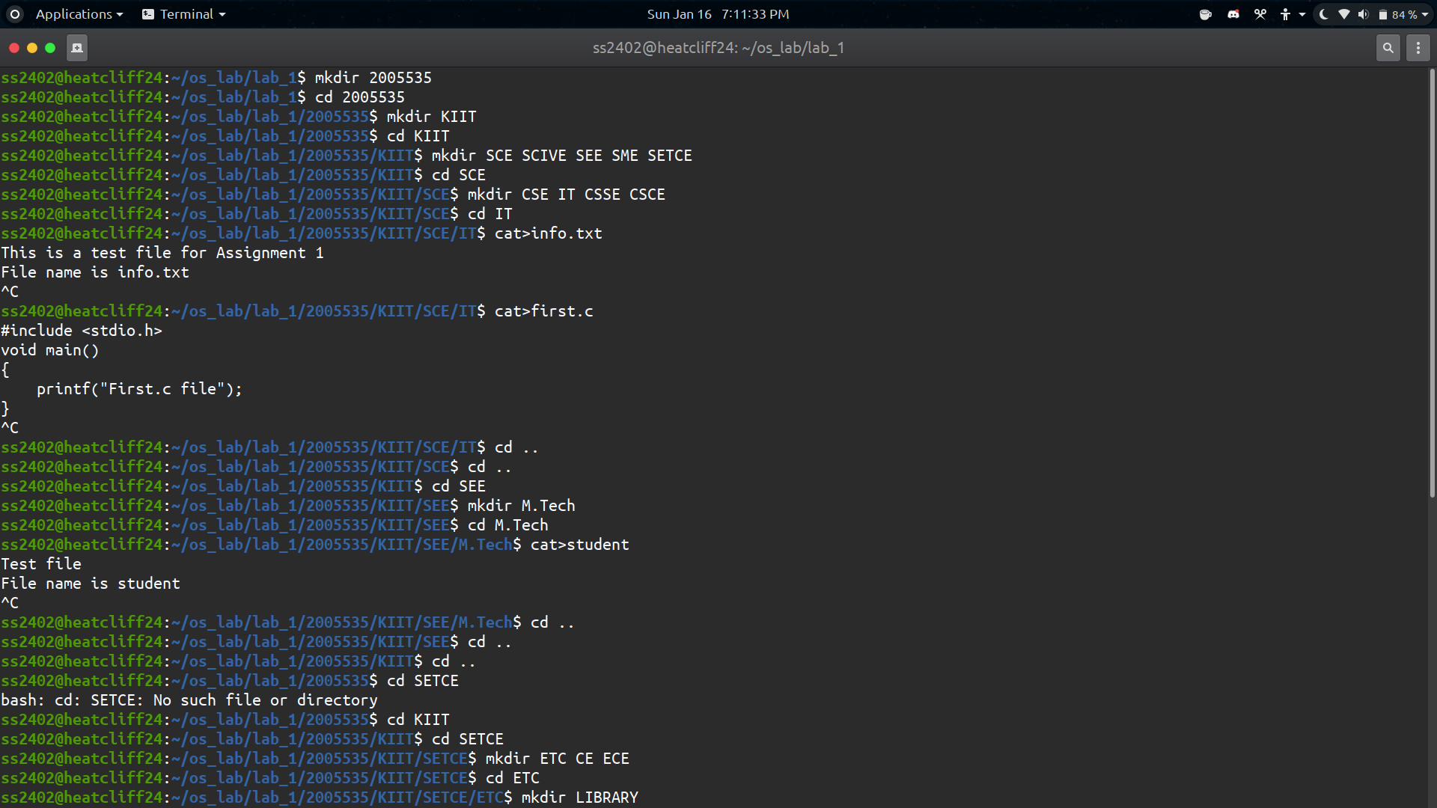

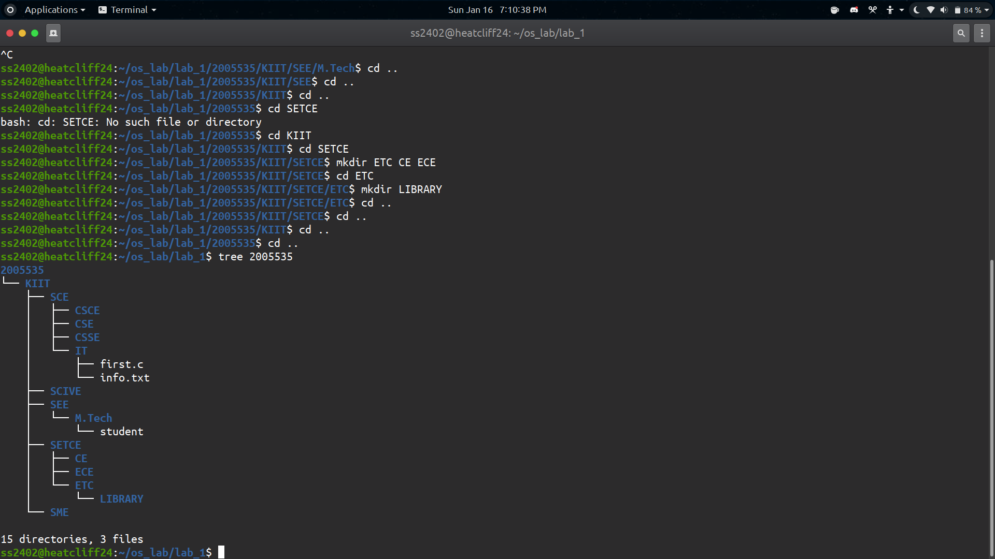

**B) Rename the file info.txt as itstudentsdata.txt.**

SOLUTION:

/2005535/KIIT$ mv SCE/IT/info.txt SCE/IT/itsstudentdata.txt

/2005535/KIIT$ cat SCE/IT/itsstudentdata.txt

This is a test file for Assignment 1

File name is info.txt

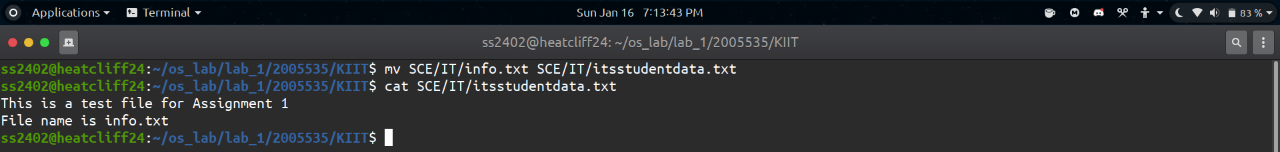

**C) Copy the file first.c into the directory CE with the same name.**

SOLUTION:

/2005535/KIIT$ cp SCE/IT/first.c SETCE/CE/

/2005535/KIIT$ cat SETCE/CE/first.c

#include <stdio.h>

void main()

{

printf("First.c file");

}

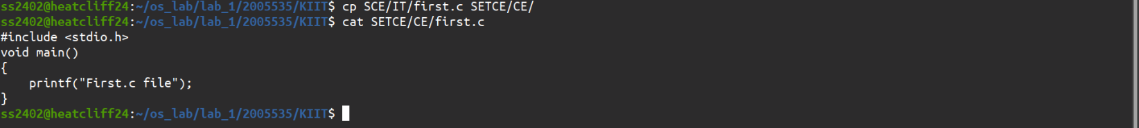

**D) Copy the file first.c into the directory SME with a new name as hello.c.**

SOLUTION:

/2005535/KIIT$ cp SCE/IT/first.c SME/hello.c

/2005535/KIIT$ cat SME/hello.c

#include <stdio.h>

void main()

{

printf("First.c file");

}



**E) Transfer the file student into the directory SCIVE and check whether transferred or not.**

SOLUTION:

/2005535/KIIT$ mv SEE/M.Tech/student SCIVE/

/2005535/KIIT$ ls SCIVE

student

/2005535/KIIT$ cat SCIVE/student

Test file

File name is student



**F) Rename CSSE to SYSTEM ENGG**

SOLUTION:

/2005535/KIIT$ ls SCE

CSCE CSE CSSE IT

/2005535/KIIT$ mv SCE/CSSE SCE/'SYSTEM ENGG'

/2005535/KIIT$ ls SCE

CSCE CSE IT 'SYSTEM ENGG'



**G) Delete ECE directory.**

SOLUTION:

/2005535/KIIT$ rmdir SETCE/ECE

/2005535/KIIT$ ls SETCE/ECE

ls: cannot access 'SETCE/ECE': No such file or directory

/2005535/KIIT$ ls SETCE

CE ETC



**H) Delete SEE directory.**

SOLUTION:

/2005535/KIIT$ ls

SCE SCIVE SEE SETCE SME

/2005535/KIIT$ rm -r SEE

/2005535/KIIT$ ls SEE

ls: cannot access 'SEE': No such file or directory

/2005535/KIIT$ ls

SCE SCIVE SETCE SME

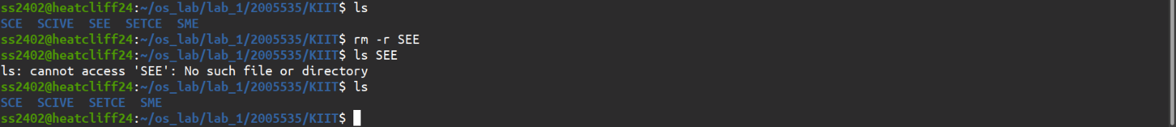

**I) Copy IT directory to LIBRARY**

SOLUTION:

/2005535/KIIT$ cp -r SCE/IT SETCE/ETC/LIBRARY

/2005535/KIIT$ ls SETCE/ETC/LIBRARY

IT

/2005535/KIIT$ tree SETCE

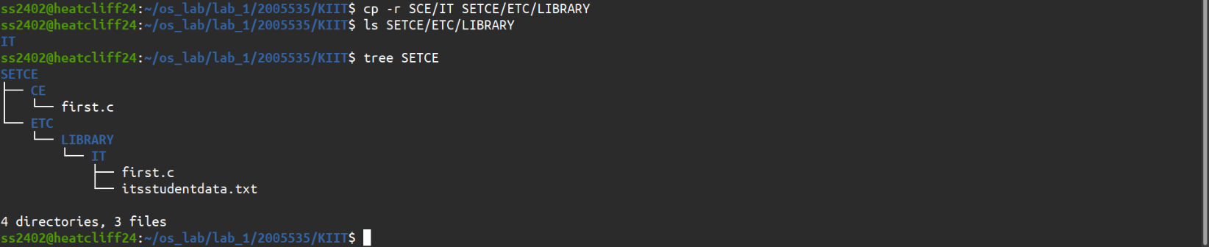

Final Directory



