Lab Assignment-01

ROLL: 2005535 | NAME: SAHIL SINGH | DATE: 04/01/22

**Linux/Unix Commands**

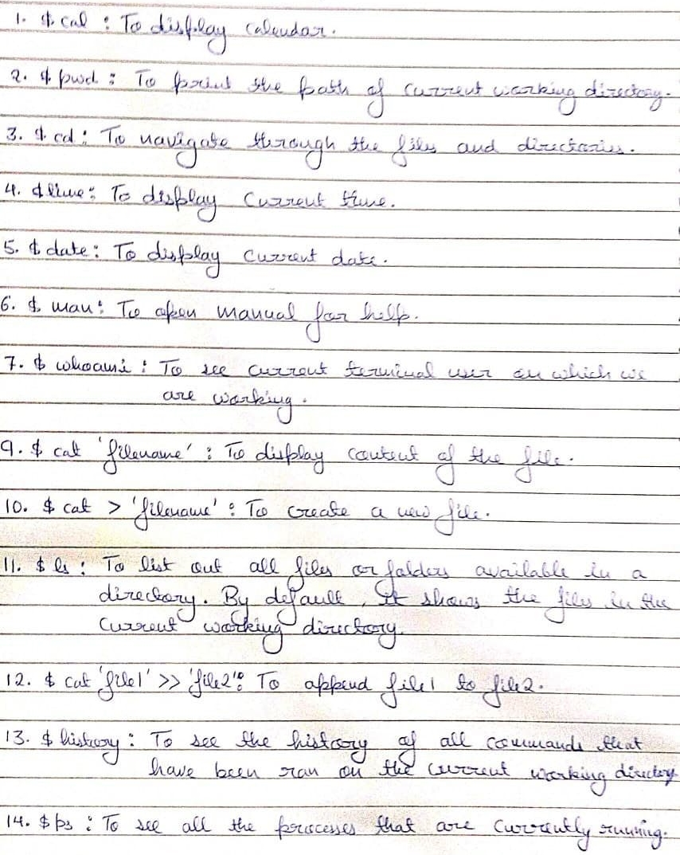

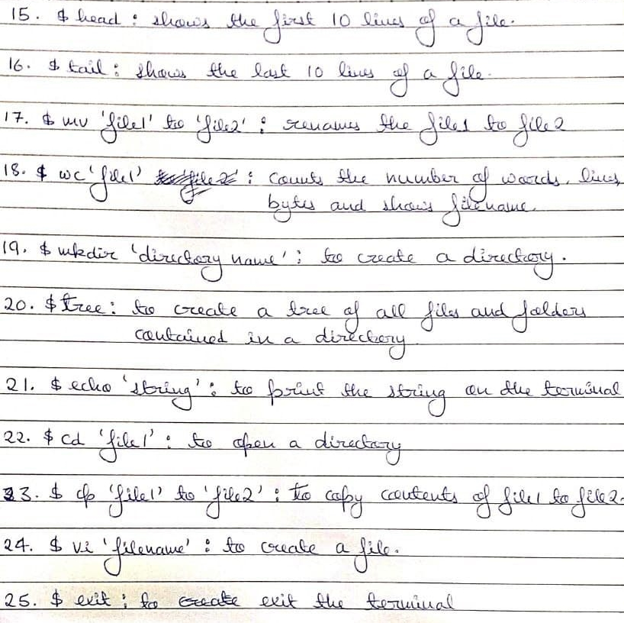

Lab Assignment-02

ROLL: 2005535 | NAME: SAHIL SINGH | DATE: 11/01/22

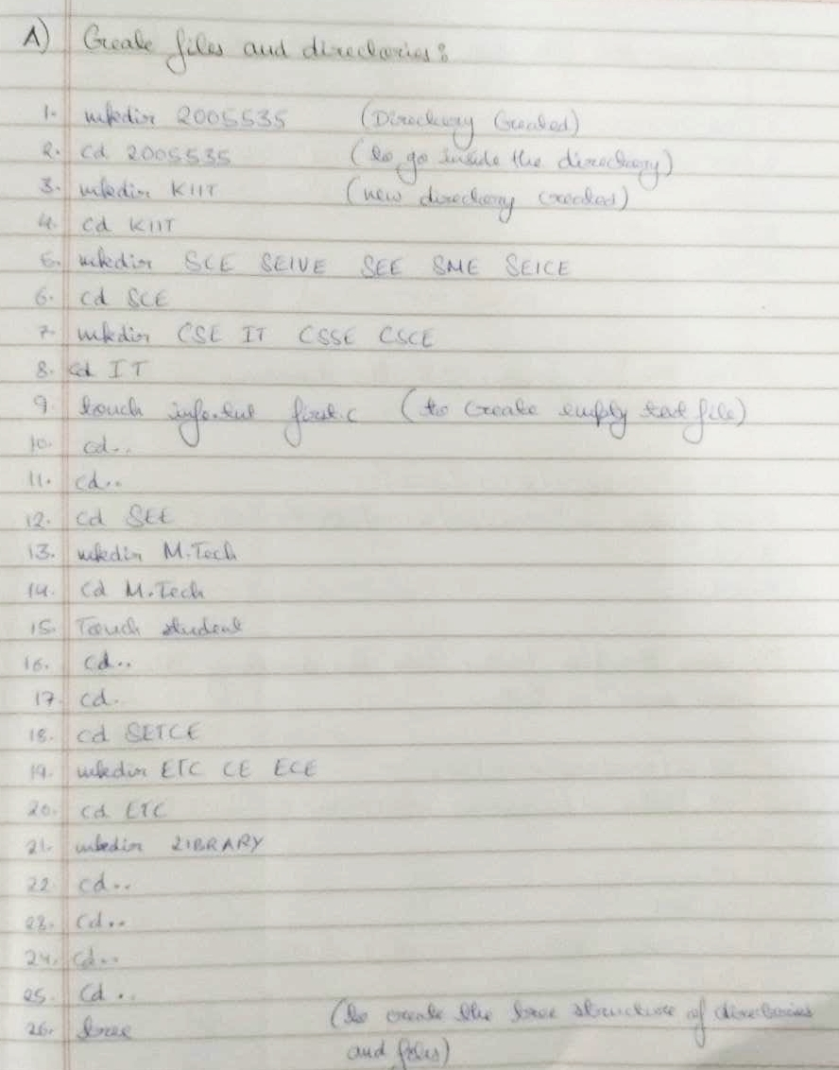

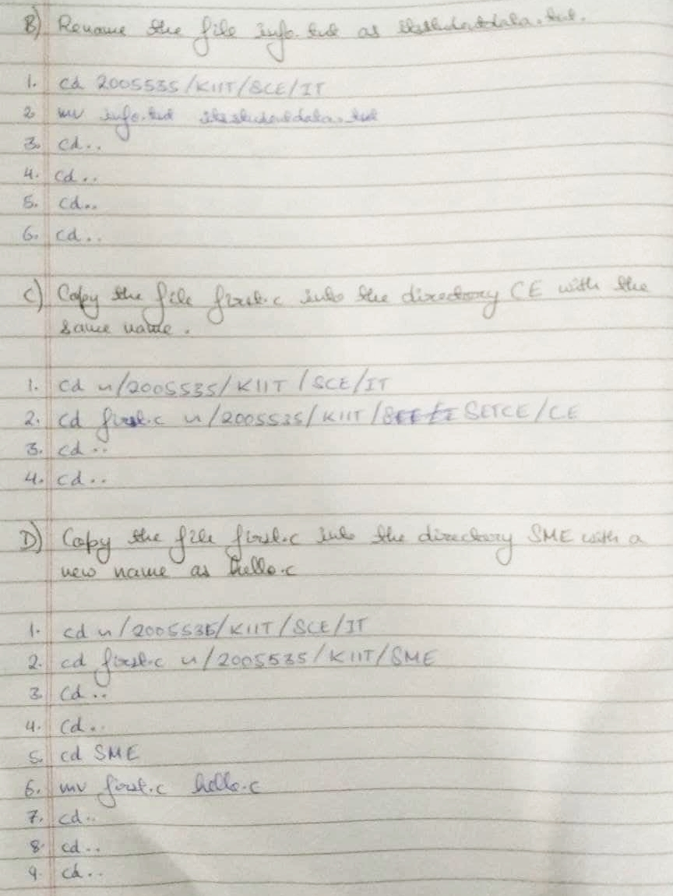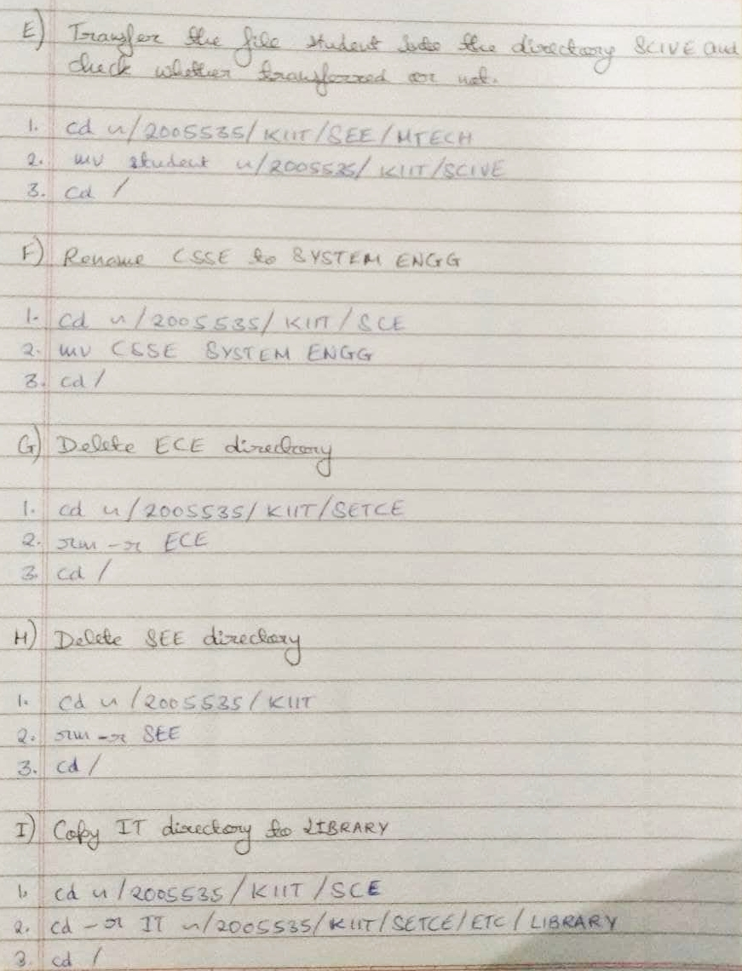

Created Directory

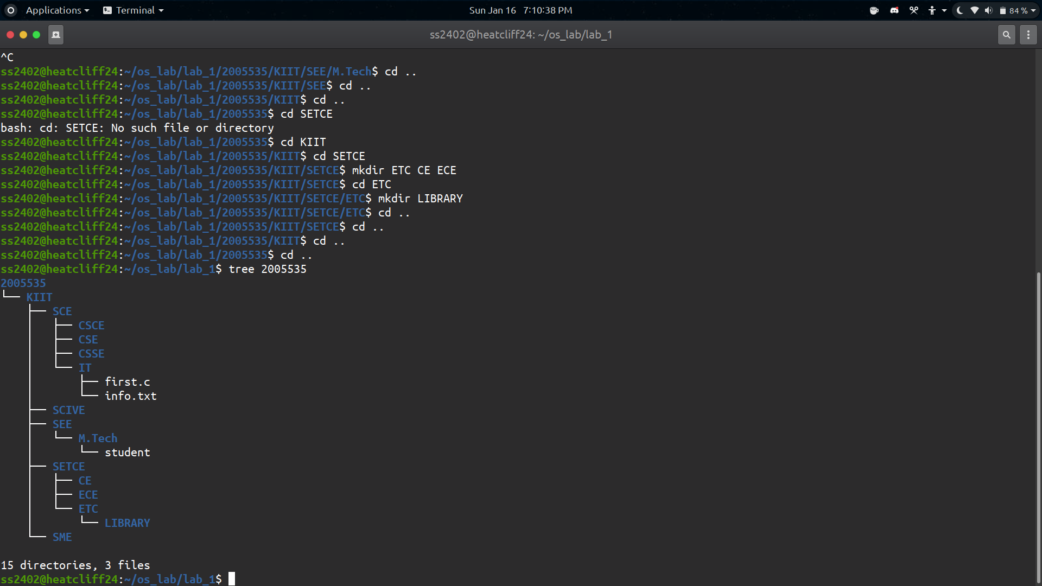

Final Directory



