Lab Assignment-03

ROLL: 2005535 | NAME: SAHIL SINGH | DATE: 18/01/22

**QUES 1: WAS to perform all the arithmetic operation of two integers and display the results.**

SOLUTION:

echo "---Arithematic Operations---\n"

read -p "Enter 1st number: " num1

read -p "Enter 2nd number: " num2

echo "\n---Addition---"

sum=`echo $num1 + $num2|bc`

echo "$num1 + $num2 = $sum"

echo "\n---Subtraction---"

sub=`echo $num1 - $num2|bc`

echo "$num1 - $num2 = $sub"

echo "\n---Multiplication---"

mul=`echo $num1 \* $num2|bc`

echo "$num1 * $num2 = $mul"

echo "\n---Division---"

div=`echo $num1 / $num2|bc`

echo "$num1 / $num2 = $div"

OUTPUT:

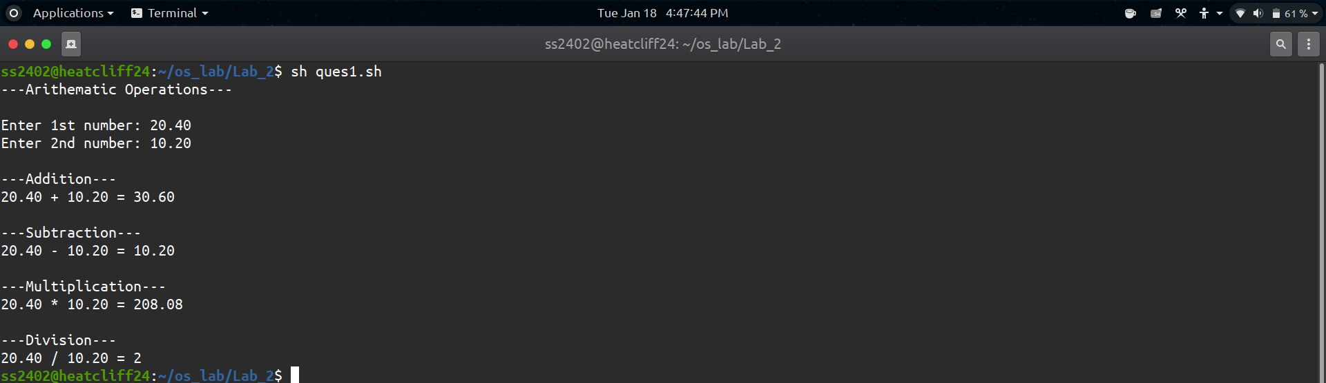

**QUES 2: WAS to calculate the area of a circle.**

SOLUTION:

echo "---Area of Circle---\n"

read -p "Enter the radius: " radius

area=`echo 3.14159 \* $radius \* $radius|bc`

echo "Area of circle is $area"

OUTPUT:

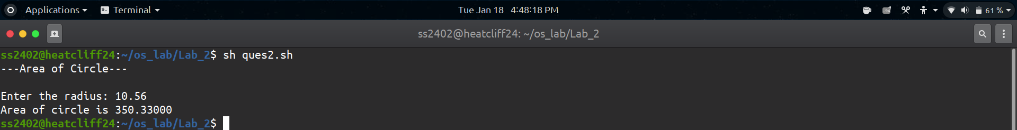

**QUES 3: WAS to swap two integer numbers without using a third variable.**

SOLUTION:

echo "---Swapping of Integers---\n"

read -p "Enter two integers: " num1 num2

echo "\n---Before Swapping---"

echo "Variable 1: $num1"

echo "Variable 2: $num2"

num1=`expr $num1 + $num2`

num2=`expr $num1 - $num2`

num1=`expr $num1 - $num2`

echo "\n---After Swapping---"

echo "Variable 1: $num1"

echo "Variable 2: $num2"

OUTPUT:

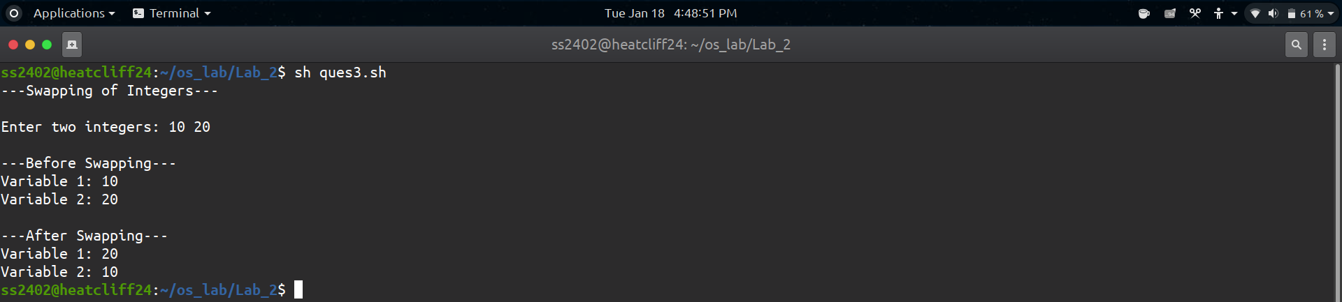

**QUES 4: WAS to find centigrade for a given Fahrenheit temperature.**

SOLUTION:

echo "---Fahrenheit to Celsius---\n"

read -p "Enter the temperature in fahrenheit: " fahr

cels=`echo "($fahr - 32) * 0.56"|bc`

echo "$fahr F is $cels C"

OUTPUT:

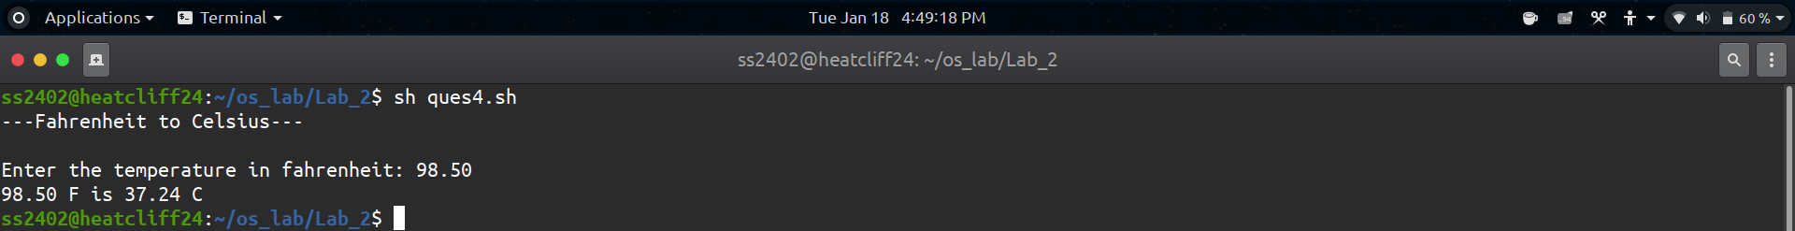

**QUES 5: WAS to convert given second into its equivalent hour, minute and second as per the following format. Example. 7560 second = 2 Hour, 6 Minute and 0 Second.**

SOLUTION:

echo "---Seconds into HH:MM:SS---\n"

read -p "Enter Seconds: " sec

hour=`echo "($sec / 3600)"|bc`

mins=`echo "($sec - (3600 * $hour)) / 60"|bc`

sec=`echo "($sec - (3600 * $hour) - ($mins * 60))"|bc`

echo "HH:MM:SS: $hour hours $mins mins $sec seconds"

OUTPUT:



