Lab Assignment-04

ROLL: 2005535 | NAME: SAHIL SINGH | DATE: 25/01/22

QUES 1: Write a script to find the largest between two numbers using command line argument.

SOLUTION:

echo "---Largest Number---\n"

echo "Enter 1st number: $1"

echo "Enter 2nd number: $2"

echo "\n---On Comparison---\n"

if test $1 -gt $2

then

    echo "$1 is Largest\n"

else

    echo "$2 is Largest\n"

fi

OUTPUT:

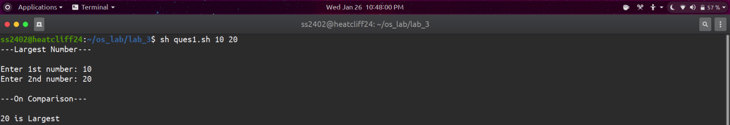

QUES 2: Write a script to determine whether a year entered through the keyboard is a leap year or not.

SOLUTION:

echo "---Leap Year Checker---"

read -p "Enter the year: " year

div4=`expr $year % 4`

div100=`expr $year % 100`

div400=`expr $year % 400`

if [ $div400 -eq 0 ]

then

    echo "$year is a leap year"

else

    if [ $div100 -eq 0 ]

    then

        echo "$year is not a leap year"

    elif [ $div4 -eq 0 ]

    then

        echo "$year is a leap year"

    else

        echo "$year is not a leap year"

    fi

fi

OUTPUT:

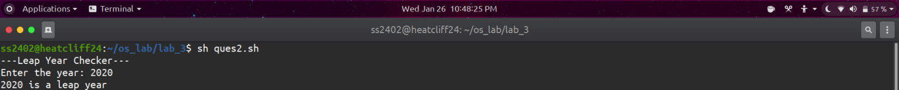

QUES 3: Write a script to find the area of a triangle by passing 3 sides of the triangle and check the triangle is possible or not.

SOLUTION:

echo "---Triangle Check---"

read -p "Enter the three sides of traingle: " side1 side2 side3

if [ `expr $side1 + $side2` -gt $side3 -a `expr $side1 + $side3` -gt $side2 -a `expr $side2 + $side3` -gt $side1 ]

then

    echo "\nTraingle with sides $side1, $side2 and $side3 is possible\n"

    semi=`echo "scale=2; ($side1+$side2+$side3)/2" | bc`

    area=`echo "scale=2; sqrt($semi\*($semi-$side1)\*($semi-$side2)\*($semi-$side3))"|bc`

    echo "Area of triangle is $area"

else

    echo "\nTraingle with sides $side1, $side2 and $side3 is not possible\n"

fi

OUTPUT:

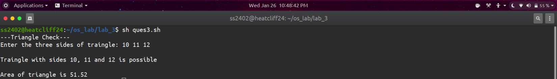

QUES 4: Write a script to check the number is odd or even.

SOLUTION:

echo "---Odd Even Checker---\n"

read -p "Enter a number: " num

if [ `expr $num % 2` -eq 0 ]

then

    echo "$num is Even"

else

    echo "$num is Odd"

fi

OUTPUT:

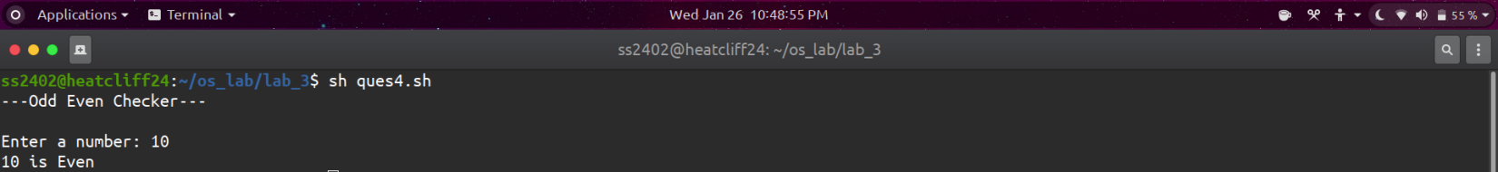

QUES 5: Write a script the check the number is palindrome or not of 3 digit number.

SOLUTION:

echo "---Pallindrome Checker---\n"

read -p "Enter the 3 digit number: " num1

a=`expr $num1 / 100`

b=`expr $num1 % 100`

c=`expr $b / 10`

d=`expr $b % 10`

e=$((d \* 100))

f=$((c \* 10))

num2=$((a + e + f))

if [ $num1 -eq $num2 ]

    then

        echo "It's a pallindrome"

else

    echo "Not a pallindrome"

fi

OUTPUT:



