Lab Assignment-05

ROLL: 2005535 | NAME: SAHIL SINGH | DATE: 01/02/22

QUES 1: Write a script to check the number is odd or even.

SOLUTION:

echo "---Odd Even---\n"

read -p "Enter the number: " num

calc=`expr $num % 2`

case $calc in

    1) echo "Odd Number"

    ;;

    0) echo "Even Number"

    ;;

    *) echo "Wrong Input!!!"

    ;;

esac

OUTPUT:

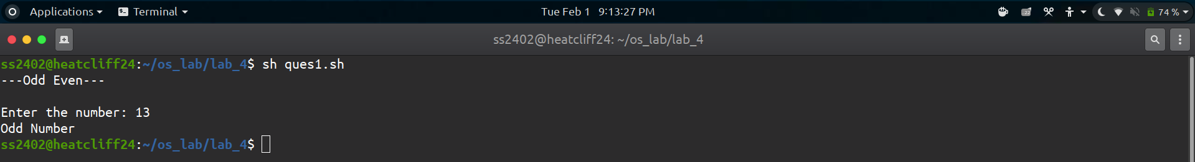

QUES 2: WASS to perform all the arithmetic operation like 1: Sum, 2:Multiplication, 3:Subtraction, 4: division using switch structure.

SOLUTION:

echo "---Arithematic Operations---\n"

read -p "Enter first number: " num1

read -p "Enter second number: " num2

echo "\n1. Addition"

echo "2. Subtraction"

echo "3. Multiplication"

echo "4. Division\n"

read -p "Enter Choice: " choice

add=`echo "$num1 + $num2"|bc`

sub=`echo "$num1 - $num2"|bc`

mul=`echo "$num1 * $num2"|bc`

div=`echo "scale=2;$num1 / $num2"|bc`

case $choice in

    1) echo "Addition: $add"

    ;;

    2) echo "Subtraction: $sub"

    ;;

    3) echo "Multiplication: $mul"

    ;;

    4) echo "Division: $div"

    ;;

    *) echo "Wrong Input!!!"

    ;;

esac

OUTPUT:

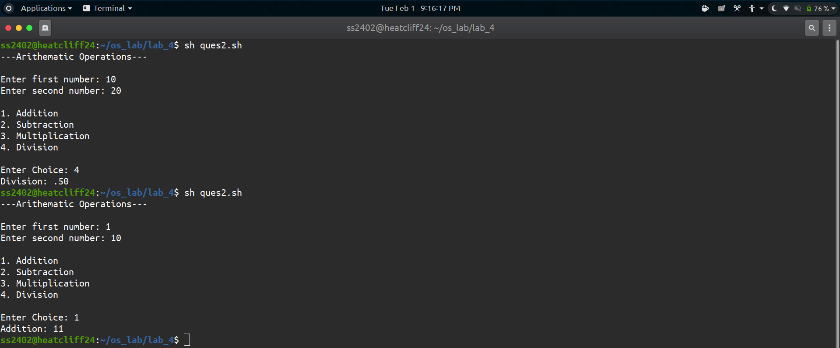

QUES 3: WASS to find out the gradation of a student by entering the 3 subject's mark using switch structure, like O-Grade, E-Grade, A-Grade ....

SOLUTION:

echo "---Grading System---\n"

read -p "Enter subject 1 marks (out of 100): " sub1

read -p "Enter subject 2 marks (out of 100): " sub2

read -p "Enter subject 3 marks (out of 100): " sub3

sub_total=`expr $sub1 + $sub2 + $sub3`

div=`expr $sub_total / 30`

case $div in

    10) echo "O Grade\n"

    ;;

    9) echo "O Grade\n"

    ;;

    8) echo "E Grade\n"

    ;;

    7) echo "A Grade\n"

    ;;

    6) echo "B Grade\n"

    ;;

    5) echo "C Grade\n"

    ;;

    4) echo "D Grade\n"

    ;;

    *) echo "F Grade(Fail)\n"

    ;;

esac

OUTPUT:

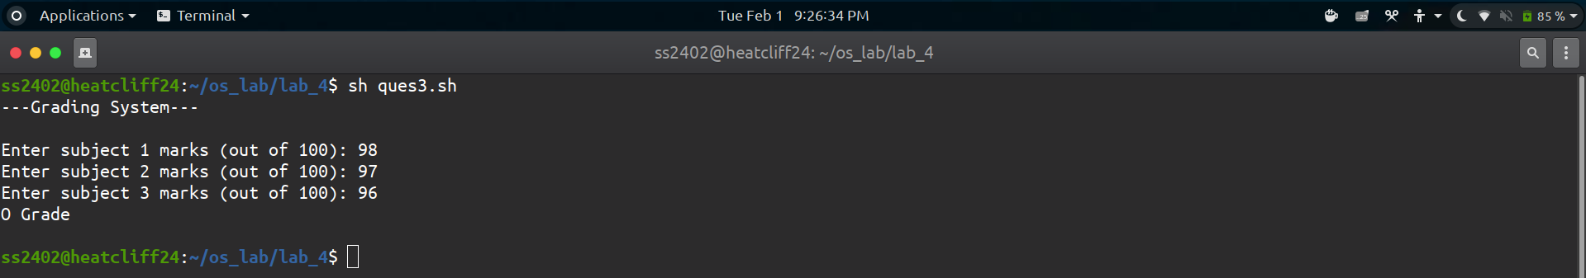

QUES 4: WASS to enter a character and check the inputted character is number or alphabet, if alphabet the upper case or lower case letter or special operator.

SOLUTION:

echo "---Character Check---\n"

read -p "Enter a character: " char

case $char in

    [0-9]) echo "Numeric Input Detected!!!\n"

    ;;

    *) case $char in

        [a-z]) echo "Lower Case Alphabet Detected\n"

        ;;

        [A-Z]) echo "Upper Case Alphabet Detected\n"

        ;;

        *) echo "Special Character Detected!!!\n";;

    esac

esac

OUTPUT:

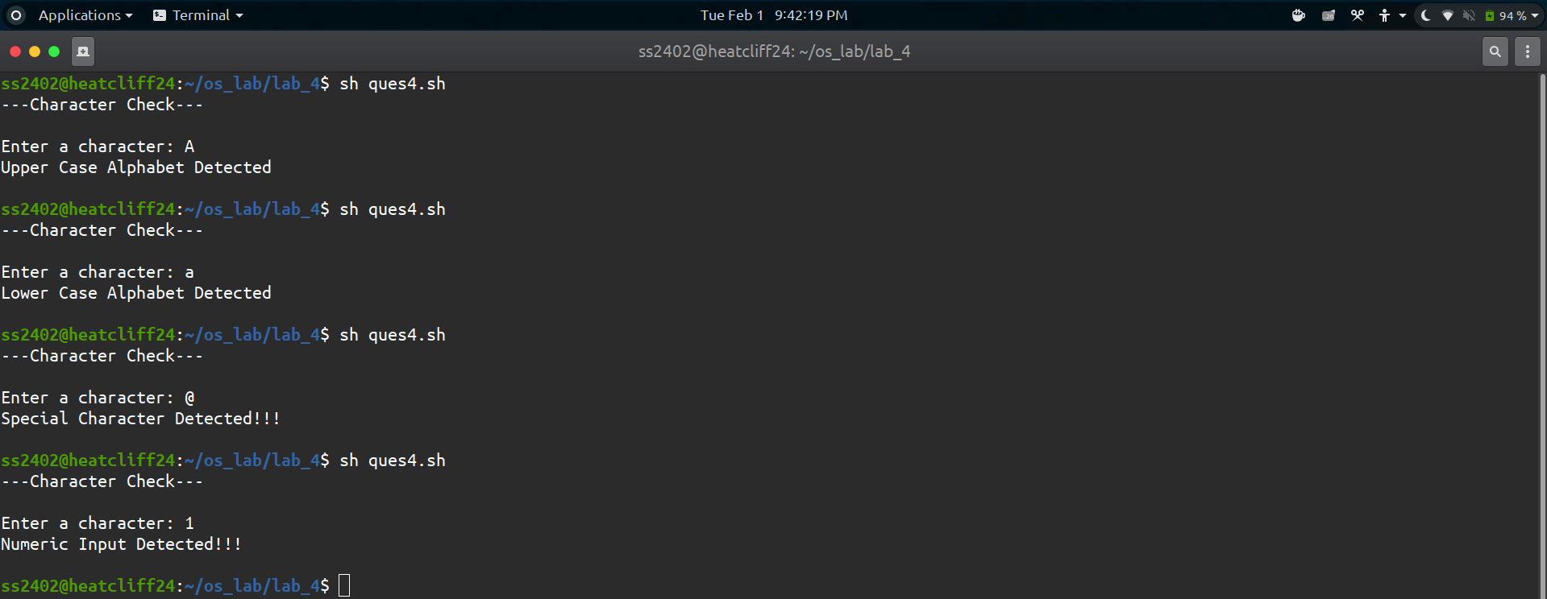

QUES 5: WASS to calculate area of circle, square and rectangle.

SOLUTION:

echo "---Area of Shapes---\n"

echo "Shapes :\n"

echo "1. Circle"

echo "2. Square"

echo "3. Rectangle"

read -p "Enter choice: " choice

case $choice in

    1) read -p "Enter the radius: " radius

    area=`echo "scale=2;3.14*$radius*$radius"|bc`

    ;;

    2) read -p "Enter the side: " side

    area=`echo "scale=2;$side*$side"|bc`

    ;;

    3) read -p "Enter length of the circle: " length

    read -p "Enter breadth of the circle: " breadth

    area=`echo "scale=2;$length*$breadth"|bc`

    ;;

    *) echo "Wrong Input!!!"

    ;;

esac

echo "The area is : $area"

OUTPUT:



