Lab Assignment-06

ROLL: 2005535 | NAME: SAHIL SINGH | DATE: 08/02/22

QUES 1: Write a Shell Script to add all the numbers from 1 to 20.

SOLUTION:

echo "---Adding Numbers till 20---"

i=0

until [ $i -eq 20 ]

do

    i=`expr $i + 1`

    echo -n "$i "

    s=`expr $s + $i`

done

echo ""

echo "Sum: $s"

OUTPUT:

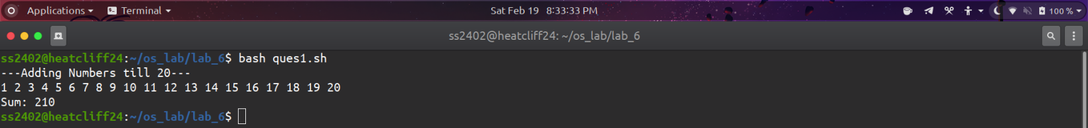

QUES 2: WASS to add all the even numbers from 1 to 20.

SOLUTION:

echo "---Adding Even Numbers---"

i=0

s=0

echo "Even Numbers: "

until [ $i -eq 20 ]

do

    i=`expr $i + 1`

    if [ `expr $i % 2` -eq 0 ]

    then

        s=`expr $s + $i`

        echo -n "$i "

    fi

done

echo ""

echo "\nSum of Even Numbers: $s"

OUTPUT:

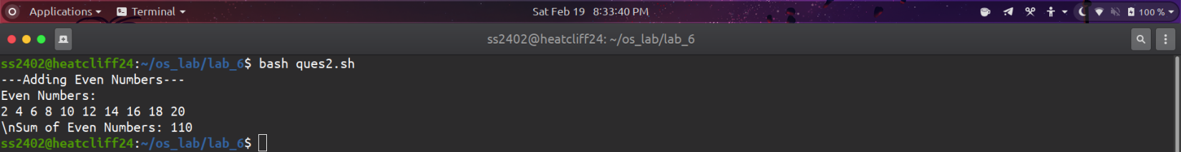

QUES 3: WASS to add all the numbers from 1 to n.

SOLUTION:

echo "---Adding n Numbers---"

read -p "Enter n: " n

i=0

s=0

until [ $i -eq $n ]

do

    i=`expr $i + 1`

    echo -n "$i "

    s=`expr $s + $i`

    if [ $i -eq $n ]

    then

        break

    fi

done

echo ""

echo "Sum: $s"

OUTPUT:

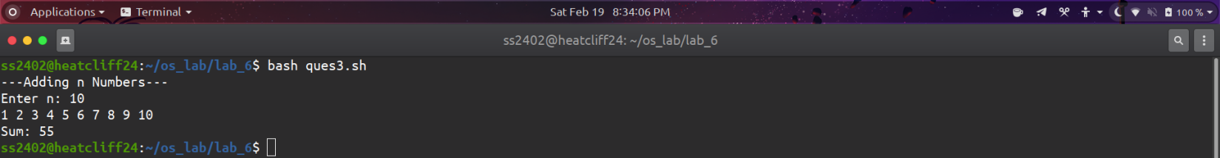

QUES 4: WASS to print all the natural numbers between 1 to n in reverse order.

SOLUTION:

echo "---Printing 1 to n Numbers in reverse---"

read -p "Enter n: " n

i=0

until [ $n -eq $i ]

do

    echo -n "$n "

    n=`expr $n - 1`

done

echo ""

OUTPUT:

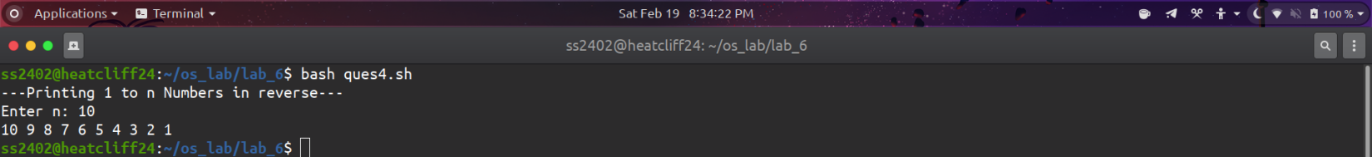

QUES 5: WASS to print all the natural numbers between 1 to 100 in different line, the user enter how many elements want to print in a line.

SOLUTION:

echo "---Print numbers till 100---"

read -p "Enter how many elements to print in a line: " n

i=0

while [ $i -le 100 ]

do

    j=1

    while [ $j -le $n ]

    do

        echo -n "$i "

        i=`expr $i + 1`

        j=`expr $j + 1`

    done

    echo ""

done

OUTPUT:

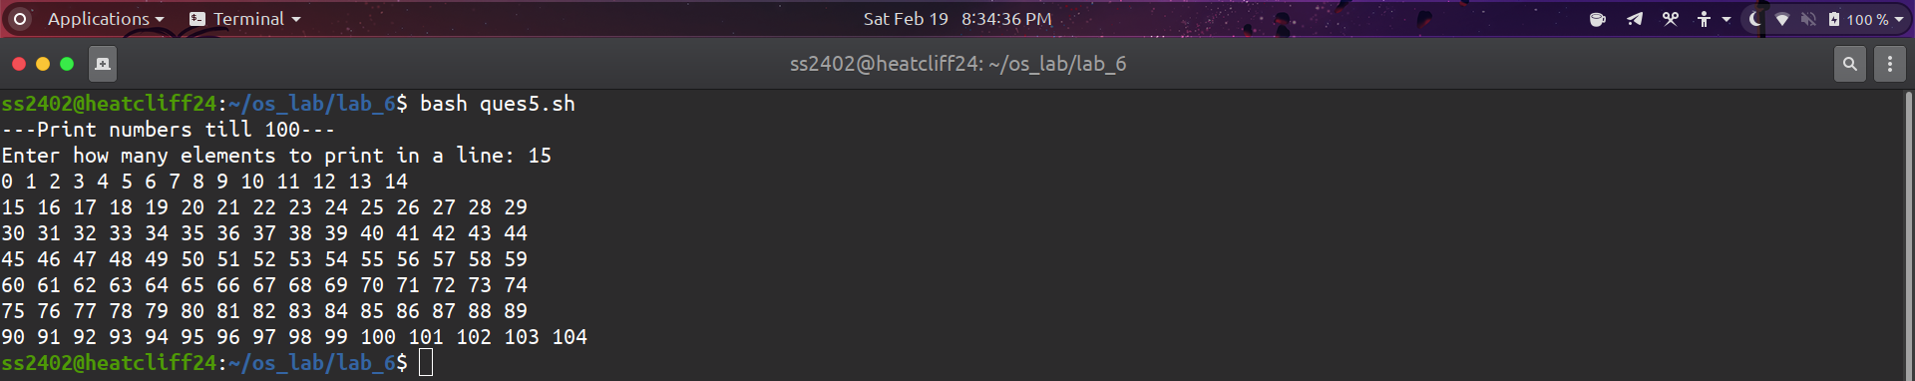

QUES 6: WASS to read a number then check if it is prime or not.

SOLUTION:

echo "---Prime Number Check---"

read -p "Enter the number: " num

i=2

count=0

while test $i -le `expr $num / 2`

do

    if [ `expr $num % $i` -eq 0 ]

    then

        count=1

    fi

    i=`expr $i + 1`

done

if [ $count -eq 1 ]

    then

    echo "Not a Prime Number"

else

    echo "Prime Number"

    fi

OUTPUT:

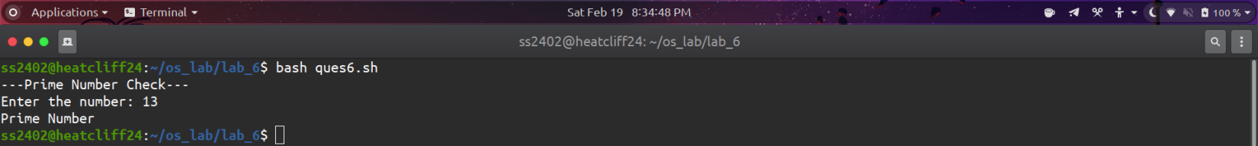

QUES 7: WASS to enter a number and check the number is perfect number or not.

SOLUTION:

echo "---Perfect Number Check---"

read -p "Enter a number: " num

i=1

res=0

while [ $i -le `expr $num / 2` ]

do

    if [ `expr $num % $i` -eq 0 ]

    then

        res=`expr $res + $i`

    fi

    i=`expr $i + 1`

done

if [ $num -eq $res ]

then

    echo "$num is perfect"

else

    echo "$num is not perfect"

fi

OUTPUT:



