Lab Assignment-07

ROLL: 2005535 | NAME: SAHIL SINGH | DATE: 15/02/22

QUES 1: WASS to show usage of all types of for loops.

SOLUTION:

echo "---Types of For Loops---"

echo "Using C style for loop"

for((i=1;i<=10;i++));

do

    echo -n "$i "

done

echo

echo

echo "Using loop over a number range"

for i in {1..10}

do

    echo -n "$i "

done

echo

echo

echo "Using loop over elements"

for i in 1 2 3 4 5 6 7 8 9 10

do

    echo -n "$i "

done

echo

echo

OUTPUT:

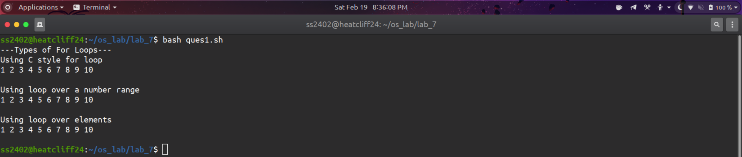

QUES 2: WASS to print the given pattern using loops.

1

1 2

1 2 3

1 2 3 4

1 2 3 4 5

SOLUTION:

num=1

rows=5

for((i=1; i<=rows; i++))

do

  for((j=1; j<=i; j++))

  do

    echo -n "$num "

    num=$((num + 1))

  done

  num=1

  echo

done

OUTPUT: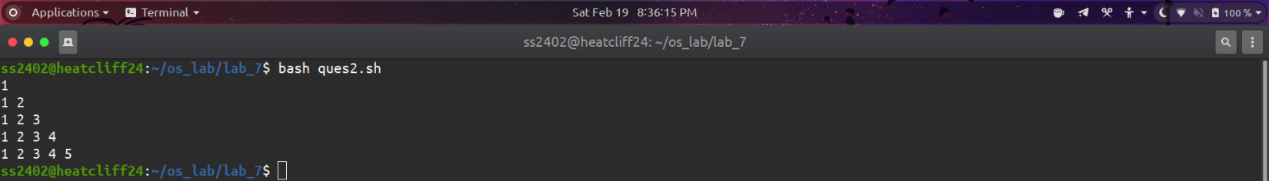

QUES 3: WASS to print the given pattern using loops.

1

2 1

3 2 1

4 3 2 1

5 4 3 3 1

SOLUTION:

num=1

rows=5

for((i=1; i<=rows; i++))

do

  for((j=1; j<=rows - i; j++))

  do

    echo -n "  "

  done

  for((j=i; j>=1; j--))

  do

    echo -n "$j "

  done

  echo

done

OUTPUT:

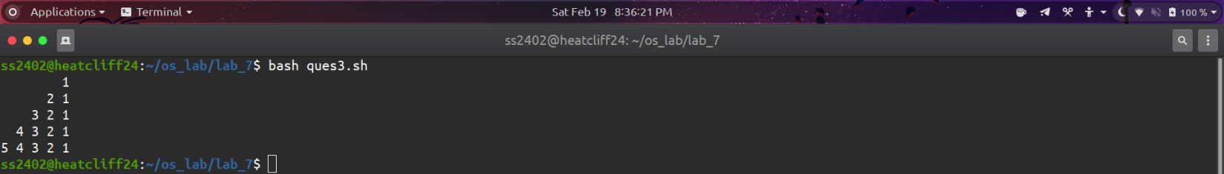

QUES 4: WASS to print the given pattern using loops.

1

1 2 1

1 2 3 2 1

1 2 3 4 3 2 1

SOLUTION:

for((i=1;i<=4;i++));

do

  for((j=4;j>i;j--));

  do

    echo -n "  "

  done

  for((k=1;k<=i;k++));

  do

    echo -n "$k "

  done

  for((l=i-1;l>=1;l--));

  do

    echo -n "$l "

  done

  echo -e ""

done

OUTPUT:

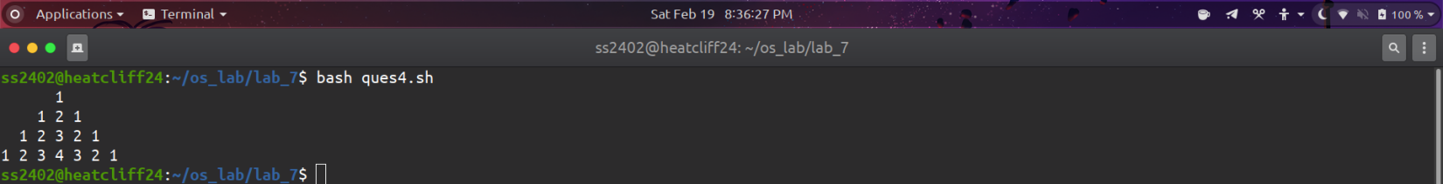

QUES 5: WASS to print the given pattern using loops.

\*

\* \*

\* \* \*

\* \* \* \*

\* \* \*

\* \*

\*

SOLUTION:

rows=4

for((i=1;i<=rows;i++));

do

    for((j=1;j<=rows-i;j++));

    do

        echo -n "  "

    done

    for((j=1;j<=i;j++));

    do

        echo -n "x   "

    done

    echo -e ""

done

for((i=rows-1;i>=1;i--));

do

    for((j=1;j<=rows-i;j++));

    do

        echo -n "  "

    done

    for((j=1;j<=i;j++));

    do

        echo -n "x   "

    done

    echo -e ""

done

OUTPUT:

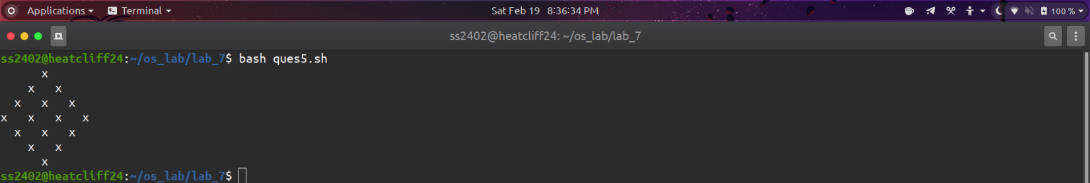

QUES 6: WASS to print the given pattern using loops.

A

AB

ABC

ABCD

ABCDE

SOLUTION:

rows=5

chars=( {A..Z} )

for((i=1;i<=rows;i++));

do

    for((j=0;j<i;j++));

    do

        echo -n "${chars[j]}"

    done

    echo -e ""

done

OUTPUT:



