Lab Assignment-08

ROLL: 2005535 | NAME: SAHIL SINGH | DATE: 22/02/22

QUES 1: WASS to input n numbers to an array and display in reverse order.

SOLUTION:

echo "---Array in Reverse---"

read -p "Enter the size of array: " n

echo "Enter the elements: "

for ((i=0;i<n;i++));

do

    read arr[$i]

done

echo

echo "Array Elements: "

for ((i=0;i<n;i++));

do

    echo -n ${arr[$i]} ""

done

echo

echo "Array Elements in reverse: "

for ((i=n;i>=0;i--));

do

    echo -n ${arr[$i]} ""

done

echo

OUTPUT:

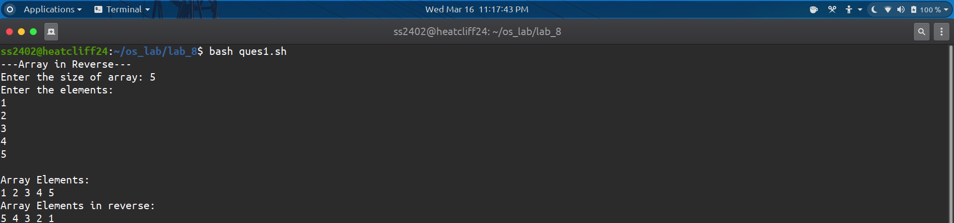

QUES 2: WASS to input n numbers to an array, reverse the array and display without using an extra array.

SOLUTION:

echo "---Store Array in Reverse and Display---"

read -p "Enter the size of Array: " n

echo "Enter the elements: "

for((i=0;i<n;i++));

do

    read arr[$i]

done

echo

min=0

max=$(( ${#arr[@]} -1 ))

while [[ min -lt max ]]

do

    x="${arr[$min]}"

    arr[$min]="${arr[$max]}"

    arr[$max]="$x"

    (( min++, max-- ))

done

echo "Array Elements: "

for((i=0;i<n;i++));

do

    echo -n ${arr[$i]} ""

done

echo

OUTPUT:

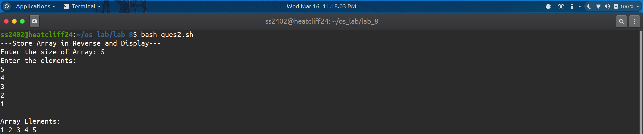

QUES 3: WASS to input n numbers to an array and perform the following operation like press 1: display the elements in ascending order and press 2: to display the elements in descending order using case structure.

SOLUTION:

echo "---Display Elements in Ascending and Descending---"

read -p "Enter the size of Array: " n

echo "Enter the elements: "

for((i=0;i<n;i++));

do

    read arr[$i]

done

echo

for ((i = 0; i<n; i++))

do

    for((j = 0; j<n-i-1; j++))

    do

        if [ ${arr[j]} -gt ${arr[$((j+1))]} ]

        then

            temp=${arr[j]}

            arr[$j]=${arr[$((j+1))]}

            arr[$((j+1))]=$temp

        fi

    done

done

echo "Display Order:"

echo "1. Ascending Order"

echo "2. Descending Order"

read -p "Enter Choice: " ch

case $ch in

    1)

    echo "Array Elements: "

    for((i=0;i<n;i++));

    do

        echo -n ${arr[$i]} ""

    done

    echo

    ;;

    2)

    echo "Array Elements in reverse: "

    for((i=n;i>=0;i--));

    do

        echo -n ${arr[$i]} ""

    done

    echo

    ;;

    \*) echo "Wrong Input!!!"

    ;;

esac

OUTPUT:

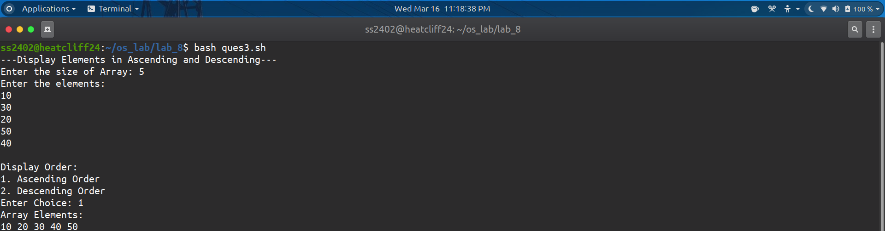

QUES 4: WASS to input two array with size m and n. Concatenate that two array and display.

SOLUTION:

echo "---Concatenate two Arrays and Display---"

echo "Input array 1"

read -p "Enter the size of Array: " m

echo "Enter the elements: "

for((i=0;i<m;i++));

do

    read arr1[$i]

done

echo

echo "Input array 2"

read -p "Enter the size of Array: " n

echo "Enter the elements: "

for((i=0;i<n;i++));

do

    read arr2[$i]

done

echo

arr1+=(${arr2[@]})

echo "Array Elements: "

for((i=0;i<m+n;i++));

do

    echo -n ${arr1[$i]} ""

done

echo

OUTPUT:

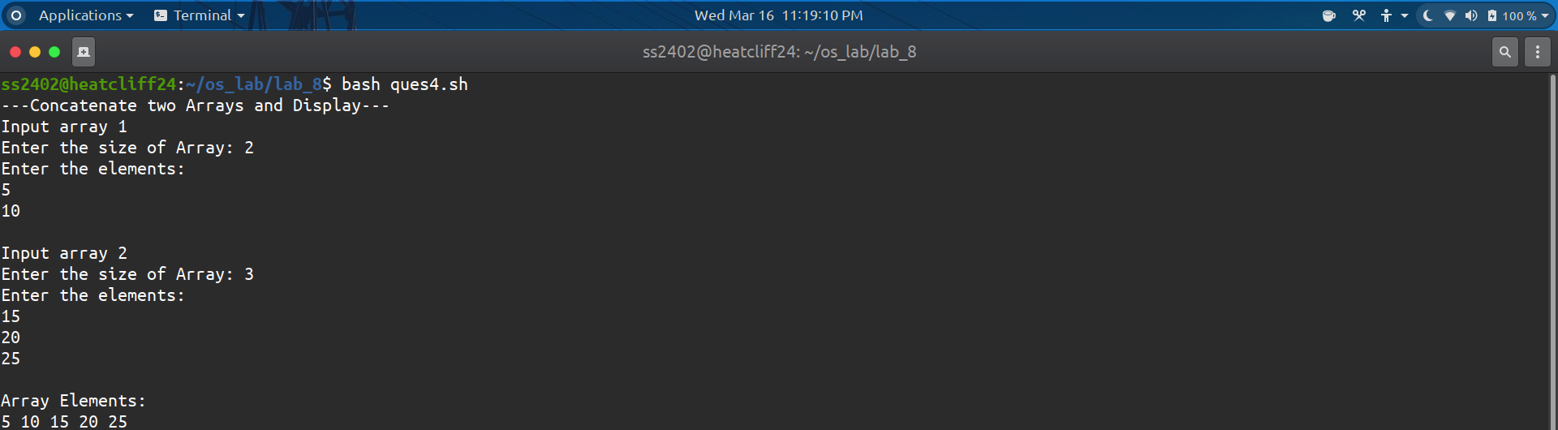

QUES 5: WASS to input n numbers to an array. Swap the pairing element starts from the start index and display.

Example: A = {1, 2, 3, 4, 5}, O/P: A = {2, 1, 4, 3, 5}

SOLUTION:

echo "---Swap Pairing Elements---"

read -p "Enter the size of array: " n

echo "Enter the elements: "

for((i=0;i<n;i++));

do

    read arr[$i]

done

echo

for ((i = 0; i<n; i++))

do

    for((j = 0; j<n; j+=2))

    do

        temp=${arr[j]}

        arr[$j]=${arr[$((j+1))]}

        arr[$((j+1))]=$temp

    done

done

echo

echo "Array Elements: "

for((i=0;i<n;i++));

do

    echo -n ${arr[$i]} ""

done

if [ `expr $n % 2` != 0 ]

then

    echo ${arr[$n]}

fi

echo

OUTPUT:



