Lab Assignment-02

ROLL: 2005535 | NAME: SAHIL SINGH | DATE: 20/01/22

**QUES 1: Design a user registration form implementing internal css.**

**SOLUTION:**

<!DOCTYPE html>

<html lang="en">

<head>

    <meta name="viewport" content="width=device-width, initial-scale=1">

    <meta charset="UTF-8">

    <meta http-equiv="X-UA-Compatible" content="IE=edge">

    <meta name="viewport" content="width=device-width, initial-scale=1.0">

    <title>User Registration Form</title>

    <style>

        body {

*font-family*: Consolas, Helvetica, sans-serif;

*background-color*:  #0e0b16;

*color*: #0e0b16;

        }

        * {

*box-sizing*: border-box;

        }

        .container {

*padding*: 16px;

*background-color*: #4717f6;

        }

        input[type=text],

        input[type=password] {

*width*: 100%;

*padding*: 9px;

*margin*: 5px 0 22px 0;

*display*: inline-block;

*border*: none;

*background*: navajowhite;

        }

        input[type=text]:focus,

        input[type=password]:focus {

*background-color*: #ddd;

*outline*: none;

        }

        input[type=checkbox]:focus {

*width*: 0.9%;

*margin*: 9px 1;

*background-color*: navajowhite;

        }

        input[type=email]:focus {

*width*: 100%;

*padding*: 9px;

*margin*: 5px 0 22px 0;

*display*: inline-block;

*border*: none;

*background*: navajowhite;

        }

        input[type=dropdown]:focus {

*width*: 100%;

*padding*: 9px;

*margin*: 5px 0 22px 0;

*display*: inline-block;

*border*: none;

*background*: navajowhite;

        }

        input[type=radio]:focus {

*width*: 1%;

*background-color*: navajowhite;

        }

        input[type=file]:focus {

*width*: 100%;

*padding*: 9px;

*margin*: 5px 0 22px 0;

*display*: inline-block;

*border*: none;

*background*: navajowhite;

        }

        hr {

*border*: 1px solid navajowhite;

*margin-bottom*: 25px;

        }

        select {

*width*: 100%;

*padding*: 9px;

*margin*: 5px 0 22px 0;

*display*: inline-block;

*border*: none;

*background*: navajowhite;

        }

        textarea {

*width*: 100%;

*padding*: 9px;

*margin*: 5px 0 22px 0;

*display*: inline-block;

*border*: none;

*background*: navajowhite;

        }

        .registerbtn {

*background-color*: navajowhite;

*color*: #0e0b16;;

*padding*: 16px 20px;

*margin*: 8px 0;

*border*: none;

*cursor*: pointer;

*width*: 100%;

*opacity*: 0.9;

        }

        .registerbtn:hover {

*opacity*: 1;

        }

        .signin {

*background-color*: #0e0b16;;

*text-align*: center;

        }

    </style>

</head>

<body>

    <form action="">

        <div class="container">

            <h1>User Registration Form</h1>

            <p>Enter user details below.</p>

            <hr>

            <label for="first"><b>First Name</b></label>

            <input type="text" placeholder="Enter First Name" name="first" id="first" required>

            <label for="second"><b>Second Name</b></label>

            <input type="text" placeholder="Enter Second Name" name="second" id="second" required>

            <label for="email"><b>Email</b></label>

            <input type="text" placeholder="Enter Email" name="email" id="email" required>

            <label for="psw"><b>Password</b></label>

            <input type="password" placeholder="Enter Password" name="psw" id="psw" required>

            <label for="school"><b></label>Select School</b></label>

            <select name="dropdown" id="" size="" font="Consolas">

                <option value="">Computer Applications</option>

                <option value="" selected>Computer Engineering</option>

                <option value="">Civil Engineering</option>

                <option value="">Electronics Engineering</option>

                <option value="">Mechanical Engineering</option>

                <option value="">Electrical Engineering</option>

                <option value="">Chemical Engineering</option>

                <option value="">Biotechnology</option>

                <option value="">Applied Sciences</option>

                <option value="">Architecture & Planning</option>

            </select>

            <label for="semester"><b>Semester</b></label>

            <select name="dropdown" id="" size="">

                <option value="">1</option>

                <option value="">2</option>

                <option value="">3</option>

                <option value="" selected>4</option>

                <option value="">5</option>

                <option value="">6</option>

                <option value="">7</option>

                <option value="">8</option>

                <option value="">9</option>

                <option value="">10</option>

            </select>

            <label for="address"><b>Address</b></label><br>

            <textarea name="mytext" cols="60" rows="3"></textarea>

            <label for="doj"><b>Date of Joining</b></label>

            <input type="date" name="doj">

            <label for="gender"><b>Gender</b></label>

            Male <input type="radio" name="gender">

            Female <input type="radio" name="gender">

            Others <input type="radio" name="gender"><br><br>

            <label for="courses"><b>Courses</b></label><br>

            <input type="checkbox">M.Tech

            <input type="checkbox" checked="check">B.Tech

            <input type="checkbox">Ph.D

            <input type="checkbox">B.Arch

            <input type="checkbox">Dual Degree<br><br>

            <label for="gc"><b>Attach Grade Card</b></label>

            <input type="file"><br><br>

            <button type="submit" class="registerbtn">Register</button>

            <button type="reset" class="registerbtn">Reset</button>

        </div>

    </form>

</body>

</html>

**OUTPUT:**

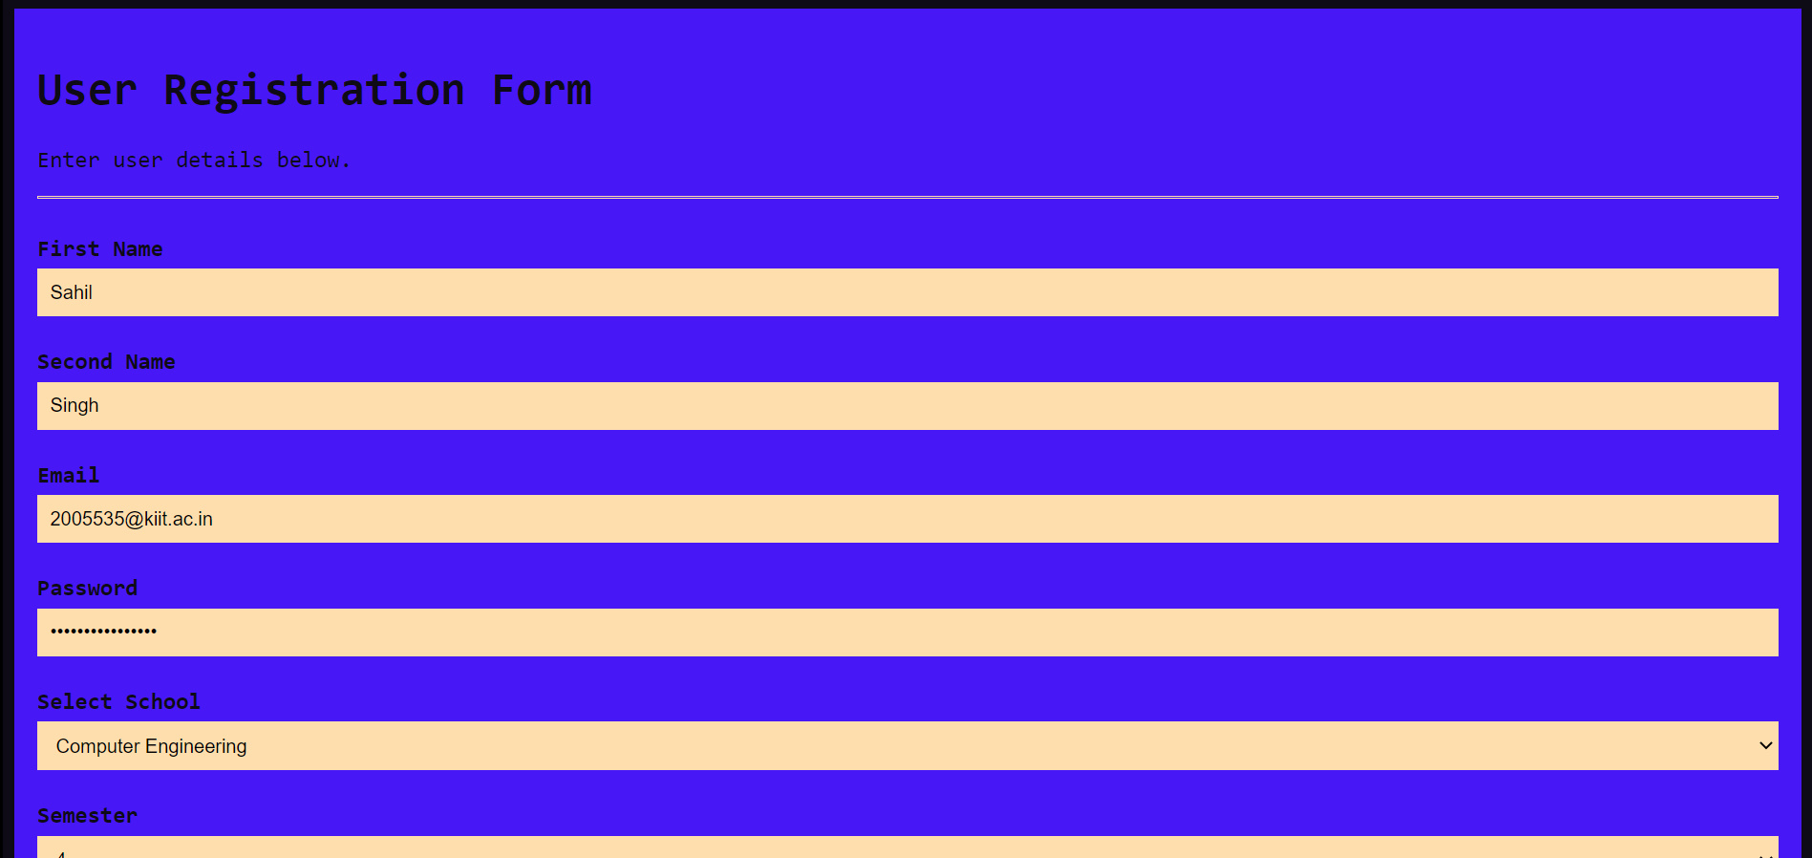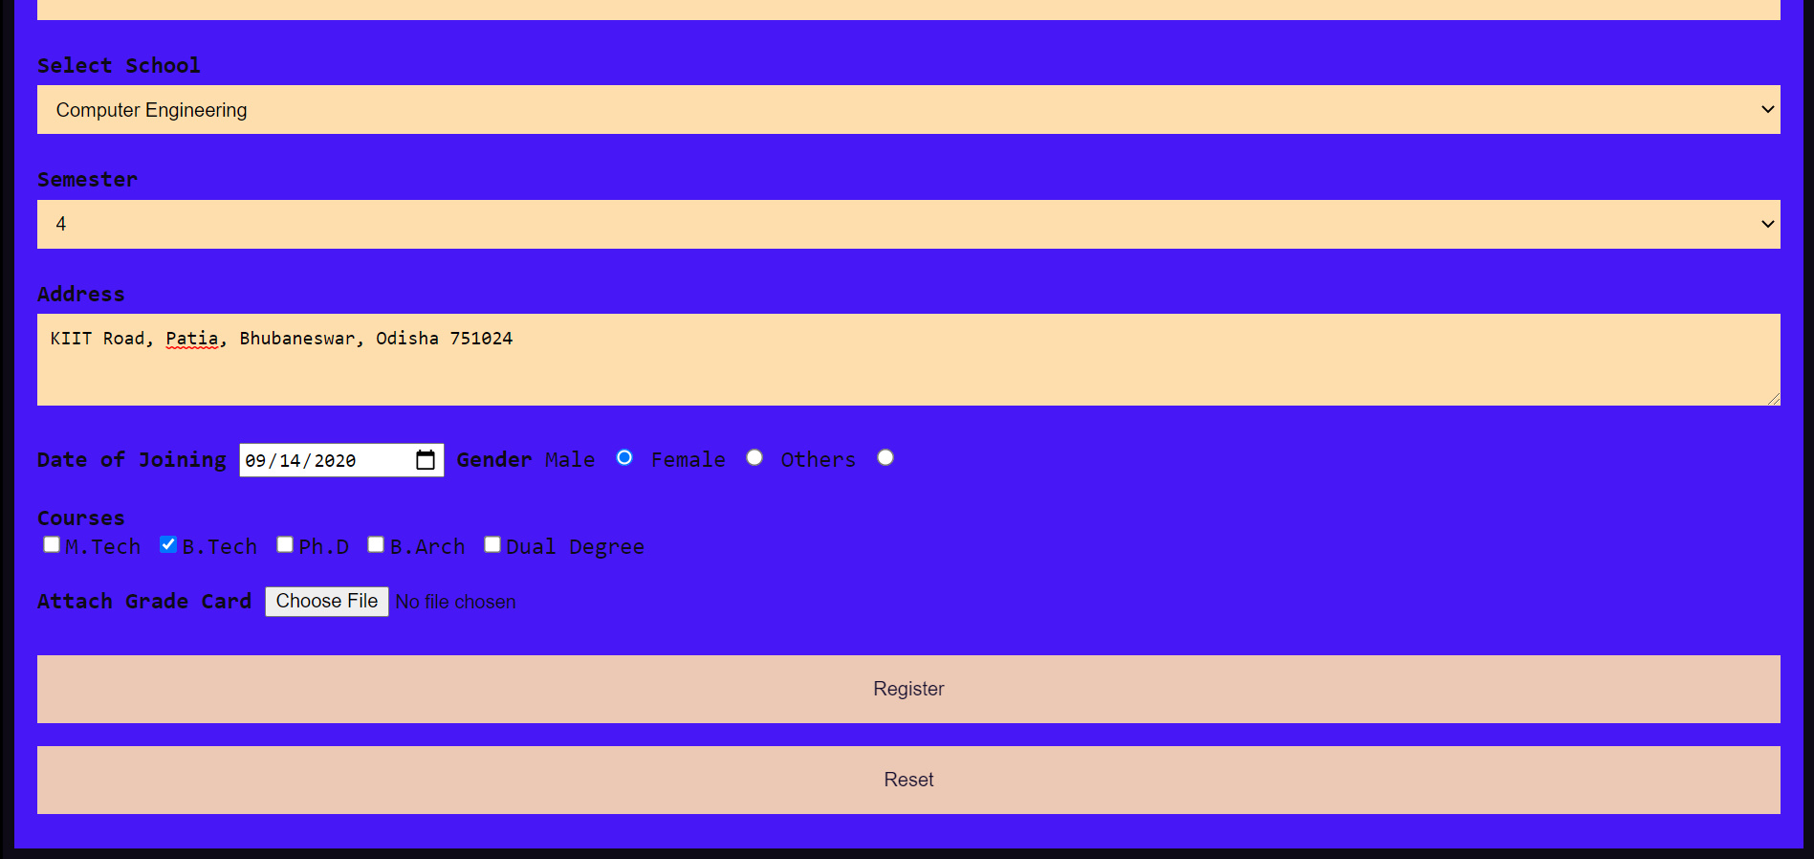

**QUES 2: Create a web page as follows: having 3 frames. KIIT University will move in marquee in the top frame. In the left frame, 3 hyperlinks named Login, About KIIT and Feedback will be there and clicking on that the desired result will be displayed in the main frame.**

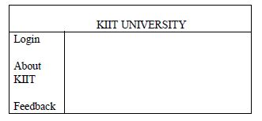

**SOLUTION:**

**Code: index.html**

<!DOCTYPE html>

<html lang="en">

<head>

    <meta charset="UTF-8">

    <meta http-equiv="X-UA-Compatible" content="IE=edge">

    <meta name="viewport" content="width=device-width, initial-scale=1.0">

    <title>KIIT University</title>

</head>

<frameset rows="20%, 80%">

    <frame src="frame1.html"></frame>

    <frameset cols="20%, 80%">

        <frame src="frame2.html"></frame>

        <frame src="frame3.html" name="content"></frame>>

    </frameset>

</frameset>

</html>

**Code: frame1.html**

<!DOCTYPE html>

<html lang="en">

<head>

    <meta charset="UTF-8">

    <meta http-equiv="X-UA-Compatible" content="IE=edge">

    <meta name="viewport" content="width=device-width, initial-scale=1.0">

    <title>KIIT University</title>

    <style>

        body {

*background-image*: url(*https://img.republicworld.com/republic-prod/stories/promolarge/xhdpi/q8sdsrgwedjql6op_1619239991.jpeg*);

*background-repeat*: no-repeat;

*background-attachment*: fixed;

*background-size*: cover;

*background-color*: black;

        }

        head {

*text-align*: center;

*padding*: 0;

        }

    </style>

</head>

<body>

    <center>

        <marquee>

            <h1><b>KIIT University</b></h1>

        </marquee>

    </center>

</body>

</html>

**Code: frame2.html**

<!DOCTYPE html>

<html lang="en">

<head>

    <meta charset="UTF-8">

    <meta http-equiv="X-UA-Compatible" content="IE=edge">

    <meta name="viewport" content="width=device-width, initial-scale=1.0">

    <title>Document</title>

    <style>

        h2 {

*text-align*: center;

*background-color*: #d0f0c0 ;

*background-image*: url(*https://static.kiit.ac.in/news/2019/04/06101153/kiitcampus.jpg*);

        }

    </style>

</head>

<body>

    <h2>

        <br><br><br><br><br>

        <a href="login.html" target="content">Login</a> <br> <br>

        <a href="about.html" target="content">About KIIT</a> <br> <br>

        <a href="feedback.html" target="content">Feedback</a> <br> <br><br><br><br><br>

    </h2>

</body>

</html>

**Code: frame3.html**

<!DOCTYPE html>

<html lang="en">

<head>

    <meta charset="UTF-8">

    <meta http-equiv="X-UA-Compatible" content="IE=edge">

    <meta name="viewport" content="width=device-width, initial-scale=1.0">

    <title>Document</title>

</head>

<body>

</body>

</html>

**Code: login.html**

<!DOCTYPE html>

<html lang="en">

<head>

    <meta name="viewport" content="width=device-width, initial-scale=1">

    <meta charset="UTF-8">

    <meta http-equiv="X-UA-Compatible" content="IE=edge">

    <meta name="viewport" content="width=device-width, initial-scale=1.0">

    <title>Login Form</title>

    <style>

        body {

*font-family*: Consolas, Helvetica, sans-serif;

*color*: #0e0b16;

        }

        * {

*box-sizing*: border-box;

        }

        .container {

*padding*: 16px;

*background-color*: #d0f0c0;

        }

        input[type=text],

        input[type=password] {

*width*: 100%;

*padding*: 9px;

*margin*: 5px 0 22px 0;

*display*: inline-block;

*border*: none;

*background*: navajowhite;

        }

        input[type=text]:focus,

        input[type=password]:focus {

*background-color*: #ddd;

*outline*: none;

        }

        input[type=email]:focus {

*width*: 100%;

*padding*: 9px;

*margin*: 5px 0 22px 0;

*display*: inline-block;

*border*: none;

*background*: navajowhite;

        }

        input[type=dropdown]:focus {

*width*: 100%;

*padding*: 9px;

*margin*: 5px 0 22px 0;

*display*: inline-block;

*border*: none;

*background*: navajowhite;

        }

        hr {

*border*: 1px solid navajowhite;

*margin-bottom*: 25px;

        }

        select {

*width*: 100%;

*padding*: 9px;

*margin*: 5px 0 22px 0;

*display*: inline-block;

*border*: none;

*background*: navajowhite;

        }

        textarea {

*width*: 100%;

*padding*: 9px;

*margin*: 5px 0 22px 0;

*display*: inline-block;

*border*: none;

*background*: navajowhite;

        }

        .registerbtn {

*background-color*: navajowhite;

*color*: #0e0b16;

            ;

*padding*: 16px 20px;

*margin*: 8px 0;

*border*: none;

*cursor*: pointer;

*width*: 100%;

*opacity*: 0.9;

        }

        .registerbtn:hover {

*opacity*: 1;

        }

        .signin {

*background-color*: #0e0b16;

            ;

*text-align*: center;

        }

    </style>

</head>

<body>

    <form action="">

        <div class="container">

            <h1>Login with KIIT ID Only</h1>

            <hr>

            <label for="email"><b>Email</b></label>

            <input type="text" placeholder="Enter Email" name="email" id="email" required>

            <label for="psw"><b>Password</b></label>

            <input type="password" placeholder="Enter Password" name="psw" id="psw" required>

            <label for="school"><b></label>Select School</b></label>

            <select name="dropdown" id="" size="" font="Consolas">

                <option value="">Computer Applications</option>

                <option value="" selected>Computer Engineering</option>

                <option value="">Civil Engineering</option>

                <option value="">Electronics Engineering</option>

                <option value="">Mechanical Engineering</option>

                <option value="">Electrical Engineering</option>

                <option value="">Chemical Engineering</option>

                <option value="">Biotechnology</option>

                <option value="">Applied Sciences</option>

                <option value="">Architecture & Planning</option>

            </select>

            <label for="semester"><b>Semester</b></label>

            <select name="dropdown" id="" size="">

                <option value="">1</option>

                <option value="">2</option>

                <option value="">3</option>

                <option value="" selected>4</option>

                <option value="">5</option>

                <option value="">6</option>

                <option value="">7</option>

                <option value="">8</option>

                <option value="">9</option>

                <option value="">10</option>

            </select>

            <button type="submit" class="registerbtn">Login</button>

            <button type="submit" class="registerbtn">Forgot Password</button>

        </div>

    </form>

</body>

</html>

**Code: about.html**

<html lang="en">

<head>

    <meta charset="UTF-8">

    <meta http-equiv="X-UA-Compatible" content="IE=edge">

    <meta name="viewport" content="width=device-width, initial-scale=1.0">

    <title>About KIIT</title>

    <style>

        * {

*text-align*: center;

*padding*: 0;

*width*: auto;

        }

        body {

*background-color*: #d0f0c0;

        }

    </style>

</head>

<body>

    <div class="head1">

        <h1>KIIT UNIVERSITY</h1>

    </div>

    <div class="body1">

        <p>

            Established in 1992 and opened five years later as a KIIT University is today one of the most prestigious

            universities in India. Its commitment to teaching excellence led to the grant of university status under

            Section 3 of UGC Act, 1956 by the Ministry of Human Resources Development, Govt. of India in 2004, within

            only seven years of its inception. KIIT is relatively young, but prizes excellence and ambition. The

            contributions of KIIT’s faculty, students and alumni have been earning national and international

            recognition.

        </p>

        <hr>

        <br>

        <i>

            It serves more than 27,000 students through its 28 Schools imparting globally recognised bachelor’s,

            master’s and doctoral degree programmes in 100 plus disciplines, spanning engineering, medicine, management,

            biotechnology, law and more. Apart from global recognition and pedagogical excellence, the University

            provides the best possible academic and non-academic grooming and empowerment that enable one to become a

            global citizen and make an impact in the global workplace.

        </i>

        <hr>

        <br>

        <b>

            KIIT is an internationally focused university and welcomes students from all corners of the globe. With

            international students enrolled from around 45 countries, it prides itself on being a cosmopolitan and

            multicultural campus. Laying claim to a global mindset, the university actively partners with other leading

            higher education institutions around the world to provide international opportunities to its students and

            faculty. With tie-ups with 140 leading institutions of the world, KIIT has a presence in over 50 countries,

            including USA, UK, Germany, Russia, Czech Republic, Japan, South Korea and Kenya.

            KIIT is a multi-campus university. Its 23 campuses span 25 sq. km. and have a built up area of 12 million

            sq. ft. Apart from academic blocks, administrative blocks and student residences, attractions on campus

            include a Rose Garden, Art Gallery, Sculpture Garden, Tribal Museum and a 35000 capacity multisport stadium.

        </b>

        <hr>

        <br>

        <p>

            KIIT emphasises close collaborations between faculty and students to address academic, technological and

            societal challenges. A strong and effective tutor-mentoring system is among many innovative

            teaching-learning and student-friendly initiatives taken by KIIT. Students of the University have not only

            gone on to join some of the world’s most successful companies, but also excelled in fields of their

            choosing, including participating in Olympic games as a member of Indian

            contingent.

            KIIT University is unique in integrating professional education with social concern. Its protégé, Kalinga

            Institute of Social Sciences (KISS), provides holistic education from KG to PG, food accommodation, health

            care and all basic necessities absolutely free to 25,000 poorest of the poor tribal children.

            KIIT has embraced memberships of several important institutions including :

            International Association of Universities (IAU)

            Association of Indian Universities (AIU)

            Association of Commonwealth Universities (ACU)

            University Mobility in Asia and the Pacific (UMAP)

            International Association of University Presidents (IAUP)

            Association of Universities of Asia and the Pacific (AUAP)

            European Association of International Education (EAIE)

            International Institute of Education (IIE), New York

            United Nations Academic Impact (UNAI)

            Eurasian Silk Road Universities Consortium (ESRUC), Turkey

        </p>

    </div>

</body>

</html>

**Code: feedback.html**

<!DOCTYPE html>

<html lang="en">

<head>

    <meta charset="UTF-8">

    <title>FEEDBACK FORM</title>

    <link rel="stylesheet" href="style_feed.css">

</head>

<body>

<div class="wrapper">

  <h2>Feedback Form</h2>

  <div id="error_message"></div>

  <form id="myform" onsubmit="return validate();">

    <div class="input_field">

        <input type="text" placeholder="First Name" id="fname">

    </div>

    <div class="input_field">

        <input type="text" placeholder="Last Name" id="lname">

    </div>

    <div class="input_field">

        <input type="text" placeholder="Phone" id="phone">

    </div>

    <div class="input_field">

        <input type="text" placeholder="Email" id="email">

    </div>

    <div class="input_field">

        <textarea placeholder="Your Feedback" id="yourfeedback"></textarea>

    </div>

    <div class="btn">

        <input type="submit">

    </div>

  </form>

</div>

</body>

</html>

**OUTPUT:**



