Lab Assignment-07

ROLL: 2005535 | NAME: SAHIL SINGH | DATE: 31/03/22

QUES 1: Illustrate the usage of abstract class with following Java classes –

i)An abstract class student (package name- pack1)with data member roll no, reg no and a abstract method course().

ii)A subclass kiitian (package name- pack2) with course() method implementation.

SOLUTION:

pack1 (student.java):

package pack1;

public abstract class student {

    protected *int* roll;

    protected *int* reg;

    protected abstract *void* course();

}

pack2 (kiitian.java)

package pack1.pack2;

import pack1.student;

public class kiitian extends student {

    @*Override*

    protected *void* course() {

        System.out.println("Course Method Called!!!");

    }

    public *int* getroll() {

        return roll;

    }

    public *int* getreg() {

        return reg;

    }

    public *void* setroll(*int* *roll*) {

        this.roll = *roll*;

    }

    public *void* setreg(*int* *reg*) {

        this.reg = *reg*;

    }

}

class Test {

    public static *void* main(String[] *args*) {

        kiitian n = new kiitian();

        n.setreg(10503021);

        n.setroll(2005535);

        System.out.println("Roll no: " + n.getroll());

        System.out.println("Reg no: " + n.getreg());

        n.course();

    }

}

Package Creation:

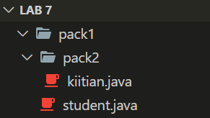

OUTPUT:

Roll no: 2005535

*Reg* no: 10503021

Course Method Called!!!

**-----------------------------------------------------------------------------------------**