SQL
________________________________________________________________________
SQL Stands for structure query language which is used for perform operations on database like as storing data, manipulating data and retrieving a data from a database.

Q. What is database?
_______________________________________________________________________
Database is a technique which is provide some standard to us to manage and store data permanently in database as well as provide security to data and provide some technique to us to search and retrieve data from database.

Q. Why use Database?
______________________________________________________________________________
1. Provide permanent storage to user data
2. Provide security to user data.
3. Provide relationship between data
4. Provide different facilities to search and modify user data as per his requirement
5. Provide user authentication facility means using database we can provide data access to user as per his role.
Q. Types of Databases?
_____________________________________________________________________________
1. Object oriented database: Object oriented database means a data can store in the form of objects means object consider as record and field of object consider as data called as object oriented database.
Example of object oriented database is mango db or firebase
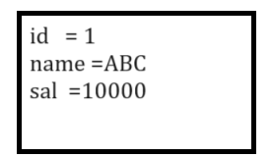
2. Hierarchical Database: Hierarchical database means a database can store data in the form of tree called as hierarchical database.
Best example of hierarchical database is your operating system file is best example of hierarchical database.

3. Relational Database: relational database management system means a data can store in the form of tables or relation and multiple database can connect with each by using integrity constraints and it contain row and columns
Example of relational database is MySQL, Oracle etc
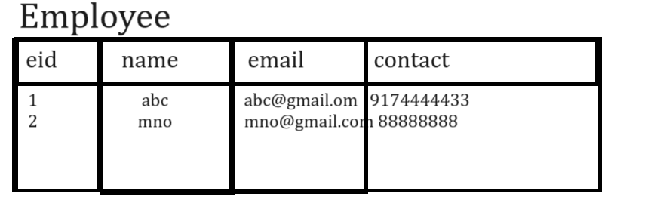
4. Distributed Database: distributed database means we have multiple databases store at different places and they connected with central database called as distributed database.
etc

How to works with Relational database management system
_____________________________________________________________________________
If we want to work with relational database management system we have some following steps.

1. Installed MYSQL as database tool
______________________________________________________________________
MYSQL is database tool which provide the environment to us to work with relational database management system concept.
https://dev.mysql.com/downloads/installer/

once we installed the MYSQL database software in your system we have some important steps.
a. open the MYSQL tool
start ---- search --- type mysql command prompt.

When we found this then type the password which provide at the time of installation.
B. enter in database

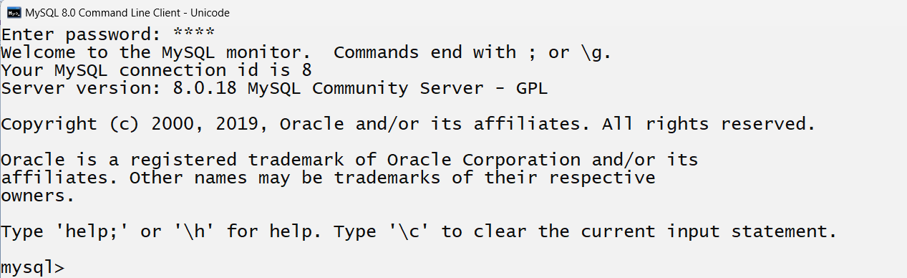

Once we input password and if we found this type of screen consider we enter in database tool.
So you have to use inbuilt database of MYSQL tool name as mysql
Syntax: use mysql.

Note: if we think about use mysql here we enter in mysql database means we can work with mysql tool by using SQL Commands

2. Create your own database
_________________________________________________________________________
Note: when we install the MYSQL then we have one inbuilt database provided by MYSQL tool to us name as mysql If we want to create your own database then we have some steps

3. Work with database.
If we want to work with database using SQL we have some command provided by SQL to us

Types of SQL Commands
_________________________________________________________________________
DDL: DDL stands for data definition language or command and this commands help us to create table or database or procedure or trigger as well as drop table , drop trigger , alter table or modify table etc
purpose

Types of DDL command
a. create b. alter c. truncate d. drop e. desc

DML: DML stands for data manipulation language and it is used for perform database operation like as insert, delete, update, select etc
Types of DML Commands
a. insert b. delete c. update d. select
TCL : Transaction control language these command can with DML commands and decide the commit operation on DML statement , Rollback operation on DML statement as well as set the save point on DML Statement
a. commit b.rollback c. savepoint
DCL: Data Control language means using this language we can provide the grant or authority to database as well as revoke etc
a. grant b.revoke

DDL Statements: DDL statements can work with table structure
___________________________________________________________________________
DDL stands for data definition language which provide the following command to us to work with database
1. create: create statement is used for create database , create table, create procedure , create function , create view , create trigger ,create index etc

Now we want to discuss about how to create database and table using MYSQL

How to create user defined database using MYSQL
____________________________________________________________________________
if we want to create your own database in mysql we have statement
Syntax: create database databasename;
Example: create database octnovjanapril;

Steps
_________________________________________________________________
a) Open MYSQL
start menu --- search --- MYSQL
b) Enter password and enter in database
c) Enter in inbuilt database name as mysql using following statement
Syntax: use mysql
d) Type the command: create database databasename;
Example: create database octnovjanapril;
Once we create database octnovjanapril we have to use database or enter in database for working purpose and for that we have statement name as
Syntax: use databasename
Example: use octnovjanapril
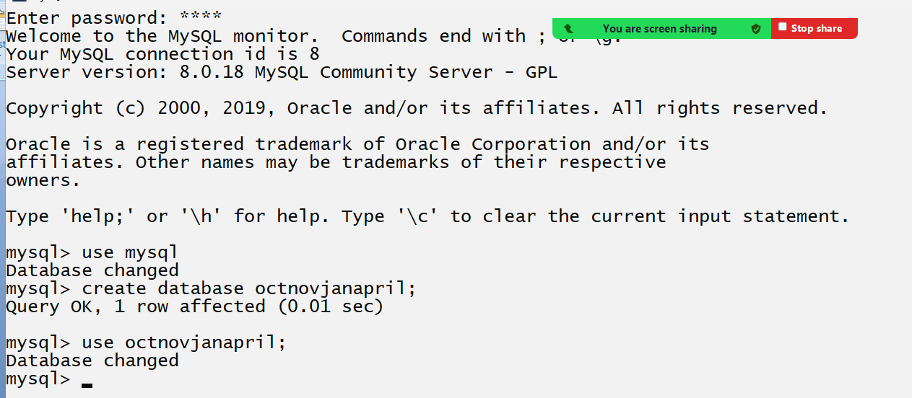
Above diagram indicate the process of creating database and use it.

once we create database then we can work with database means you can create table in database
if we want to create table in database we have following statements.
Syntax: create table tablename(columnname datatype(size),columnname datatype(size)…columnname datatype(size));

Example: we want to create table name as employee with column or field or attribute name as id, name and salary

2. alter: alter statement is used for modify the table structure like as add new column in table , change data type or size of column, rename column and drop column from table.

There are four options provided by alter statement to us
____________________________________________________________________________________
A. add: this option helps us to add new single column in database table or add multiple column in database table.
Syntax: alter table tablename add column columnname datatype(size) : this syntax help us to add single column in previous or already existing table.
or
alter table tablename add column (columnname datatype(size),columnname datatype(size)):
This syntax help us to add more than one columns in already existing tables.

Example: we have already created table name as employee with field id,name and salary and we want to two new columns in employee table name as email and contact so you alter statement look like as
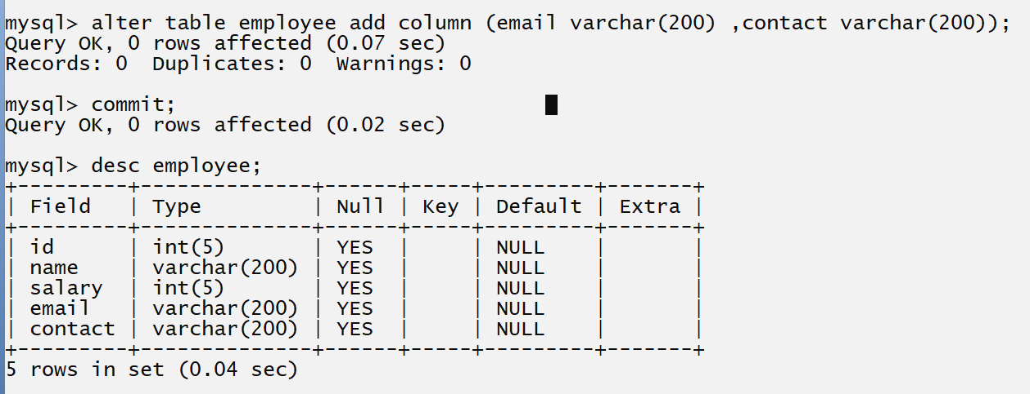
Note: if we think about above screen short we added two columns in database table name as email and contact.
B. modify: modify option help us to modify the table column data type or its size.
Syntax: alter table tablename modify column datatype(size): this statement only use modify the column data type or its size.
Example: Suppose consider we have table name as Employee and it contain column name as id name salary and email and contact so if we think about contact column its previous data type is varchar with size 200 but contact number not more than 10 or 14 digits so we want to modify the size of contact from 200 to 14 so you alter statement work as
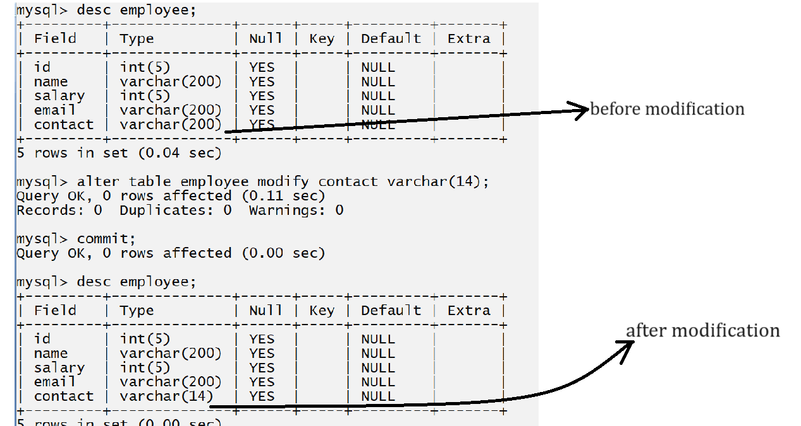
C. drop: drop statement helps us to drop the column from database table or remove column from database table
Syntax: alter table tablename drop column columnname
Example: if we think about above example we have table name as employee which contain id, name, salary, email and contact and we want to drop the contact column from database table.
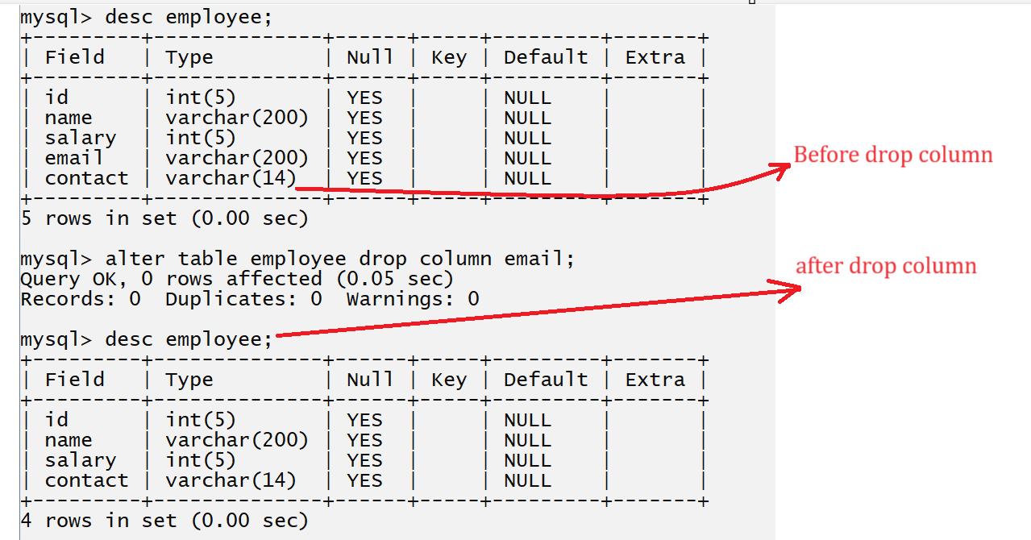
D. rename: this option help us to rename the column from database table.
Sytax: alter table tablename rename column old columnname to new columnname;

Example: if we think about above table we have table name as employee which contain column id,name ,salary and contact so we want to modify the column name salary to sal
Example: alter table employee rename column salary to sal;
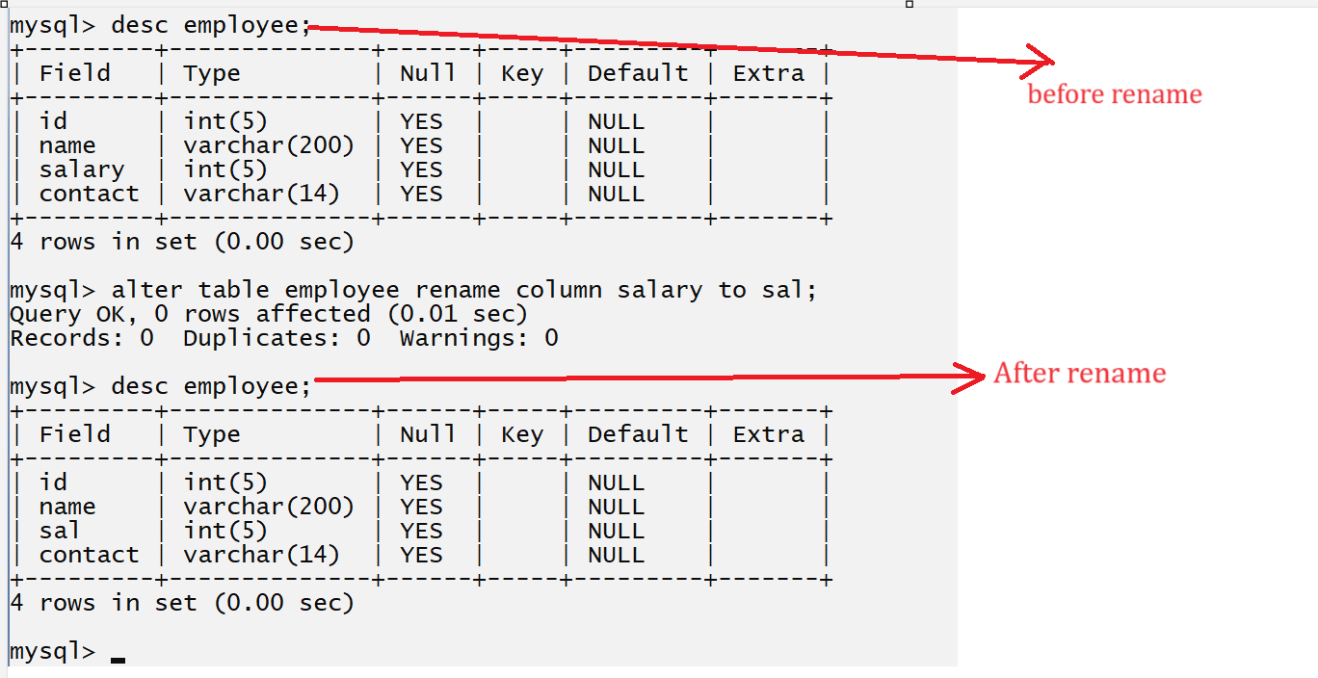
3. drop: this statement helps us to drop the table or delete the table from database.
Syntax: drop table tablename;
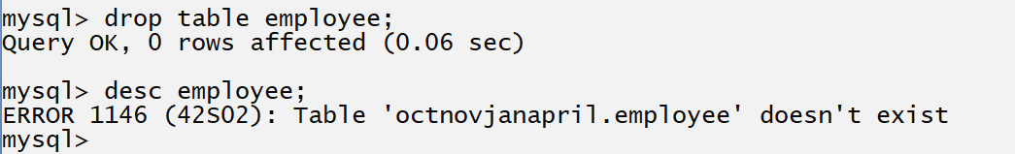
If we think about above screen short we get error employee table doesn’t exist because we drop table employee and after that we try to describe it.

4. desc: this statement help us to provide detail description about table structure like as column name of table, its data type, size, constrains apply on column etc
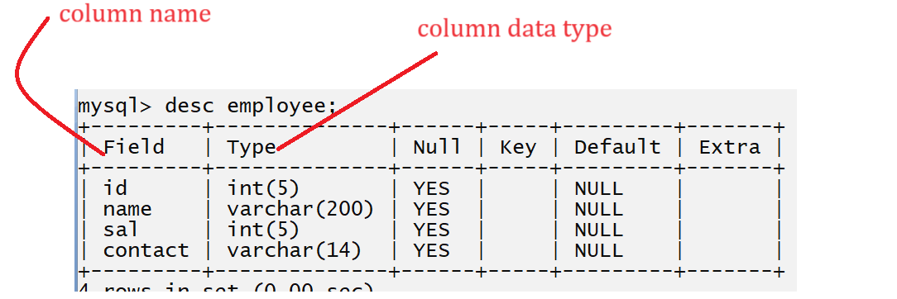

5. truncate: truncate is used for delete the all records from database table or data from database table
Syntax: truncate tablename;

DML Statements: DML stands for data manipulation language it is used for perform operations with data in table like as insert data in database table, update data from database table, select data from table, delete data from table etc.

There are four commands in DML
1. Insert: insert statement is used for insert data in database table.
There are two types insert statement or you can use insert by using two ways.
1. Wild card insert: wild card insert we insert the values in all column of database table
Syntax: insert into tablename values (column1, column2……column…n);
Example: suppose consider we have table name as employee with field id,name and salary and we insert the values in all columns.
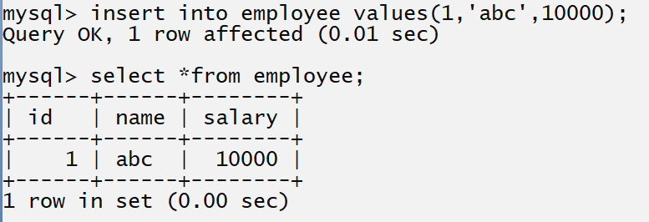
2. Partial insert: partial insert means we try to insert the specific column values means suppose consider we have table name as employee with field id,name and salary but we want to insert id and name not insert salary in employee table means we have three columns in table but we want to insert only 2 columns means we want to partial data in table not complete data so it is known as partial insertion .

Syntax: insert into tablename (columnname, columnname…..)values (value1,value….);
if we think about above syntax we provide column name before values because we want to insert specific column means we need to specify column name before values which values we want to insert in table.
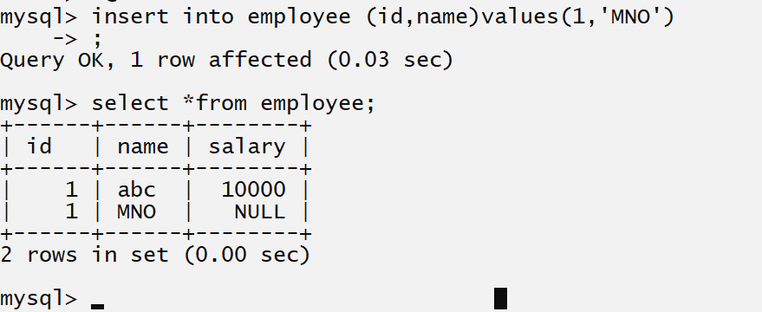

if we think about above statement we have salary column with null value because we insert only id name means 1 and mno but not inserted salary value to the by default value is null.

2. Select: this is used for display the output on console means this statement can help us fetch data from database table and display on output screen or display anything on output like as string, variable values etc

There are two types of select
_________________________________________________________________
Wild card select: wild card select means fetch all column data from table and it is denoted by *.
Syntax: select *from tablename;
Example: select *from employee;
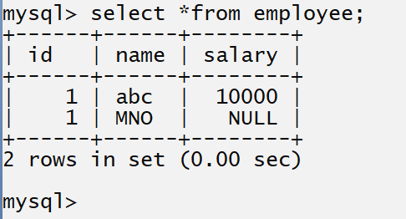

Partial select: partial selection means fetch specified column data from database table called as partial selection
Syntax: select column1, column2……column…n from tablename;
Example: select id, name from employee;
Means we want to fetch two columns data from employee table
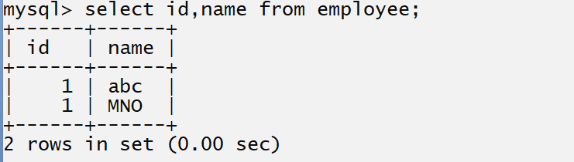

Note: using select command you can show any thing on program output screen.

Example: display the good morning using MYSQL
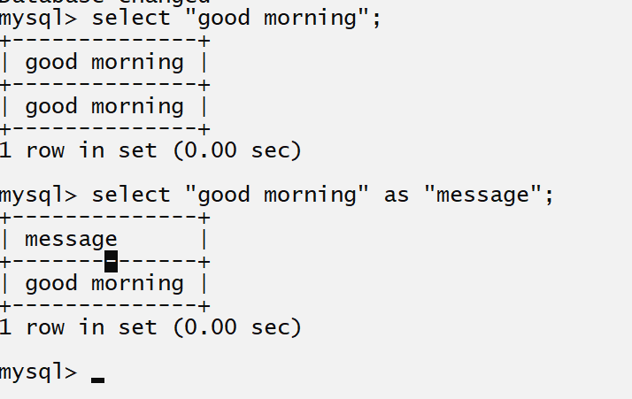

Example display three different number on program output screen in MYSQL
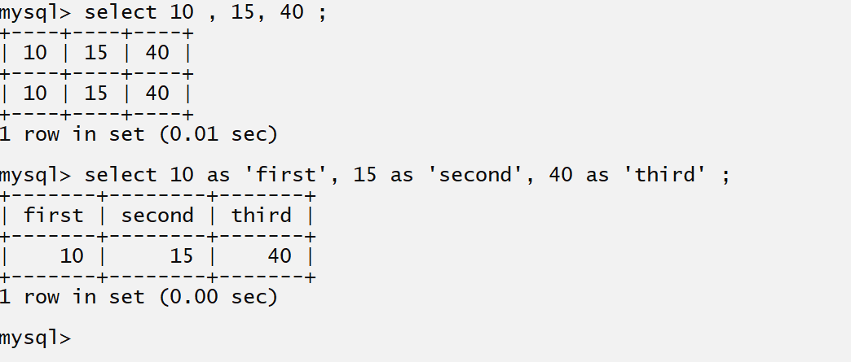
Example: you can print any mathematical equation using select
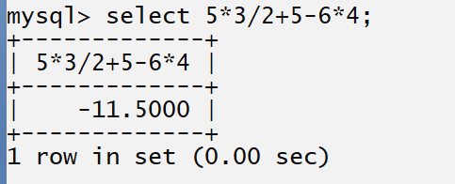
3. Delete: delete statement help us to delete data from database table
___________________________________________________________________________________
Delete is used for delete the complete table data or may be particular record or row

How to delete the complete table data using delete
________________________________________________________________________
Syntax: delete from tablename;
Example: delete from employee;
Note: above SQL statement is responsible for delete the complete data from employee table.

How to delete the specified row from database table
_____________________________________________________________________
If we want to delete the specified row from database table we have following syntax
Syntax: delete from tablename where condition;
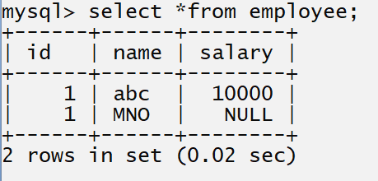

Note: if we think about above statement we want to delete the MNO statement

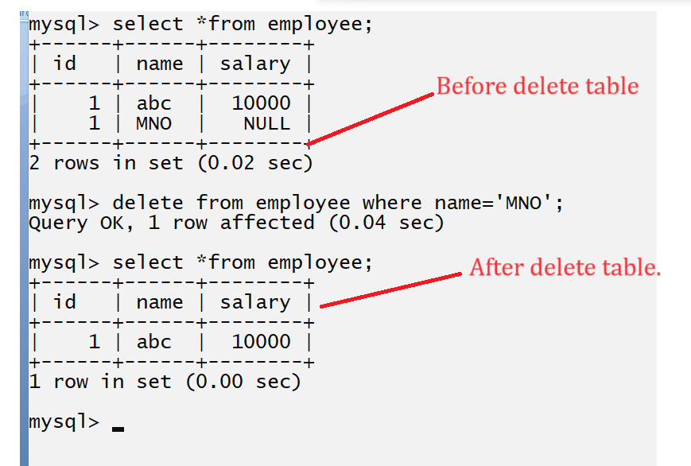

4. Update: update statement help us to update the row in database table.
______________________________________________________________________
If we think about update statement then we can update value of specified columns using some conditions.

Syntax: update tablename set columname=value,columnname=value: this statement is used for update the all column in table.
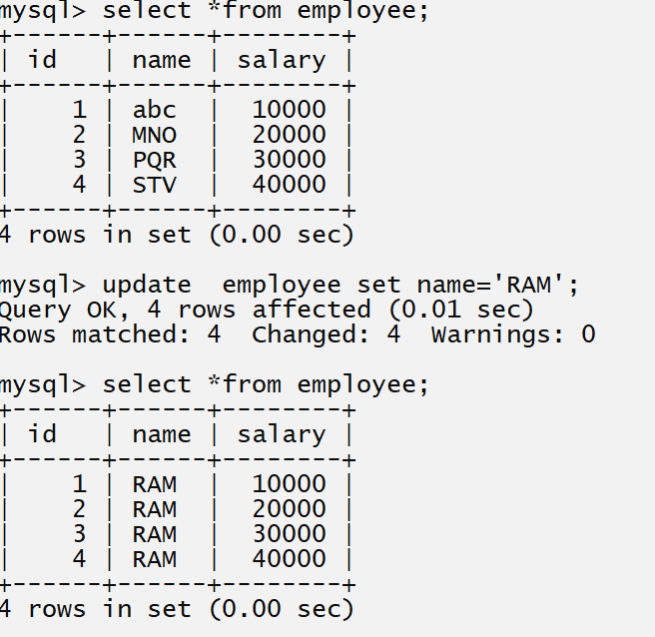
Note: if we think about above statement we have update statement and we change name column values without using any condition so update statement change all column values in employee table

If we want to update the specified column or row then we required to use condition with update statement.
Syntax update with condition
____________________________________________________________________________
update tablename set column=value where condition

Example: suppose consider we have table name as Employee and we want to name of employee whose id is 3.
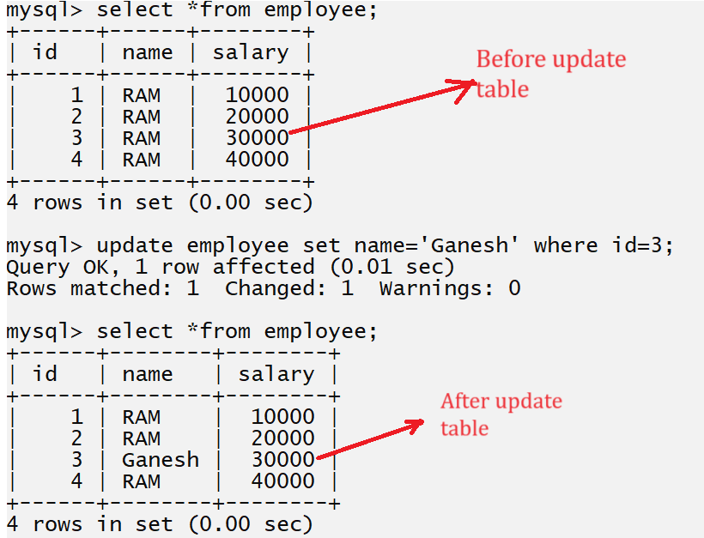

Constraints
________________________________________________________________________
Constraints means if we apply rules and regulation on database table or specified column in database table called as constraints

Q. Why we need to use constraints?
__________________________________________________________________________
1. Avoid inputting wrong data in column means constraints help us to verify the data before insert in database table.
2. Avoid storing duplicate data in column
3. Set the default data in column if user not provide the value to that column
4. Manage the relationship between two different tables.
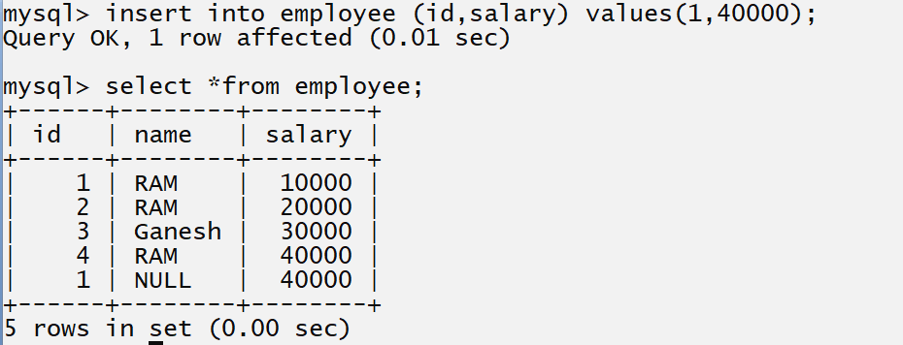
Note: if we think about above table there is problem we duplicated id of employee as well as we have null value in name column but it is wrong data means if you give salary to anyone then we must be know its name as well as we cannot same id to multiple employee these are the limitation in above tableso if we want to avoid this types of problem we required to use constraints.

Types of constraints in SQL
_________________________________________________________________________
1. not null: when we use not null constraints in SQL then we cannot store null value in database column and if we try to store null value in database column then database will generate error to us at run time.
Syntax:
create table tablename(columnname datatype(size) not null,columnname datatype(size) not null)

Example: Suppose consider we want to create employee table with field id,name,email,contact and salary and we want to name should not be null.
When we add data of employee we must know employee name so in this case we need to set null value in name column
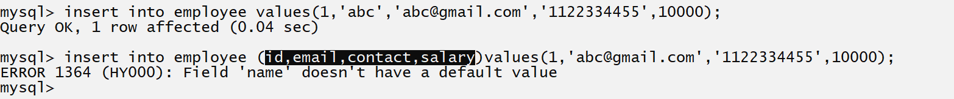
if we think about above screen shot we have error in second statement because we not provide value to name column using insert statement so we get error name does not have default value because when we not provide value column then database provide null as default value to column but here we apply not null constraints on name column and we not provide value to name column so database cannot give default value a s null so we get error
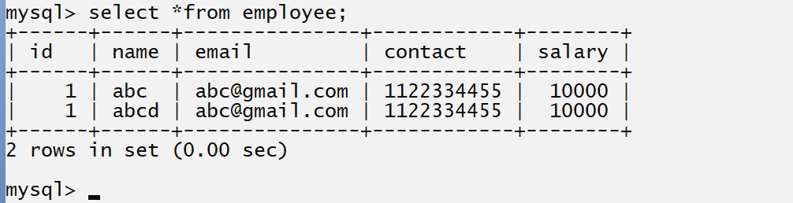
if we think about above table we have duplicate entry of id,name and contact means we can say two employee have same salary but cannot have same email so if we want to avoid this problem we have one more constraints known as unique constraint or key

2. unique: unique constraints help us to avoid duplicated data in table column
means we cannot store duplicate database in column and if we try to store duplicate data in column we get error at run time.
Syntax: create table tablename (column name data type (size) unique)
Note: we can apply more than one constraints on single column.

mysql> create table employee(id int(5),name varchar(200) not null,email varchar(200) unique,contact varchar(20) not null unique ,salary int(5));
Query OK, 0 rows affected, 2 warnings (0.05 sec)

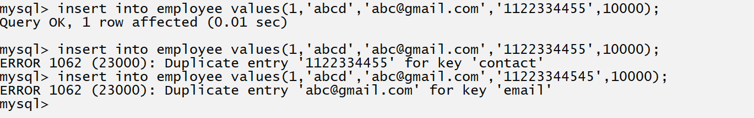
If we think about above screen we get error at run time duplicate entry for contact and email
Because we apply unique constraints on email and contact.

3. primary: primary key constraints is by default not null and unique means we cannot store duplicate value in primary key as well as cannot store null value in primary key column and single table can have only one primary key column
Syntax:
create table tablename(columnname datatype(size) primary key );
or
create table tablename(columnname datatype(size) primary key auto_increment);

Example: we want to create table name as employee with field id,name,email,contact and salary and here we want to create id as primary key ,name as not null field , email and contact as not null and unique and salary as not null

mysql> create table employee(id int(5) primary key,name varchar(200) not null, email varchar(200) not null unique, contact varchar(200) not null unique,salary int(5) not null);
Query OK, 0 rows affected, 2 warnings (0.06 sec)

How to use primary key with auto increment value
_____________________________________________________________________________
If we want to use primary key with auto increment value we have to use auto_increment with primary key or unique key

Syntax when we create primary key with auto_increment value
___________________________________________________________________________________
create table tablename(columnname datatype(size) primary key auto_increment, column name datatype(size));

Example: we want to create table name as player with field pid, name, run and we want to increase the player id automatically.

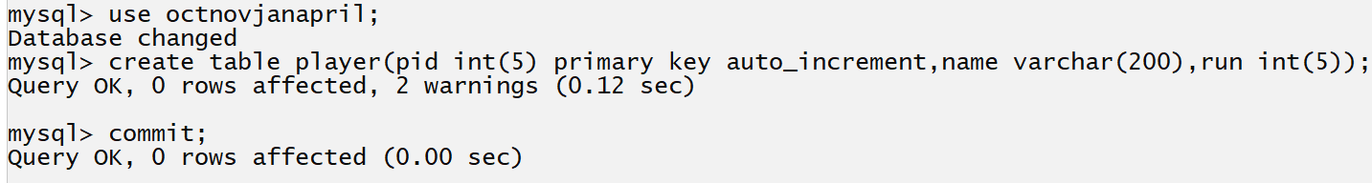

How to insert the value when we have primary key with auto_increment
_________________________________________________________________________
if we want to insert the value when we have primary key with auto_increment values

Syntax : insert into tablename values(‘0’,data,data);
Here ‘0’ indicate the primary with auto_increment column or we can pass null here but null not store in column database can access the previous value and +1 it and insert in table and if table not contain any value then initially 1 insert in column
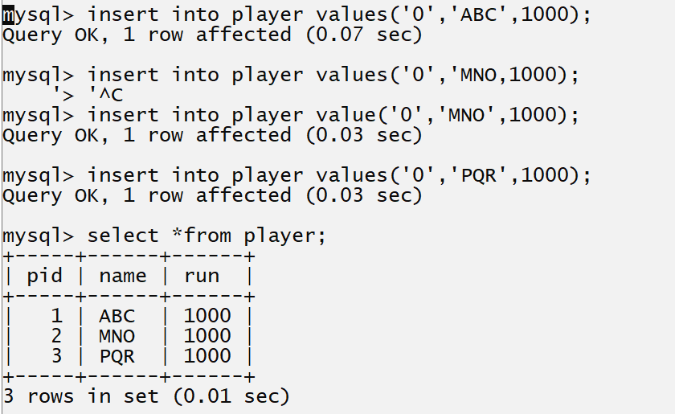

Q. what is difference between primary key and unique key constraints?
Primary key | Unique key
Primary key is by default not null and unique means primary key cannot accept null value and if your primary key is auto_increment and if we use null then primary key accept last value and +1 it and insert in column as new record | But unique can accept null value
Single table can have only one primary key | Single table may be contain more than one unique keys
primary key use the cluster indexing | Unique is non cluster indexing

4. foreign key constraints: foreign key constraints help us to create reference column for map data with another table means foreign key is primary key in another table or may be unique key in another table
so if we want to provide relationship between two tables then we can use foreign key constraints.
Note: primary key column known as parent table and foreign key column table known as child table.

Example: Suppose consider we have two tables name as Dept and Employee and dept table contain primary key name as deptid and we want to identify dept of employee so we need to provide reference of dept in employee table so we required to use deptid as reference column in employee table so we can foreign key concept.

How to create foreign key using MYSQL
______________________________________________________________________________
create table tablename(columnname datatype(size),foreign key(columnname) references parenttablename(primary key column name));

Example with source code
mysql> create table dept(id int(5) primary key auto_increment,name varchar(200) not null unique);
Query OK, 0 rows affected, 1 warning (0.05 sec)

mysql> create table employee(empid int(5) primary key auto_increment,name varchar(200),email varchar(200),contact varchar(200),id int(5),foreign key(id) references dept(id));
Query OK, 0 rows affected, 2 warnings (0.07 sec)
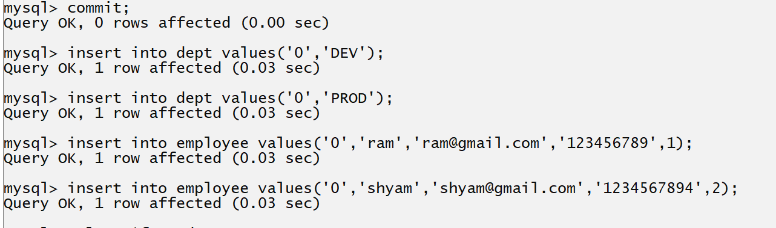
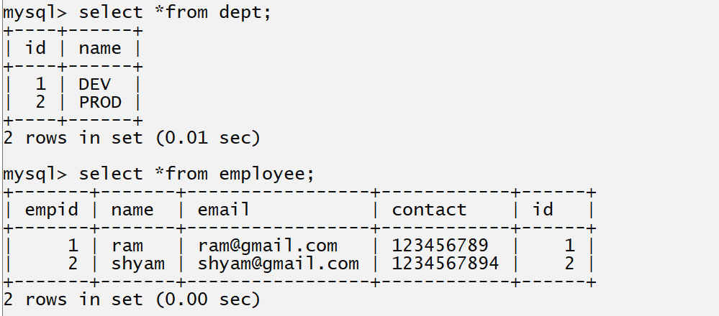
Example: we want to delete the dept whose id is 1
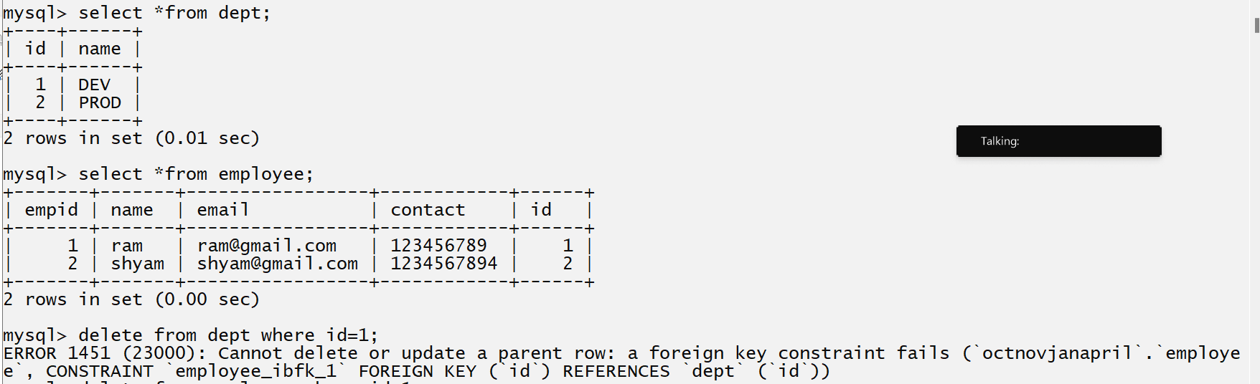

if we think about above screen shot we get error at run time because the rule is if we want to delete any primary key or update any primary key and if primary key value present in child table as reference then we cannot delete or update primary key value before that we need to delete its child record and after that you can delete parent record or primary record.
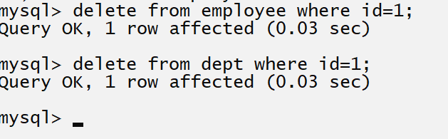
Note: if is not feasible solution in real time we have large number of database table present in database
if we want to solve this problem we have three additional constraints which we can use with foreign key

1. on delete cascade: on delete cascade can use with foreign key and when we delete the primary key then its associated child record get deleted automatically.

How to use on delete cascade with foreign key
_____________________________________________________________________

Syntax: create table tablename(columnname datatype(size),foreign key(columnname) references parenttablename(reference column name) on delete cascade);

Example:
mysql> create table student(sid int(5) primary key auto_increment,name varchar(200),email varchar(200),contact varchar(200),cid int(5),foreign key(cid) references course(cid));

mysql> create table student(sid int(5) primary key auto_increment,name varchar(200),email varchar(200),contact varchar(200),cid int(5),foreign key(cid) references course(cid) on delete cascade);
Query OK, 0 rows affected, 2 warnings (0.05 sec)
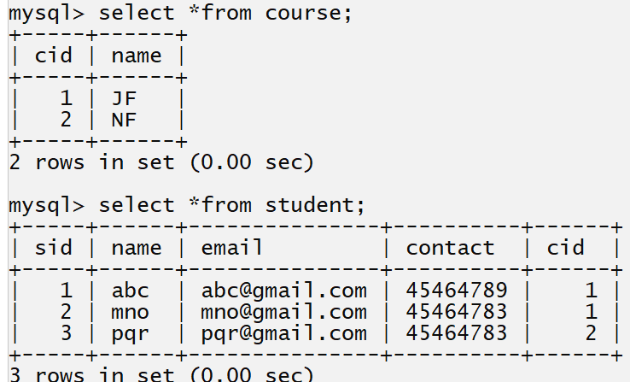

After delete
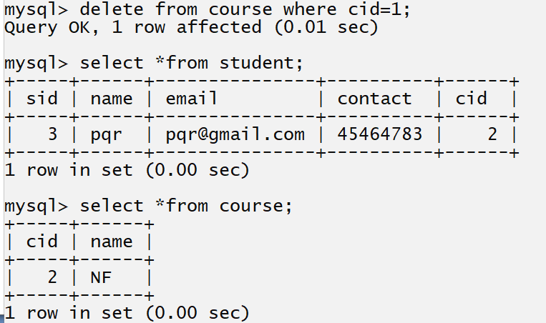

2. on update cascade: on update cascade means when we update the primary key record then child or foreign key record automatically get updated.

Syntax: create table tablename(columnname datatype(size),foreign key(columnname) references parenttablename(reference column name) on update cascade);

mysql> create table student(sid int(5) primary key auto_increment,name varchar(200),email varchar(200),contact varchar(200),cid int(5),foreign key(cid) references course(cid));

mysql> create table student(sid int(5) primary key auto_increment,name varchar(200),email varchar(200),contact varchar(200),cid int(5),foreign key(cid) references course(cid) on update cascade);
or
we can use the on delete cascade and on update cascade at same time.
mysql> create table student(sid int(5) primary key auto_increment,name varchar(200),email varchar(200),contact varchar(200),cid int(5),foreign key(cid) references course(cid) on update cascade on delete cascade);
Example: before update the parent table i.e course
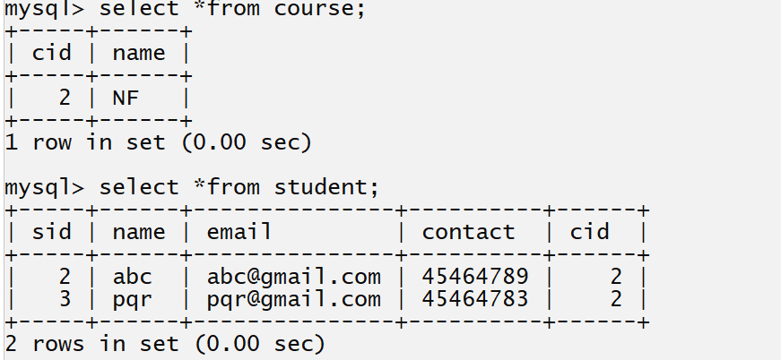

After update the parent table i.e course.
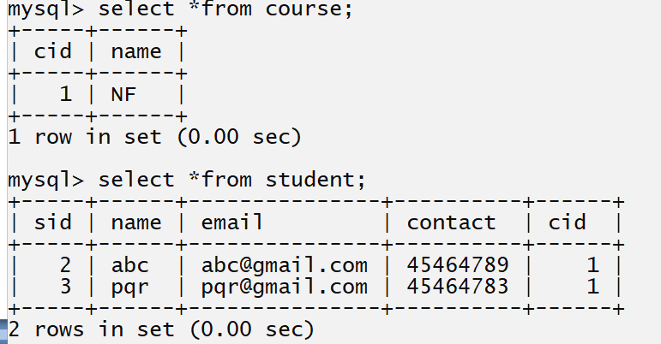
3. on delete set null.
___________________________________________________________________
on delete set null constraint is used for set the foreign key as null when we delete primary key.
Note: on delete cascade and on delete set null cannot use at same time
but on delete update can work with both individually

Syntax: create table tablename(columnname datatype(size),foreign key(columnname) references parenttablename(reference column name) on delete set null);
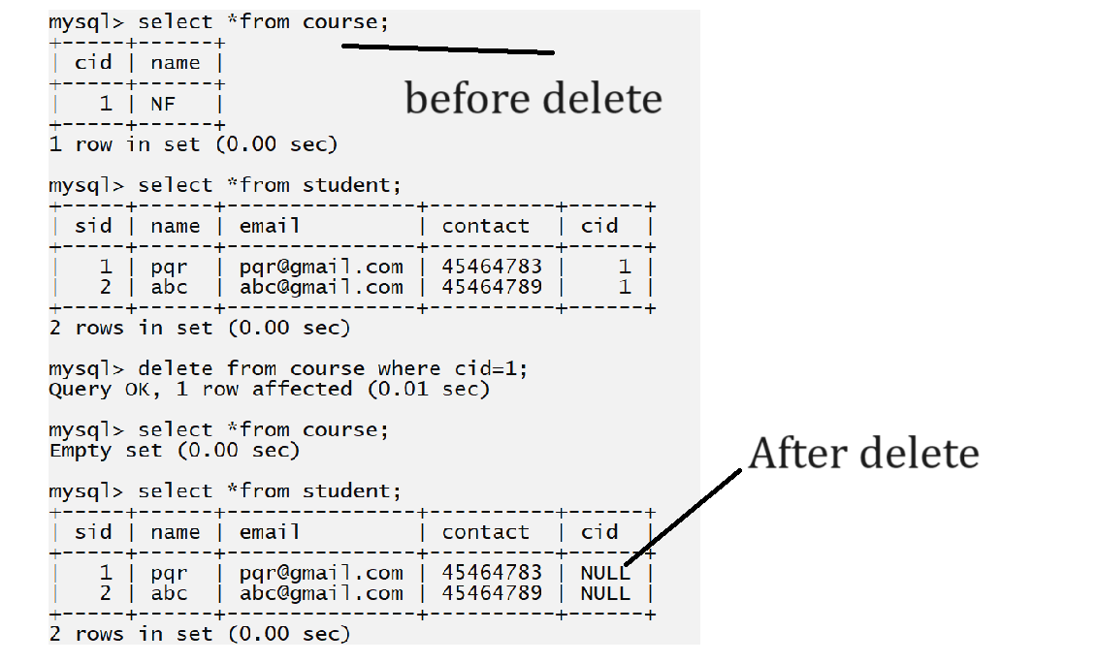

5. Check: check constraints is used for check the condition when we insert the data column.
or verify the data before inserting it is major goal of check constraints.
Syntax: create table tablename(columnname datatype(size) check condition);

Example: we want to create table name as voter with field vid name and age but the requirement is if voter age is greater than 18 then insert data in table otherwise not
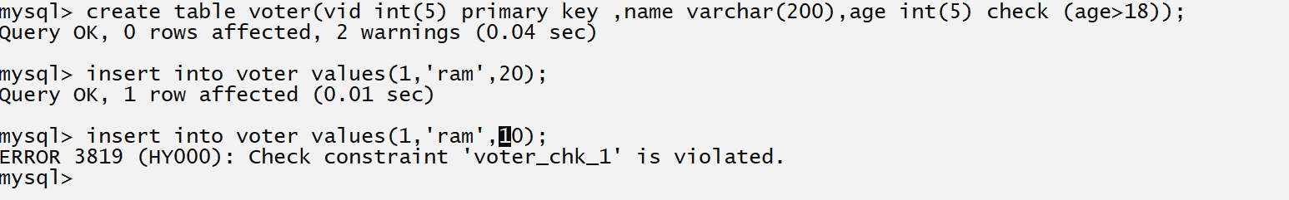

6. Default: default constraint is used for set the default value with column if user not provides it.

Syntax: create table tablename(columnname datatype(size) default value);

Example: we want to create table name as voter with field id,name age and nationality
so the condition age should be greater than 18 and by default voter nationality consider as Indian

mysql> create table voter(vid int(5) primary key ,name varchar(200),age int(5) check (age>18),nation varchar(200) default 'indian');
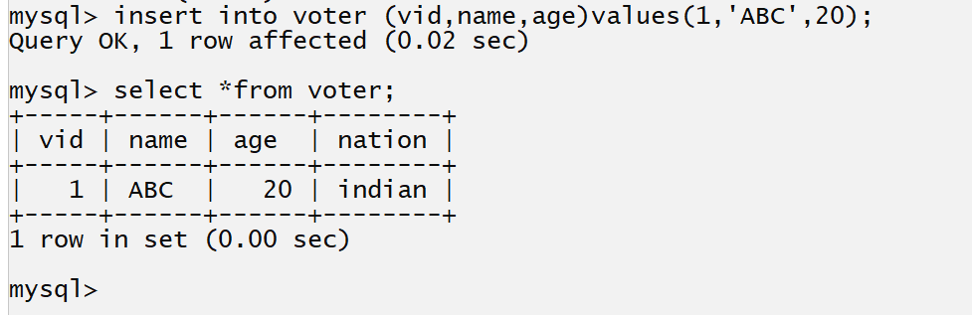
Note: when user provide value to column then user value get override on default value.
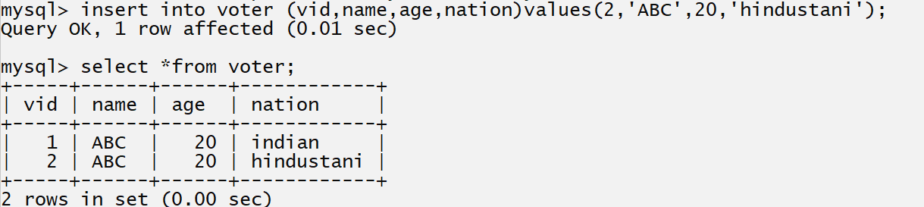

Where clause, logical operator, in and between operator, distinct
___________________________________________________________________________
Where clause is used for check the conditions with any DML statement
Syntax: sql statement where condition

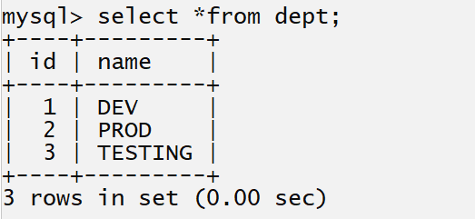
Consider we have above table name dept and we want to fetch dept whose id is 1 so your select query looks like as
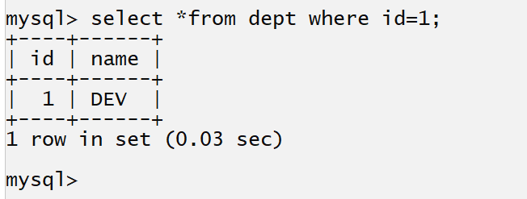

Logical Operator in SQL
________________________________________________________________________
Logical operator helps us to combine the more than one condition and check it.

Logical Operator in SQL
_______________________________________________________________________
Operator | Meaning
&& , and | This is your logical and operator means if your all conditions are true then condition is true otherwise condition is false.
|| , or | This is your logical OR operator means if your any one condition is true then condition is true otherwise condition is false.
!, not , <> | This is your negation operator or not operator.

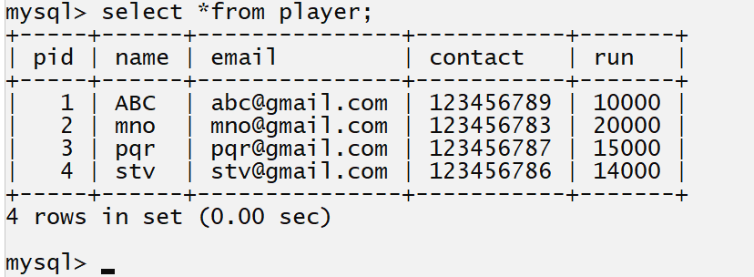
Consider we have above table

Q. WA SQL Query fetch player whose name is ABC and run is 10000
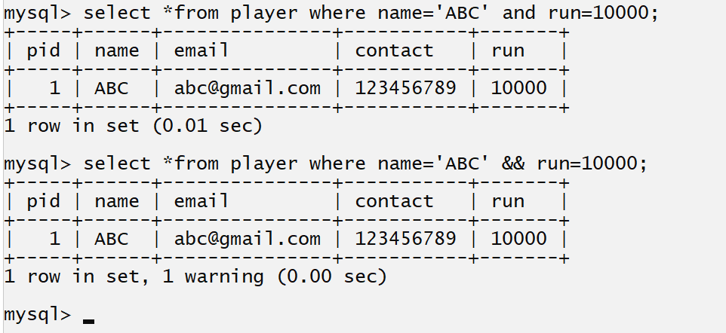

Q. WA SQL Query to show the player details whose run is not 10000
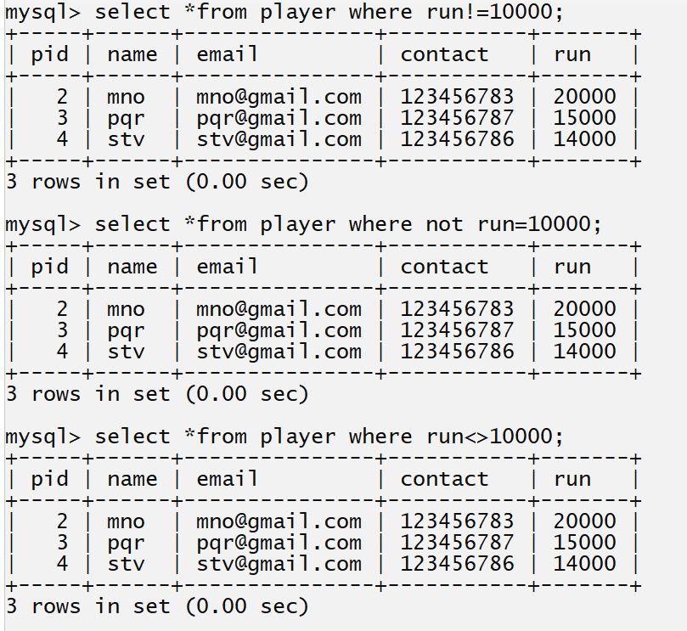

Q. WA SQL to player details whose name is abc or run is 15000 or run is 14000
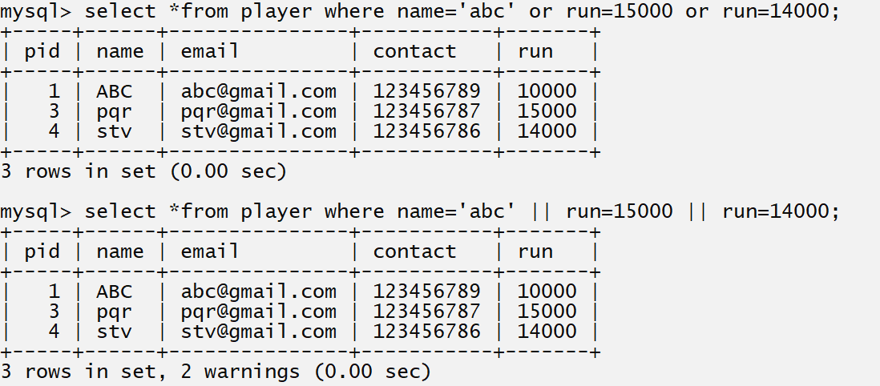

distinct keyword
_______________________________________________________________________
distinct keyword is used for fetch or display the unique data on output screen means not display the duplicated records or attributes or column data on output screen.

Example: suppose consider if we fetch particular column data using select command and if column container same repeated values then values get display on output screen but if we want to avoid show the duplicated values on output screen but value should be present in background table in this scenario we can use distinct keyword.
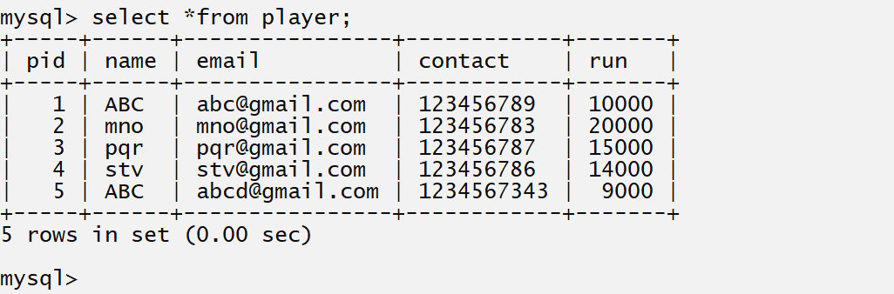
Consider we have above player table and it contain name ABC and it is repeated value in name column

Q. WA SQL Query to fetch name of player from above table.
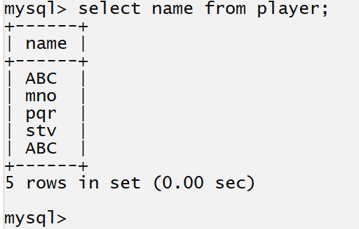

if we think about above SQL Statements we get ABC two times on output screen because ABC present two times in name column in database table but we want to ABC should present repeated in name column but should not display on output screen then we can use distinct keyword with select query.

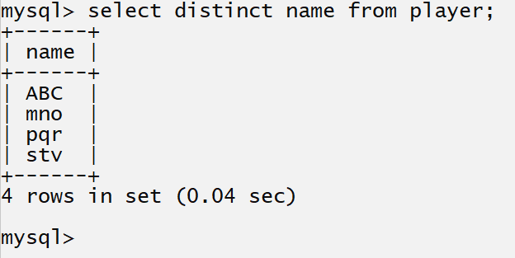

if we fetch multiple column from table and if any one column value is different than distinct not work
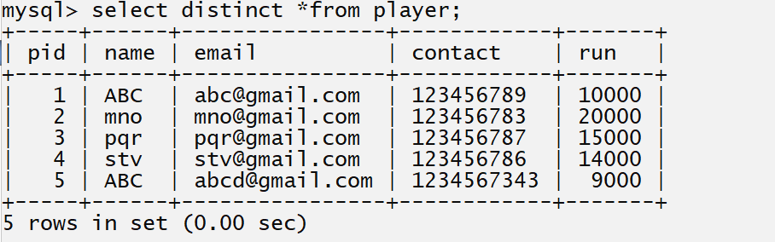
Suppose consider we have table name as player and we want to fetch name and run of player
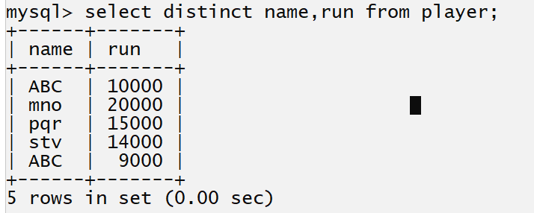
If we think about above output we get name ABC even is duplicated record and we use the distinct keyword but run value is different with ABC means distinct can avoid to show the record if all columns values are duplicated.

IN and between operator
___________________________________________________________________________
IN operator
_______________________________________________________________________
IN operator specially design for avoid multiple OR conditions as well as IN operator help us to work as conjunction with inner query or sub query.
Syntax: select *from tablename where columnname IN (value1, value2…..value…n);
or
select column1, column2…..column…n from tablename where columnname IN(value1,value2….value..n);

Example without IN operator
________________________________________________________________________
Q. WA SQL Query to display player record whose run is 10000,15000,14000,20000
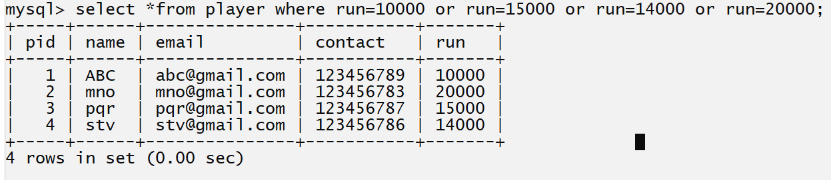

If we think about SQL Query we use three time or operator for fetch data as per the given conditions in problem statement.
if we want to use multiple OR condition in select query or select statement then we can use the IN operator show in following statement.
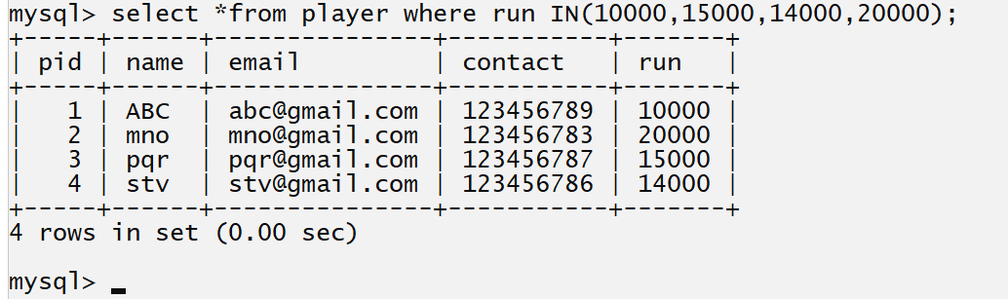

between operator
_______________________________________________________________________
It is used for fetch data between two specified ranges means it is like as >= and <=

Syntax: select *from tablename where column name between value1 and value2;
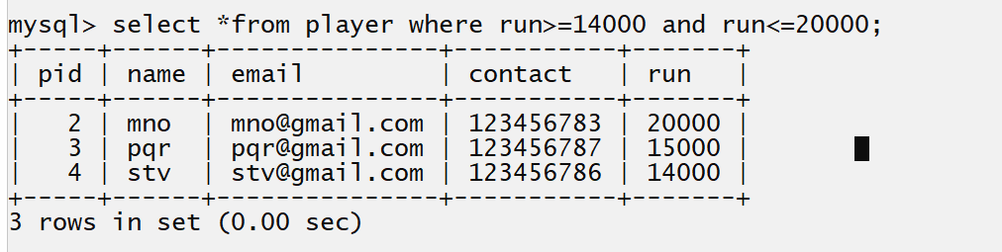
if we think about above example we execute the statement without using between operator
and in give example we execute statement using between
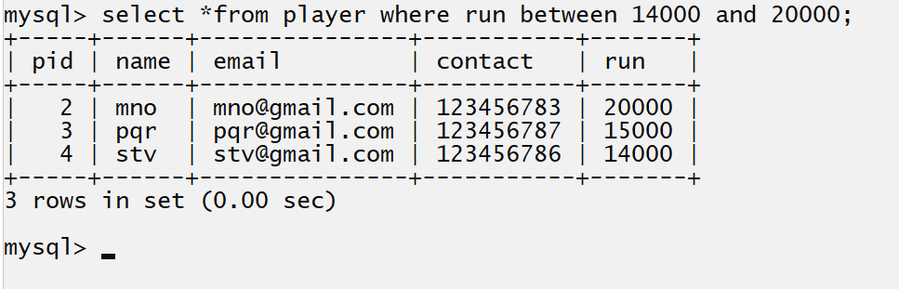

Group function or aggregate function, group by and having clause
____________________________________________________________________
Aggregate function or Group function
Group function is used for perform operation on attribute or column of table and generate the single value as resultant value.
There are five types of group function in SQL
____________________________________________________________________________
1. count() 2. sum() 3.max() 4. min() 5. avg()

count function: count function is used for count the records or rows from database table.

Syntax: select count(column name) from tablename: if we pass particular column name in count function then count only not null values means null value is not consider as part of counting.
or
select count(*) from tablename: if we pass * in count() function then we can count the null value as well as not null values from table.

Example: suppose consider we have given table.
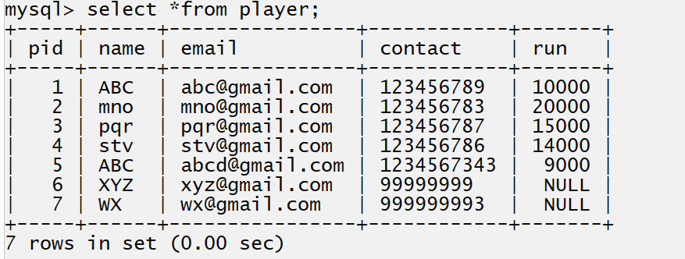
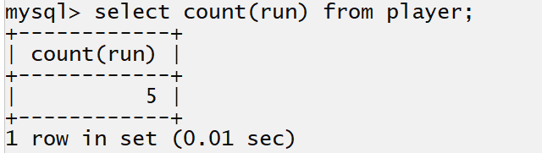
if we think about above SQL statement we have total number of 7 record present in database table and our select query show the 5 in counting because we pass column name i.e run in count function and we have two records whose value is null in run column and when we pass column as parameter in count function then null value is not consider as part of counting so we get 5 as counting value.
so if we want to count the not null as well as null value using count function then we can use * (wild card operator) in count function.
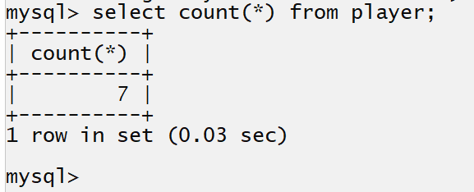

sum(): sum() function is used for calculate the sum of all values of column.
Example: calculate the sum of all players run
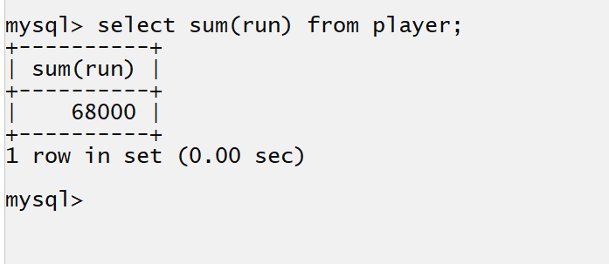

avg(): it is used for calculate the average value of particular column or attributes
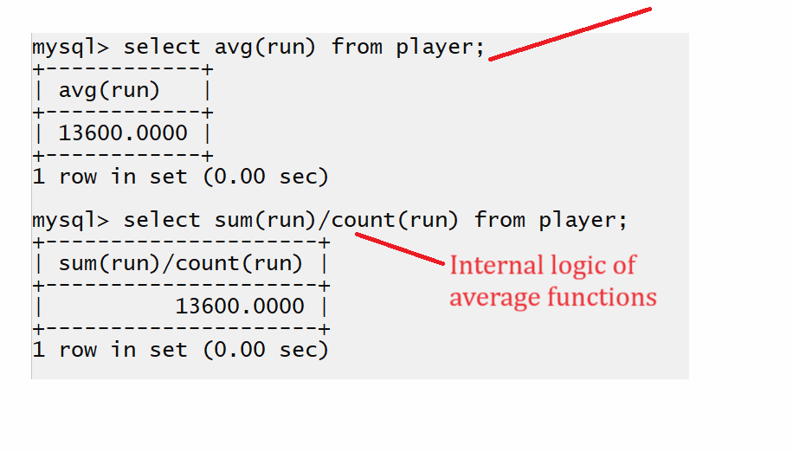
max(): max function is used for find the maximum value from column
Syntax: select max(columnname) from tablename;
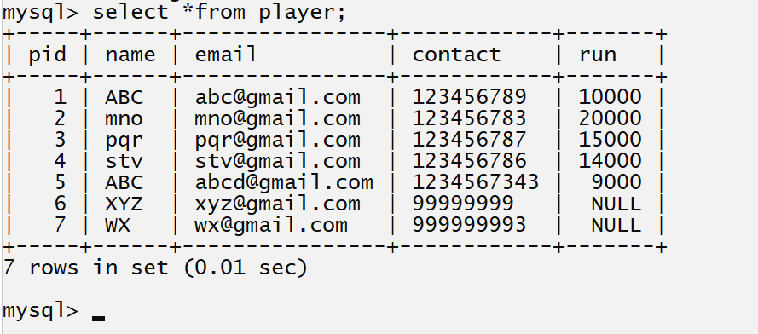
We want to find the maximum run from player table.
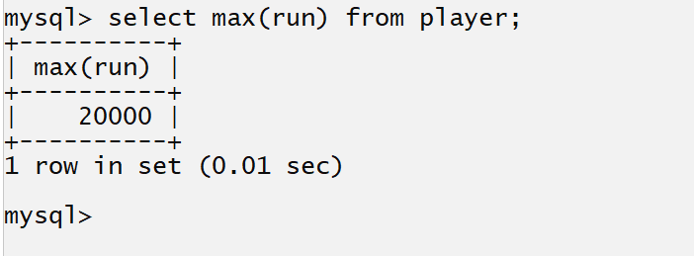
min(): this function is used for find the minimum value from database table.
Syntax: select min(columnname) from tablename;
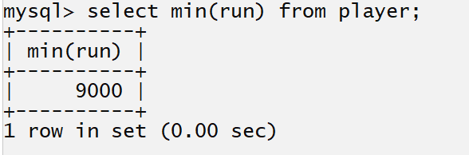
like operator in SQL
__________________________________________________________________________
Q. what is like operator?
Like operator is used for pattern matching purpose means like operator specially design for search data by creating specified pattern with string values.

Syntax: select *from tablename where column like ‘pattern’;

If you want to work with like operator we have to use two wild card operators.

_: this operator is used for represent single character
%: this operator is used for represent the multiple character data.

Consider we have following table
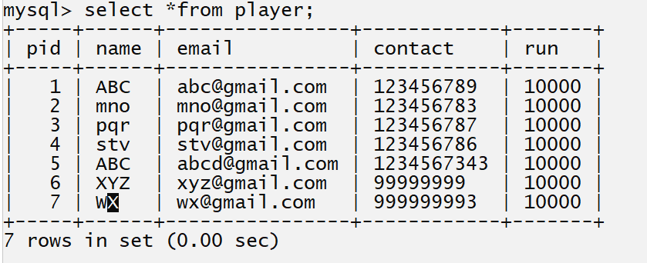
Example: WA SQL Query to find the player whose name start with a
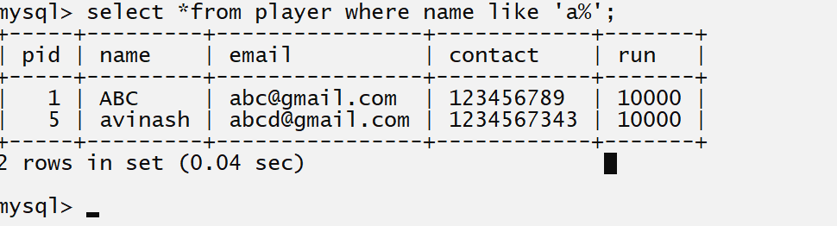
Example: WA SQL Query to find the player whose name ends with sh
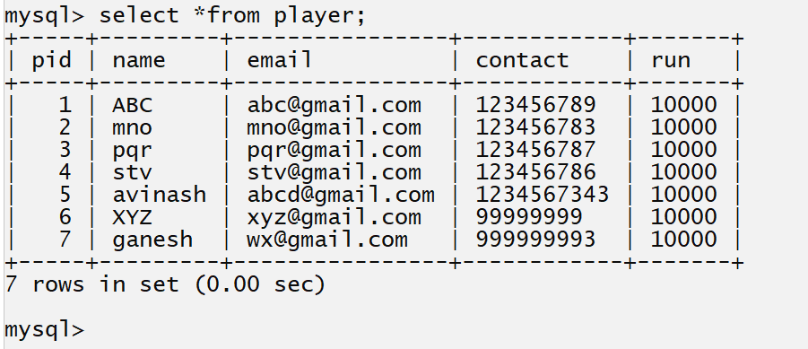

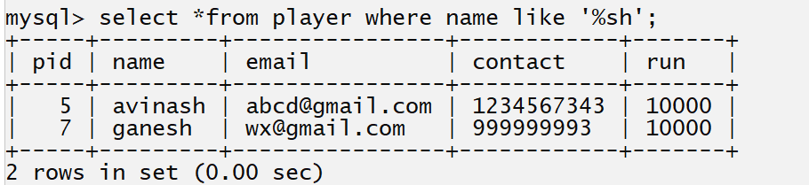

Example: WA SQL Query to find the player whose name start with a and ends with sh
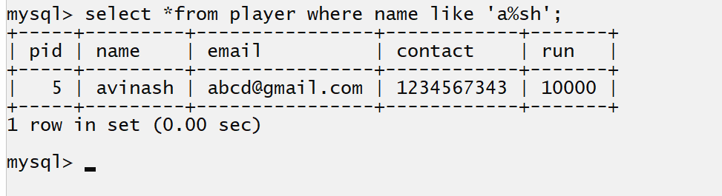
Example: WA SQL Query to show the player whose name contain only three letters
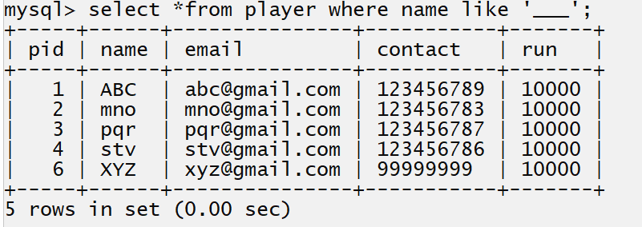
Note: in above SQL Statement we use the three underscore characters.

Example: WA SQL Query to display the player whose name contain more than three letters
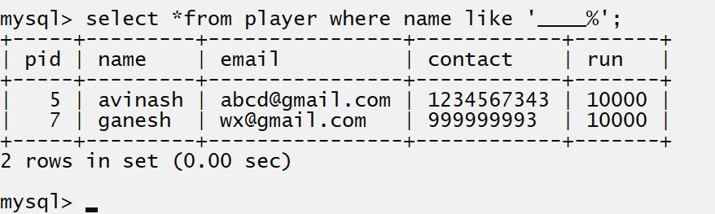

Consider we have following table
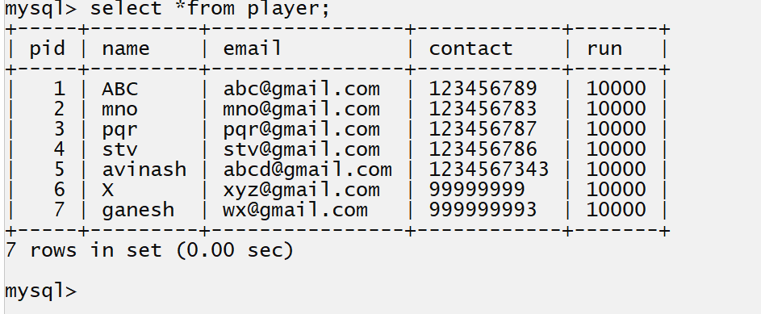

Example: WA SQL Query to show the player details whose name contain at least 3 letters
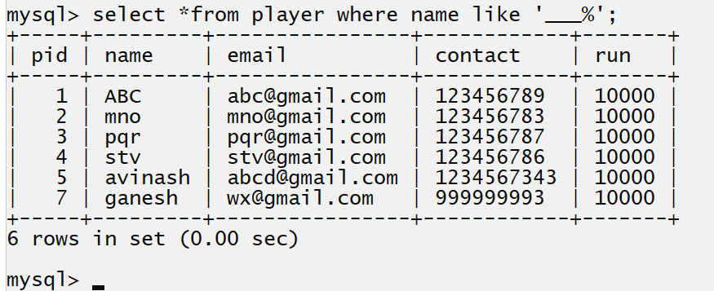

Group by clause in SQL
______________________________________________________________________
Group by clause help us to categories data by using specified column
Example: count the employee by its designation or count the employee by using salary

Syntax: select columnname ,aggfunction(columnname) from tablename group by columname;

Important points related with group by clause
____________________________________________________________________
1. Group by clause only works with aggregate function
2. If we use the group by clause normally we use column in select query whose name mention in group by clause.

Example: WA SQL Query to create group of employee salary wise.
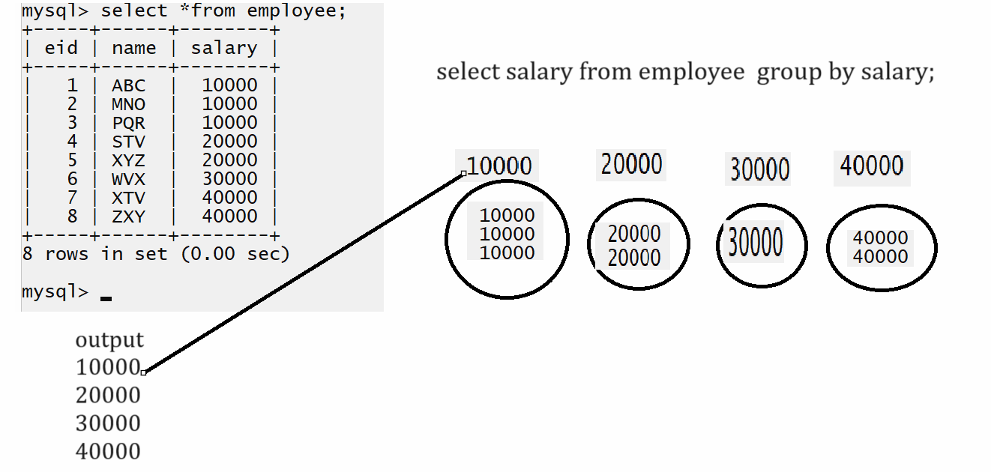
Note: if we think about above SQL statement then here salary represent the group means we created group of similar salary values so in output we get single value from group for represent group.
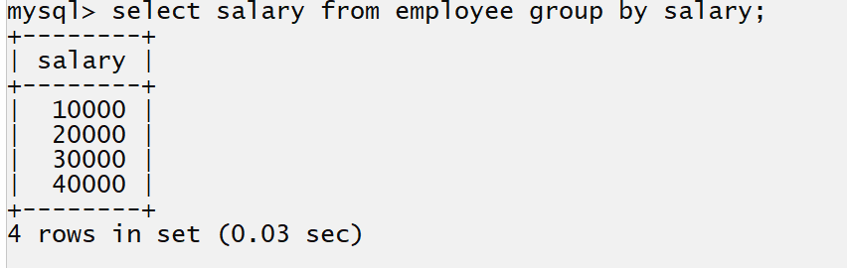
Example: WA SQL Query count the employee who is taking similar salaries
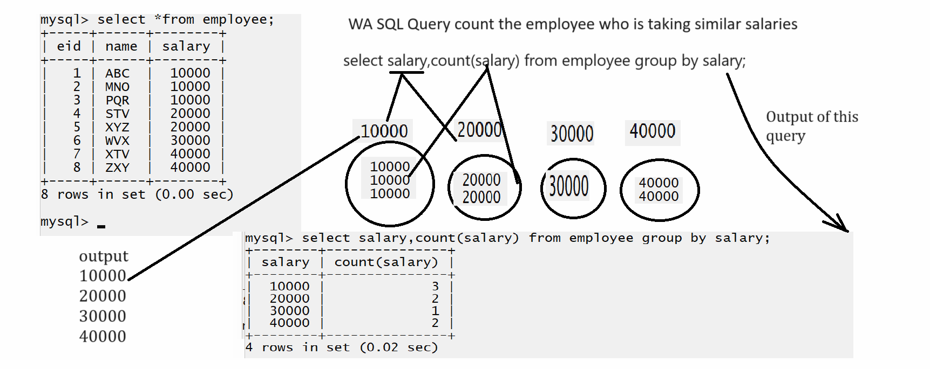

Example: WA SQL Query find sum of employee salary who is taking similar salaries
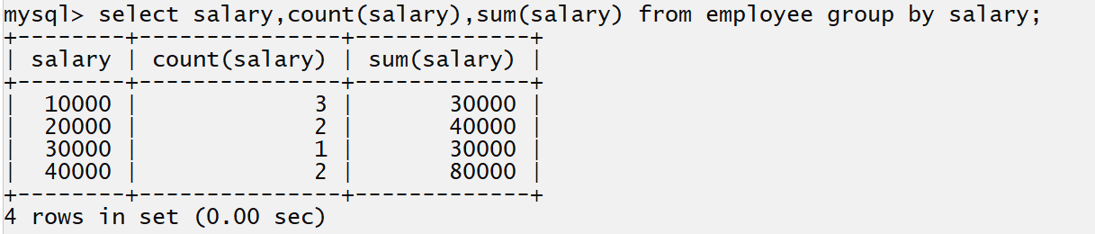

having clause
__________________________________________________________________________
Having clause normally comes with group by clause.
The major reason to use having clause is because we cannot use aggregate function or group function as condition in where clause and if we want to use the group function as condition then have one more option name as having clause.

Syntax: select columnname from tablename group by columnname having aggregate function with condition;

Example: WA SQL Query count the employee who is taking unique salary
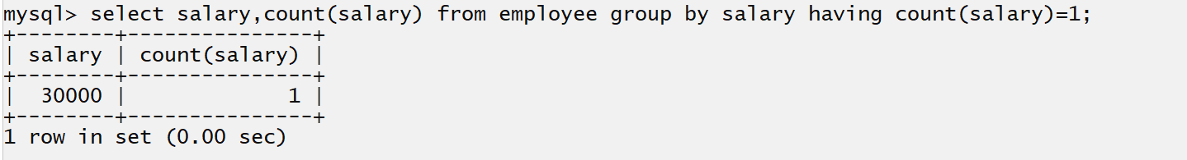

Order by clause
_____________________________________________________________
Order by clause is used for arrange data in ascending order or in descending order.

syntax: select *from tablename order by columnname asc|desc;
asc- stands for arrange data in ascending order and it is by default behavior of order by clause.
means if we not use any option with order by clause then order by arrange by default in ascending order.
desc: stands for descending order and if is not default behavior of order by clause.

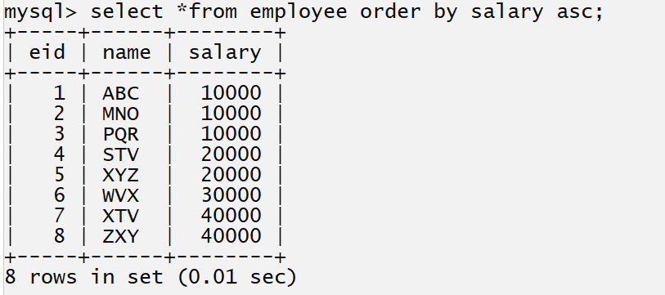
Example using desc
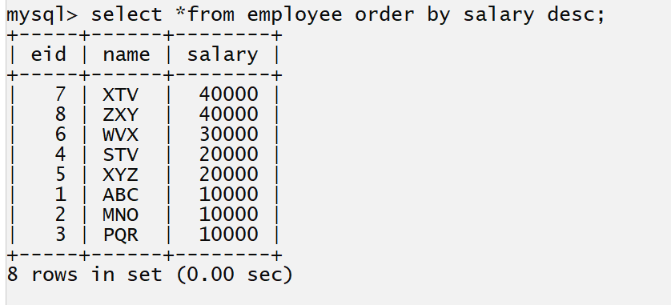

Q. what is correct sequence of where,order by ,having and group by as well as like?

select *from tablename where condition like columnname pattern group by columnname having condition order by columnname asc | desc;

Joins In SQL
__________________________________________________________________________

Q. What is joins?
____________________________________________________________________________
Joins is used for fetch data from different database tables those are interconnected with each other.

Types of Joins
________________________________________________________________
1. Inner join: inner join means fetch common data from both side tables means from left hand side table and right hand side tables.
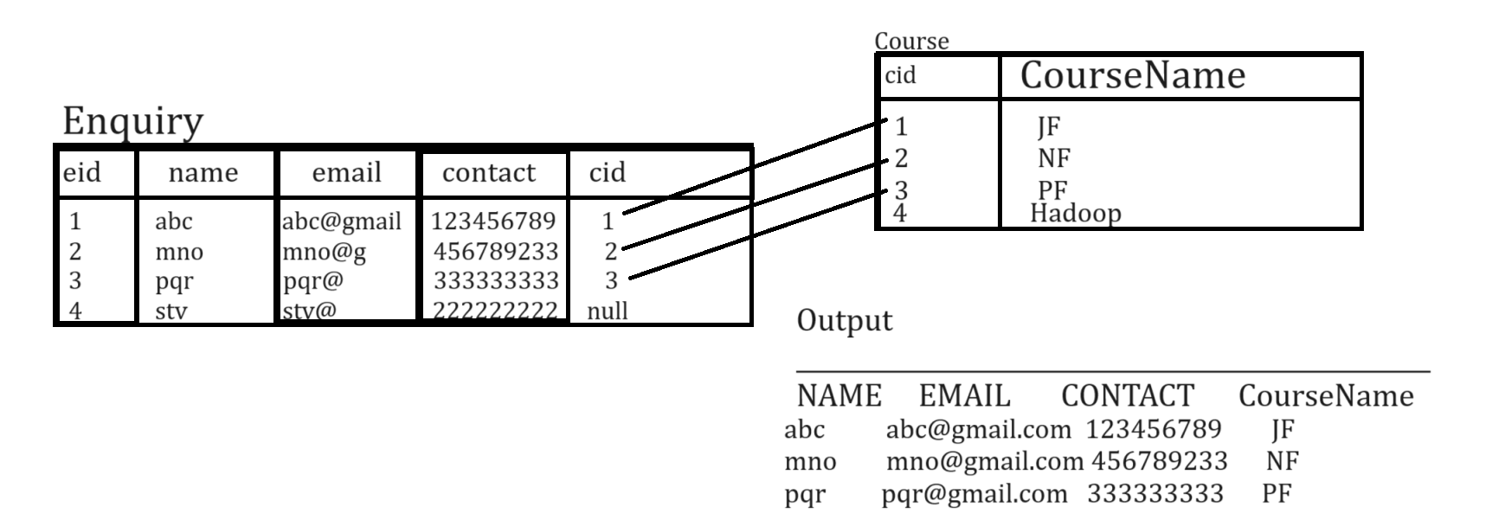
2. Left join: left join means fetch all data from left hand side tables and common data from right hand side tables means as per our above table structure we have course name as hadoop there is no enquiry associate in enquiry table but if we execute the left join and if we consider course is our left hand side tables then we get all course information means hadoop as our example we get students record which associated with course id shown in following output
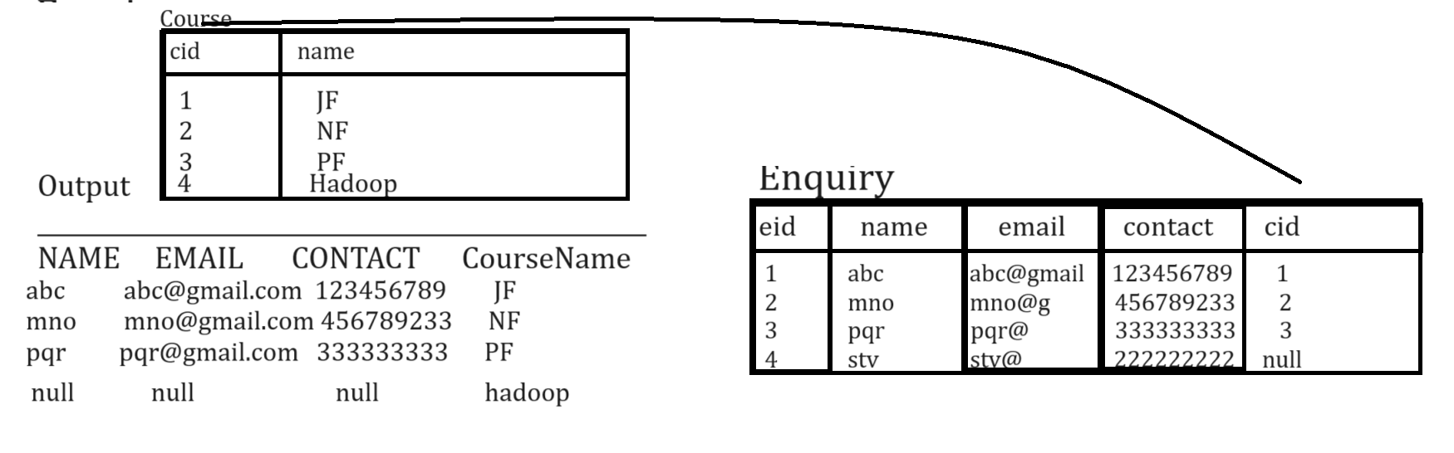
3. Right join: right joins means fetch all records from right hand side tables and common records from left hand side tables.
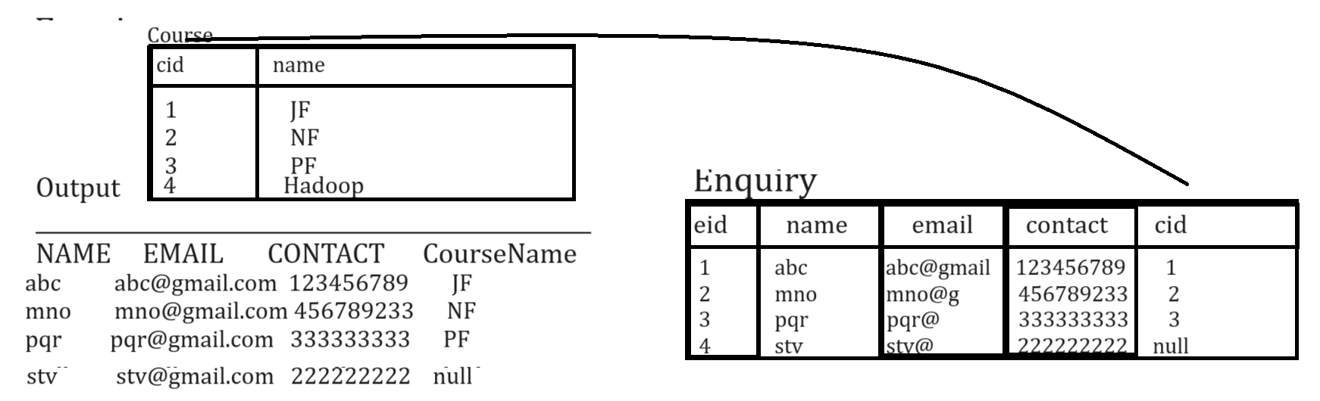

4. Outer joins: outer join means fetch all records from left hand side tables and all records from right hand side tables.
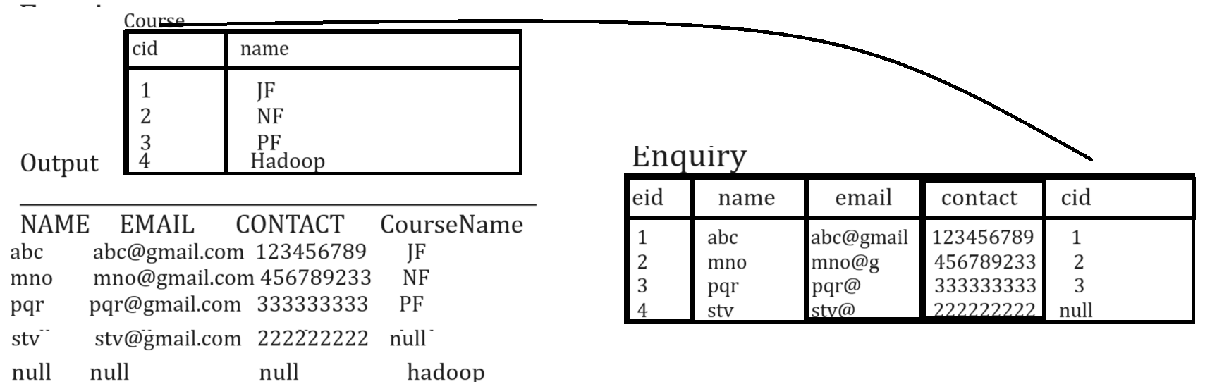

Note: MYSQL not support to outer join directly for that we required to use union or union all concept.
5. Self joins: if we perform joins with same table called as self join.

How to perform joins practically?
___________________________________________________________________
If we want to perform joins practically we have following syntax.
Syntax:
select lstref.columnname,rstref.columnname from lefthandsidetable lstref join type righthandsidetable rstref on lstref.columnname=rstref.columnname;
Now we want to see the simple examples of joins using two tables.
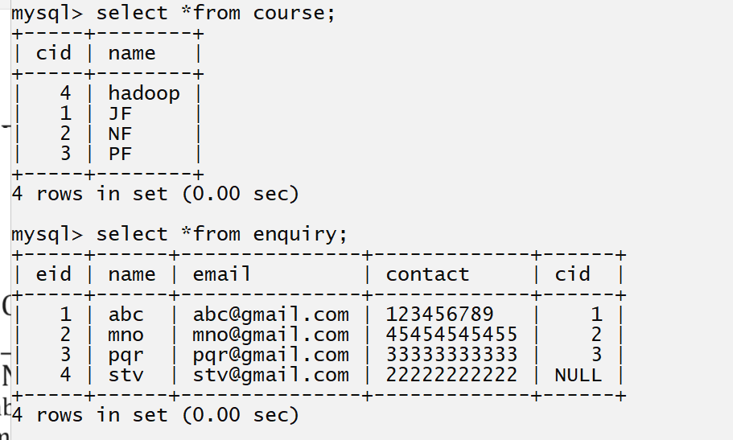

Example of inner joins
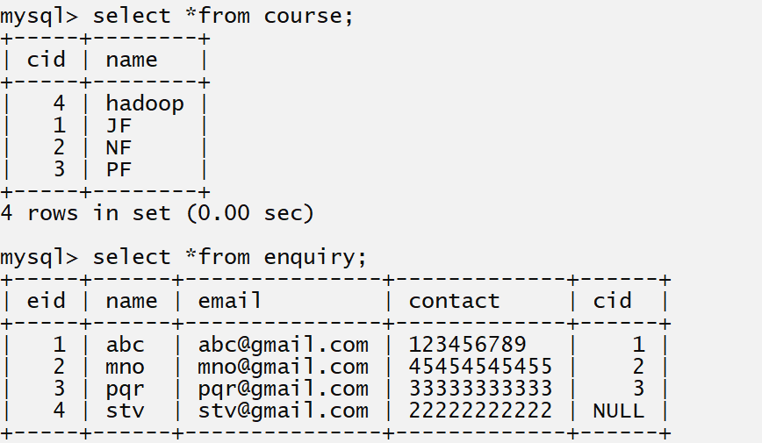
Output
mysql> select c.name as 'Course Name',e.name as 'Student Name',e.email as 'Student Email',e.contact as 'Student Contact' from course c inner join enquiry e on c.cid=e.cid;
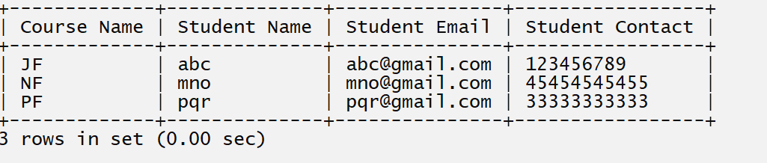

Example of left join
mysql> select c.name as 'Course Name',e.name as 'Student Name',e.email as 'Student Email',e.contact as 'Student Contact' from course c left join enquiry e on c.cid=e.cid;
Output
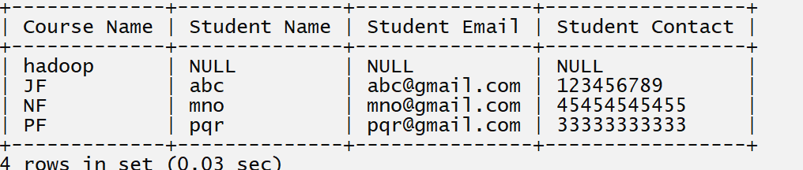

Example of right join
mysql> select c.name as 'Course Name',e.name as 'Student Name',e.email as 'Student Email',e.contact as 'Student Contact' from course c right join enquiry e on c.cid=e.cid;
Output
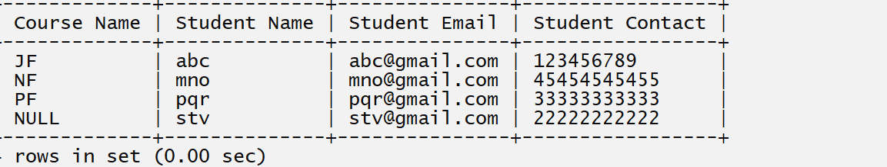

Example of outer join
_________________________________________________________________
it is combination of left join as well as right join and if we want to perform outer join in MYSQL we have to use union keyword or union all so when we want to perform outer join we required write left join at left hand side of union keyword and right join at right hand side keyword of union so it is outer join in mysql

Example with SQL Query
mysql> select c.name as 'Course Name',e.name as 'Student Name',e.email as 'Student Email',e.contact as 'Student Contact' from course c left join enquiry e on c.cid=e.cid union select c.name as 'Course Name',e.name as 'Student Name',e.email as 'Student Email',e.contact as 'Student Contact' from course c right join enquiry e on c.cid=e.cid;
Output
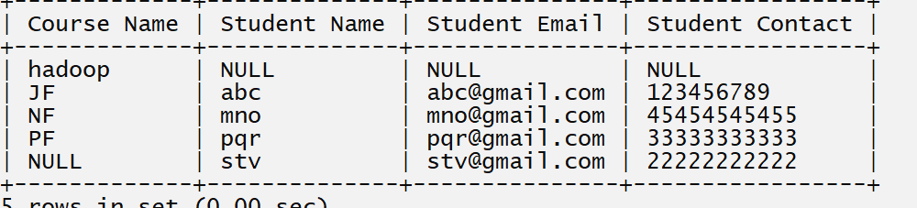

How to perform joins with three tables
__________________________________________________________________________
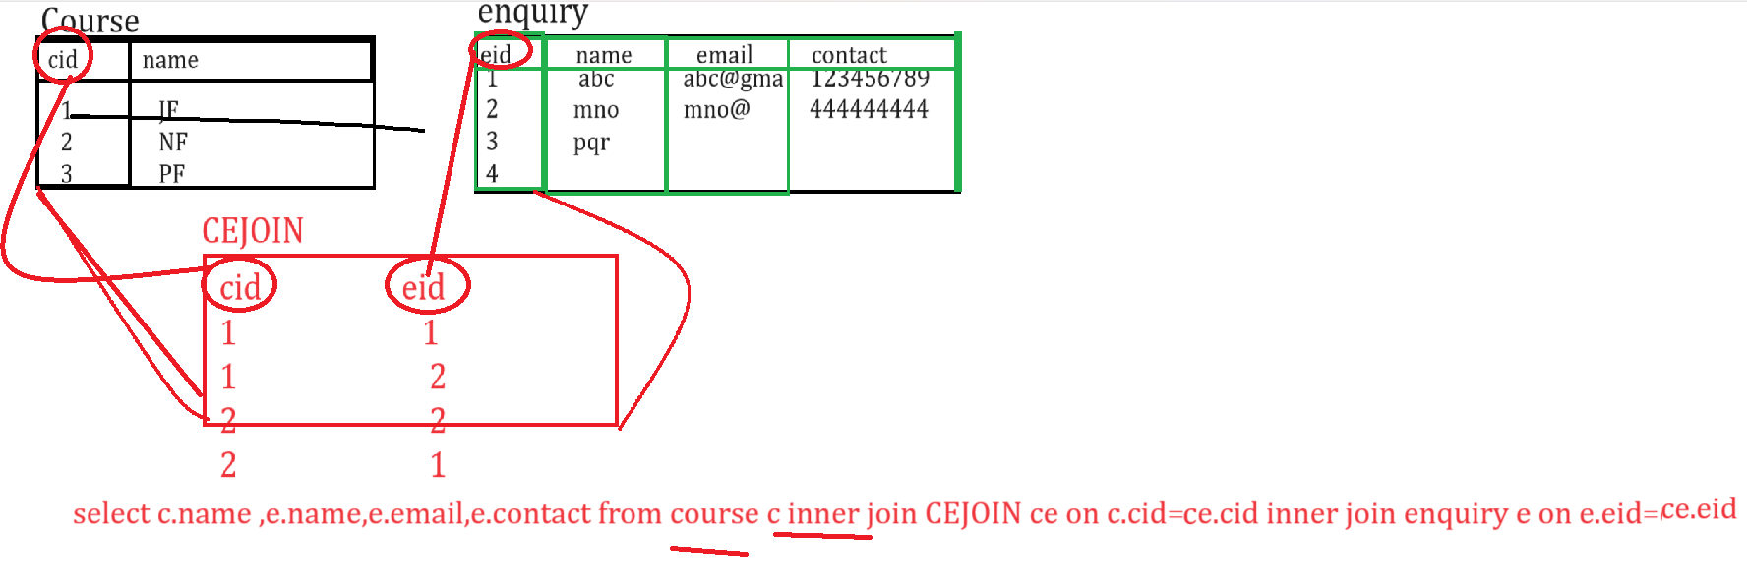
Example with source code
mysql> select c.name as 'course name',e.name as 'stud name',e.email as 'stud email',e.contact as 'stud contact' from course c inner join cejoin ce on c.cid=ce.cid inner join enquiry e on e.eid=ce.eid;
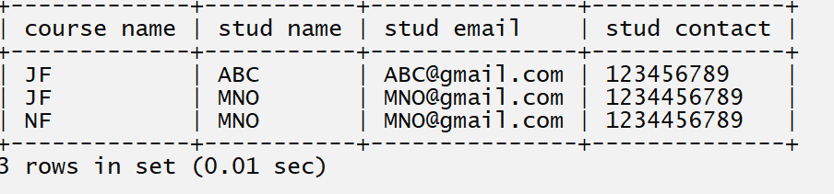

.Q.Write a SQL Query to show the enquiry count Course Wise?
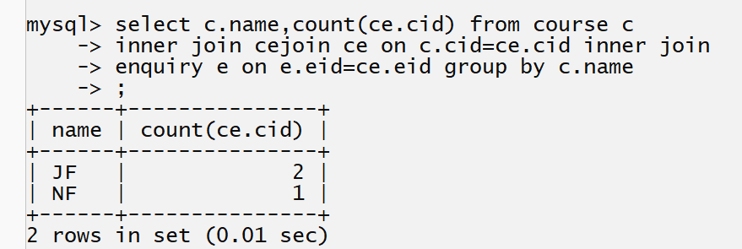
Q. Write a SQL Query to show the course name whose enquiry count is more than 1
