Requirement Analysis:
​Functional Requirements (FR)
​FR1 - List Movies: The system shall display all currently playing movies with their title, language, and duration.
​FR2 - List Shows: For a selected movie, the system shall list all available shows including screen identifier and start time.
​FR3 - Display Seat Layout: For a selected show, the system shall display the grid layout of seats, clearly indicating each seat's identifier, seat type (SILVER, GOLD, PLATINUM), and availability status (AVAILABLE / BOOKED).
​FR5 - Pricing: The system shall calculate ticket prices based on seat types: SILVER = 150, GOLD = 250, and PLATINUM = 400.
​FR7 - Ticket Generation: Upon payment confirmation, the system shall print a ticket containing Booking ID, Movie Title, Screen Name, Show Time, Seat Numbers, Total Amount, and Booking Status.
​FR8 - Cancellation: A customer can cancel a booking using a valid Booking ID, upon which the reserved seats revert to AVAILABLE status.
​Non-Functional Requirements (NFR)
​NFR1 - Modularity: High cohesion and low coupling with one class per file. Adding new components must not modify core domain logic.
​NFR2 - Extensibility: Open-Closed Principle adherence, allowing new payment methods (e.g., NetBanking) to be added without modifying existing booking services or payment processing code.
​NFR3 - Robust Input Validation: The system must validate user inputs (invalid menu choices, non-existent seats, already booked seats) and gracefully handle errors without crashing or compromising data consistency.

Noun Verb Analysis:
Noun found | Class? | Justification
Movie | Yes | Core domain entity with title, language, duration.
Seat | Yes | Physical chair layout entity with number and tier.
Seat layout | No | It's just a runtime view/loop printing seats. Not a class.
Screen | Yes | Physical room/auditorium holding a collection of seats.
Cinema | Yes | Top-level venue containing screens.
Show | Yes | Links a Movie to a Screen at a specific timestamp.
Showseat | Yes | Decouples the physical seat from show-specific availability states
Customer | Yes | Holds basic user info (name, phone).
Booking | Yes | Represents the transaction record, status, seats, and final bill.
Payment | Yes (Abstract Class) | Base interface defining the polymorphic pay() contract
UPI/Card/Cash | Yes | Concrete implementations of the payment interface
PriceCalculator | Yes | Stateless utility purely for summing up seat tier prices.
TicketPrinter | Yes | Dedicated utility for formatting and printing console output.
BookingService | Yes | Controller orchestrating locks, payments, and state rollbacks
Cinema/MainMenu | Yes | Entry point driving the standard I/O menu loop

Class Responsibilities
- Movie
  - Knows: Title, language, runtime.
  - Does: Returns movie info.
  - Must NOT do: Manage showtimes, screen assignments, or prices.
- Seat
  - Knows: Seat ID (e.g., A1, B2) and category tier.
  - Does: Returns physical seat details.
  - Must NOT do: Track dynamic booking status across different shows.
- Screen
  - Knows: Screen number and its physical Seat vector.
  - Does: Exposes seat configurations.
  - Must NOT do: Manage show schedules or process transactions.
- Cinema
  - Knows: Cinema name and list of screens.
  - Does: Manages screen setups.
  - Must NOT do: Handle customer bookings or ticket issuance.
- Show
  - Knows: References to Movie, Screen, time slot, and local ShowSeat mappings.
  - Does: Exposes current show status and seat availability.
  - Must NOT do: Handle payment logic or calculate totals.
- ShowSeat
  - Knows: Reference to underlying physical Seat and current status (AVAILABLE / BOOKED).
  - Does: Locks seat or releases it back.
  - Must NOT do: Track customer profiles or transaction IDs.
- Customer
  - Knows: Name, phone number.
  - Does: Returns profile details.
  - Must NOT do: Validate seats or issue bookings.
- Booking
  - Knows: Booking ID, list of ShowSeat*, total cost, state enum.
  - Does: Updates its own state (CONFIRMED, CANCELLED).
  - Must NOT do: Print directly to stdout or run payment routines.
- Payment (Base Interface)
  - Knows: Contract for payments.
  - Does: Defines pure virtual pay(double amount).
  - Must NOT do: Implement concrete logic.
- UpiPayment / CardPayment / CashPayment
  - Does: Executes simulated payment and returns a boolean status.
  - Must NOT do: Directly mutate booking records.
- PriceCalculator
  - Does: Iterates over chosen seats and returns the sum based on tier constants.
  - Must NOT do: Reserve seats or handle user I/O.
- TicketPrinter
  - Does: Takes a Booking reference and prints a formatted terminal receipt.
  - Must NOT do: Modify booking state or recalculate prices.
- BookingService
  - Does: Central controller. Checks availability, acquires seat locks, delegates to Payment, and commits or rolls back state.

Relationships & Lifetime Test
- Cinema — Screen (Composition): Screens belong to the cinema building. If the Cinema object is deleted, its Screen instances don't make sense on their own and get destroyed.
- Screen — Seat (Composition): Physical seats belong to that specific screen layout. Deleting the Screen destroys its underlying seats.
- Show — Movie (Aggregation): A Show references a Movie. If a particular showtime is removed from schedule, the Movie still exists in the system catalogue.
- Show — Screen (Aggregation): A Show uses a Screen for a time block. Cancelling a show doesn't destroy the physical auditorium.
- Show — ShowSeat (Composition): A ShowSeat represents status specifically for that slot. If the Show instance is destroyed, its show-specific seat records are garbage and get cleaned up with it.
- Booking — Customer (Association): A Booking links to a Customer. Cancelling or dropping a booking does not wipe the customer's record.
- Booking — ShowSeat (Aggregation): A Booking holds references to the booked ShowSeat objects. If the booking is cancelled, the seats are freed back to AVAILABLE, not deleted from memory.
- Payment — UpiPayment / CardPayment / CashPayment (Inheritance): Standard polymorphic subclassing; derived payments implement the base Payment interface.
- BookingService — Booking (Aggregation): The service keeps a map of active bookings. Re-instantiating the service shouldn't conceptually blow away existing transactions.

Class Diagram:
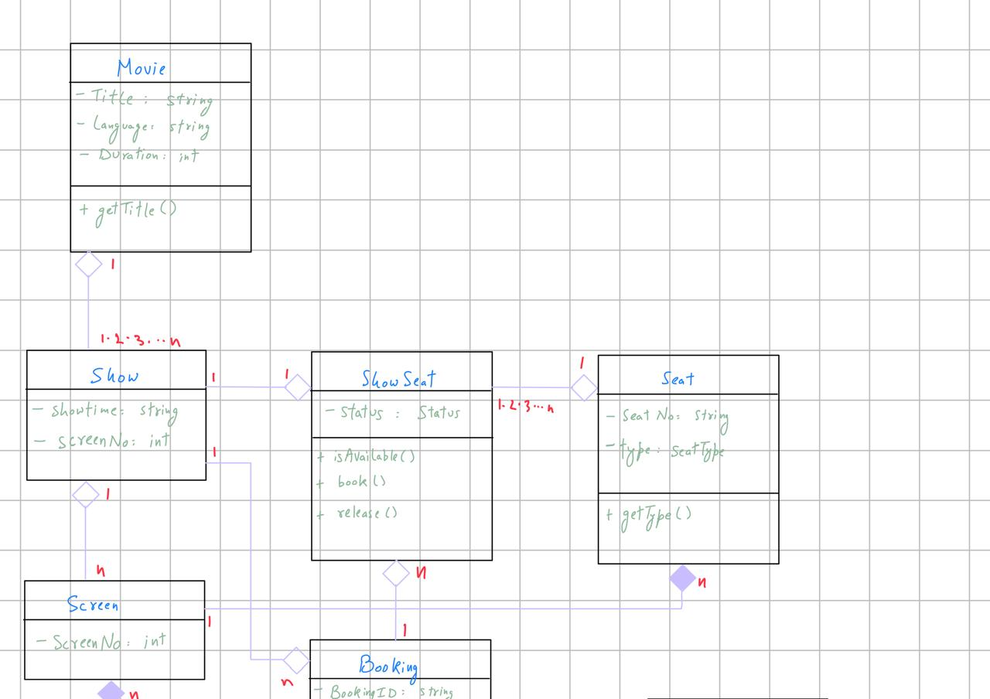

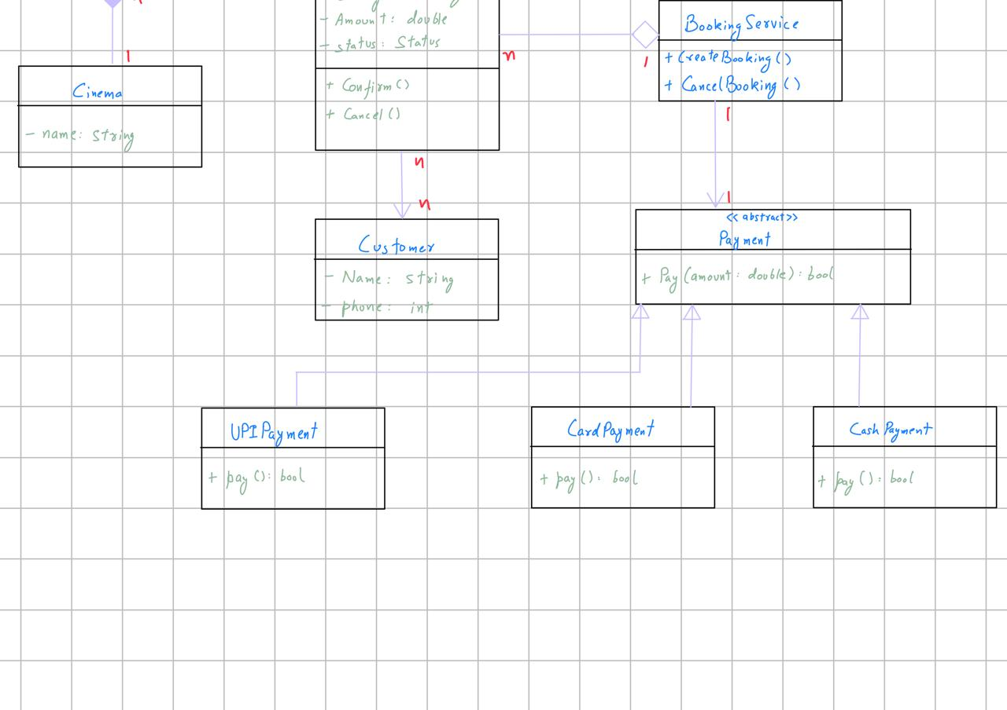

Behavioral Diagram:
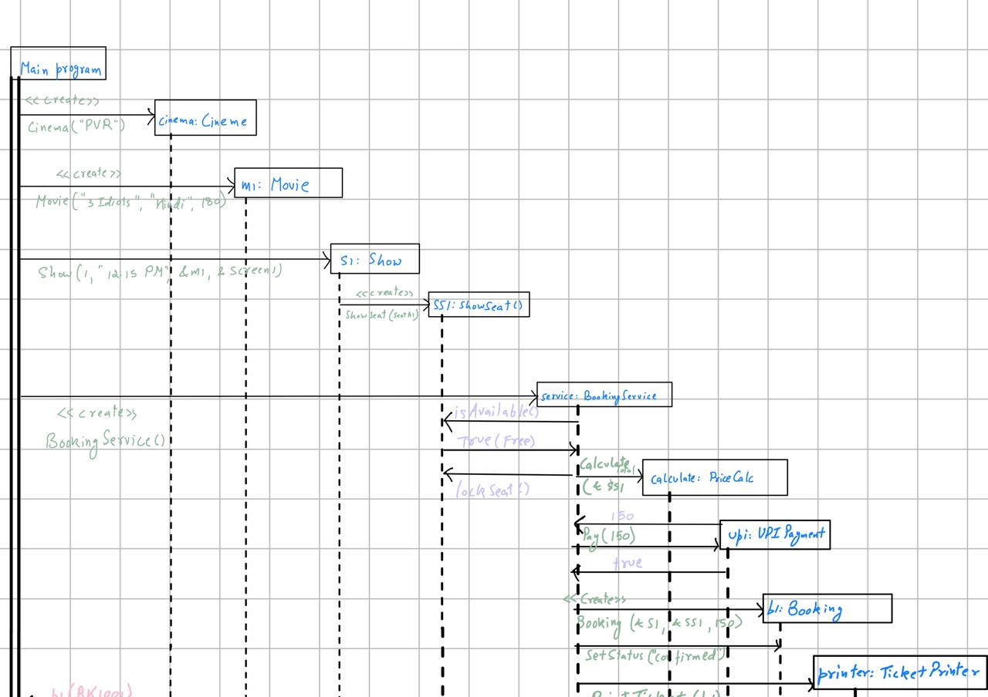

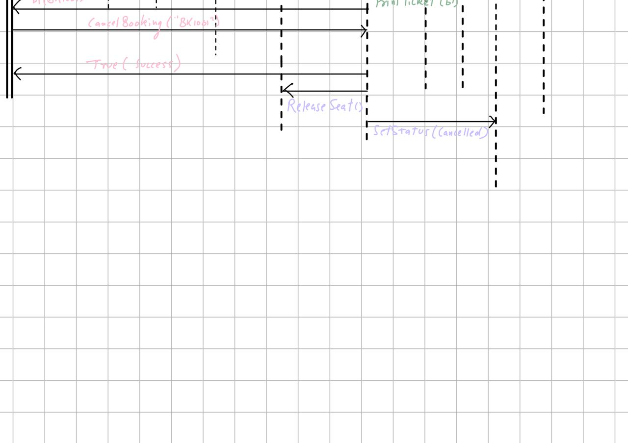

SOLID Mapping & Design Trade-offs
- Single Responsibility Principle (SRP): Isolated ticket formatting inside TicketPrinter and pricing math inside PriceCalculator. Booking just holds its own state and doesn't do console I/O.
- Open/Closed Principle (OCP): If we need a new payment mode (like NetBanking), we just write a new subclass of Payment. Zero edits required inside BookingService.
- Liskov Substitution Principle (LSP): Any concrete payment (UpiPayment, CardPayment, CashPayment) can be passed via Payment& to BookingService::createBooking without breaking runtime behavior.
- Dependency Inversion Principle (DIP): BookingService accepts the high-level Payment abstraction instead of depending directly on concrete classes like CardPayment.

Deliberatly did not do:
- What I avoided: Putting std::cout receipt formatting directly inside the Booking class.
- Reasoning: It’s tempting to just write a quick .print() inside Booking and call it a day, but mixing UI formatting into domain models breaks SRP.

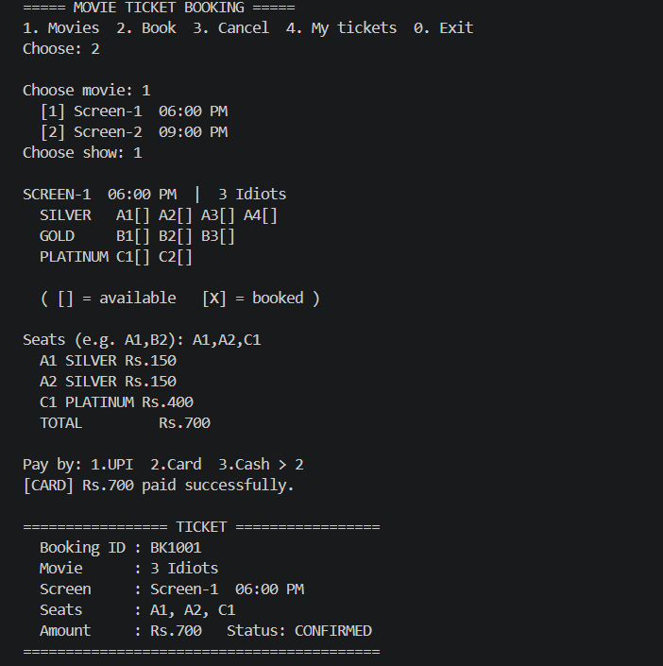
OUTPUT:
