Optimising Hospital Waiting Lists with a Discrete Event Simulation Model

Student Name: Student ID:

- The conceptualised pathway is below. [6 marks]

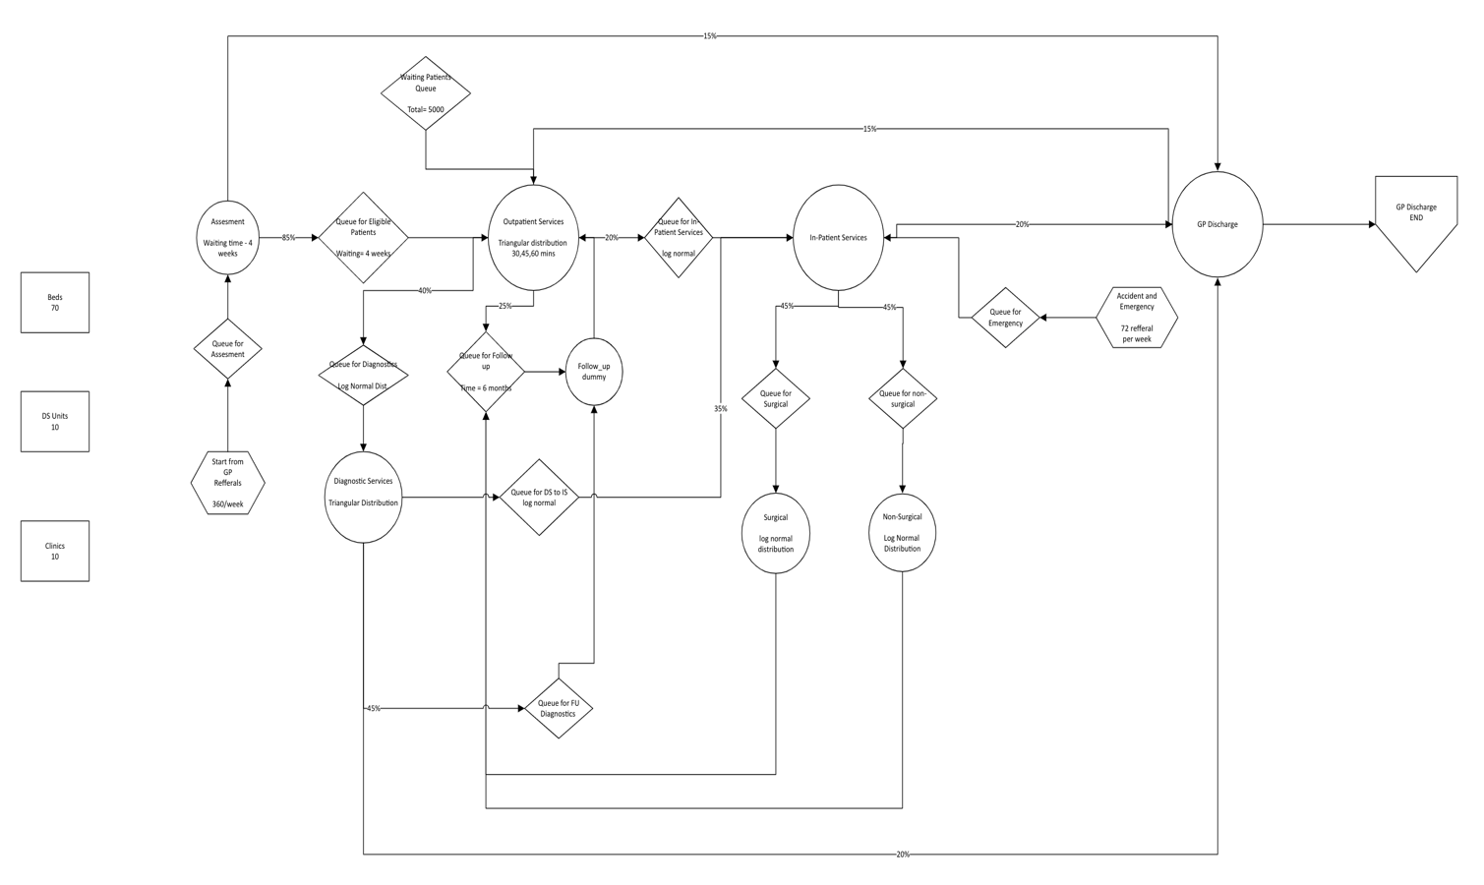s

- Simul8 (.S8) file to be uploaded to Canvas [20 marks]
- Baseline Scenario (As-Is) [6 marks]
Key Performance Metrics | Lower 95% CI | Average | Upper 95% CI
Waiting List Size (for OS) | 4.58 | 6.30 | 8.02
Number of patient waiting for surgical operation | 1259.89 | 1299.50 | 1339.11
Number of patient waiting for non-surgical operation | 148.21 | 180.20 | 212.19
Bed Utilisation | 98.60 | 98.71 | 98.82
Diagnostic Units Utilisation (%) | 32.20 | 32.52 | 32.84
Average time in system (in weeks) | 19.96 | 20.21 | 20.45

- Capacity Expansion [6 marks]
Key Performance Metrics | Lower 95% CI | Average | Upper 95% CI
Waiting List Size (for OS) | 4.77 | 6.10 | 7.43
Number of patient waiting for surgical operation | 1026.92 | 1067.90 | 1180.88
Number of patient waiting for non-surgical operation | 0.00 | 0.40 | 1.30
Bed Utilisation | 94.88 | 95.38 | 95.88
Diagnostic Units Utilisation (%) | 24.26 | 24.73 | 24.99
Average time in system (in weeks) | 19.78 | 20.08 | 20.43
- Process Efficiency Improvement [6 marks]
Key Performance Metrics | Lower 95% CI | Average | Upper 95% CI
Waiting List Size (for OS) | 4.91 | 6.30 | 7.69
Number of patient waiting for surgical operation | 0.00 | 0.00 | 0.00
Number of patient waiting for non-surgical operation | 0.00 | 0.00 | 0.00
Bed Utilisation | 57.11 | 57.67 | 58.22
Diagnostic Units Utilisation (%) | 18.57 | 18.77 | 18.96
Average time in system (in weeks) | 21.15 | 21.47 | 21.80
- New Referral System and Pathway Optimisation. [6 marks]
Key Performance Metrics | Lower 95% CI | Average | Upper 95% CI
Waiting List Size (for OS) | 4.69 | 6.10 | 7.51
Number of patient waiting for surgical operation | 0.00 | 0.00 | 0.00
Number of patient waiting for non-surgical operation | 0.00 | 0.00 | 0.00
Bed Utilisation | 65.73 | 66.32 | 66.91
Diagnostic Units Utilisation (%) | 25.37 | 25.63 | 25.89
Average time in system (in weeks) | 17.59 | 17.77 | 17.95

