LAB Logbook

Lab 1

Lab 2

Task 1

Test accuracy: 0.940

Task 2

**Step 1: Calculate Input Values**

Given:

* SID = 2353465
* x1 = (SID / 8964879) * 23
* x2 = (SID / 8964879) * 32
* x3 = (SID / 8964879) * 56
* x4 = (SID / 8964879) * 48

First, compute the value of SID / 8964879:

SID/8964879 = 2353465/8964879

≈ 0.2625

Now, calculate the input values:

x1 = 0.2625∗23 ≈ 6.0375

x2 = 0.2625∗32 ≈ 8.4

x3 = 0.2625∗56 ≈ 14.7

x4 = 0.2625∗48 ≈ 12.6

**Step 2: Calculate Hidden Layer 1 (H1 and H2)**

We will use the perceptron formula:

Z = b+∑(wi∗xi)

For H1:

zH1 = w1∗x1+w3∗x2+w5∗x3+w7∗x4

zH1 = 0.2∗6.0375+0.2∗8.4+0.2∗14.7+0.2∗12.6

zH1 = 8.3475

Apply ReLU activation:

H1 = max (0, zH1) = max (0, 8.3475) = 8.3475

For H2:

zH2 = *w*2∗*x*1+*w*4∗*x*2+*w*6∗*x*3+*w*8∗*x*4

zH2 = 0.2∗6.0375+0.2∗8.4+0.2∗14.7+0.2∗12.6

zH2 = 8.3475

Apply ReLU activation:

H2 = max (0, zH2) = max (0, 8.3475) = 8.3475

**Step 3: Calculate Hidden Layer 2 (H3 and H4)**

For H3:

zH3 = w9∗H1+w11∗H2

zH3 = 0.1∗8.3475+0.1∗8.3475

zH3 = 1.6695

Apply ReLU activation:

H3 = max (0, zH3) = max (0, 1.6695) = 1.6695

For H4:

zH4 = *w*10∗*H*1+*w*12∗*H*2

zH4 = 0.1∗8.3475+0.1∗8.3475

zH4 = 1.6695

Apply ReLU activation:

H4 = max (0, *zH*4​) = max (0, 1.6695) = 1.6695

**Step 4: Calculate Output Layer (O1 and O2)**

For O1:

zO1 = w13∗H3+w15∗H4+0.5

*zO*1 ​=0.50085+0.50085+0.5

zO1 ​= 1.5017

Apply Sigmoid activation:

O1 = 1/1+*e^(*−*zO*1​)​ = 1/1+*e^ (*−1.50171) ​≈ 0.8176

For O2:

zO2 = w14∗H3+w16∗H4+0.5

zO2 ​= 0.3∗1.6695+0.3∗1.6695+0.5

zO2 = 0.50085+0.50085+0.5

zO2 = 1.5017

Apply Sigmoid activation:

O2 = 1/1+*e^(*−*zO*1​)​ = 1/1+*e^ (*−1.50171) ​≈ 0.8176

**Final Output**

The final output of the neural network is:

O1 ≈ 0.8176

O2 ≈ 0.8176

This means that the neural network, given the inputs and weights, produces outputs O1 and O2 both equal to 0.8176.

Lab 3

Model's Test Accuracy: 91.24%

Lab 4

Lab 5

1. Plot of the model's summary

2. A graphical representation depicting the train loss and validation loss trends.

3. Based on this analysis, determine the optimal number of epochs for training your model.

Lab 6

2

2.1

2.2

3.

4.

Lab 7

1. Plot graphs for Accuracy and Loss Function for VGG16 and VGG19 (4 graphs in total).

2. Based on this analysis, determine the optimal number of epochs for training your VGG16 model.

3. Add the final Performance Table

4. Plot the performance comparing histogram of VGG16 and VGG19

Lab 8

1 - LSTM architecture using model.summary()

2 - code and training result using model.fit()

3 - the resulting test MSE & MAE and

4 - MAE detailed graph.

Lab 9

1 - code your Use EarlyStopping() and ModelCheckpoint() functions

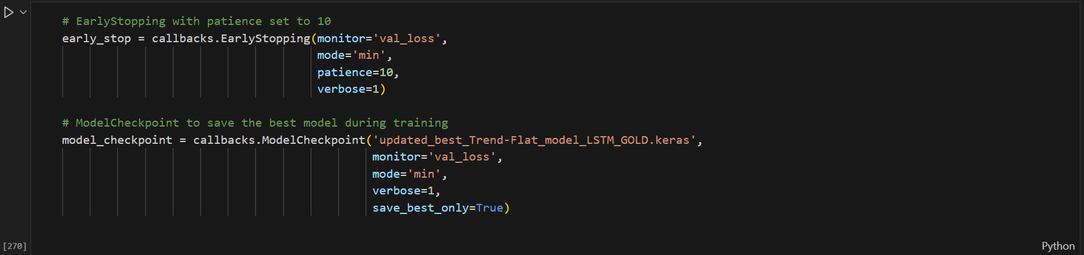

2 - code and training result using model.fit()

3 - the resulting test Accuracy and other error metrics for the classification task using classification_report().

4 - Accuracy detailed graph

Lab 10

Task 1

- Encoder, Decoder and Basic Autoencoder models using summary()

Task – 2

- Table of your model autoencoder.summary()

- Code of your autoencoder.fit()

- Accuracy detailed graph

- Document the plot of the decoded images for task 2. Change the colour, appearance, and shape of the plot according to your own choice (see plt.figure() parameters).

Lab 11

Lab 12

- calculation of your parameters

- your code of using EarlyStopping() and ModelCheckpoint() functions

- your code and training result using model.fit()

- received loss for train and test datasets

- Loss (MSE) graph for the 3 models together during the training process

- performance histogram for train and test loss (MSE) of the 3 models together

