LAB Logbook

Lab 1

Lab 2

Test accuracy: 0.940

Lab 3

Model's Test Accuracy: 91.24%

Lab 4

Lab 5

1. Plot of the model's summary

2. A graphical representation depicting the train loss and validation loss trends.

3. Based on this analysis, determine the optimal number of epochs for training your model.

Lab 6

2

2.1

2.2

3.

4.

Lab 7

1. Plot graphs for Accuracy and Loss Function for VGG16 and VGG19 (4 graphs in total).

2. Based on this analysis, determine the optimal number of epochs for training your VGG16 model.

3. Add the final Performance Table

4. Plot the performance comparing histogram of VGG16 and VGG19

Lab 8

1 - LSTM architecture using model.summary()

2 - code and training result using model.fit()

3 - the resulting test MSE & MAE and

4 - MAE detailed graph.

Lab 9

1 - code your Use EarlyStopping() and ModelCheckpoint() functions

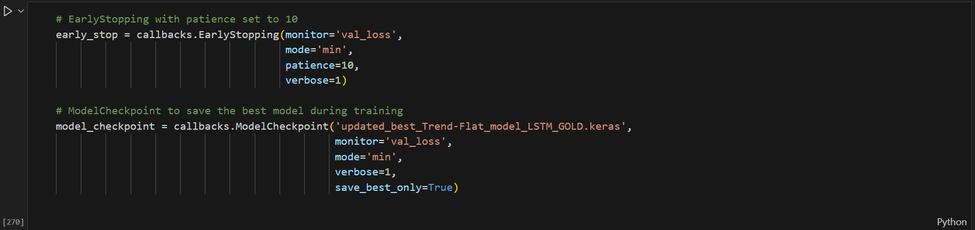

2 - code and training result using model.fit()

3 - the resulting test Accuracy and other error metrics for the classification task using classification_report().

4 - Accuracy detailed graph

Lab 10

Lab 11

Lab 12