**Name – Sahil**

**Rollno – 17/1426**

**BSc(H) CS 3rd year**

**AI Assignment**

**Q.1.What is artificial intelligence ? What are the various applications of artificial intelligence?**

**Ans :** It is a branch of computer science by which we can create intelligent machines which can behave like human, think like humans and able to make decisions.

Applications :

1. AI in Healthcare

* In the last, five to ten years, AI becoming more advantageous for the healthcare industry and going to have a significant impact on this industry.
* AI make a better and faster diagnosis than humans.
* AI can help doctors with diagnoses and can inform when patients are worsening so that medical help can reach to the patient before hospitalization.

2. AI in Robotics:

* Artificial Intelligence has a remarkable role in Robotics. Usually, general robots are programmed such that they can perform some repetitive task, but with the help of AI, we can create intelligent robots which can perform tasks with their own experiences without pre-programmed.
* Humanoid Robots are best examples for AI in robotics.

3. AI in Entertainment

* We are currently using some AI based applications in our daily life with some entertainment services such as Netflix or Amazon. With the help of ML/AI algorithms, these services show the recommendations for programs or shows.

4. AI in E-commerce

* AI is providing a competitive edge to the e-commerce industry, and it is becoming more demanding in the e-commerce business.
* AI is helping shoppers to discover associated products with recommended size, color, or even brand.

5. AI in education:

 It automates grading, giving educators more time. It can also assess students and adapt to their needs, helping them work at their own pace.

**Q.2.Solve the following cryptoarithmetic problem:**

**EAT + THAT = APPLE**

**Ans :** In the above problem, A must be 1

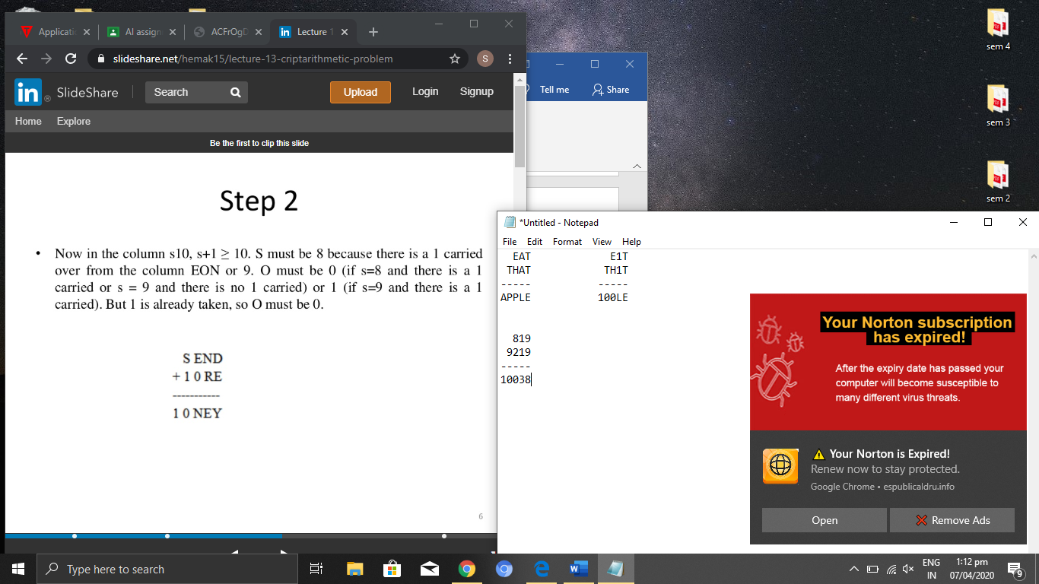

T must be 9 because there is a 1 carried over from the column EH1. E must be 8 as in column TTE, (T=9) and H must be 2.

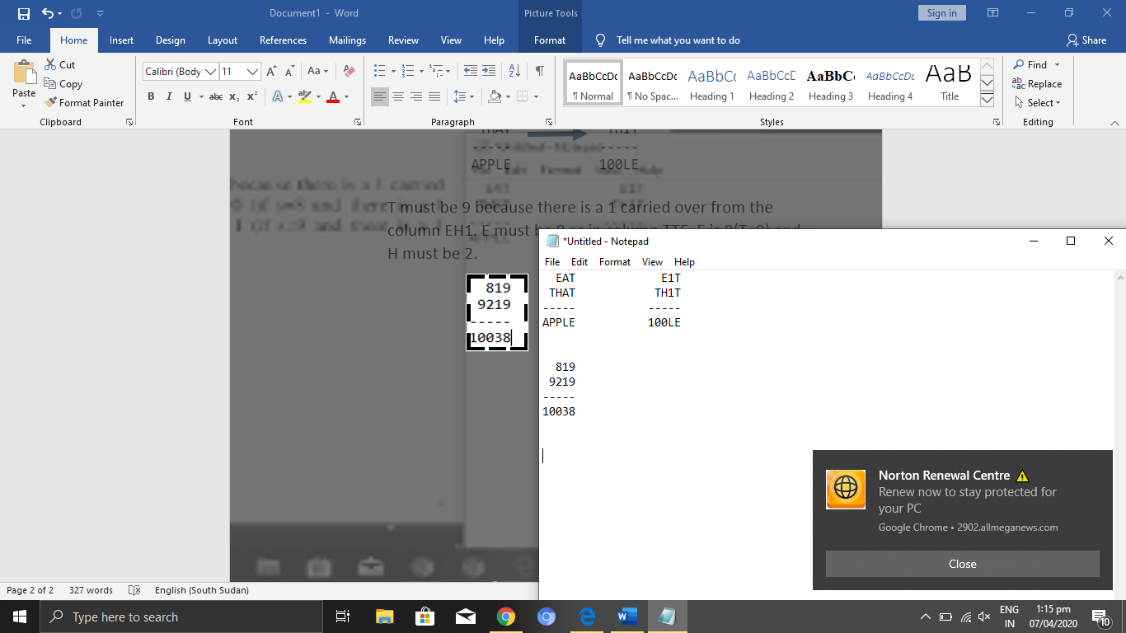

Therefore, the **solution to the given Crypt-Arithmetic problem is**:

A=1, T=9, P=0, E=8, H=2, L=3

**Q3. Define Frames. Draw a semantic network for the representation of the following statements.**

**a. Every kid likes candy.**

**b. Every school going kid likes candy.**

**Ans :** Frames are an artificial intelligence data structure used to divide knowledge into substructures by representing “sterotypes situation”.

a)

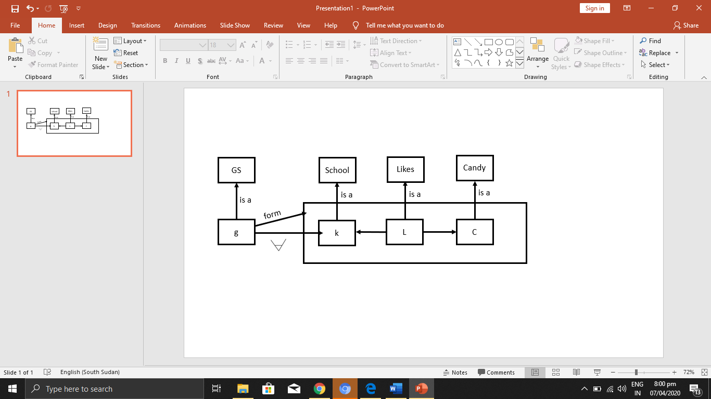

b)

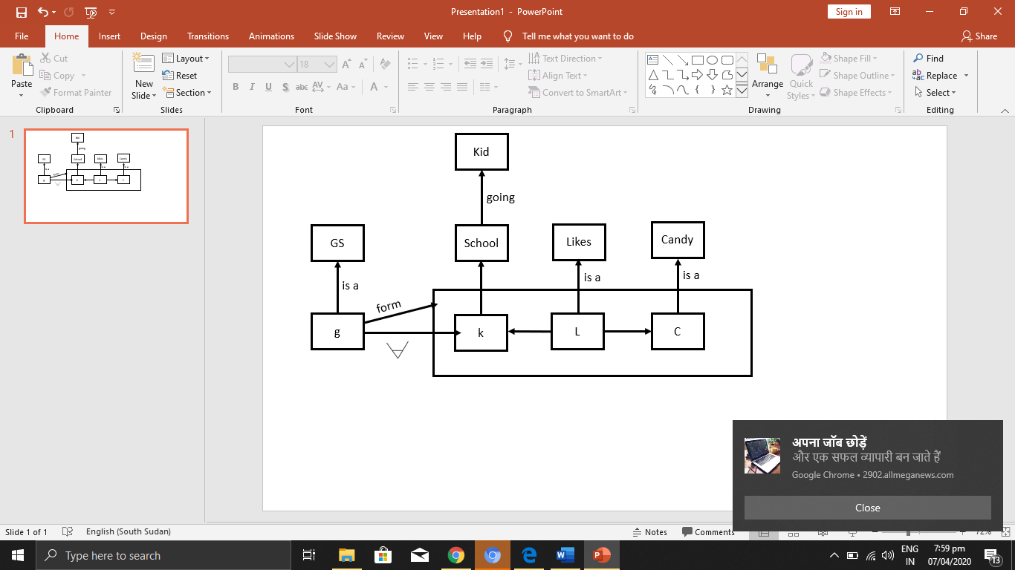

**Q.4. Describe the following :**

**a. Monotonic reasoning**

**b. Nonmonotonic reasoning**

**c. Default reasoning**

**d. Truth Maintenance systems**

**e. Default reasoning**

**Ans :**

a. Monotonic reasoning :

* Monotonic in the sense that anything that could be concluded before a clause is added can still be concluded after it is added.
* Adding knowledge does not reduce the set of prepositions that can be derived.
* To solve monotonic problems, we can derive the valid conclusion from the available facts only, and it will not be affected by new facts.
* Logic based systems are monotonic in nature.
* **Example:** **Earth revolves around the Sun.** It is a true fact, and it cannot be changed even if we add another sentence in knowledge base like, "The moon revolves around the earth" Or "Earth is not round," etc

b. Nonmonotonic reasoning :

* some conclusions may be invalidated if we add some more information to our knowledge base.
* Logic will be said as non-monotonic if some conclusions can be invalidated by adding more knowledge into our knowledge base.
* Non-monotonic reasoning deals with incomplete and uncertain models.
* **Example:** Let suppose the knowledge base contains the following knowledge:
  + **Birds can fly**
  + **Penguins cannot fly**
  + **Pitty is a bird**

So from the above sentences, we can conclude that **Pitty can fly**.

* we can choose probabilistic facts or can make assumptions.

c. Default reasoning :

* It is deducing new information from logically related known information.
* It is the form of valid reasoning, which means the argument's conclusion must be true when the premises are true.
* It is a type of propositional logic in AI, and it requires various rules and facts.
* Sometimes referred to as top-down reasoning, and contradictory to inductive reasoning.
* In deductive reasoning, the truth of the premises guarantees the truth of the conclusion.
* Mostly starts from the general premises to the specific conclusion.
* **Example:**
  + **Premise-1: All the human eats veggies**
  + **Premise-2: Suresh is human.**
  + **Conclusion: Suresh eats veggies.**

d. Truth Maintenance systems:

* It is a knowledge representation method for representing both beliefs and their dependencies and an algorithm called the ‘truth maintenance algorithm’ that manipulates and maintain the dependencies.
* It is to maintain consistency of the knowledge being used by the problem solver and not to perform any inference functions

e. Default reasoning:

* Default reasoning is a form of nonmonotonic reasoning where plausible conclusions are inferred based on general rules which may have exceptions (defaults).
* It is nonmonotonic in the sense that additional information may force us to withdraw earlier conclusions, namely whenever the additional information shows that the case at hand is exceptional.

**Q.5. Write a prolog program to find the factorial of a given number.**

**Ans :** factorial(0,1).

factorial(N,F) :-

(

N>0->

(

N1 is N-1,

factorial(N1,F1),

F is N * F1.

)

;

N<0->

(

N1 is N-1,

factorial(N1,F1),

F is N * F1.

)

).

**Q.6. Discuss Bay’s theorem.**

**Ans :** It describe the probability of an event based on prior knowledge of conditions that might be related to the event.

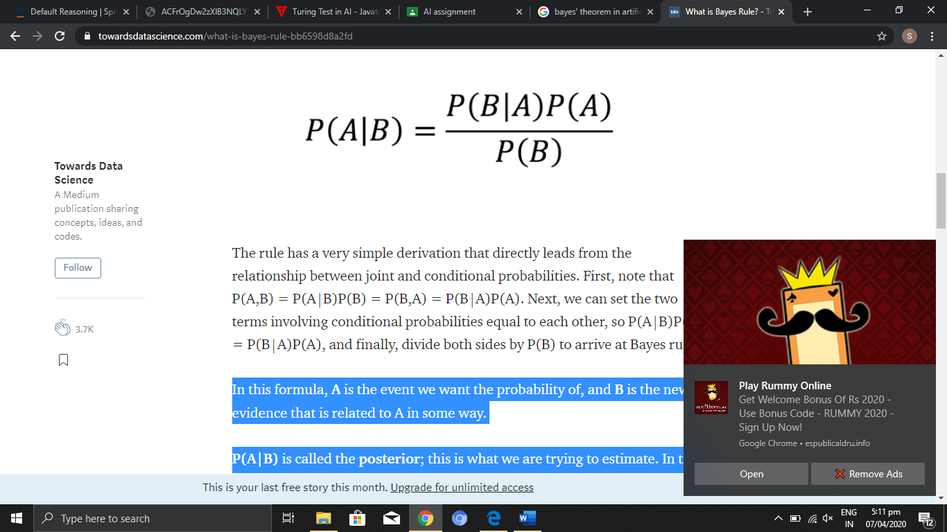

In this formula, **A** is the event we want the probability of, and **B** is the new evidence that is related to A in some way.

**P(A|B)**is called the **posterior**; this is what we are trying to estimate.

**P(B|A)** is called the**likelihood**; this is the probability of observing the new evidence, given our initial hypothesis

**P(A)** is called the **prior**; this is the probability of our hypothesis without any additional prior information.

**P(B)** is called the **marginal likelihood**; this is the total probability of observing the evidence

**Q.7. Explain steps of Natural language processing**

**Ans**

1. Lexical Analysis : Lexicon of a language means the collection of words and phrases in language
2. Syntactic Analysis(Parsing): Checks grammar and words arrangement shows the relationship among the words.
3. Semantic Analysis: Draws the exact meaning or the dictionary meaning from the text checks for sensibility and meaningfulness.
4. Discourse Integration: Meaning of any sentence depends upon the meaning of the sentence just before it.
5. Pragmatic Analysis: It involves those aspects of language which require real world knowledge.

**Q.8. Discuss Cut and Fail in prolog.**

**Ans :**

Cut : It always succeeds and ensures that backtracking never passes the cut point, so if the clause fails it fails hard(doesn’t backtrack to the last choice point before the cut).

Fail : It immediately initiates a backtrack to the last choice point or fails the entire query.

**Q.9. Discuss Turing test.**

**Ans :**

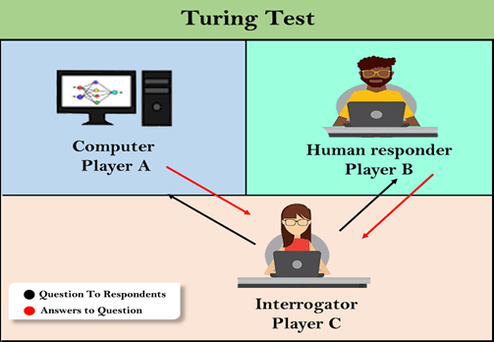

A Turing Test is a method of inquiry in AI for determining whether or not a computer in capable of thinking like a human being. The test is named after Alan Turing.

Example :

A party game "Imitation game," involves three players in which one player is Computer, another player is human responder, and the third player is a human Interrogator, who is isolated from other two players and his job is to find that which player is machine among two of them.

Consider, Player A is a computer, Player B is human, and Player C is an interrogator. Interrogator is aware that one of them is machine, but he needs to identify this on the basis of questions and their responses.

The conversation between all players is via keyboard and screen so the result would not depend on the machine's ability to convert words as speech.

The test result does not depend on each correct answer, but only how closely its responses like a human answer. The computer is permitted to do everything possible to force a wrong identification by the interrogator.

The questions and answers can be like:

**Interrogator:** Are you a computer?

**PlayerA (Computer):** No

**Interrogator:** Multiply two large numbers such as (256896489*456725896)

**Player A:** Long pause and give the wrong answer.

In this game, if an interrogator would not be able to identify which is a machine and which is human, then the computer passes the test successfully, and the machine is said to be intelligent and can think like a human.

**Q.10. Write a prolog program to find the sum of first N natural numbers.**

**Ans :**

Sum(0,0).

Sum(N,R):-

N1=N-1,

Sum(N1,R1),

R=R1+N.