**High Performance Computing Lab**

**Assignment 1**

**Name: Sahil Pravin Thakur**

**PRN: 2020BTECS00042**

**Batch: B3**

**------------------------------------------------------------------------------------**

**Installation of OpenMP**

------------------------------------------------------------------------------------------------

**Basic program using OpenMP:**

Hello World program:

#include <omp.h>

#include <stdio.h>

#include <stdlib.h>

void printMes()

{

    int tn;

    tn = omp_get_thread_num();

    printf("\nHello world %d \n", tn);

}

int main(int argc, char *argv[])

{

#pragma omp parallel num_threads(4)

    printMes();

    return 0;

}

Output:

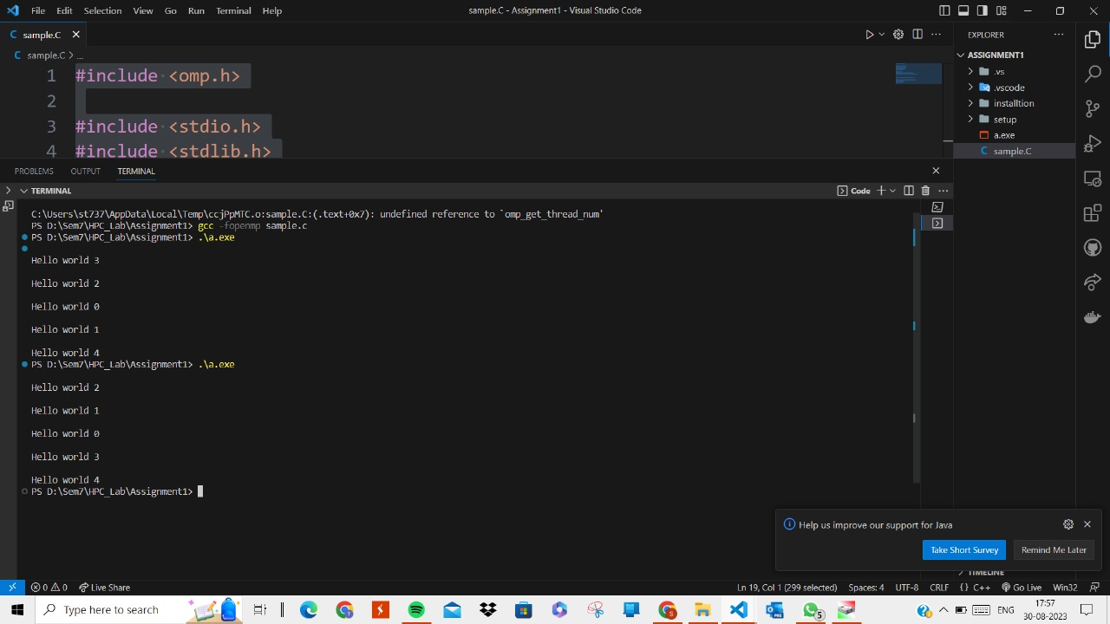

Here “Hello world” is printed using different 4 threads. We can set the number of threads with which we want to execute our program. If not set, it will take the number equal to physical threads of our machine.

The order of the execution the threads is not always sequential. It can be any arbitrary order each time. We may get different execution orders for multiple threads.

------------------------------------------------------------------------------------------------