**TY CSE AY-2022-23 Sem-I**

**Artificial Intelligence and Machine Learning Lab**

**Assignment No 2 Due date- 06/09/2022**

1. Consider the below graph, Find the optimal path from start node S to goal node G using A* algorithm.



The length(cost) of each edge is marked on the graph. Use the Manhattan distance as a heuristic function. Assume that each square side on the grid is 10KM.

1. Consider below a directed graph given and corresponding heuristic function values given in the table.

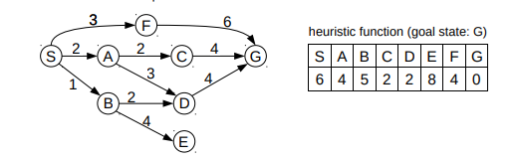

1. Implement A* algorithm and Best first search algorithm to identify an optimal path from Starting state S to goal state G.
2. What will be the time and space complexity?
3. Consider the following logic puzzle: In five houses, each with a different color, live five persons of different nationalities, each of whom prefers a different brand of candy, a different drink, and a different pet. Given the following facts, the questions to answer are “Where does the zebra live, and in which house do they drink water?”

The Englishman lives in the red house.

The Spaniard owns the dog.

The Norwegian lives in the first house on the left.

The green house is immediately to the right of the ivory house.

The man who eats Hershey bars lives in the house next to the man with the fox.

Kit Kats are eaten in the yellow house.

The Norwegian lives next to the blue house.

The Smarties eater owns snails.

The Snickers eater drinks orange juice.

The Ukrainian drinks tea.

The Japanese eats Milky Ways.

Kit Kats are eaten in a house next to the house where the horse is kept.

Coffee is drunk in the green house.

Milk is drunk in the middle house.

Discuss different representations of this problem as a CSP. Why would one prefer one representation over another?

1. Given a set of cities and distance between every pair of cities, the problem is to find the shortest possible tour that visits every city exactly once and returns to the starting point.

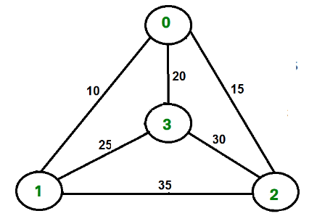

Identify the optimal path and implement this TS problem using branch and bound concept.

1. Using branch and bound identify optimal path of below graph from starting state S to goal state G.

4

5 4 9

8

7

4 3

5

3

7

***********************************