Walchand College of Engineering, Sangli

Computer Science & Engineering

Third Year

Course: Design and analysis of algorithm Lab

Lab course coordinator:

Dr. B. F. Momin- Batch: - T6, T7, T8

Mr. Kiran P. Kamble- Batch: - T1, T2, T3, T4, T5

**Week 9 Assignment**

Dynamic Programming

1. From a given vertex in a weighted connected graph, Implement shortest path finding Bellman-Ford algorithm.

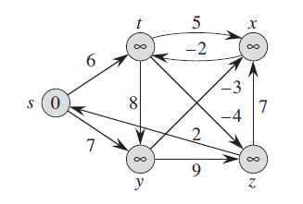

Q) Show that Dijkstra’s algorithm doesn’t work for above graph

Q) 