|  |  |
| --- | --- |
|  | **NAme :- sahil pravin thakur**  **prn : - 2020btecs00042**  **batch : - s3**  **sub :- Data base enginnering lab Assignment 1** |

**Experiment 1.**

**TITLE: - STUDY OF OPEN SOURCE AND COMMERCIAL DATABASE**

**1. Open-Source Database:** An open-source database is a database that anyone can open and free to download. No Authorized Licence are required.

**e.g., MYSQL, PostgreSQL, MongoDB etc**.

1)**MySQL:**

**History** :-

MySQL was created by a Swedish company MySQL AB in 1995. The developers of the platform were Michael Widenius , David Axmark and Allan Larsson. The purpose of developing is to provide efficient and reliable data management options to home and professional users.

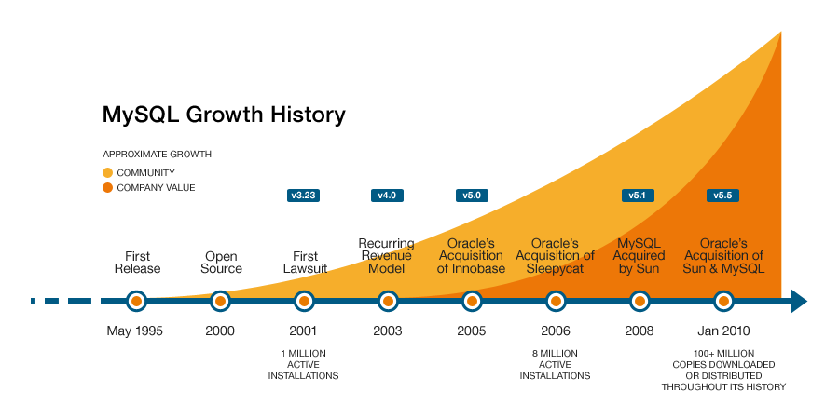

**Introduction:-**

It is a relational database system. MySQL is open-source and free software under the GNU license. It is supported by **Oracle Company**. It is fast, scalable, and easy to use database management system. It is used in conjunction with PHP scripts for server-side and web-based application. It allows us to implement database operations on tables, rows, columns, and indexes.

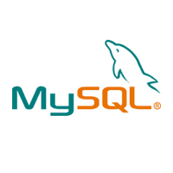

**Basic Query used in SQL**

1. SELECT - extracts data from a database
2. UPDATE - updates data in a database
3. DELETE - deletes data from a database
4. INSERT INTO - inserts new data into a database
5. CREATE DATABASE - creates a new database
6. ALTER DATABASE - modifies a database
7. CREATE TABLE - creates a new table
8. ALTER TABLE - modifies a table
9. DROP TABLE - deletes a table
10. CREATE INDEX - creates an index (search key)
11. DROP INDEX - deletes an index

**Advantage:**

1) Fast and high-performance Database, Easy to use and Easy to maintain.

2)MySQL provide Provides scalability, usability and reliability.

3) Accuracy and Efficiency is more.

4) Provides minimized code repetition

**Disadvantage:**

1)MySQL does not support a very large database size as efficiently.

2) It suffers from poor performance scaling.

3)Difficult to debug and maintain.

**2. Commercial Database:** Commercial database are that which has been created for Commercial Purpose and They are premium and are not free like open-source database. Authorized Licence are required. **e.**g., Oracle, IBM DB2 etc.

**IBM DB2:**

**History:-**

Db2 or Database 2, is a collection of relational database solutions developed by IBM and delivered on the mainframe platform. It is a [Relational Database Management System (RDBMS)](https://www.thecrazyprogrammer.com/2017/03/difference-between-dbms-and-rdbms.html) that is used to efficiently store, analyze, and retrieve data.

DB2 was originally exclusively available on IBM mainframes, but by the 1990s, it had migrated to a variety of other platforms, including LUW (Linux, Unix, Windows), i5/OS, and even PDAs. The Universal Server moved the technology to an object-related SQL DBMS, allowing developers to create custom data types from more primitive ones.

Db2 solutions include operational databases, data warehouses, data lakes, and rapid data. It also includes Object-Oriented features and non-relational structure. The Db2 family helps your organization explore the value of AI by making your data simple and accessible.

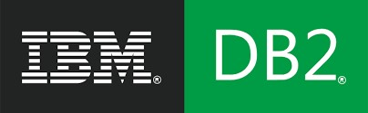

**Introduction**

DB2 is a database product from IBM. It is a Relational Database Management

System (RDBMS). DB2 is designed to store, analyse and retrieve the data efficiently. DB2 product is extended with the support of Object-Oriented features and non-relational structures with XML. The products feature AI-powered capabilities to help modernize the management of both structured and unstructured data across on premises and multicolour environments.

**IBM Db2 data management product package, which contains the following tools:**

* **Db2 Database**
* **Db2 Warehouse**
* **Db2 on Cloud**
* **Db2 Warehouse on Cloud**
* **Db2 Big SQL**
* **Db2 Event Store**

**Advantage:**

1) Reliable and secure.

2)Excellent performance.

3)Cross platform.

4)Accessing is significantly faster.

5)Redundancy is significantly low.

**Disadvantage:**

1)Lack of modern client tool to connect and query database.

2)Debugging is difficult.

3)Licensing is a bit expensive, and support is paid.

Open-source database is choose as compared to commercial DBMS because open-Source database is cheaper, more secure and preferred and better-quality source code.